
What Happened in -
JULY 2012
The Shelley Newsletter

In This Edition:

- Birthdays
- Outings
- Entertainment
- Richard Ratcliffe
- Present and past torches
- Remembering...
- And finally

One of the last regions in the UK but we did finally get the Olympic Flame in Worthing on the 16th July!

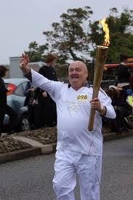
One of the official 13 runners who had been elected to carry the flame through Worthing

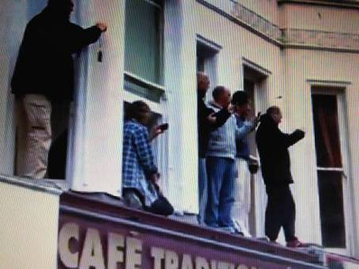
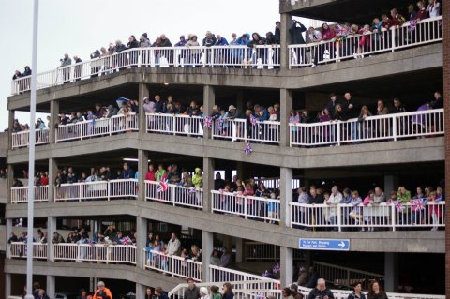

It rained all day long and the crowds had already gathered in their thousands then, just as the torch run arrived in Worthing the rain stopped.
BUT – how many knew or witnessed the other race, also known as the ‘Real’ Olympic race?! A group of people decided the officialism surrounding the official relay missed many people and places and ‘cheated’ by going part of the way on a coach. Word passed around and the unofficial run began – in the same place as the official one and they took almost the same route covering all places in the UK but with one difference, they had no transport, they ran day and night, arriving at the Olympic Stadium on Sunday 22nd July. All for charity.
Below is the moment the leg which ran from Arundel Castle reached and handed over their union flag-torch in Worthing on the 17th July.

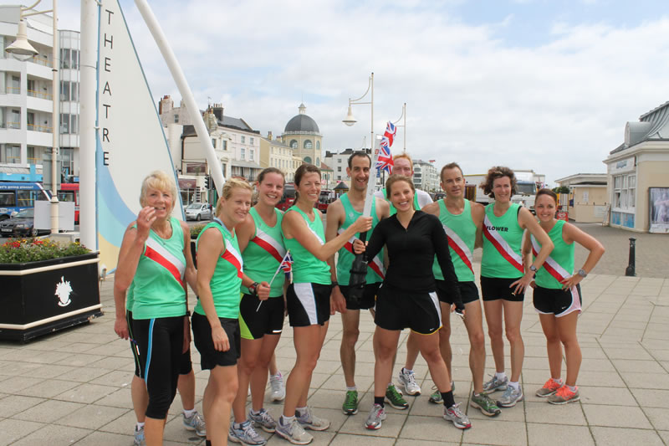

Birthdays and Other Congratulations:
A couple of birthdays this month:

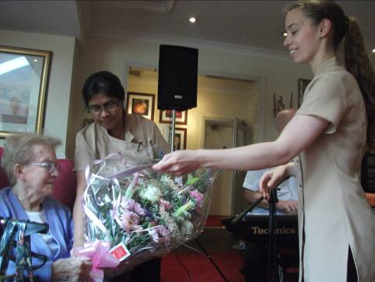
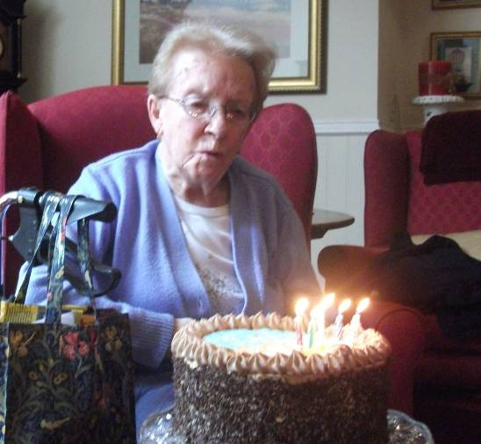
Betty

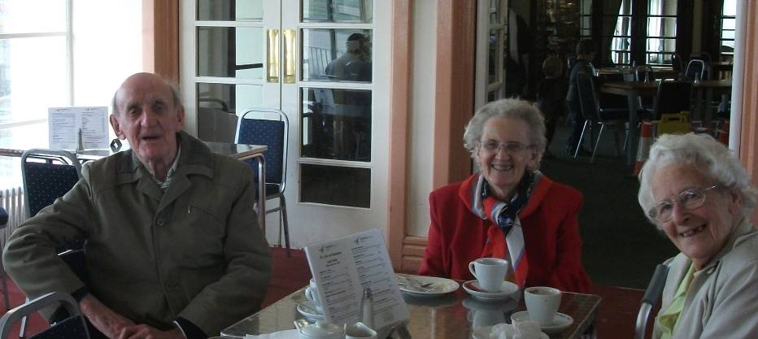

And Leslie, our ‘Lady in Red’

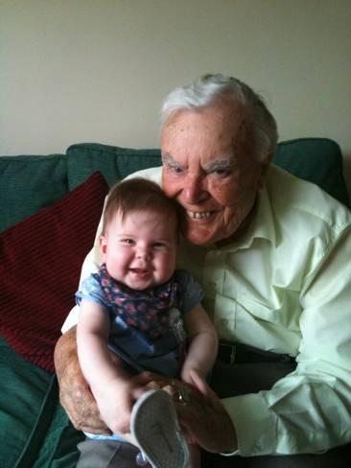

Not a birthday, but a visit to Ron from his young lady friend – Rosie!
You may remember she made her first appearance in our Newsletter back in February – just look at her now!

Congratulations to you all.

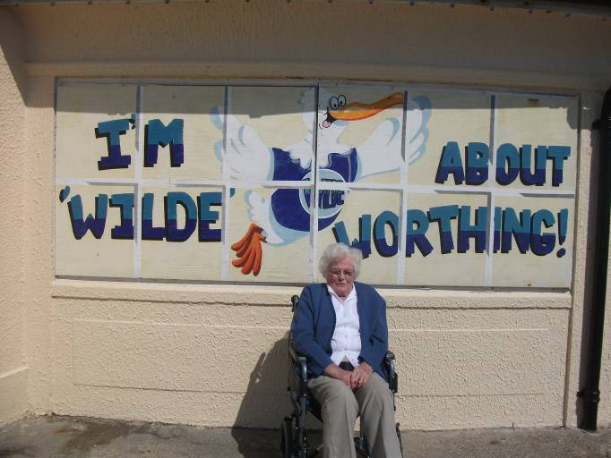
Outings this month included trips around the Sussex countryside – Steyning and Bramber, to parks, tea rooms, Worthing Sea Front and shopping.

July Outings and Entertainment:

The RSPB - Pulborough Brooks
Enjoyed by a group of residents watching the wildlife from hides in the open, owls in their nest box which could be seen in the distance and also their inside activity thanks to a camera and viewing screen in the visitors centre and finishing the trip with a cup of tea and slice of cake.

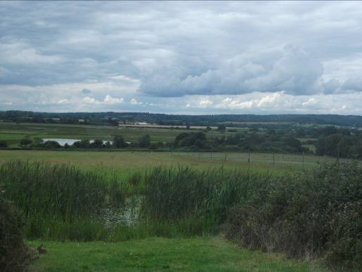
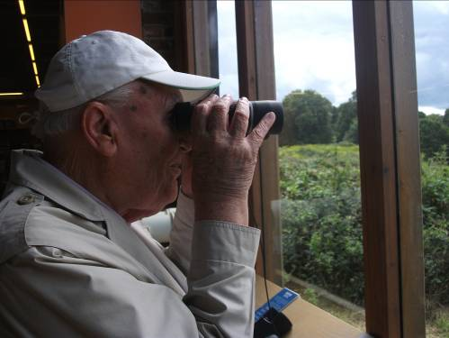

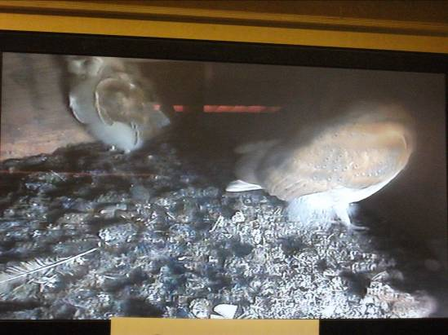
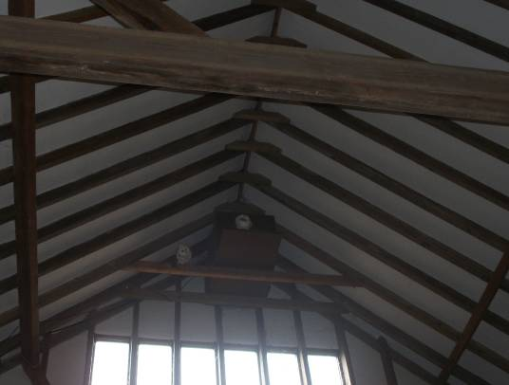

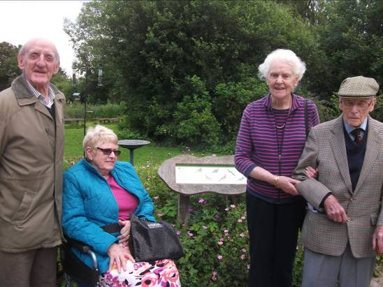

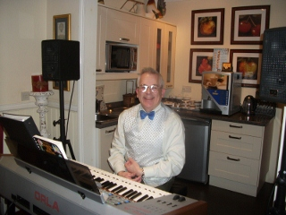
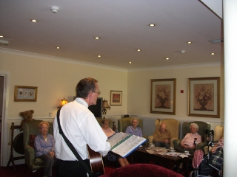

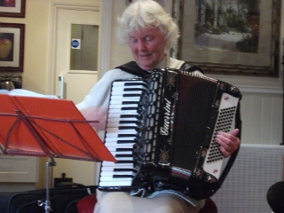
Jeanette invited a group of residents back to her home for afternoon tea and line-dancing in the large garden and as the day began so warm and sunny after all of that horrid rain, a number of residents jumped at this opportunity.
Unfortunately the weather changed its mind and the clouds gathered once more, luckily without dampening the afternoon!

Some of the many entertainers who visited us in July

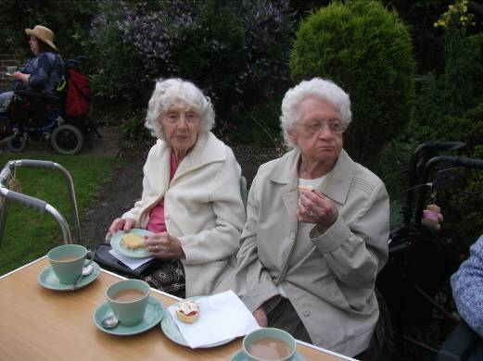
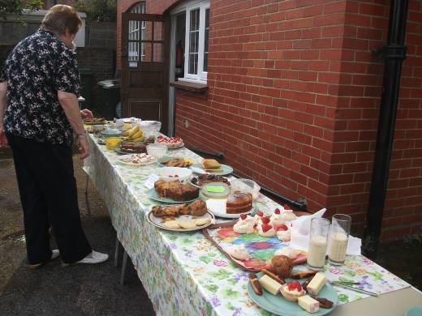

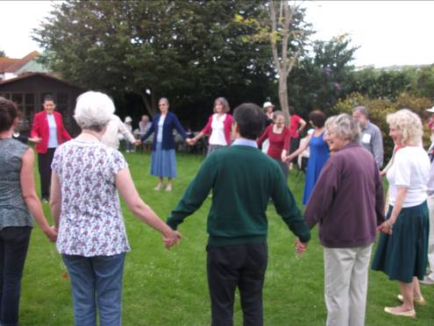

Looking Ahead:
A few dates for your August diary:
1st  3rd  4th  11th | Connie – Clothes Party - morning  Richard ‘Shiny Shoes’ Ratcliffe – afternoon  (See the following page)  Fish ‘n’ chips Friday  Mark Jones  Sarah – The violinist  The Shelley Summer Fayre all family members and friends of The Shelley are welcome  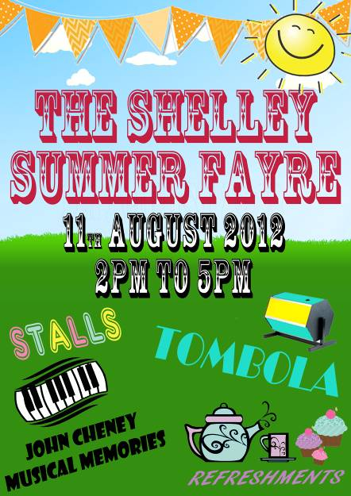

- We will also be welcoming back: Paul Rothera, Tim West, GAPP, Sally with Music for Health, Alex (Nocturnal), Eddy, Frank King and Bernard. As well as aromatherapy, Quizzes and your Exercise and Yoga classes.
- Jenny will be with us as usual, to patch up and sort out any minor sewing repairs/alterations you may need.
- Anna will be coming to carry on with your art and crafts.
Richard Ratcliffe Biography
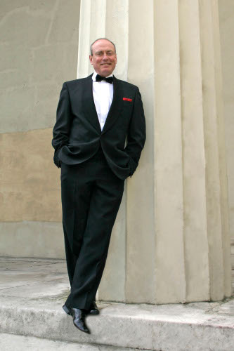
Born in London Richard Ratcliffe went to school just around the corner from the Ealing Studios. That is where he got his first taste for showbiz watching them filming the exterior shots! Ironically a few years later he had his first Television job there in an episode of Z Cars! Later on he worked there again with one of his heroes Spike Milligan in Q10. Other TV includes guest appearances in Eastenders, Doctors, The Bill, Casualty, Bergerac, Keeping up Appearances, Lovejoy and Minder.

Richard was also a regular member of the BBC Radio Rep and he often acted and sang on Children's Radio. He has also written comedy scripts and short stories for Radio; and composed several jingles for Radio Commercials! He has often performed Soundalikes too and is a well-established Voiceover Artiste for TV and Video documentaries.

His singing career has included all sorts of music from seasons with the Black and White minstrels, International Ice shows, Barber Shop Quartet and right through to supper cabarets. He has appeared in many successful West End musicals including 'The Sound of Music' starring Christopher Cazenove and Amanda Holden; 'Me and My Girl' with Gary Wilmot; 'Joseph', 'Some Like It Hot' with Tommy Steele, 'Annie' and many many more!
He has also acted in several prestigious stage productions with Terence Stamp, Jenny Seagrove, Philip Madoc, Frank Finlay, Gerald Harper and many others. On tour he has appeared in several of the famous Ray Cooney farces and has co-written and starred in a revue at the Edinburgh Festival. Of course one of his all-time favourite jobs was working with The Two Ronnies when they performed their live shows, both at the London Palladium and on subsequent tours.
For many years Richard has been combining all his skills as a writer, singer and actor to create his own one-man show 'Recipe of Love'. With this show he has headlined in some of the most prestigious venues in Europe, including Ireland, East Berlin and Denmark. He has also worked as Master of Ceremonies for larger Corporate events, Dinner Dances and Weddings; a cabaret artiste for smaller, private functions; and a lounge singer.
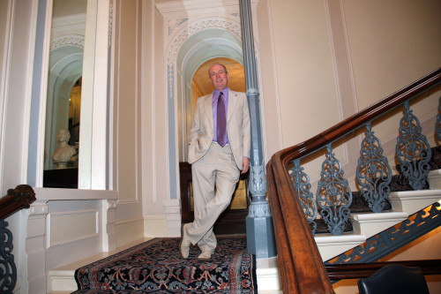

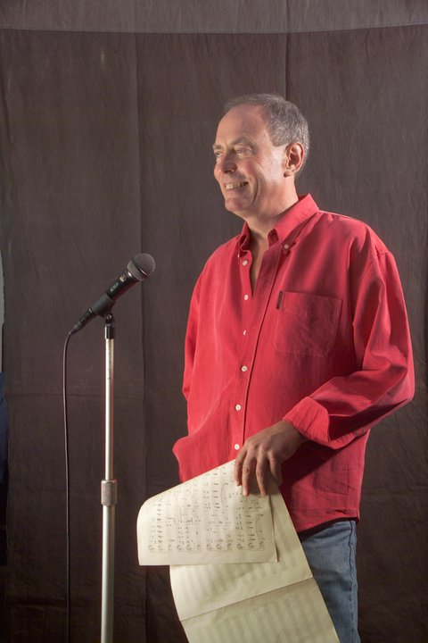
Richard lives on the Sussex coast and when he is not busy performing he still writes comedy scripts and short stories. Some years ago he was proud to receive the prestigious 'Centurion' award from CALIBRE, a British based charity, when he had recorded over 250 books onto cassettes for the blind!

Richards life-long dream is to sing a duet with Tony Bennett - so far Tony has been a little bit too busy!

Taken from Richard’s own Internet pages, with his kind permission.
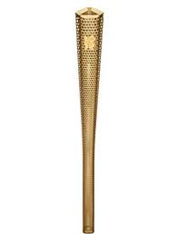
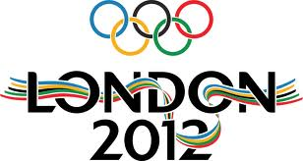
THE 2012 TORCH
The Torch was designed by east Londoners Edward Barber and Jay Osgerby, who won the opportunity through a competitive tender run by the London 2012 Organising Committee and the Design Council.
Basildon-based product engineers Tecosim, Birmingham-based LPG Gas specialists and manufacturers, Bullfinch and Coventry manufacturers Premier Sheet Metal have taken the design and moved it into mass production.
The Torch stands 800mm high and weighs 800 grams.
In April 2012 the Torch was recognised as the Design of the Year at an awards ceremony hosted by the Design Museum.

Design: an inspirational 8,000
The Torch is made up of an inner and an outer aluminum alloy skin, held in place by a cast top piece and base, perforated by 8,000 circles.
Representing the inspirational stories of the 8,000 Torchbearers who will carry the Olympic Flame, the circles which run the length of the body of the Torch also offer a unique level of transparency. You can see right to the heart of the Torch and view the burner system which will keep the Olympic Flame alive on its journey around the UK.
The circles also help ensure heat is quickly dissipated, without being conducted down the handle, and providing extra grip.
The Torch is being tested in BMW’s climatic testing facility in Munich to make sure it can withstand all weather conditions. BMW is a Supporting Partner of the London 2012 Olympic Torch Relay.

Shape: the power of '3'
The triangular-shaped Torch was inspired by a series of 'threes' that are found in the history of the Olympic Games and the vision for the Olympic Movement:

Weight: as light as possible
- The three Olympic values of respect, excellence and friendship;
- The three words that make the Olympic motto – faster, higher, stronger;
- The fact that the UK has hosted the Olympic Games in 1908, 1948 and will host them for the third time in 2012; and
- The vision for the London 2012 Olympic Games to combine three bodies of work – sport, education and culture.
More than half of the London 2012 Torchbearers are expected to be young people aged as young as 12, so the designers aimed to make the Torch as light as possible.
It is made from a special aluminum alloy developed for the aerospace and automotive industry. The alloy is lightweight but strong, with excellent heat resistance. The 8,000 circles also reduce the weight of the final design, whilst ensuring strength isn’t compromised.

Colour: Gold
The gold colour embraces the qualities of the Olympic Flame – the brightness and the warmth of the light that it shines
PAST OLYMPIC TORCHES
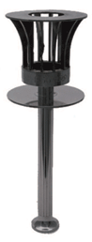
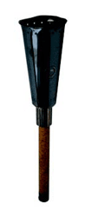
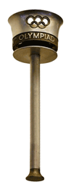
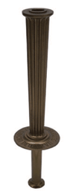
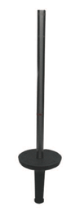
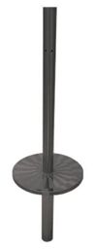
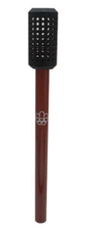
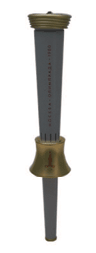
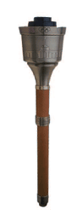
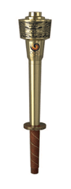
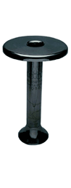
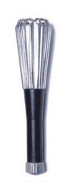
2
1
3
4
5
6
7
8
9
10
11
12
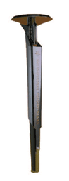
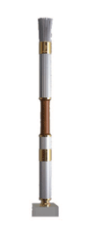
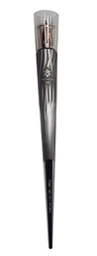
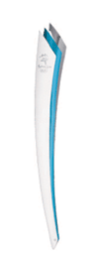
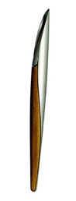
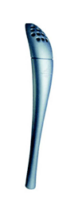
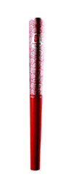
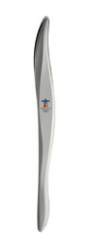
13
14
15
17
18
19
20

16

Berlin 1936
London 1948
Helsinki 1952
Melbourne 1956
Rome 1960
Tokyo 1964
Mexico 1968
Munich 1972
Montreal 1976
Moscow 1980
Los Angeles 1984
Seoul 1988
Barcelona 1992
Atlanta 1996
Sydney 2000
Salt Lake City Winter Olympics 2002
Athens 2004
Torino Winter Olympics 2006
Beijing 2008
Vancouver Winter Olympics 2010

SMUDGE – OUR SPANISH CAT

There once lived a cat called Smudge
Who lived at The Shelley for years.
She was pampered and loved, and gave lots in return.
Oh, we miss her so very, very much.
Smudge was born in Spain. She was rescued by a European animal charity and lived in a shelter with other dogs. To reach the UK, she had to travel with 7 dogs in a van and this took 48 hours. Smudge had her own European passport which was stamped with all her inoculations. The European charity placed an advertisement in a newspaper seeking a home for a beautiful cat, which Nada saw..........

To read the rest of this lovely story which was written by Clare with input and tears from Nada, plus other stories and photos, please ask one of the staff to show you Smudge’s own Remembrance Book which is kept in the hall or lounge.

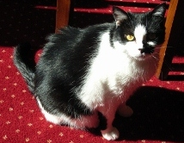

And finally:

STUDENT WHO OBTAINED 0% ON AN EXAM

Q1. In which battle did Nelson die?  His last battle  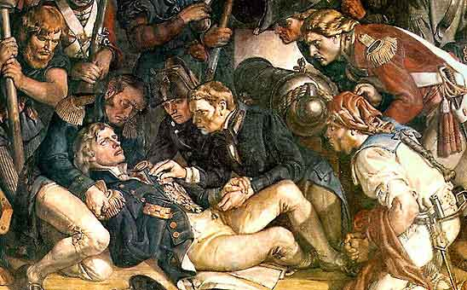  Q2. Where was the Declaration of Independence signed?  At the bottom of the page  Q3. River Ravi flows in which state?  Liquid  Q4. What is the main reason for divorce?  Marriage  Q5. What is the main reason for failure?  Exams  Q6. What can you never eat for breakfast?  Lunch & dinner  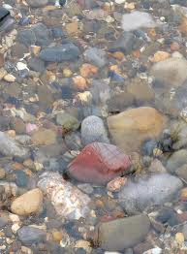  Q7. If you throw a red stone into the blue sea what it will become?  Wet | Q8. What looks like half an apple?  The other half  Q9. How can a man go eight days without sleeping ?  No problem, he sleeps at night.  Q10. How can you lift an elephant with one hand?  You will never find an elephant that has only one hand.  Q11. If you had three apples and four oranges in one hand and four apples and three oranges in other hand, what would you have ?  Very large hands  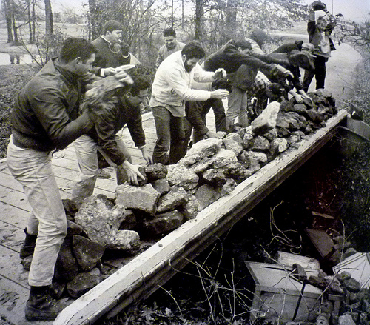  Q12. If it took eight men ten hours to build a wall, how long would it take four men to build it?  No time at all, the wall is already built.  Q13. How can u drop a raw egg onto a concrete floor without cracking it?  Any way you want, concrete floors are very hard to crack  (Thanks go to Quizmaster Peter)

www.theshelley.com http://theshelleynewsletters.weebly.com TheShelley Worthing


