
The Shelley - 54 Shelley Road, Worthing, West Sussex, BN11 4BX. t: 01903 237000 e: info@theshelley.com
The Shelley Newsletter

What Happened in December 2013

What’s to come in January 2014

YAY – It is that time of the year

Inside This Issue
That time of the year 1
Birthdays and other Celebrations 2
Entertainment and Outings 3
Residents Contributions 4
Next Month 8
And Finally 9

When
The decorations are all up – old and new Just look at some of them this year



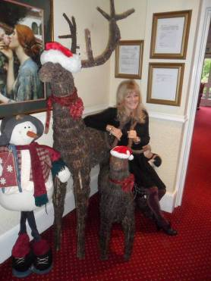

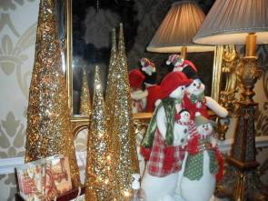

Walk along the various corridors – they are all decorated. As are some of the room doors designed and made by their owners!
The Tuesday Quiz is always popular and keeps Beverley on her toes devising clues to keep those taking part on their toes too!

The sun did shine for a few days which allowed us to get out into the garden.
reader The article should clarify, inspire, decides that your products or services provide the solutions they need.
To sum it up, grab the reader’s attention through an effective headline and hook, and then reward the reader for following through by giving them something they didn’t have before. In addition, keep the article brief and well focused, and if appropriate, demonstrate how your products and services address the issues raised in the article. By doing so, you stand a good chance of keeping the readers you have, and gaining new readers with every issue.

Many Happy Returns To:
Page 3



Birthdays and Other Celebrations

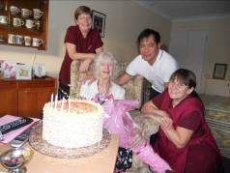
Joyce – our only birthday in December

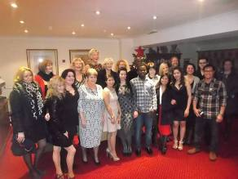
The staff had their party – this year watching an Elvis tribute show in Brighton
And you all had your party too followed closely by Christmas Day!

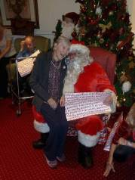
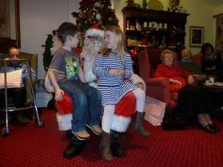
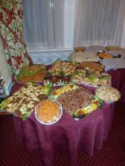
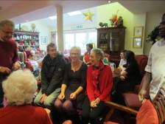



Entertainment and Outings

Page 3
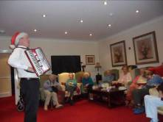



Ah and the heartthrob “Mr Richard Shiny Shoes” wooed us all!
A visit to the dentist was not too bad after all!
Bing came to sing to us

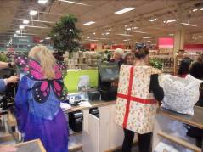
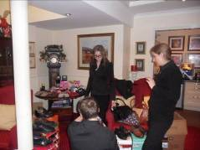

Gifts were bought
And
Shoes too!

And Storm came

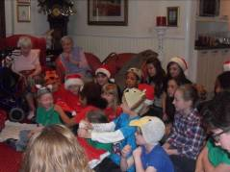
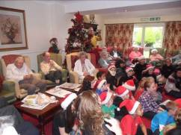
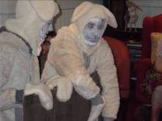
New friends were made



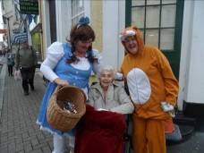

Page 4

Residents Contributions: UK Place Names

There are many, many strange names in the UK, some funny and some to make you blush. Most mean the surroundings of where they are. Others come from old Norse family names, who settled in the area and used their names to name a town.
Below are a few examples of strange UK names with their origins.

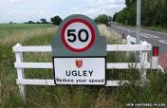
Let’s start with this one – Ugley. This name probably comes from “Ugga” which means a forest or wood. It later came to mean a pasture, meadow or clearing.
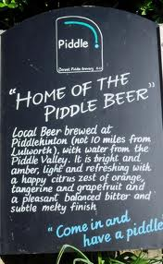
It is commonly pronounced as 'Usley '

Puddletown and The Piddle River are in Dorset (close to Tolpuddle where the Martyrs came from). It came from “Farm on the River Piddle”. “Tun” meant an enclosure, a farmstead, village or estate.
The locals use the name to their advantage.

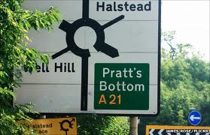
Pratt’s Bottom, now there is a place to live (or not)

A small village in Kent - Pratts Bottom - Pratt coming from the Latin word Pratum meaning Meadow.
Want to know the origin of where you were born or lived?
Tell Sherry and she will look into it for you!

Here are some more strange names -

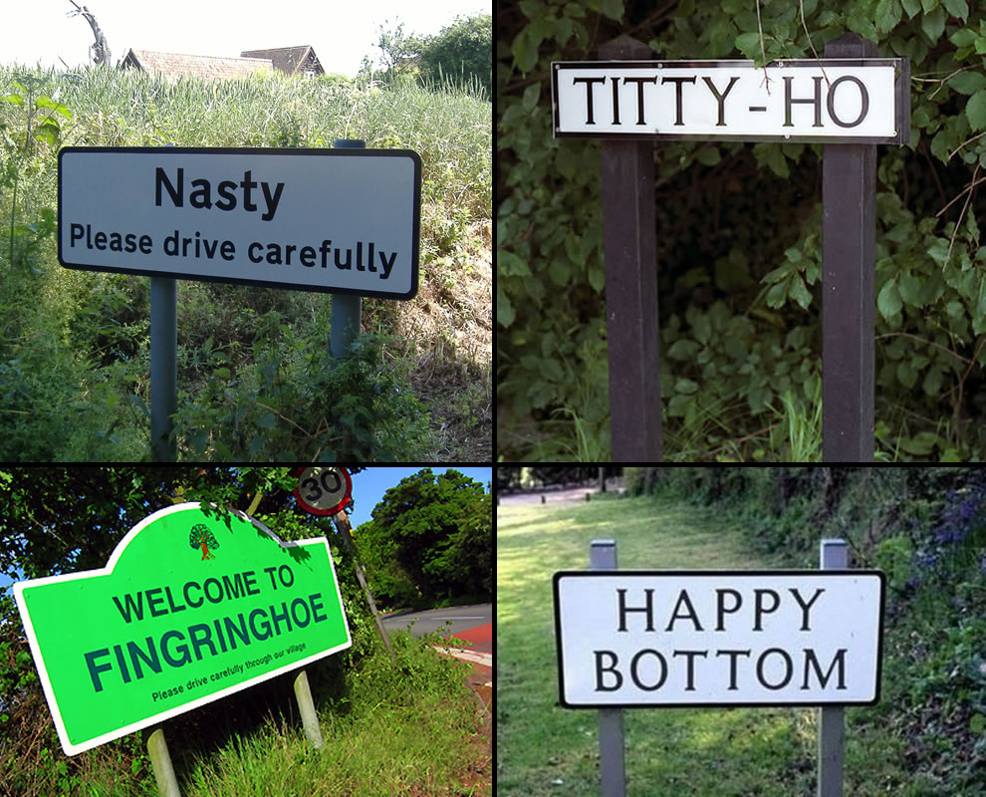

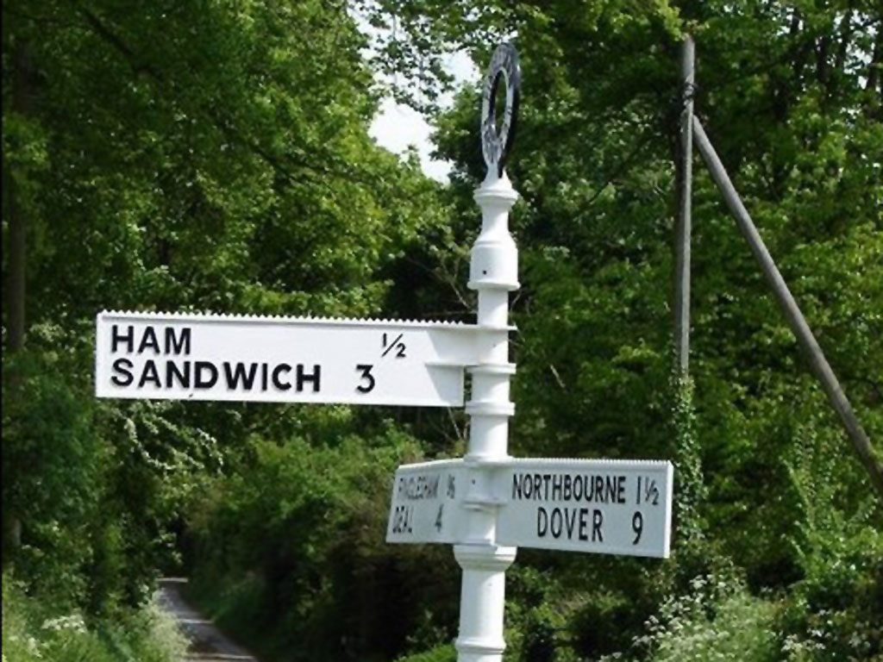

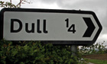

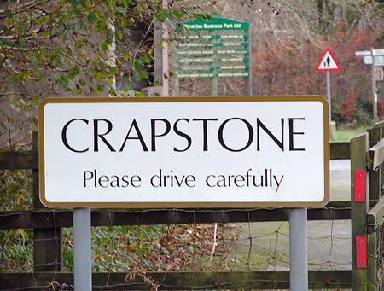
But this is the one which was voted as the most embarrassing place to live -

Our thanks to Peter for this Newsletter contribution.

Page 5

Residents Contributions: Everyday Sayings

Andrew was interested in the origin of some of our everyday sayings.
He did some investigation and found that although there are a few explanations, the more common and widely believed traces it back to a dispute between two of the ancient livery companies in the City of London.

These companies, trade guilds, grew up from the latter part of the twelfth century as associations to protect their members’ interests. (They were called livery companies because members had the right to wear a distinctive costume or livery.) There was a lot of squabbling with other guilds about precedence in the early days. One especially troublesome dispute concerned the Merchant Taylors Company, whose members were tailors, and the Skinners Company, whose members controlled the trade in furs. In 1484 the then Lord Mayor, Sir Robert Billesden, settled the dispute in a judgement of Solomon by ruling that the two companies should alternate between the sixth and seventh positions in successive years, a ruling still in force. This might seem to settle the matter. What could be clearer? The two companies were permanently at sixes and sevens with each other.

“All at sixes and sevens”

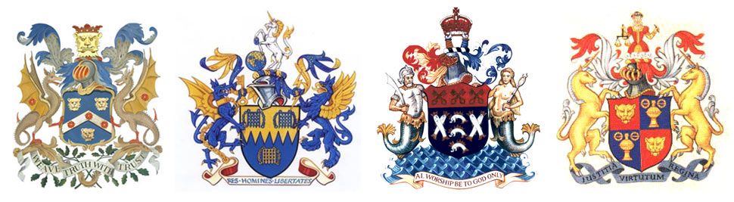

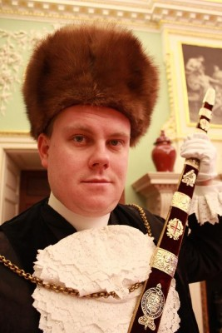
“Keep it under your hat”
There is some doubt to where this saying originated. The Americans say it came from President Abraham Lincoln, who famously wore a stove-pipe hat. He had the habit of keeping important papers in it, to the extent that he referred to it as his office.
In the City of London the popular etymology is that when the new Lord Mayor is admitted to office, he is presented with the symbols - the mace, sword, and seals of office - in the Silent Ceremony. The swordbearer wears a Muscovy fur hat which has a small pocket in which he keeps the seals safe. The post was introduced in 1420.
A former Lord Mayor, Richard Martin confirms the basic facts: "I keep the Lord Mayor's key to the Christ's Hospital Seal in a pocket inside my hat, a traditional medieval design

which implies the wearer is a man of importance. The one I wore was created in 1975 and is of sable. Following the Silent Ceremony I pass the key to the outgoing Lord Mayor, who passes it to the incoming Lord Mayor, who returns it to me with the instruction 'keep it under your hat'."

During WWII the phrase was widely used as posters in all forms to remind the allies that careless talk can cost lives.

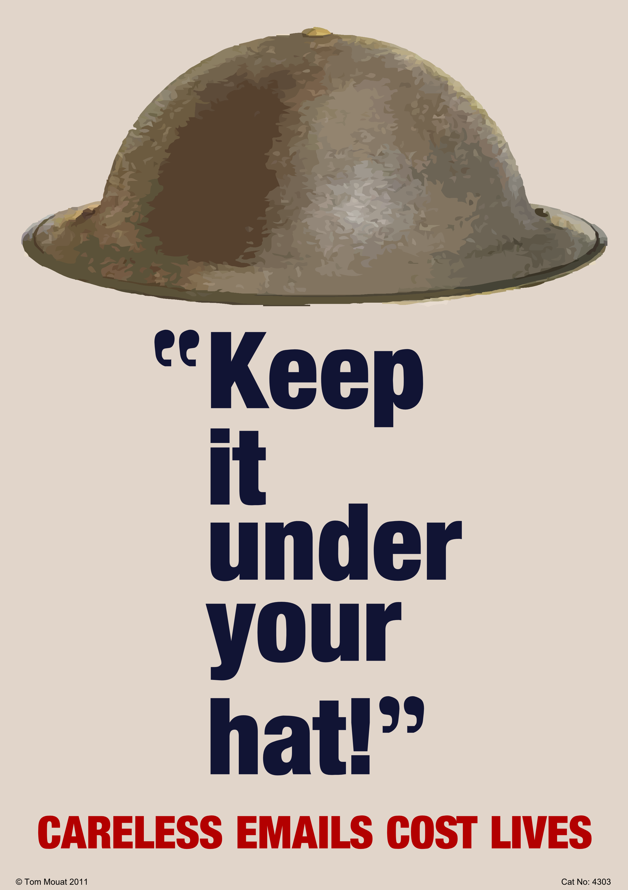

Written evidence of the phrase being used dates to the 1800’s in both the UK and USA (the earliest found so far is The Old Factory, A Lancashire Story, by W B Westall, 1881)


It’s possible the story about Lincoln’s hat is indeed the origin. But, in view of English examples, I wouldn’t bet on it.

The photo on the left gives it a whole new meaning!

Page 6

Residents Contributions: John’s Rhymes

DREAMS


I wish I could visit India
A funny place to go
With all that heat and poverty
But at least they don’t have snow

I wish I could speak Spanish

No real reason why
Except I like the sound of it
But I can only try

I wish I could drive an E-Type
They’re history now I know

But once they were the very best
And I want to have a go

I wish I could ride in a bobsleigh
Whizzing down the slope
People say I am too old
But I reckon I could cope

I wish I had more knowledge

So many things to learn
I want to know why waters wet
And what makes fire burn

I wish I could work a computer
Properly, not just messing
Then I could find the answers
Instead of only guessing

I wish I could write a decent rhyme
Full of thought and meaning
But as it is the best I can do
Is just to go on dreaming

Page 7

Residents Contributions: Poems

The True Spirit
As Christmas time comes round again,  With so many things to do,  We’re apt to forget the reason why  It’s important to me and you.  Bethlehem seems so far away,  Not only in time and space  But so remote from out modern world  And our scurrying human race.  The very simplicity of it all  Is so hard to understand,  How God could send us His precious Son..  But that is the way he planned. | The Holy Babe in the humble stall,  The bright star high above,  And angel voices filling the night  With anthems of joy and love.  Yet, if we’ve peace and joy and love  In our hearts on Christmas Day,  Bethlehem, and the Holy Babe  Are not really so far away...  And if those feelings we cherish, and bear  In mind, in all that we do,  The spirit of Christmas will linger on  It will last the whole year through!
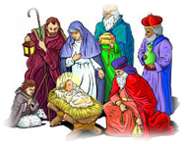

Kathleen O’Farrell

New Year
“Our thanks to everyone for their contribution – keep them coming!
Write in on your calendar
And write it on your heart,
Mark it in your diary –
This year’s a fresh new start.
A time of new beginnings
Of looking forward too,
A time for all those hopes and dreams,

Now make them all come true!
Write it on your calendar
And mark it out in red,
A time for going forward,
A brighter path ahead.
Forget those resolutions

And step out day by day,
The past is simply left behind,
Go bravely on your way!
Iris Hesselden

Our thanks to Clare Bear for passing these on to us

Page 8
Next Month

Some Dates For Your January Diary
As well as our weekly outings in the mini-van or walk/ride to the shops/parks etc. We also have many of our favourite entertainers joining us, such as:
3rd – Fish ‘n’ Chips Friday | And Sarah, Violinist
4th - Jo Claydon | 10th - Frank King
11th – Jo and Graham, Harmony Singers
13th - Sarah, Tea Dance 17th - GAPP

18th – Ratcliffe Brothers, Pianists
23rd – Shirley Verene
25th – John Beaver with a Scottish Theme
31st – Nathan, guitarist / singer


PLUS our usual

Yoga – Exercises with Nick – Aromatherapy – Pampering Afternoons - Manicures – Art – Communion –
Breathing Spaces - Outings in the mini-van - Shopping Trips

Page 9
And Finally

For those who many have overindulged this Christmas – some suggestions

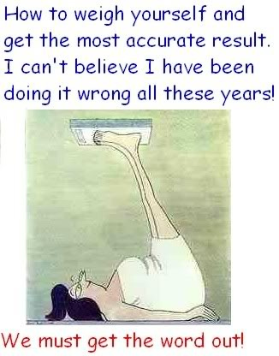

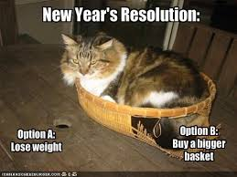



We’re on the Web!
Visit us: theshelley.com
Find us on Facebook: TheShelley Worthing
Read Past Newsletters: theshelleynewsletters.weebly.com/
For Just Photos: theshelleyphotos.weebly.com/

The Shelley does not hold, nor claim to hold the copyright on any article or photograph found in print or on the Internet.

