The “OUTSTANDING” Shelley

Newsletter – December 2015

**The Shelley -** 54 Shelley Road, Worthing, West Sussex, BN11 4BX. t: 01903 237000 e: [info@theshelley.com](mailto:info@theshelley.com)

### Inside This Issue

December 1

November in Pictures 2

Santa 4

John’s Rhymes 7

Entertainment 9

And Finally 10

***WELL DONE THE SHELLEY***

*Just after the last newsletter went to print, we heard the news we had been waiting 8 weeks for – We have been awarded “Outstanding” by CQC, the inspectors.*

*In one month we had the double accolades for Best Manager and runner up for Best Ancillary. Then this Outstanding news. With just 0.3% of all inspected premises in the UK awarded this highest achievement and 0.1% of Care Homes, we feel extremely proud and the local press were proud to join in by coming to our celebration party so they could report we are the first to achieve this in Worthing!*



***CELEBRATIONS CONTINUE***

*This month we celebrate 10 years of The Shelley!*

*So with another party on the way, your own Christmas Party and plenty of Christmas entertainment, we are in for a busy month!*

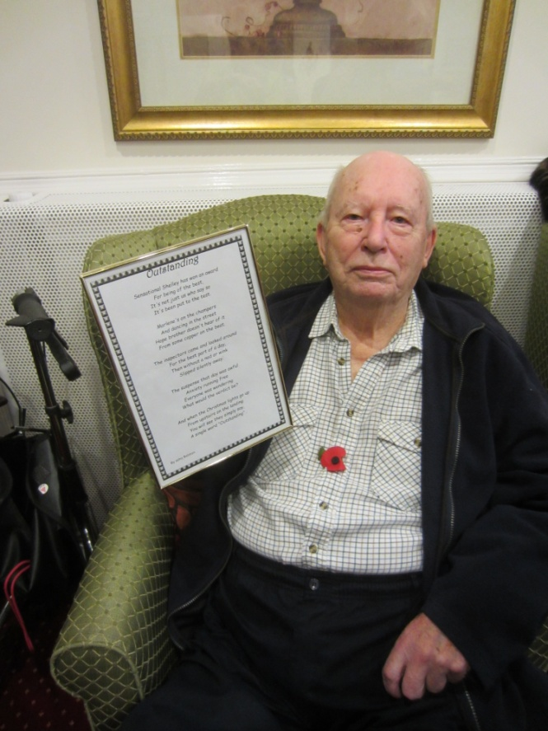

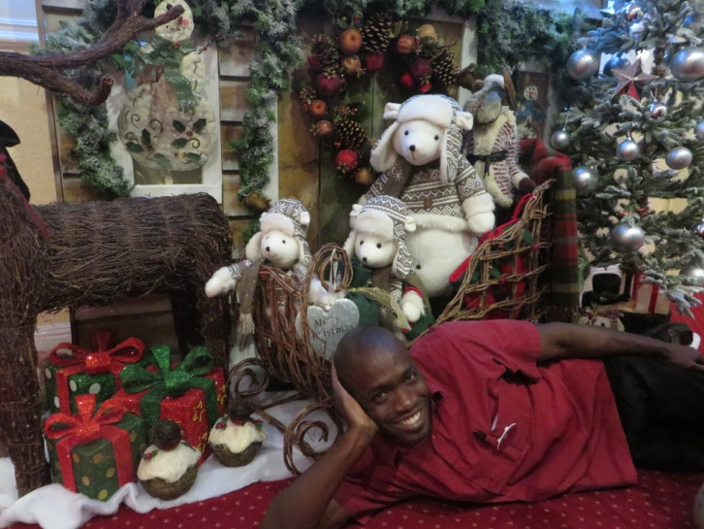

Page 2 November in Pictures

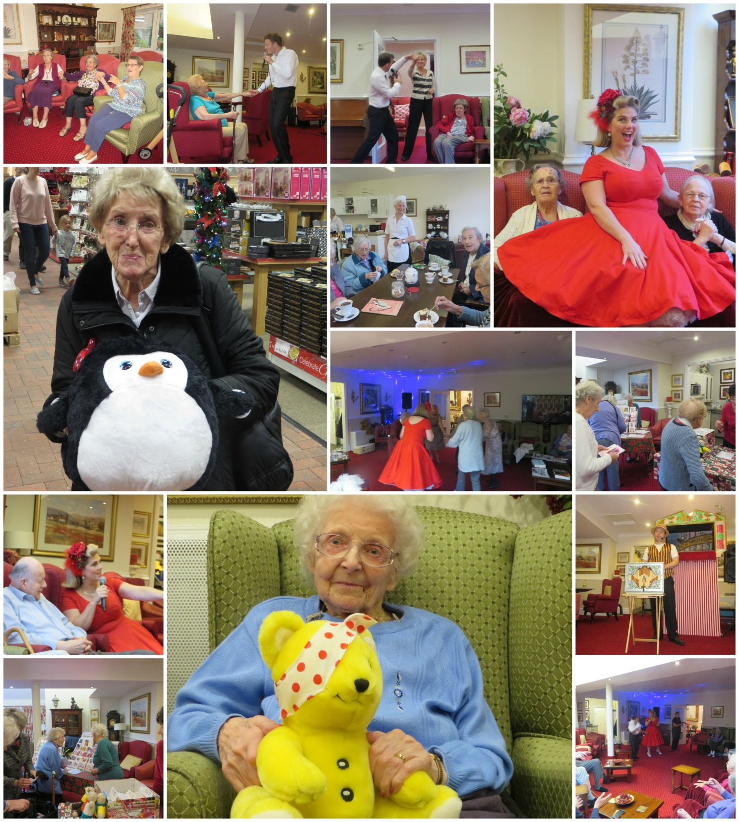

This Month – In a short time you raised money for:

The Cat League

Children in need

And Worthing Polio Foundation

Well, done and Thank You very much, from all the charities

Page 3

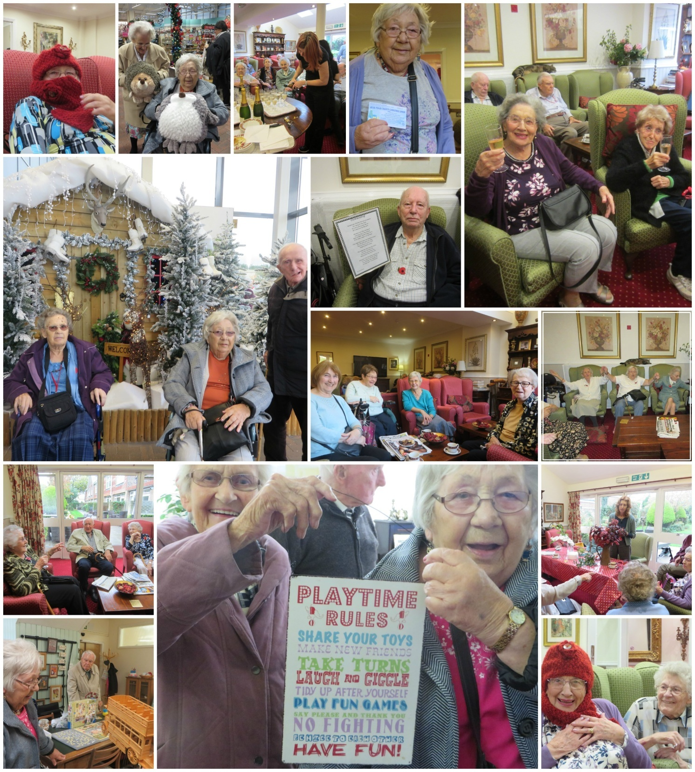

Page 4 Santa’s Origins

Where did Santa come from? (Apart from the North Pole of course!)

We associate Christmas with giving each other gifts – but why?

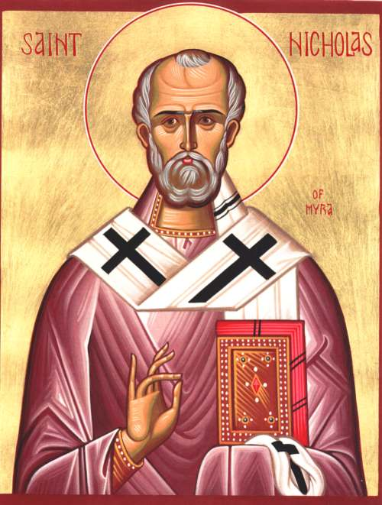Santa Claus is associated with St. Nicholas who was the Greek bishop of Myra, a Roman town in Turkey. He lived between 3rd and 4th centuries and defended Christianity while followers were being persecuted.

He was imprisoned for many years until Constantine came to power and made Christianity the dominant religion in the Roman Empire.

When St. Nicholas died he was given his own saint day (December 6th) and became the patron saint of a diverse group of people, such as sailors, entire nations, saint of children and a magical gift giver. The latter resulting from a story who told how he had brought 3 murdered boys back to life after praying to God.

*At about this time Pope Julius 1st decided to establish a date for the celebration of the birth of Jesus and chose to assign a pagan mid-winter festival, December 25th. in the hope to use the holiday to Christianize the celebrations. St Nicholas’s feast day eventually also became associated with this date along with his connection with Christmas.*

*Using the story of bringing the boys back to life, therefore a gift giver, it was said he visited children on Christmas Eve and children would leave fruit, nuts and sweets around the home for him. However, after the reformation, most of Protestant Europe dropped St Nicholas tradition apart from the Dutch who named him Sinter Klaas.*

*Many countries had their own folk tales including:*

***Frau Holda*** *in Germany who protected children’s souls, flying through the night to give children gifts delivered by coming down chimneys and food and milk would be left for her in return.*

***Le Befana*** *in Italy tell of a soot-covered woman who flew on a broomstick giving children presents if they had been good or lumps of coal if they had been naughty. She came on Epiphany (January 6th) the day The Three Kings gave gifts to Jesus.*

Page 5

*It was a poem, “A Visit from St. Nicholas” aka “The Night Before Christmas” that cemented Santa Claus’ role in America’s Christmas tradition. Though its author is disputed, with the poem being* [*attributed*](http://en.wikipedia.org/wiki/A_Visit_from_St._Nicholas) *to both Clement Clarke Moore and Henry Livingston Jr. over the years, it was definitely first published on Dec. 23, 1823 in the* Troy Sentinel *newspaper in upstate New York.*

*This poem tells of St Nicholas having a round tummy, dressed in fur with a bundle of toys on his back, covered in soot from the chimney he goes down to fill children’s stockings with toys.*

*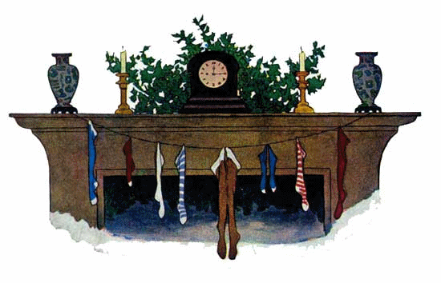Most of us recognise parts of this poem, here it is transcribed in full:*

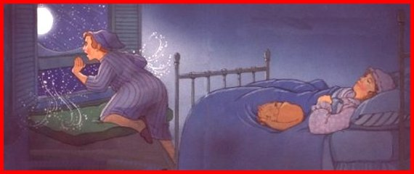Twas the night before Christmas, when all through the house  
Not a creature was stirring, not even a mouse.  
The stockings were hung by the chimney with care,  
In hopes that St Nicholas soon would be there.  
  
The children were nestled all snug in their beds,  
While visions of sugar-plums danced in their heads.  
And mamma in her ‘kerchief, and I in my cap,  
Had just settled our brains for a long winter’s nap.  
  
When out on the lawn there arose such a clatter,  
I sprang from the bed to see what was the matter.  
Away to the window I flew like a flash,  
Tore open the shutters and threw up the sash.   
  
The moon on the breast of the new-fallen snow  
Gave the lustre of mid-day to objects below.  
When, what to my wondering eyes should appear,  
But a miniature sleigh, and eight tinny reindeer.  
  
With a little old driver, so lively and quick,  
I knew in a moment it must be St Nick.  
More rapid than eagles his coursers they came,  
And he whistled, and shouted, and called them by name!

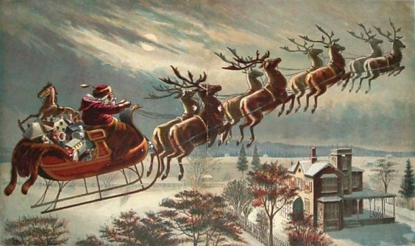

"Now Dasher! now, Dancer! now, Prancer and Vixen!  
On, Comet! On, Cupid! on, on Donner and Blitzen!  
To the top of the porch! to the top of the wall!  
Now dash away! Dash away! Dash away all!"

Page 6

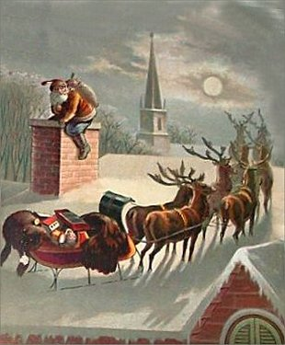  
As dry leaves that before the wild hurricane fly,  
When they meet with an obstacle, mount to the sky.  
So up to the house-top the coursers they flew,  
With the sleigh full of Toys, and St Nicholas too.  
  
And then, in a twinkling, I heard on the roof  
The prancing and pawing of each little hoof.  
As I drew in my head, and was turning around,  
Down the chimney St Nicholas came with a bound.  
  
He was dressed all in fur, from his head to his foot,  
And his clothes were all tarnished with ashes and soot.  
A bundle of Toys he had flung on his back,  
And he looked like a peddler, just opening his pack.  
  
His eyes-how they twinkled! his dimples how merry!  
His cheeks were like roses, his nose like a cherry!  
His droll little mouth was drawn up like a bow,  
And the beard of his chin was as white as the snow.  
  
The stump of a pipe he held tight in his teeth,  
And the smoke it encircled his head like a wreath.  
He had a broad face and a little round belly,  
That shook when he laughed, like a bowlful of jelly!

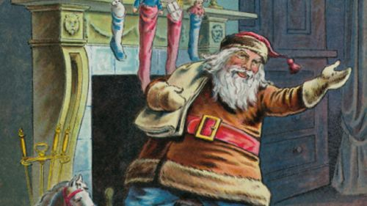He was chubby and plump, a right jolly old elf,  
And I laughed when I saw him, in spite of myself!   
A wink of his eye and a twist of his head,  
Soon gave me to know I had nothing to dread.  
  
He spoke not a word, but went straight to his work,  
And filled all the stockings, then turned with a jerk.  
And laying his finger aside of his nose,  
And giving a nod, up the chimney he rose!  
  
He sprang to his sleigh, to his team gave a whistle,  
And away they all flew like the down of a thistle.  
But I heard him exclaim, ‘ere he drove out of sight,  
"Happy Christmas to all, and to all a good-night!"

*And thus, Santa was cemented in minds of millions around the world.*

Page 7 John’s Rhymes

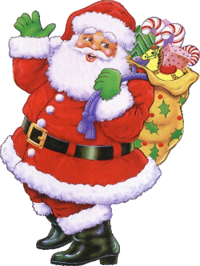Christmas   
  
  
  
  
  
.

Is there anything new about Christmas?  
Something that hasn't been said?  
I'm pretty sure there must be  
It's rattling in my head.  
  
We all know all about Santa  
Nothing more to say about him  
He looks a very genial cove  
With those whiskers round his chin.  
  
I once played Father Christmas   
At a children's Christmas party.  
I rang the bell and shouted loud  
But, alas, it was too hearty.

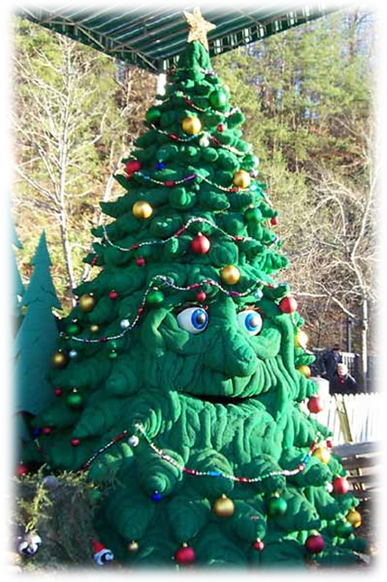

The older children were surprised   
The parents simply stared  
But I'm sad to say the worst bit was  
The little ones were scared.  
  
What about the Christmas tree?  
There's nothing new to see  
Though I once was rather startled  
When one spoke to me.  
  
Then there are the Christmas cards.  
They're not very new  
And every year we wonder  
Whom shall we send them to?

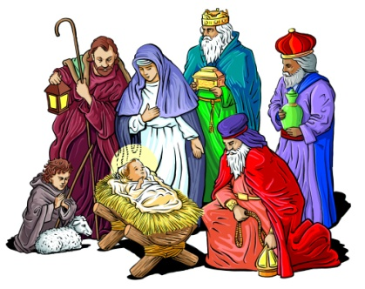

So it seems there's nothing new  
But as always we can say  
That Jesus Christ our Saviour  
Was born on Christmas Day

Page 8

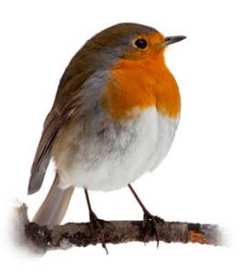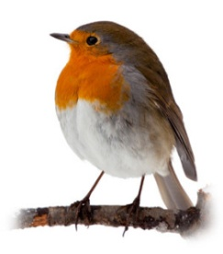

Robin

I hear the robin redbreast   
Is the nation's favourite bird,  
Not hard to guess the reason why  
He's the one of which we've heard.  
  
If you haven't seen one lately  
Don't worry very hard  
You can bet your bottom dollar  
He'll be on a Christmas card.  
  
And what of poor Cock Robin  
Slaughtered by an arrow?  
Not hard to find the culprit   
"I dunnit," said the sparrow.  
  
Then there's good old Robin Hood  
A very famous man.  
He robbed the rich, gave to the poor,  
Just like the dear tax-man.  
  
We've a Robin at the Shelley,  
A very useful chap,  
He can fix 'most anything  
From a tele to a tap.  
  
Myself, I like the buzzard  
With that lovely wide wingspan  
He floats around and stalks his prey  
And whacks them when he can.

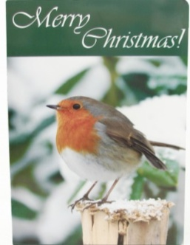

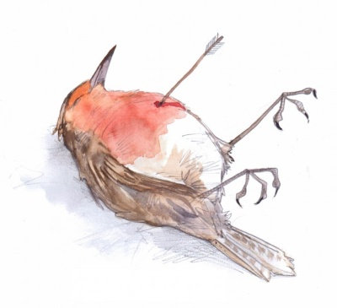

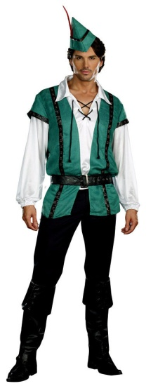



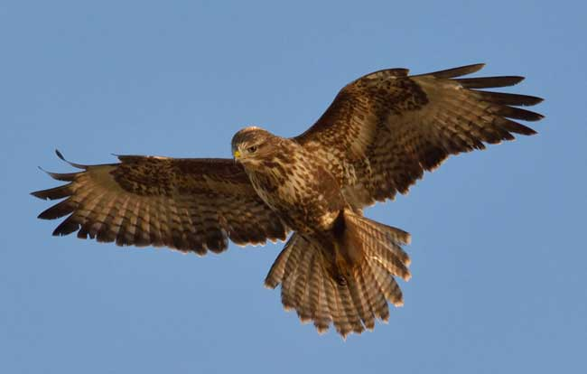

Page 9 Entertainment

Some Entertainment Coming This Month

As well as our weekly outings in the mini-van or walk/ride to the shops/parks etc. We also have many of our favourite entertainers joining us this December, always a busy month!

Owls About Town

The Campbells - Evening Christmas Songs

Papa Geoff

Z o e

S T O R M - Christmas Show

Julie Paton

Salvation Army Brass Band

B i n g

Robbie – Magic Show

Eloise – Christmas Crafts

Amaryllis Christmas Show

Corrine – Vintage Voccals

The Shelley 10th Anniversary Celebrations with Snacks, Drinks and Firework Display

Chesswood School Boys Choir

Roger Brett – Talk on Christmas around the World

Harvest Home

Matthew Luft – Christmas Carol Service and

Your Father Christmas Party on one Day!

Tim West

Johnny

And the Year Finishing with:

A New Years Eve Celebration Party

With Games, Nibbles and Drinks

**PLUS OUR USUAL**

Yoga – Exercises – Aromatherapy – Manicures Pampering Afternoons – Art and Crafts – Communion

Breathing Spaces - Outings in the mini-van - Shopping Trips

In July this year, a stunned lady found out she was pregnant.

A letter with all her correct details was sent to her inviting her to an anti-natal class. So? You ask!

Often a happy event, in this case almost a miracle – she is 100 years old this year!

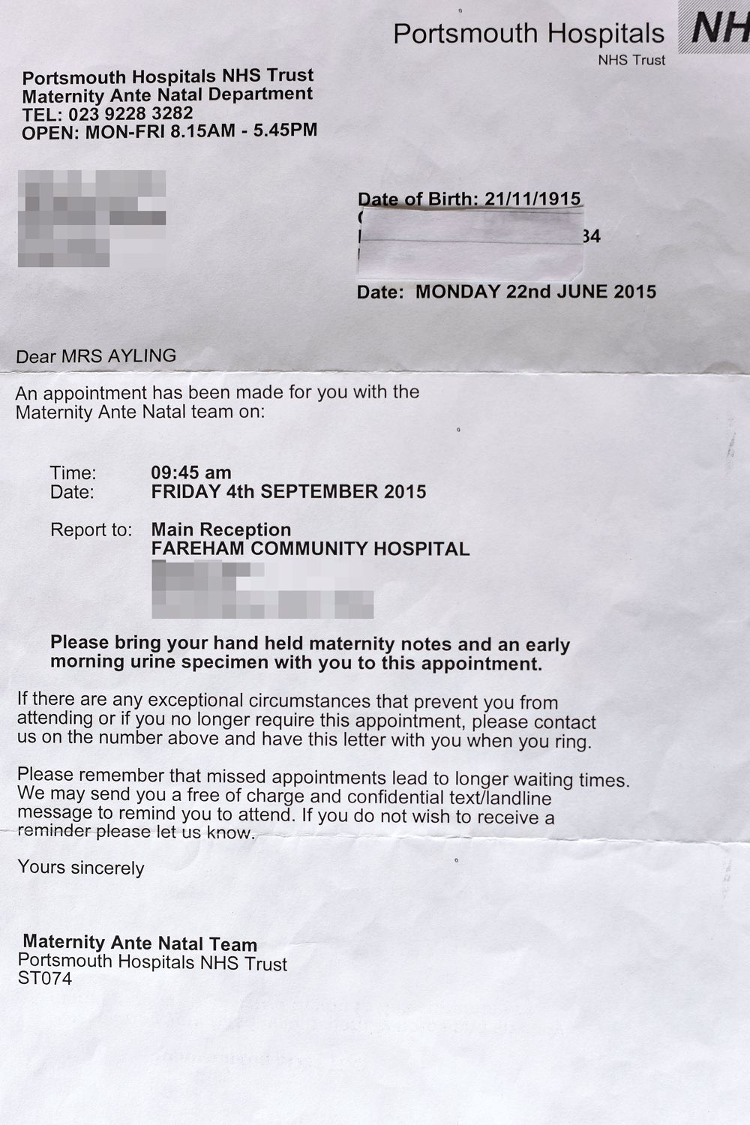

Page 10 And Finally

And yes, they had made a mistake!

Page 11

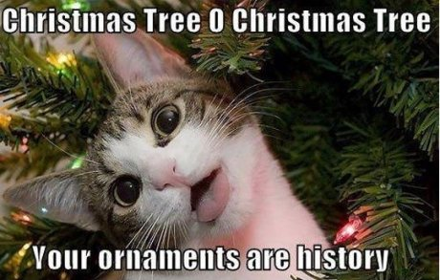

We love the traditional carols!

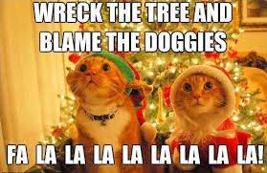

Page 12

Wishing You All A Very Happy Christmas

From Us All At The Shelley

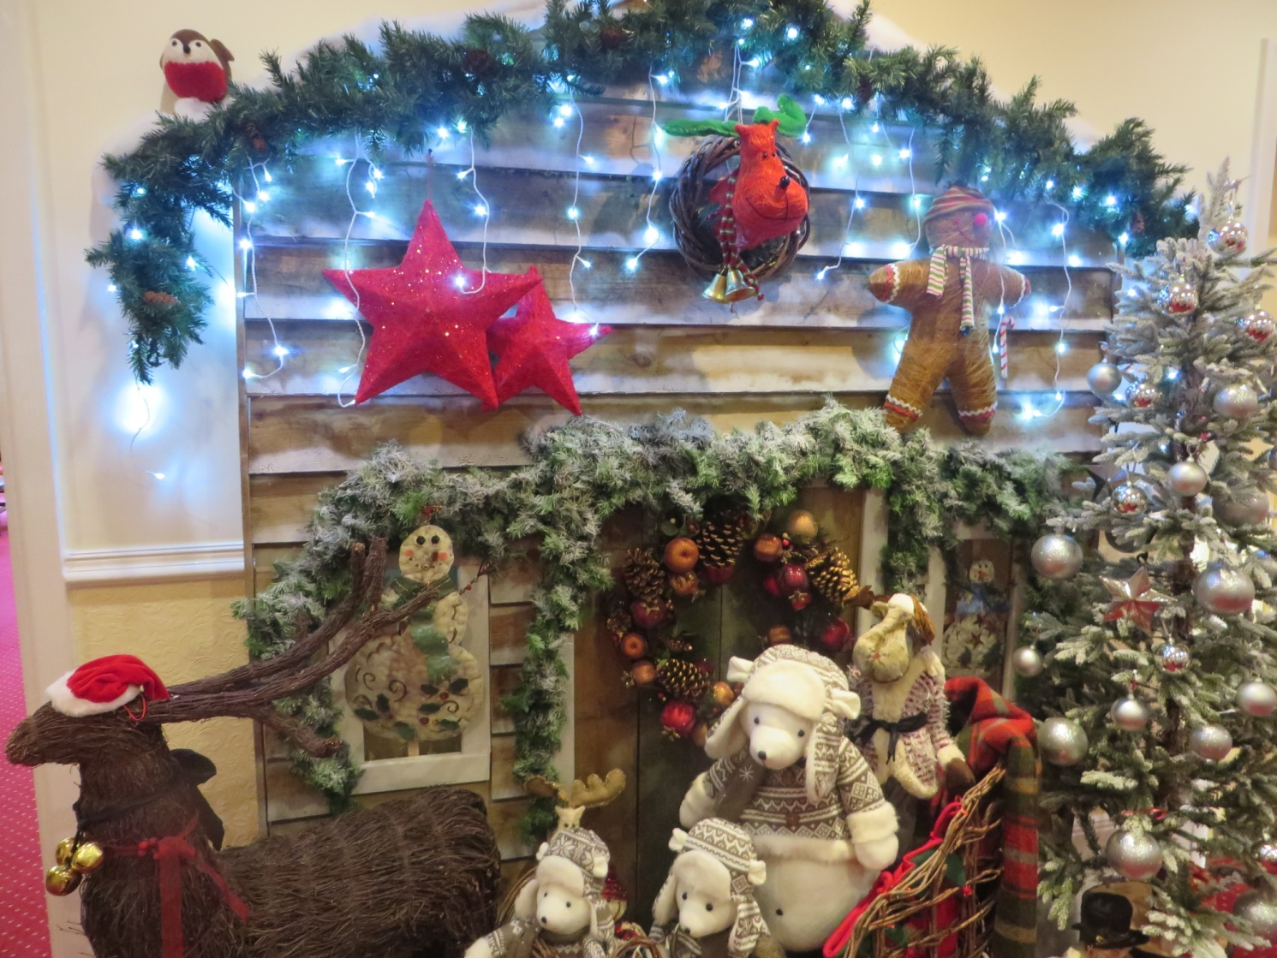

***We’re on the Web!***

*Visit us:* theshelley.com

*Find us on Facebook:*  TheShelley Worthing

*Read Past Newsletters:* theshelleynewsletters.weebly.com/

*For Just Photos:* theshelleyphotos.weebly.com/

*The Shelley does not hold, nor claim to hold the copyright on any article or photograph found in print or on the Internet.*