The “OUTSTANDING” Shelley

Newsletter – November 2015

**The Shelley -** 54 Shelley Road, Worthing, West Sussex, BN11 4BX. t: 01903 237000 e: [info@theshelley.com](mailto:info@theshelley.com)

***WELL DONE LADIES!***

*At the very last minute Nada and Julie were entered in the Care Home ‘Oscars’, for Registered Manager and Ancillary Worker of the Year Awards respectively.*

*Nada won her category while Julie was runner up in hers!*

*We need to enter more categories next year!!*

### Inside This Issue

November 1

October in Pictures 2

Was Guy a Goody or Baddy? 4

Churchill 6

John’s Rhymes 9

Entertainment 11

And Finally 12

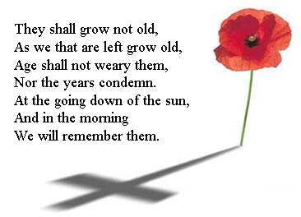

***Sir Winston Churchill***

*Remembering those who fought so bravely in both wars (and those since) we cannot do so without mentioning Churchill.*

*See page 6*

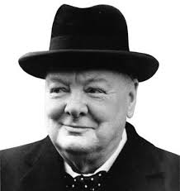

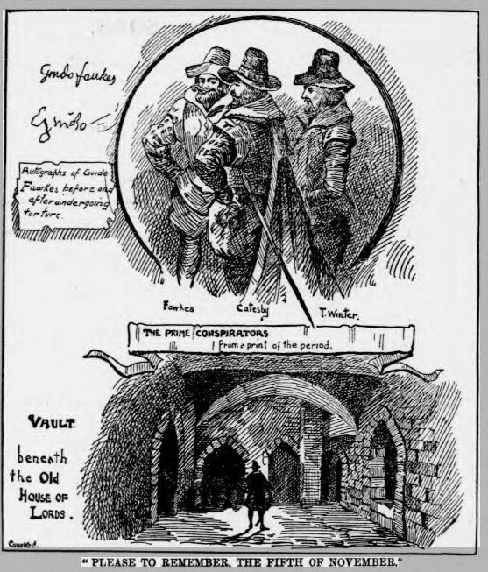



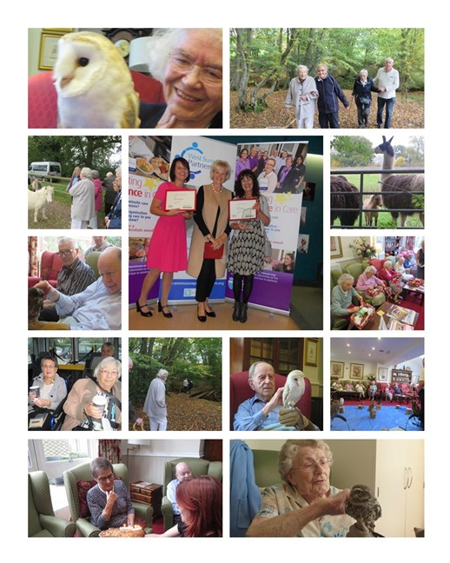

Page 2 October in Pictures



Page 3

Page 4 Remember Remember

Guy Fawkes – Goody or Baddy?

*The Gunpowder Plot – explained (in simple terms) and why a* ***cat*** *not a* ***guy*** *should be burnt on the 5th November (stay calm Nada and read on!)*

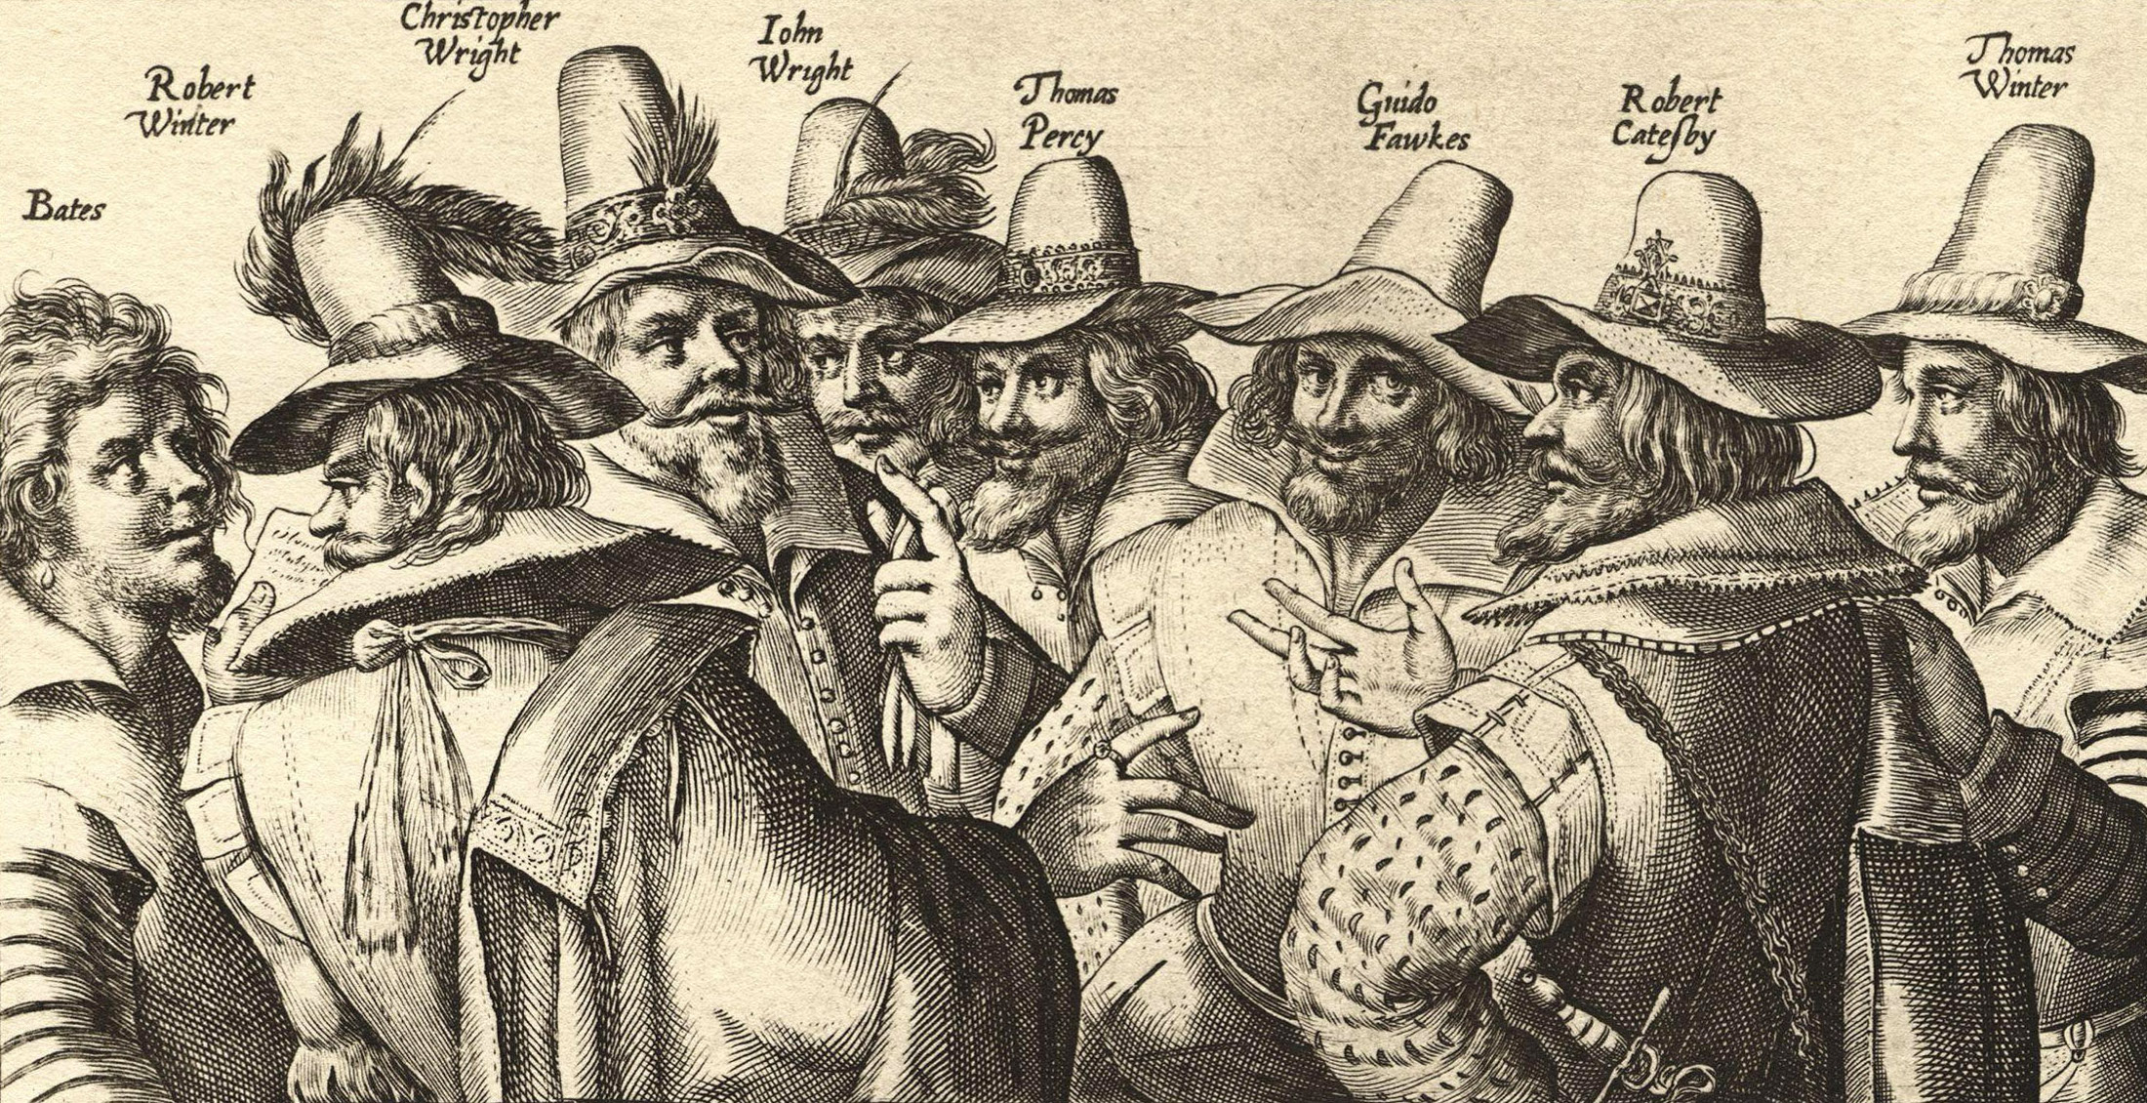In the sixteen hundreds in England, the two main religions really hated each other. The Protestants thought the Catholics were stupid , and the Catholics thought the Protestants had no brains. Unfortunately for the Catholics, King James I was a Protestant, and did not want to allow Catholics in England to worship freely. This made a few Catholics in England very angry. A guy named Robert **Cat**esby thought it would be a good idea to gather twelve of his closest Catholic pals and try to blow up King James while the State Opening of England’s Parliament was going on in the House of Lords. After that they planned to put his nine year old daughter Elizabeth (who was apparently a Catholic, if nine year olds can really be anything other than annoying) in charge of the country, because I guess that seemed like a good idea.

Guy Fawkes: Innocent fall guy with a severely ill-deserved reputation.

**Guy** Fawkes was one of the Catholics that **Cat**esby wrangled to help him with his plan to blow up one of the most powerful kings in Europe. Soon some of Catesby’s friends remembered that, oh, there are actually going to be a few Catholics in there as well. One of them, Baron Monteagle, got an anonymous letter warning him that something real bad was going to happen at Parliament, possibly, who knows, and that he should stay away on the day of the State Opening, probably, maybe, *wink wink nudge nudge*. Monteagle told this guy and this guy told that guy and that guy told the KING. OOPS. So James was worried and says, “Hey, go check below Parliament. See if there’s any nasty stuff down there.”

And guess what! There was! And also some idiot holding a match! So Fawkes was arrested, he and his pals were executed and England was free to hate Catholics for the next couple hundred years.

The point is, although Guy currently shoulders the brunt of the historical responsibility for the failed attempt on the King’s life, he was far from being the lone conspirator.  But his name alone remains popularly attached to the plot, probably because of the intrigue and drama of having nabbed the guy who was about to flip the proverbial switch. Guy simply drew the short straw, so to speak, and had to sit on thirty six barrels of explosives holding a slow-burning match. It could be that decision making process went something like this:

**Catesby**: Okay, we’ve all sworn our oaths of secrecy on the prayer book, we’ve all taken the Eucharist, we’ve all practiced the secret Assassination Plot Handshake a few times, let’s get this planning started! Keyes, you’re watching my house where we’re storing all the explosives?

Page 5

**Keyes**: Yes, boss.

**Catesby**: And Percy, you’re hauling all of it into the Undercroft tomorrow night, right?

**Percy**: Yes, boss.

**Catesby**: Okay I guess that just means we need someone to send down there to light all of it, and hopefully maybe but probably not escape in time to not also get blown up. Any takers?

**Catesby**: Guy?

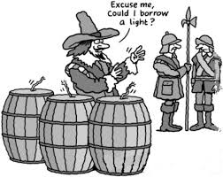**Guy**: (in a daydream) Sir?

**Catesby**: You want to…maybe…do that for us?

**Guy**: Do what, sir?

**Catesby**: Have you even been…look, nevermind. Just take this match and light the fuse when we give you the signal, okay? I promise nothing bad will come of this.

**Guy**: (brandishing match) FOR SPAIN!

**Catesby**: England, Guy.

**Guy**: FOR ENGLAND! – it should be noted her that Guy went by the name “Guido Fawkes” when he was fighting for Catholic Spain in the Dutch Low Countries. What can I say? The man didn’t make wise choices.

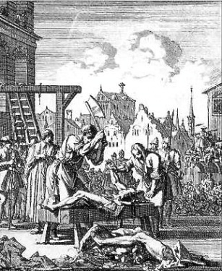Thanks to seventeenth century England’s fair and totally objective judicial system, Guy was tried and found guilty under the “You Better Not Try to Kill the King” Law. Guy and seven of his fellow conspirators were to be, I kid you not, drawn backwards behind a horse until they were nearly dead, then have their genitals cut off, eyes burnt out, bowels and hearts and heads removed, and whatever remained would be displayed so they may become “prey for the fowls of the air.”

After watching the six other men endure the aforementioned fate, Guy rightly said “yeah right” and tried to jump off the gallows, breaking his neck. They quartered him anyway and strung up his parts as warning to potential conspirators.

An Act of Parliament designated November 5th as a day of remembrance, and although the act only stood until 1859, cities throughout Britain still celebrate Guy Fawkes Night by lighting fireworks and bonfires.

Thankfully, lest we should forget the events that transpired that fateful night, we have a handy nineteenth century nursery rhyme to remind us*. “Remember, remember the fifth of November of gunpowder treason and plot. I know of no reason why the gun powder treason should ever be forgot.”*

Diluted (but no less humorous) version from http://thetangential.com/

Page 6 Churchill

This year saw the 50th anniversary of Churchill’s death and the 75th anniversary of The Battle of Britain.

This month we remember the fallen in all wars and Churchill’s name has been mentioned to me a few times in The Shelley.

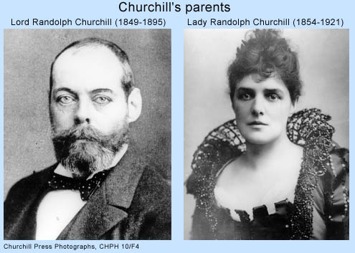We all know the usual info on Churchill but here are a few you may not have heard of:

**Churchill’s mother was an American.**

In the late 19th century, it was rather common for British aristocrats to marry U.S. heiresses. One such relationship matched Lord Randolph Churchill, the third son of the seventh Duke of Marlborough, with Jennie Jerome, the Brooklyn-born daughter of a wealthy financier. The couple had two children together: Winston in 1874 and Jack in 1880.

**Churchill almost didn’t make it into military school.**

As a student, Churchill performed poorly in virtually every subject except history and English composition. He was particularly inept at foreign languages. In a memoir, he described taking a two-hour-long Latin test that he left completely blank apart from his name and the number of the first question, along with *“a blot and several smudges.”* His plan to attend the Royal Military College at Sandhurst suffered a setback when he twice failed the entrance examinations. With the help of a military tutor, he finally qualified the third time around, but only for the cavalry class, which had lower standards than the infantry.

**A daring escape from prison camp earned him instant fame.**

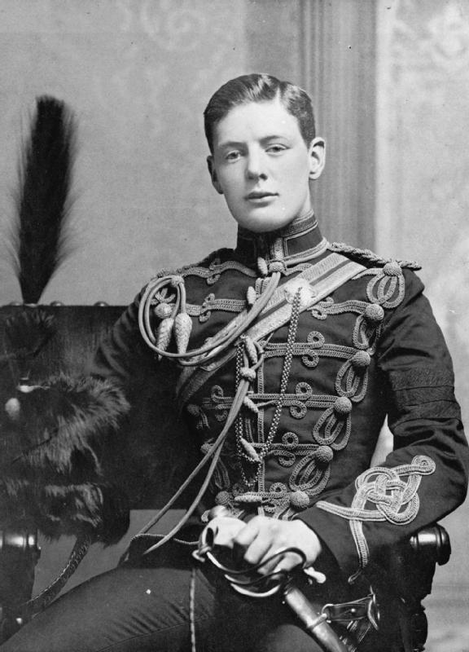He subsequently served as a war correspondent and military officer, a dual role then permitted, in India, Sudan and South Africa. Upon arriving in South Africa in 1899, his armoured train was ambushed by Boers. Churchill was captured and marched to a prison camp, which he soon escaped from by scaling a wall at night. With no precise plan, Churchill luckily stumbled upon the house of a British coal mine manager, who hid him in a mineshaft for three days and then sent him on a wool-filled rail truck into Mozambique. From there, Churchill caught a ship back to South Africa and rushed to the front a newfound hero.

**He organized a massive World War I attack that failed spectacularly.**

Churchill’s political career began in 1900 when he was elected to Parliament, a position he would hold for more than 60 years. He secured his first cabinet post in 1908, and by 1911 had advanced to become First Lord of the Admiralty. In this capacity, he prepared an amphibious assault during World War I against the crumbling Ottoman Empire. Churchill believed such action would allow the British to link up with their Russian allies, put added pressure on Germany’s eastern front and possibly even tip the balance of the entire conflict. But when Allied battleships entered the Dardanelles strait, located near present-day Istanbul, in March 1915, Ottoman fire sank three of them, severely damaged three others and sent the remainder into retreat. Allied troops similarly failed to gain ground during months of fighting on the adjacent Gallipoli Peninsula, suffering over 250,000 casualties in the process. Although Churchill lost his admiralty post as a result of the failure, he was eventually able to rehabilitate his reputation.

Page 7

**Churchill was no fan of Gandhi.**

Throughout much of his life, Churchill opposed any form of autonomy for India. He reserved particular dislike for nonviolent independence leader Mohandas Gandhi, at one point calling him *“a seditious Middle Temple lawyer now posing as a fakir of a type well known in the East,”* and he even favoured letting Gandhi die during a hunger strike. Churchill’s imperialist attitude came through with regards to other British colonies as well. He once asserted, for example, that Zulus, Afghans and Dervishes were “savages and barbarous peoples.”

**Most of his famous speeches came within a few months of each other.**

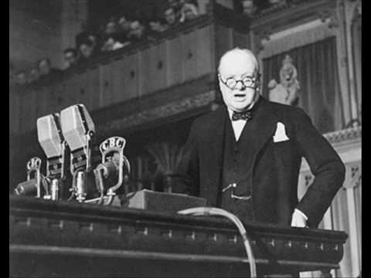Churchill took over as prime minister in May 1940 after a disastrous start to World War II in which Nazi Germany conquered much of Europe. A master orator, he did his best to rally the nation in the face of near-certain attack, giving six major speeches in four months. During the first of those, he told Parliament that he *had “nothing to offer but blood, toil, tears and sweat.”* On June 4, he similarly declared, “We shall defend our island, whatever the cost may be. We shall fight on the beaches, we shall fight on the landing grounds, we shall fight in the fields and in the streets, we shall fight in the hills. We shall never surrender.” And on June 18, as France prepared to submit to the Nazis, he told his countrymen to *“brace ourselves to our duties and so bear ourselves that if the British Empire and its Commonwealth last for a thousand years, men will still say,* *This was their finest hour.”*

**Churchill was voted out of office before World War II’s end.**

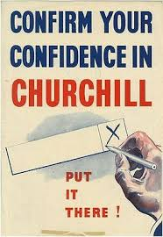In July 1945, after Germany had surrendered but not Japan, Britain held its first general election in a decade. To the surprise of many, Churchill’s Conservative Party lost in a landslide, having been successfully portrayed by the Labour Party as anti-worker and anti-welfare. *“They have a perfect right to kick us out,”* he purportedly said upon hearing the news. *“That is democracy. That is what we have been fighting for.”* He returned to the premiership in 1951, remaining there until ill health induced him to resign three-and-a-half years later.

**Churchill popularized the term *“iron curtain.”***

Despite his misgivings about communism, Churchill gladly allied himself with the Soviet Union during World War II. Afterwards, however, he began to harbour serious misgivings about the Soviet Union’s aims. In a March 1946 speech, he spoke of *“an iron curtain [that] has descended across the continent.” “Behind that line,”* he said, countries are subject *“to a very high and, in many cases, increasing measure of control from Moscow.”* From that point forward, Western officials continuously mentioned the *“iron curtain”* when talking about the USSR.

Page 8

**He was an award-winning author.**

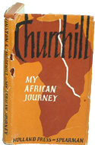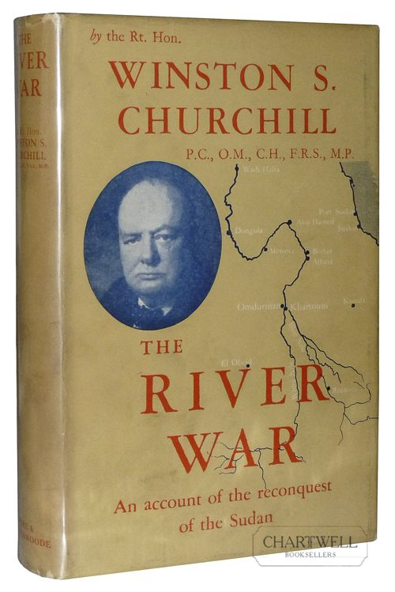Churchill wrote about 20 books over the course of his life, the first of which detailed his army experiences in India, Sudan and South Africa. He later penned a biography of his father, a biography of the first Duke of Marlborough, numerous volumes on World War I and World War II, a history of English-speaking peoples and one novel that he urged his friends not to read. In 1953, while serving his second term as prime minister, he received the Nobel Prize in Literature for *“his mastery of historical and biographical description as well as for brilliant oratory in defending exalted human values.”*

**Churchill was extremely accident prone.**

As a youth, Churchill once suffered a concussion and ruptured a kidney while playfully throwing himself off a bridge. Later on, he nearly drowned in a Swiss lake, fell several times from horses, dislocated his shoulder while disembarking from a ship in India, crashed a plane while learning to fly and was hit by a car when he looked the wrong way to cross New York’s Fifth Avenue. None of these incidents, however, left him too worse for wear. He lived until age 90 before finally succumbing to a stroke

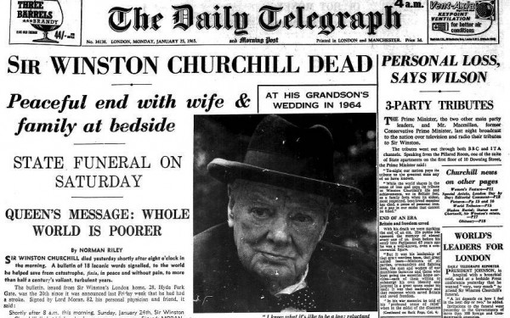

www.history.com/news/10-things-you-may-not-know-about-winston-churchill

This month is

‘Poppy Day’

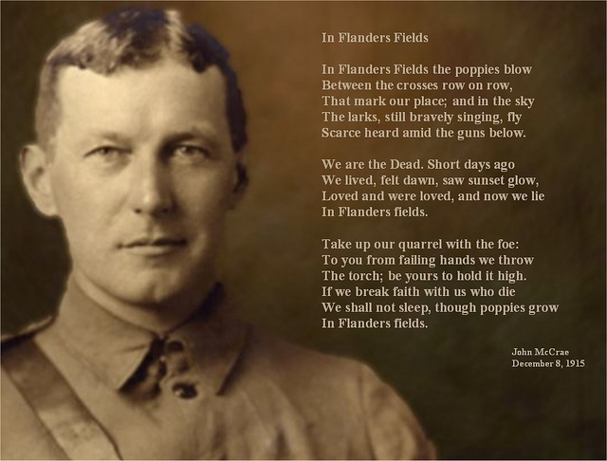

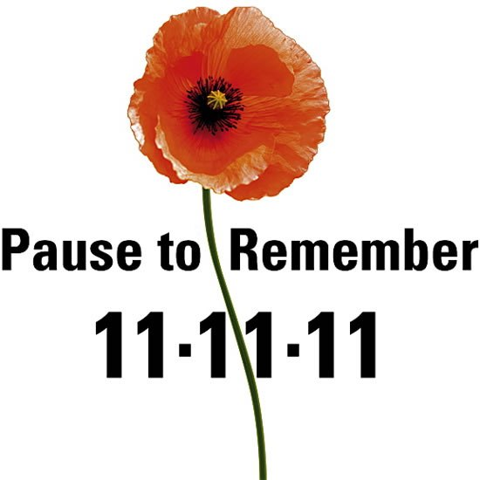

Entertainment   
  
We have entertainers at The Shellley  
Nearly every afternoon  
Some play an instrument  
Some simply stand and croon.  
  
We used to get old wartime songs  
(But not now for some time)  
Of bluebirds planned for Dover  
And of the Siegfried Line.  
  
Now usually we get songs  
Of not such ancient bones  
But we seldom get the Beatles' songs  
Much less the Rolling Stones.

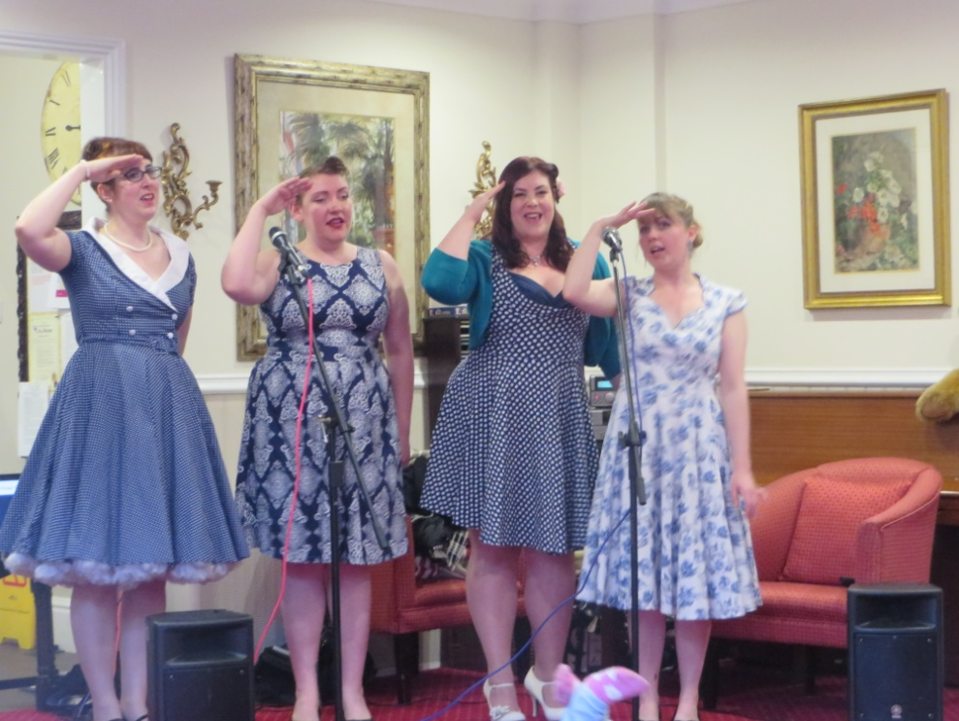

Page 9 John’s Rhymes

I don't go down to listen  
Even though the show is free  
I'm sad to say pop music  
Is not my cup of tea.    
  
I used  to like old Crosby  
But not "White Christmas" yet again  
I never liked Sinatra  
I thought he was a pain.  
  
I liked  John  Dankworth's missus  
The lovely Cleo  Laine  
She had a voice as rich as cream  
But we shan't hear her again.  
  
Today we're going to have a film  
Of entertainer there's no sign  
Let's have "The Sound of Music"  
For the 97th time,



Page 10

|  |  |  |
| --- | --- | --- |
| If Worthing had a harbour How lovely it would be  To hop on board and off to France And home again for tea.  If Worthing had a harbour Where would the ships sail to? America I daresay  And even Timbuctu.  If Worthing had a harbour What chaos there would be With lots of foreign visitors Wanting sauerkraut for tea. | https://encrypted-tbn0.gstatic.com/images?q=tbn:ANd9GcQPL_WflOLyDsOStrstgeNzSLHdtG4lSq9r0_RuefRYZoPGizb5 | If Worthing had a harbour What trouble there would be From Portsmouth and Southampton Who'd like to own the sea.  If Worthing had a harbour How awkward it would be With not a toilet in the town  They'd have to use the sea.  If Worthing had a harbour Would there be yachtsmen coming in? All rigged out in blazers And drinking lots of gin. |

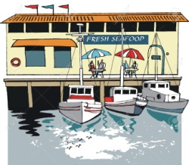Worthing Harbour

If Worthing had a harbour   
I think I'd leave the town  
And go to live at Stoke-on-Trent  
Not a ship there I'll be bound

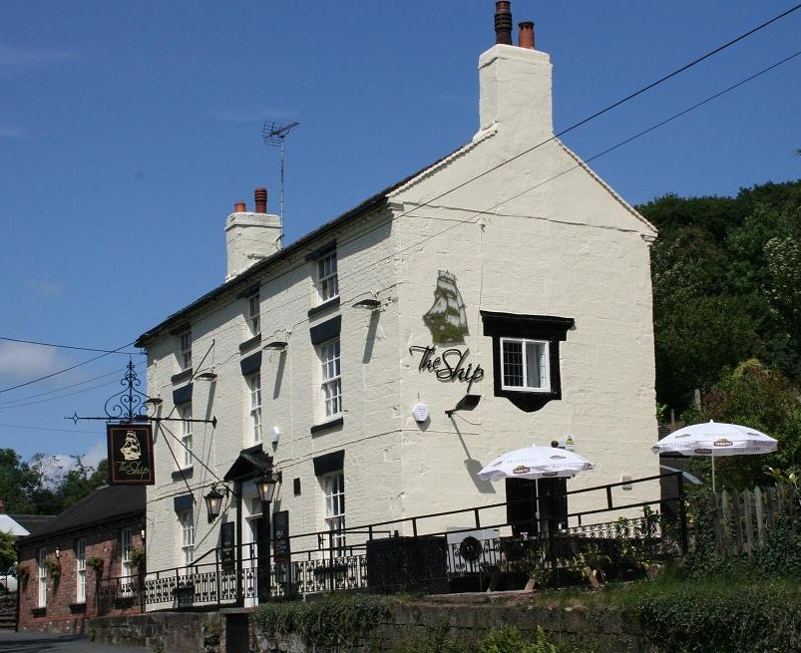

There is a Ship John

And it is your favourite kind!

Page 11 Entertainment

Some Entertainment Coming This Month

As well as our weekly outings in the mini-van or walk/ride to the shops/parks etc.

we also have many of our favourite entertainers joining us, such as:

***Curtis***

***Fireworks***

***New Dimensions***

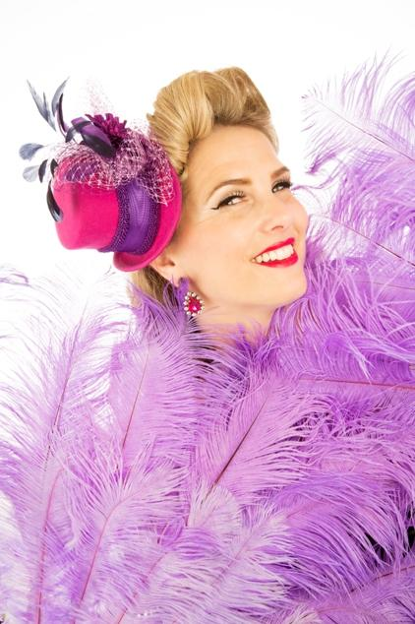***Geoff and Jean***

***Pete Pal’o’Mine***

***Roger Brett***

***‘Rat Pack’ Dean***

***Dawn***

***Charity Card Sales***

***A Victorian Christmas***

***Jessica – Curator of Rustington Museum***

***Harvest Home***

***Sarah***

***Lucy***

***Skittles***

**PLUS OUR USUAL**

Yoga – Exercises – Aromatherapy – Manicures Pampering Afternoons – Art and Crafts – Communion

Breathing Spaces - Outings in the mini-van - Shopping Trips

Page 12 And finally



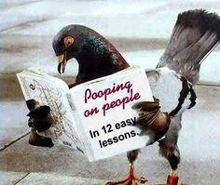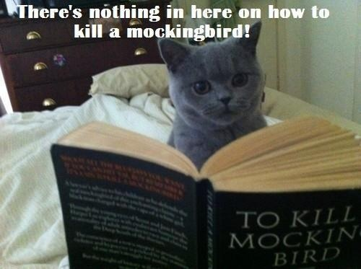

More and more animals are learning to read!

And to talk too, by the look of it!

***We’re on the Web!***

*Visit us:* theshelley.com

*Find us on Facebook:*  TheShelley Worthing

*Read Past Newsletters:* theshelleynewsletters.weebly.com/

*For Just Photos:* theshelleyphotos.weebly.com/

*The Shelley does not hold, nor claim to hold the copyright on any article or photograph found in print or on the Internet.*