The Shelley

Newsletter – November 2016

**The Shelley -** 54 Shelley Road, Worthing, West Sussex, BN11 4BX. t: 01903 237000 e: [info@theshelley.com](mailto:info@theshelley.com)

Poor Guido

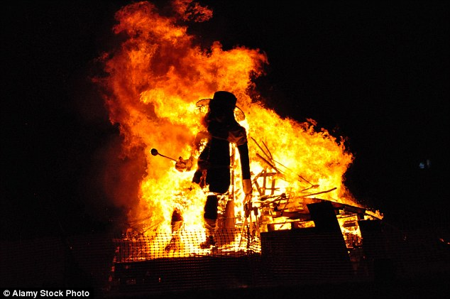

Caught with the powder and therefore the full blame.

### Inside This Issue

November 1

October in Pictures 2

Bells 4

John’s Rhymes 10

Entertainment 12

Sayings 13

And Finally 15

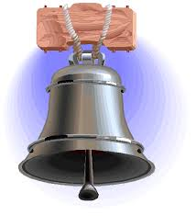

See Pages 13-14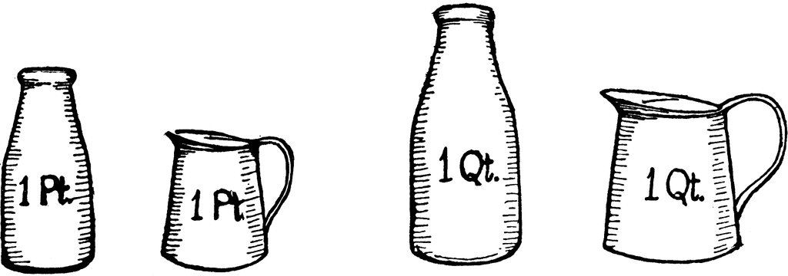

See Pages

4 – 9



We shall never forget them

Page 2 October in Pictures

Eve riding her new Harley, outings, Birthdays and Children in Need

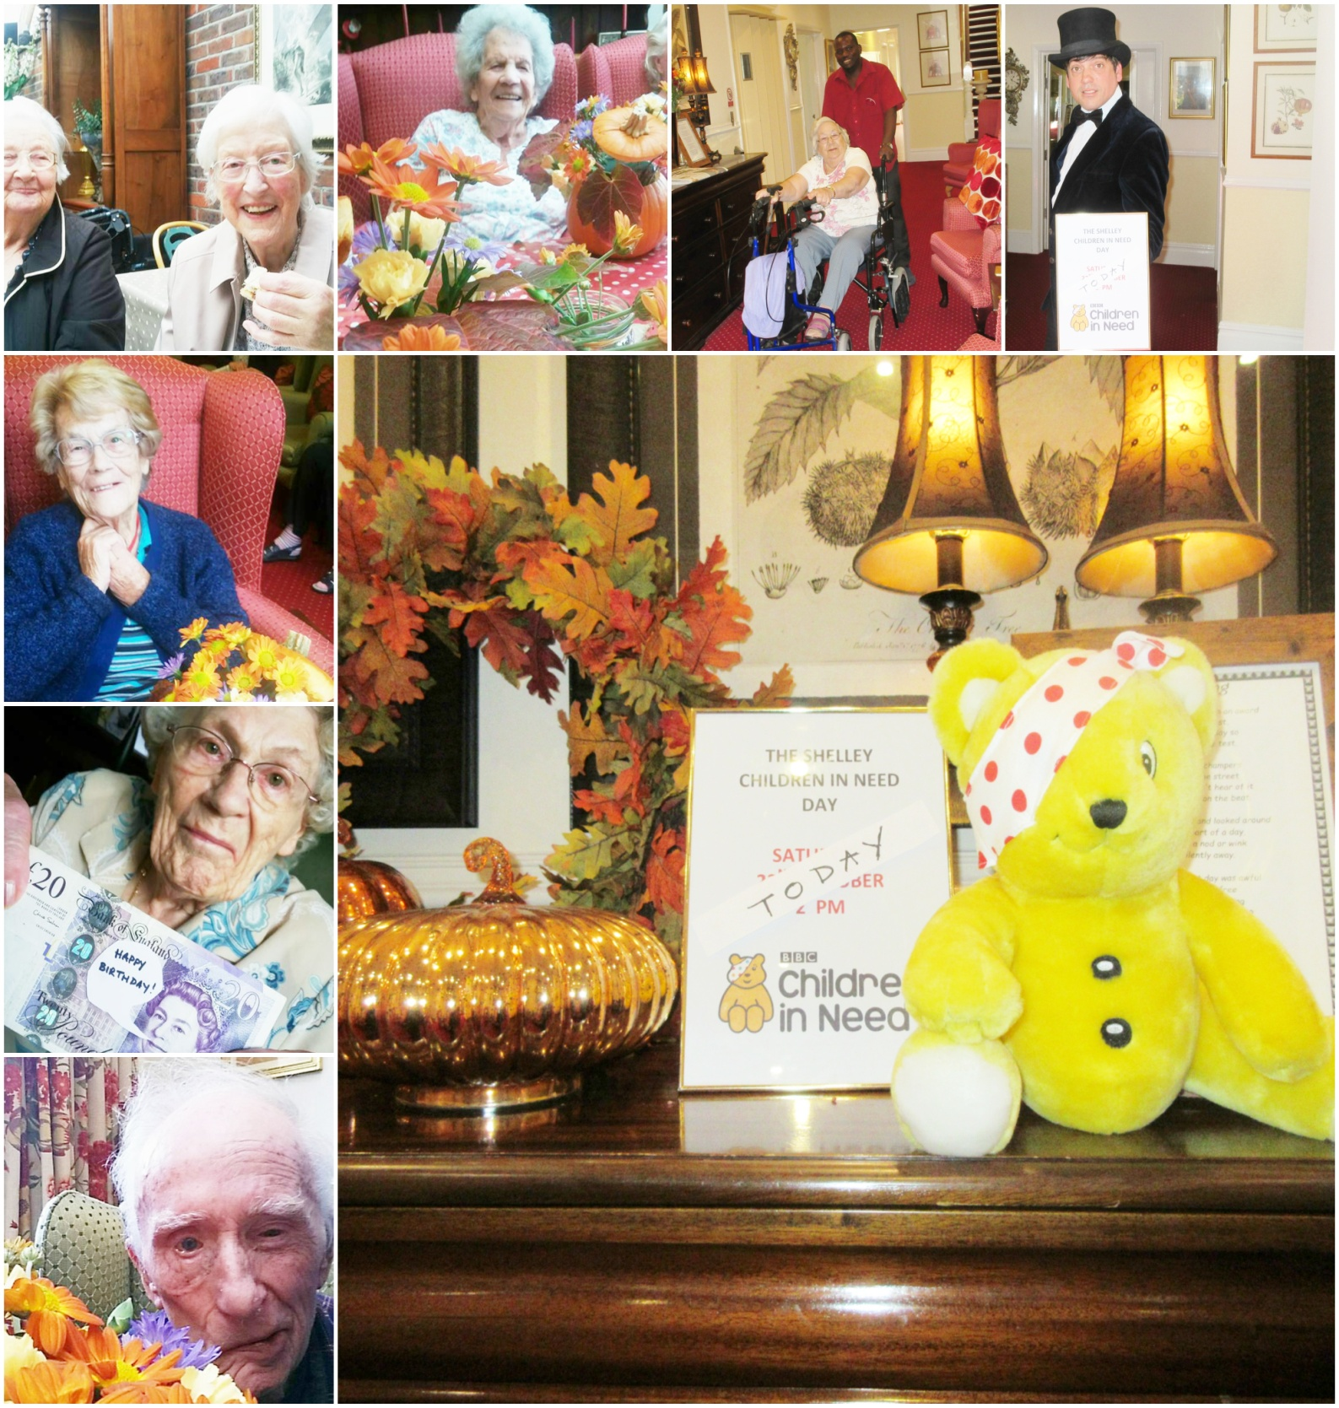

Page 3

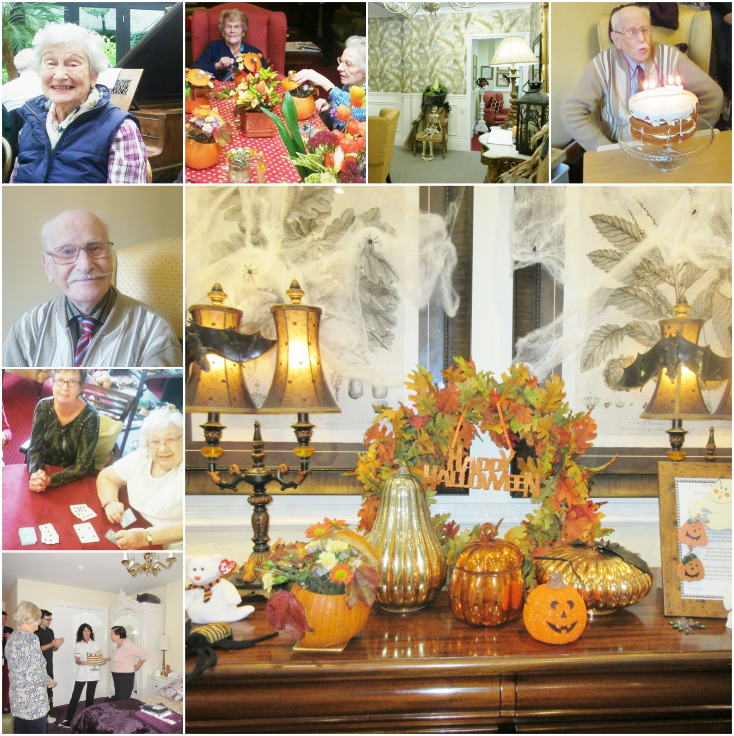

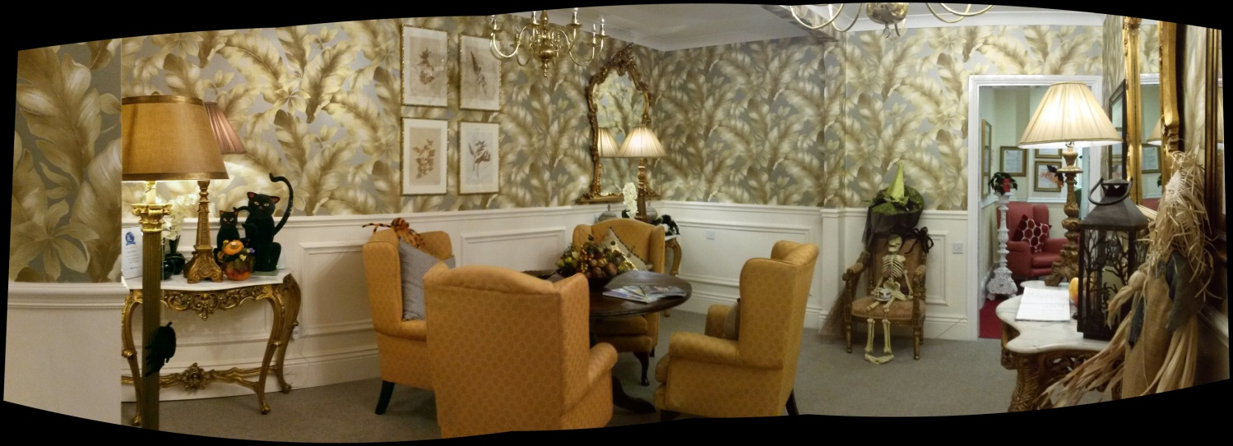and an entrance Foyer is born!

*Bell Ringing*

Page 4 Bells – Origins and How They Are Made

﻿Bells have been an important part of many cultures for thousands of years, dating back as early as the second millennium before Christ, when bells were first made in China.﻿

From early civilizations in Egypt and Phoenicia to those in Macedonia, Greece and Italy, bells were used for a variety of purposes, including opening markets, announcing the beginnings of plays, and opening the Grecian baths.

In AD 400, Paulinus of Nola introduced church bells into the Christian Church. In AD 604, Pope Sabinianus officially sanctioned their usage. By the early Middle Ages, church bells became common in Europe. They were first common in northern Europe, reflecting Celtic influence, especially that of Irish missionaries.

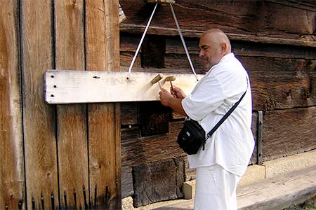Before the use of church bells, Greek monasteries would ring a flat metal plate called semantrons to announce services.

The *signa* and *campanae* used to announce services before Irish influence may have been flat plates like the *semantron* rather than bells.

The oldest surviving circle of bells in Great Britain is housed in St Lawrence Church, Ipswich.

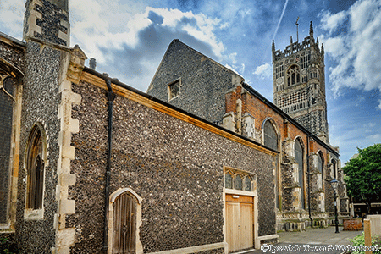

The bitter-sweet sound of just one bell or the majesty of a whole peal are now used for many reasons. They call us to wake, to pray, to work, to arms, to feast and, in times of crisis, to come together. Above all, bells are the sound of freedom and peace. In World War II bells hung silently to ring only to inform of an invasion by the enemy or until the day they could ring in the peace.

**We hear church bells ringing weekly but do you know how they are made?**

Page 5

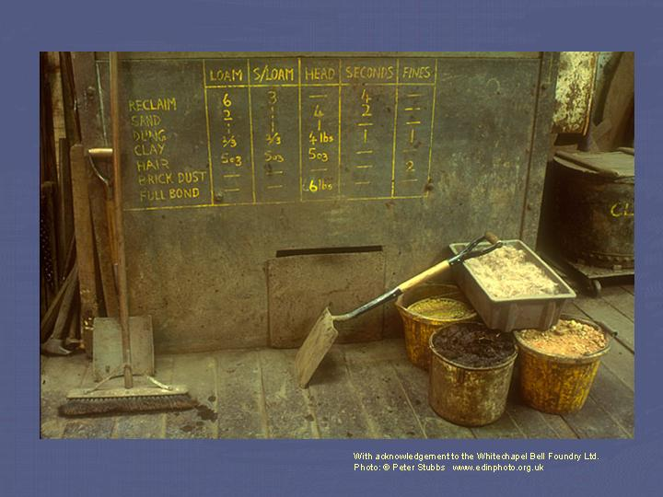The manner in which church bells are manufactured in England has changed very little over the last thousand years. The moulds are made out of a traditional moulding loam consisting mainly of a mixture of clay, cow dung and horse hair.

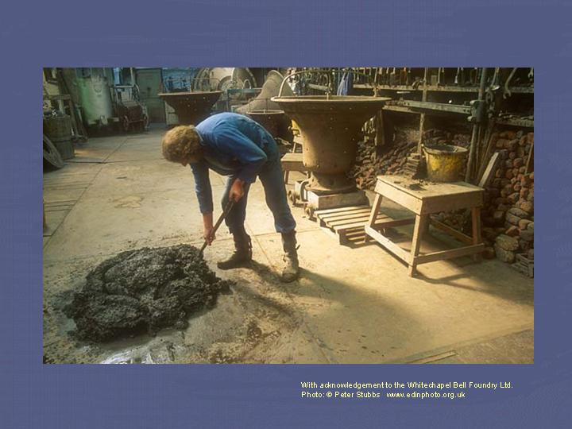

The ingredients are carefully mixed together to form an homogenous and fairly stiff 'mud pie' which can be built up into the required shape.

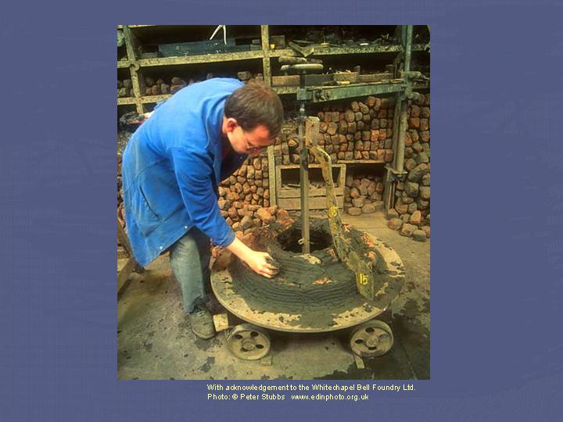The 'core', or inner mould, is built up in layers on a metal base plate and contoured to the bell's profile using a metal plate, known as a 'strickle', shaped to the required profile of the bell.

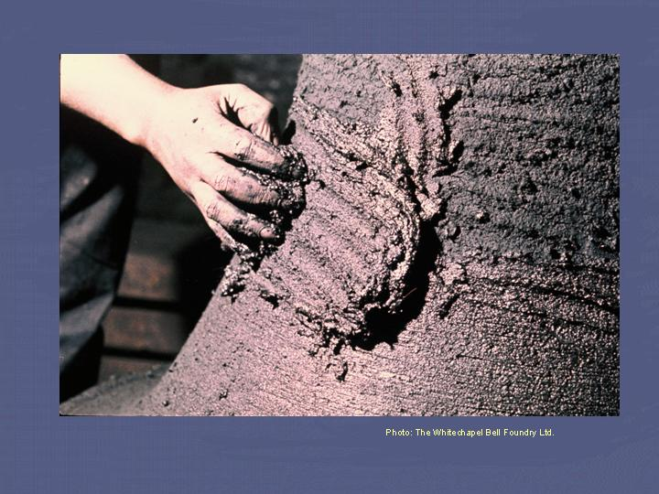Each layer of the moulding loam is slapped on top of the previous layer and carefully smoothed in, ensuring that no air pockets are left in the finished article - they could expand and burst the mould when the hot metal is poured into it.

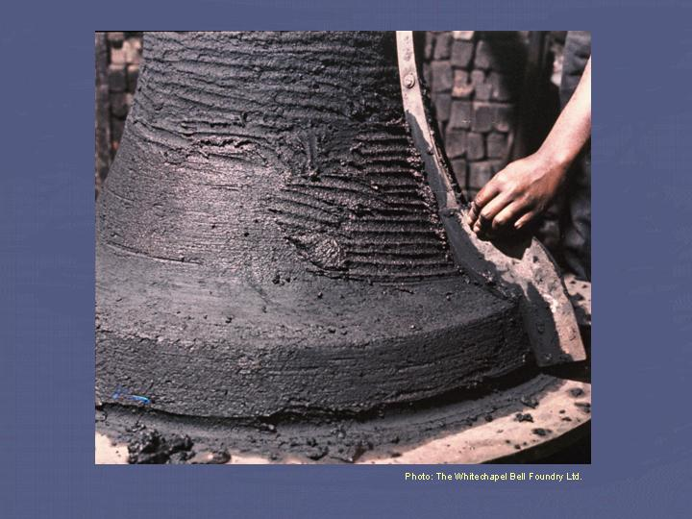The strickle is revolved around the mould, paring off excess loam and shaping it to the required profile. Once a number of layers of loam have been applied, the mould is placed in a drying oven to bake hard. It is vital that no moisture remains in the moulding material at the time of casting.

Page 6

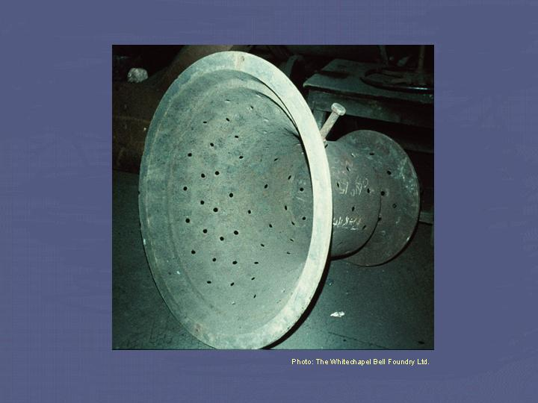The 'cope', or outer mould, is built up inside an iron case, resembling the shape of a bell. The many holes allow loam to exude through them and thus 'key' the moulding material into the cope.

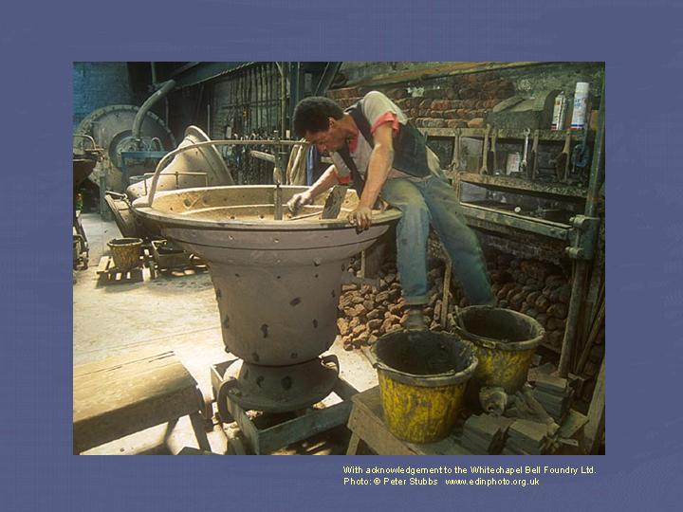As with the core, moulding loam is built up on the inside of the cope to form the shape required. The mould is placed in the drying oven at regular intervals.

The strickle, which has now been inverted, is once again used to remove surplus loam and form the required shape.

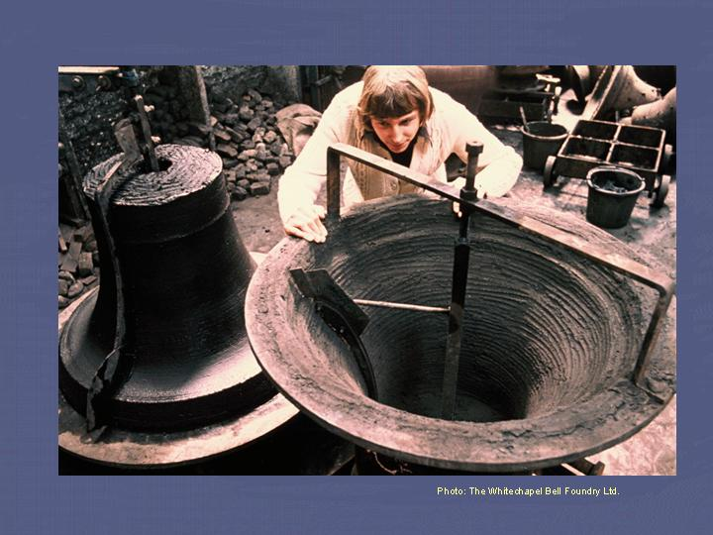

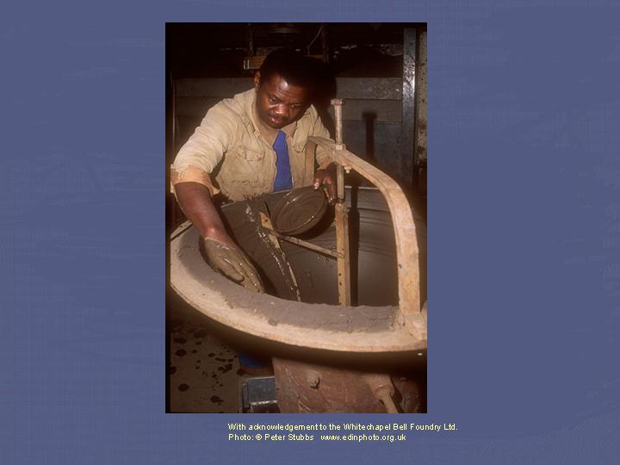The bell mould is now nearing completion. The final layer of loam is applied as a wet slurry.

Page 7

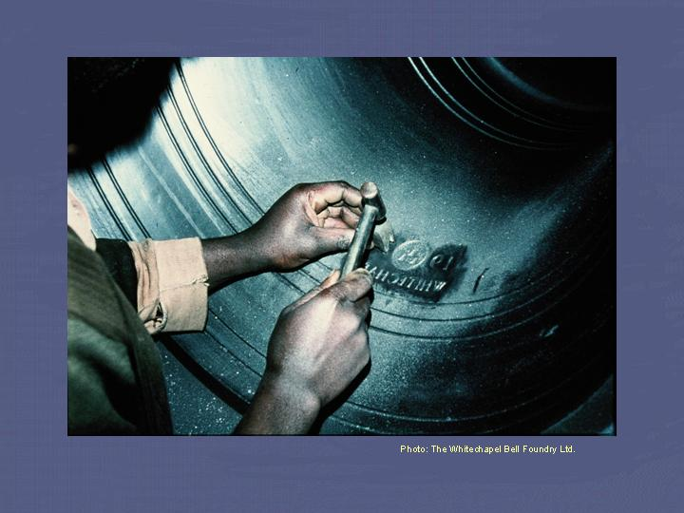Before the final layer of moulding material has been baked hard, the mould is coated in graphite (this prevents the molten metal from burning the moulding loam) and any inscription or decoration is stamped into the mould in reverse. These indentations provide a reversed relief inscription on the finished bell.

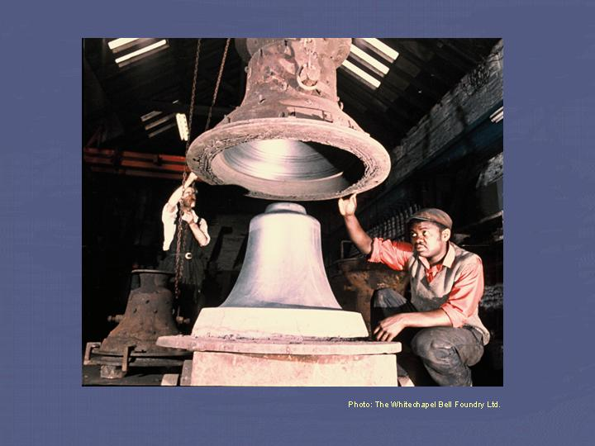Once both moulds are thoroughly dry and hard, the cope is inverted (thus the necessity for the holes for the loam to key to!) and carefully lowered over the core. It is important that the bell founder ensures the cope sits absolutely centrally over the core to ensure that the bell is of concentric shape - any variation in thickness from one side of the bell to another will spoil the tone of the finished product.

Now the moulds are finished, the bell can be made.

Page 8

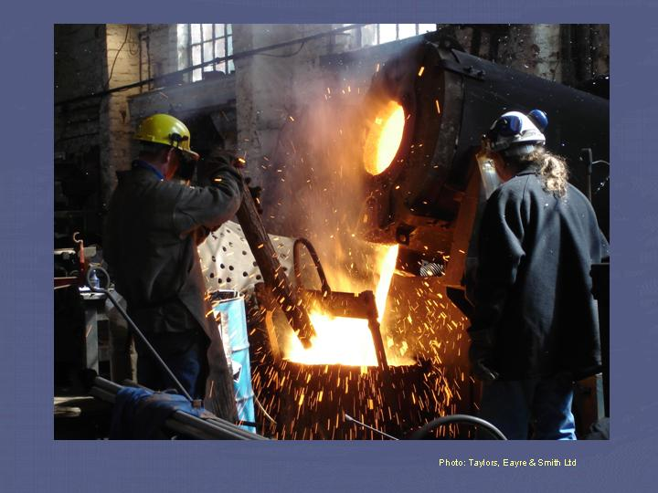Bell metal is an alloy of 77% copper and 23% tin, which is heated to about 1,100°C. When the metal is molten, more tin is added to compensate for that which burns off during the melting process, and the metal is run off into a ladle, or 'shank', ready to be poured into the waiting mould.

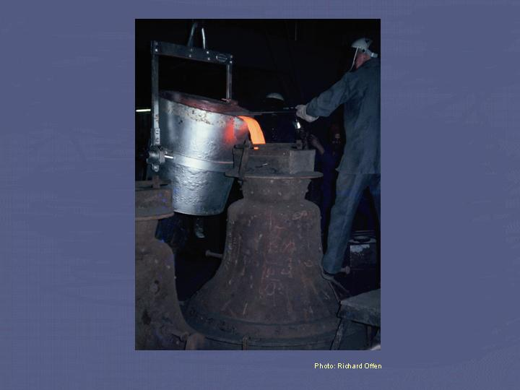When pouring the molten metal from the furnace, various methods can be used to ensure that the bell metal is free from impurities which might spoil the casting. A traditional method, still in use, is to dip a willow branch into the molten metal. This helps to 'de-gas' the metal and cause various other elements to 'burn off'.

**Casting a bell**

The metal is poured into a hole at the top of the mould and gases formed are allowed to escape through a further hole. Cooling is carefully controlled to prevent stresses within the metal which could lead to future cracking. Large bells can require up to a week to cool.

**Ding Dog Bell**. Now to make then ring to the tone that has been asked for.

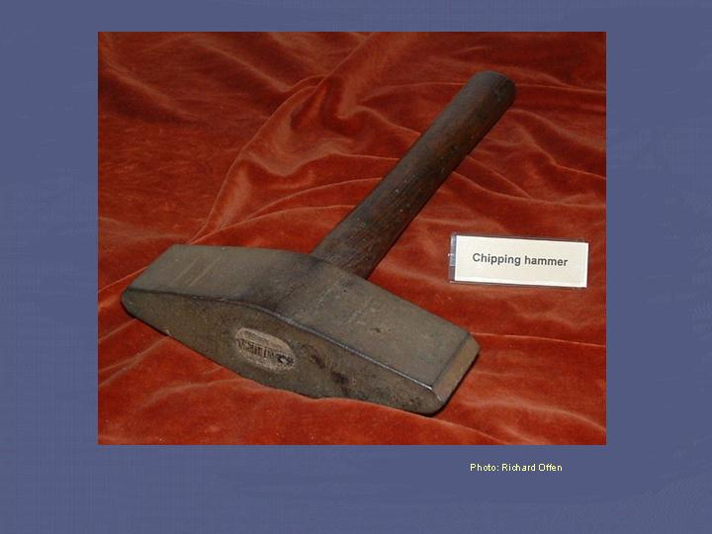The sound a bell makes is a complex function of its diameter, weight, profile and thickness. Every founder down the ages has striven to achieve his own idea of perfection of tone. In the early days each founder had his own favourite bell profile, which had evolved to produce his own idea of perfection of tone.

Until the 19th century, any 'fine tuning' required by a new bell had to be done by chipping pieces of metal off the inside surface with a hammer. This was a very imprecise technique, and could result in the bell being cracked by overzealous blows.

Page 9

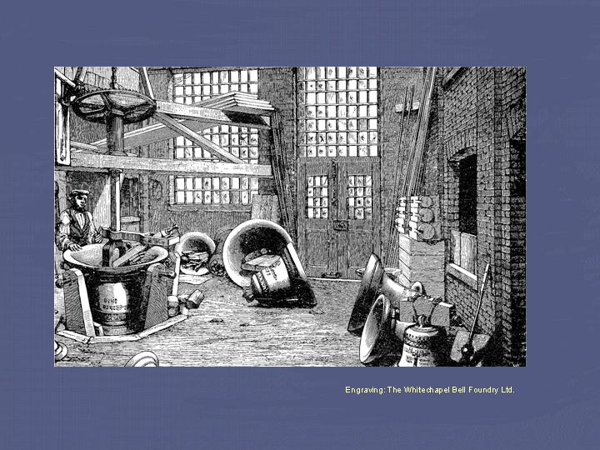An improvement came with the application of lathe technology to bell tuning. Note that unlike modern boring mills, the cutting tool revolved around the bell, rather than the bell around the tool. The machine was originally powered by a donkey, but was later converted to steam power.

During this rudimentary tuning process, progress was usually monitored by means of comparison with a violin or pitch-pipe.

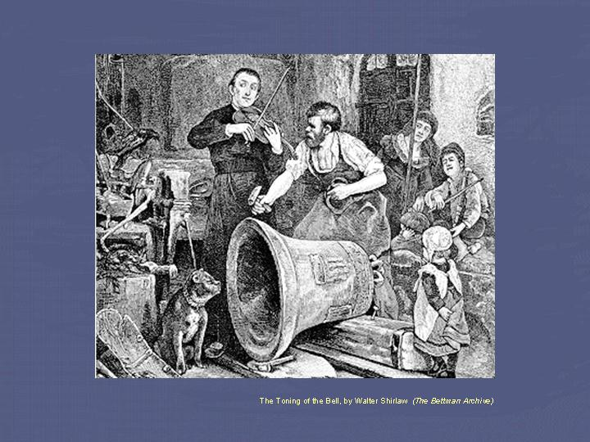Rather than using a violin or pitch pipe, tuners today employ either calibrated tuning forks or an electronic device to ensure bells are tuned to a high degree of musical accuracy.

By removing metal from different zones the various partial tones can be brought into tune with each other and the bell tuned to take its place in a ring, chime or carillon.

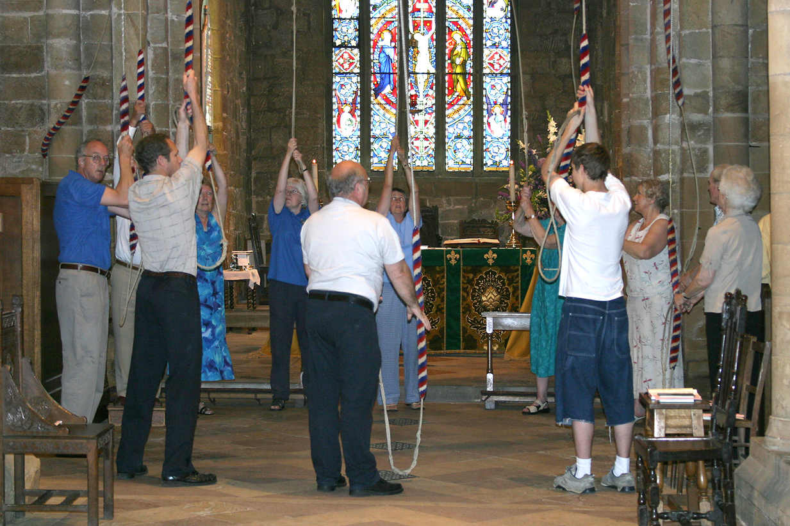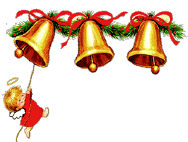So when you hear the Sunday church bells or Christmas bell peels this year, you will know exactly how they were and still are made!

Page 10 John’s Rhymes

*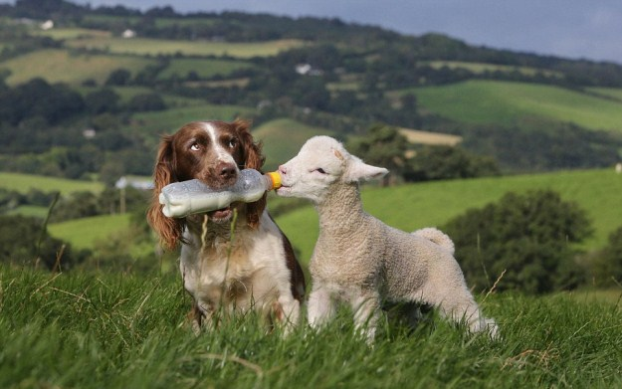Silly Old Dog*  
  
The very last dog we ever owned  
Was a very silly one  
I think she had no brains at all  
But by golly she could run.  
  
She was supposed to be a Cocker  
But she was far too big  
I never learned the history  
But there was something wrong, you dig.  
  
Let her off and she was gone  
Like a flash of light  
Straight for the horizon  
Like an arrow in full flight.  
  
She often ran on farmland  
And I waited for the shot.  
But she was very lucky  
No farmer took a pot.  
  
And always when she just ran off   
She was gone for an hour or two  
So we just sat down and waited  
What else was there to do?

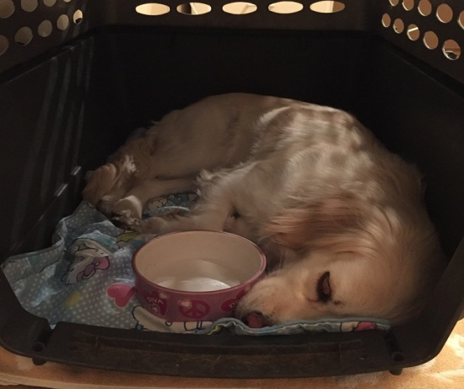Her very special record  
Was some four hours or more  
When she at last came padding back  
I'll bet her feet were sore.

She struggled back into the car  
And settled down to sleep  
We didn't say a single word  
No, not a single cheep.

  
Of

Of course we did have other dogs   
That that caused us aches and pains  
But But the one that I remember most  
Is Is Is the one that had no brains.

Page 11

*The Tidy Drawer*  
  
I have a drawer called tidy  
For that is what it's not  
It holds some very useful things  
And some that I've forgot.

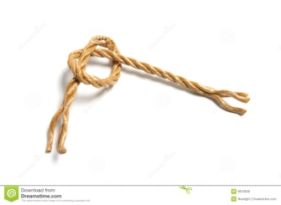

Now here's a lovely piece of string  
It's bound to come in handy  
No doubt for tying something up  
Perhaps a box of candy.  
  
And here's a splendid pocket watch  
That simply doesn't go  
Expect it needs a battery  
But still it might be slow.  
  
I know I have two hearing aids  
Lurking in a tin  
But I simply cannot find it

So I'll never hear the din.

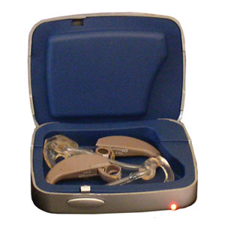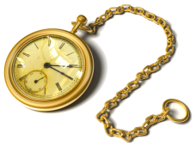

And what of all these letters?  
So safely stowed away.  
I know I'll never answer them -  
Can't remember what they say,  
  
And then the beastly sewing stuff  
For clothes that need repair  
With a needle big enough  
To fix a carpet to the stair.  
  
And an electric clipper  
To tidy up my hair,  
But since the hair has nearly gone  
It's simply resting there.

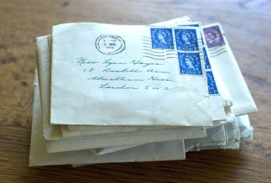





And so the drawer called tidy  
Is a splendid hiding place  
For all the things that you don't want  
Or simply cannot face.

Page 12 Entertainment

Some Entertainment Coming This Month

As well as our weekly outings in the mini-van or walk/ride to the shops/parks etc. we also have many of our favourite entertainers joining us, such as:

*4th – Fish n Chip Friday*

*Chris Simmons*

*5th Fireworks Party*

*6th - Remembrance Sunday*

*7th – Bertie Boater*

*8th – Zoe - Alive Activities*

*9th - Daniel Music Workshop 7pm*

*11th – Armistice Day (2 min silence in lounge)*

**PLUS OUR USUAL**

Yoga – Exercises – Aromatherapy – Manicures

Pampering Afternoons – Art and Crafts – Communion

Breathing Spaces - Outings in the mini-van - Shopping Trips

*Sarah Violinist*

*12th – Lord Mayors Show (TV)*

*17th – Chesswood School choir 11am*

*19th – Pianist - Lucy*

*21st –Lizzie and Tony Gillis*

*22nd – Skittles in the Dining Room with Nick*

*25th – Talk from Jessica (Curator of Rustington Museum)*

*26th – Papa Geoff*

*27th – Nathan - Singer*

*9th - Daniel Music Workshop 7pm*

Page 13 Sayings

***Origins of Some Well Known Sayings***

### *Image result for sockImage result for put a sock in it speakerPut a sock in it.*

**Definition**: Stop talking.

**Example**: Put a sock in all this talk about toasters.

**Origin**: Early gramophones had no volume control knobs. To decrease the volume, people sometimes put a sock in the amplification trumpet.

***Dead as a door nail***

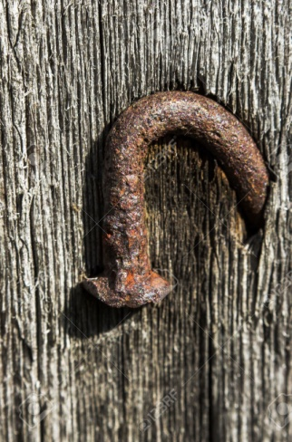**Definition**: Dead. No hope for recovery.

**Example**: Don’t bother trying to fix that toaster again; it’s dead as a doornail.

**Origin**: Nails were once hand-tooled and expensive, so they were often reused. When building a door, however, carpenters often drove the nail through then bent it over the other end, so it couldn’t work its way out during the repeated opening and closing of the door. When it came time to salvage the building, door nails were considered useless or “dead” because of the way they were bent.

### *Image result for made to measure suit 9 yards savile rowDressed to the nines*

**Definition**: Very dressed up.

**Example**: Well, lookit Ms. fancypants, all dressed to the nines like Mrs. Astor.

**Origin**: A tailor making a high quality suit uses approximately nine yards of fabric. A good suit has all the fabric cut in the same direction with the warp, or long strands of thread, parallel with the vertical line of the suit



Page 14

Page 11 Finally

### *Can’t hold a candle to*

**Definition**: Not as good as.

**Example**: Godzilla can’t hold a candle to unicorns; they’re the best.

**Origin**: Referred to someone who isn’t even qualified to hold a light for someone else doing the work.

### *Image result for eating crocodile tears Crocodile tears*

**Definition**: Fake tears.

**Example**: Stanley broke out the crocodile tears when his boss fired him.

**Origin**: It was often thought that crocodiles shed tears that slid down into their mouths, moistening their food and making it easier for them to swallow.

### *Image result for mind your p and QMind your Ps and Qs*

**Definition**: Behave yourself.

**Example**: Stanley, if you don’t mind your Ps and Qs, you’re going to get kicked out of Chuck-E-Cheese again.

**Origin**: Comes from English pubs when beer and ale was served in pint (P) and quart (Q) containers. The tab was kept on a chalkboard used to count the pints and quarts consumed.

Page 15 Finally

Page 11 Finally

***Are we THAT stupid to require the following instructions?***

On Sears hair dryer:  
*Do not use while sleeping.*

Printed on the bottom of Tesco Tiramisu dessert:  
*Do not turn upside down.*

On Marks and Spencer Bread Pudding:  
*Product will be hot after heating.*

On Boot's Children's Cough Medicine:  
*Do not drive a car or operate machinery after taking this medication.*

On Nytol Sleep Aid:  
*Warning: May cause drowsiness.*

On most brands of Christmas lights:  
*For indoor or outdoor use only.*

On Sainsbury's peanuts:  
*Warning: Contains nuts.*

On a Swedish chain saw:  
*Do not attempt to stop chain with your hands or genitals.*

On a bottle of rum:  
*Open bottle before drinking.*

Rules on a tram in Prague:  
*Beware! To touch these wires is instant death.*

*Anyone found doing so will be persecuted.*

On a can of air freshener:  
*For use by trained personnel only.*

On a bottle of baby lotion:  
*Keep away from children.*

On a pair of socks bought in Egypt:  
*Do not wash.*

On a 500-piece jigsaw puzzle:  
*Some assembly required.*

On a birthday card for a one year old:  
*Not suitable for children aged under 36 months or less.*

On shin pads for cyclists:  
*Shin guards cannot protect any part of the body they do not cover.*

***And My favourite -***

On a mattress:  
*Do not attempt to swallow.*

Page 16

Page 11 Finally

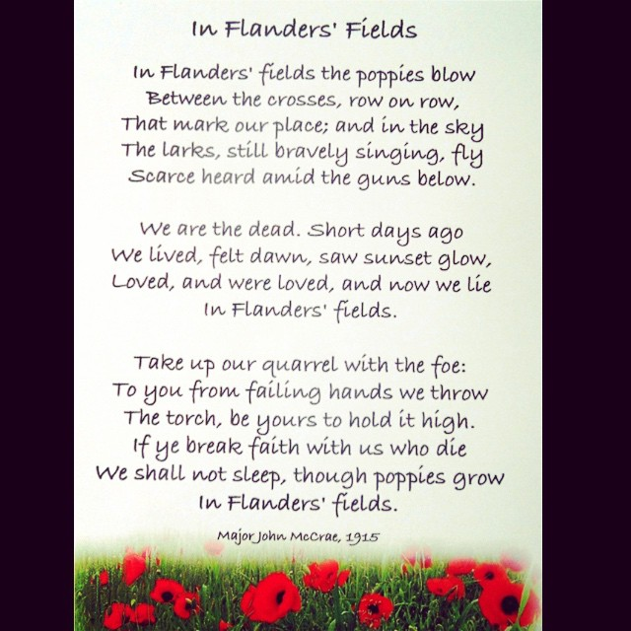

***We’re on the Web!***

*Visit us:* theshelley.com

*Find us on Facebook:* TheShelley Worthing

*Read Past Newsletters:* theshelleynewsletters.weebly.com/

*For Just Photos:* theshelleyphotos.weebly.com/

*The Shelley does not hold, nor claim to hold the copyright on any article or photograph found in print or on the Internet.*