The Shelley
Newsletter – October 2016

The Shelley - 54 Shelley Road, Worthing, West Sussex, BN11 4BX. t: 01903 237000 e: info@theshelley.com

Children in Need
Will take place on Saturday 22nd October

Inside This Issue
October 1
September in Pictures 2
Alpacas 4
John’s Rhymes 8
Entertainment 12
And Finally 13

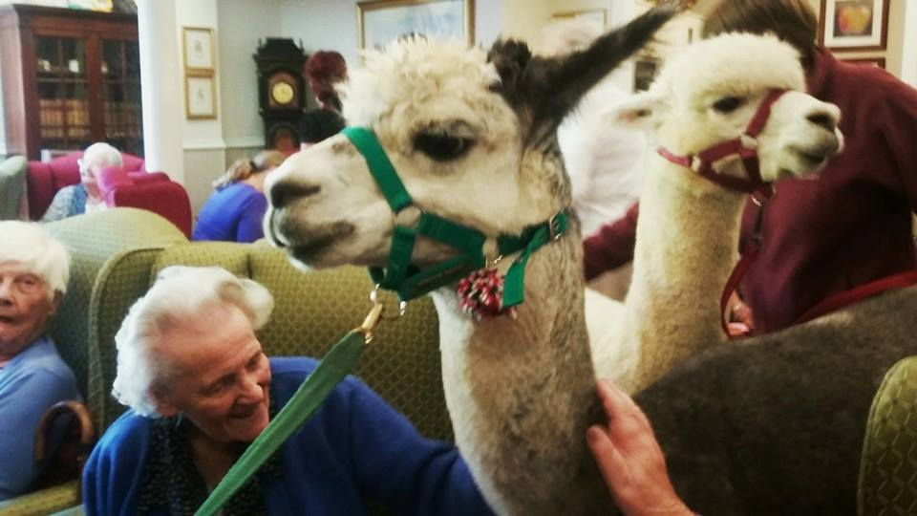

Remembering our September visitors, See – pages 4-7

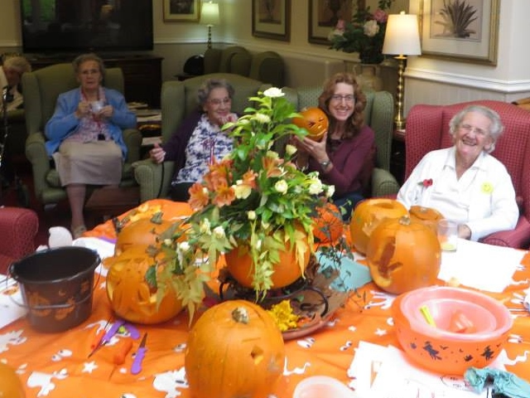
Time to dress-up - Halloween is on the way!

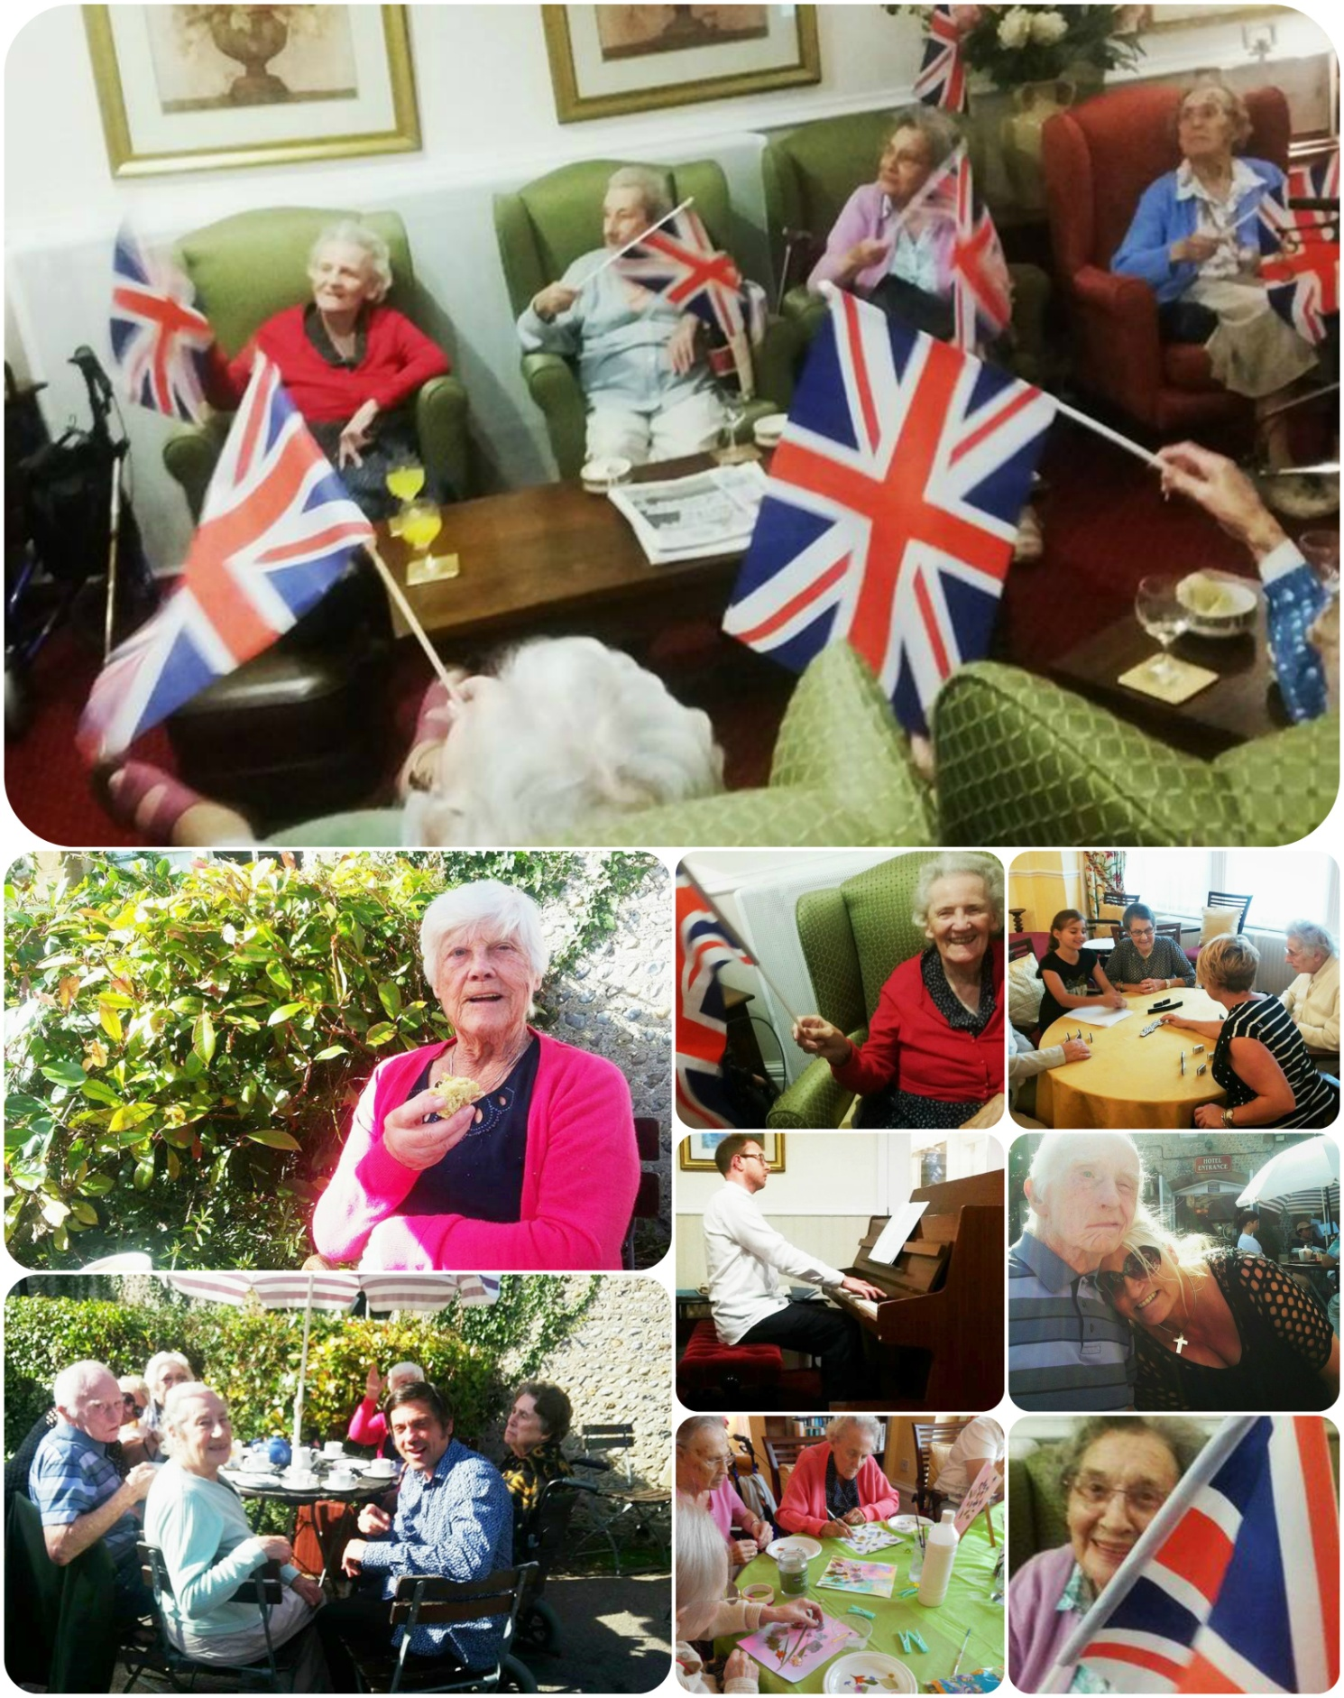
Page 2 September in Pictures

Happy memories of Alpaca’s and Pete as Julie Andrews!
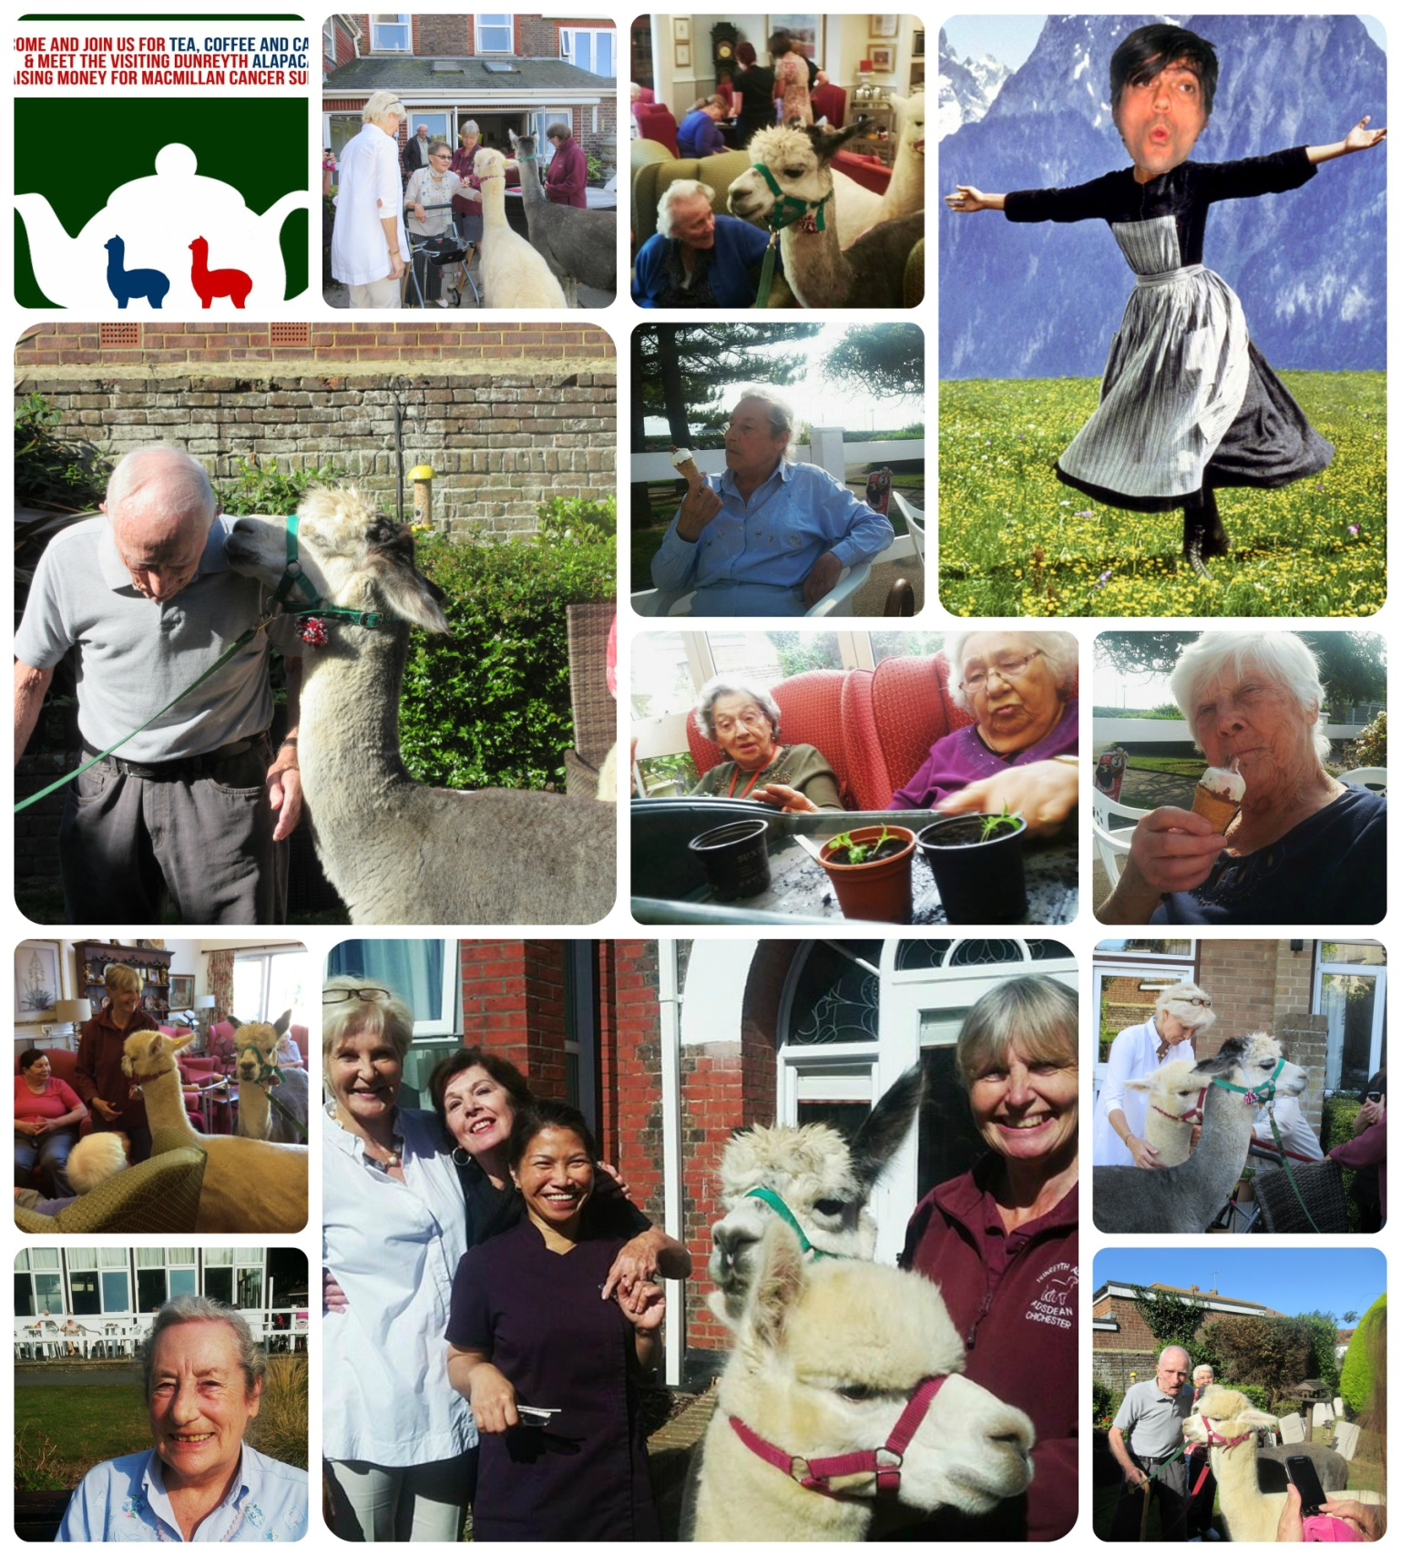
Page 3

The Alpaca
Page 4 Alpacas

What a wonderful morning Pete arranged for us to enjoy last month. Our annual Macmillan fundraising morning with cakes and the stars of the morning - The Dunreyth Alpacas.
The Alpaca is a domesticated species of South American camelid.
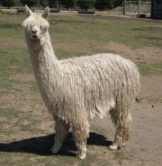
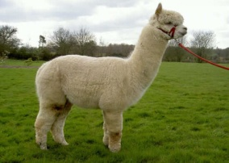
It resembles a small llama in appearance. There are two breeds of alpaca;
the Suri alpaca and the Huacaya .

Overview
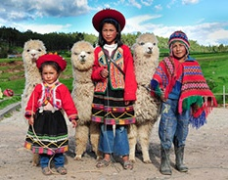
Alpacas are kept in herds that graze on the level heights of the Andes of southern Peru, northern Bolivia, Ecuador, and northern Chile at an altitude of 3,500 m (11,500 ft) to 5,000 m (16,000 ft) above sea level, throughout the year. Alpacas are considerably smaller than llamas, and unlike llamas, they were not bred to be beasts of burden, but were bred specifically for their fiber. Alpaca fiber is used for making knitted and woven items, similar to wool. These items include blankets, sweaters, hats, gloves, scarves, a wide variety of textiles and ponchos in South America, and sweaters, socks, coats and bedding in other parts of the world. The fiber comes in more than 52 natural colours as classified in Peru, 12 as classified in Australia and 16 as classified in the United States.
In the textile industry, "alpaca" primarily refers to the hair of Peruvian alpacas, but more broadly it refers to a style of fabric originally made from alpaca hair, but now often made from similar fibers, such as mohair, Icelandic sheep wool, or even high-quality English wool. In trade, distinctions are made between alpacas and the several styles of mohair and luster.
An adult alpaca generally is between 81 and 99 cm (32-35 inches) in height at the withers. They usually weigh between 48 and 84 kg (7stone 8lbs – 13stone).

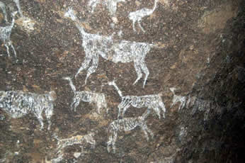
Origins
Alpacas have been domesticated for thousands of years. The Moche people of northern Peru often used alpaca images in their art. There are no known wild alpacas, and its closest living relative, the vicuña (also native to South America), are believed to be the wild ancestor of the alpaca. The alpaca is larger than the vicuña, but smaller than the other camelid species.

Page 5

Along with camels and llamas, alpacas are classified as camelids. Of the various camelid species, the alpaca and vicuña are the most valuable fiber-bearing animals: the alpaca because of the quality and quantity of its fiber, and the vicuña because of the softness, fineness and quality of its coat.
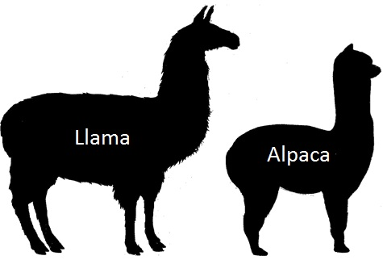
Alpacas are too small to be used as pack animals. Instead, they are bred exclusively for their fiber and meat. Alpaca meat was once considered a delicacy by Andean inhabitants. Because of the high price commanded by alpaca on the growing North American alpaca market, illegal alpaca smuggling has become a growing problem. In 2014, a company was formed claiming to be the first to export US-derived alpaca products to China.
Alpacas and llamas can successfully cross-breed. The resulting offspring are called huarizo, which are valued for their unique fleece and gentle dispositions.

Behaviour
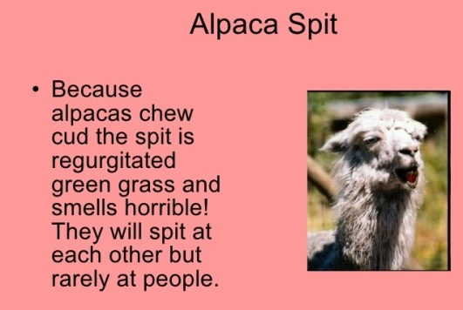
Alpacas are social herd animals that live in family groups consisting of a territorial alpha male, females and their young. Alpacas warn the herd about intruders by making sharp, noisy inhalations that sound like a high-pitched bray. The herd may attack smaller predators with their front feet, and can spit and kick. Their aggression towards members of the canid family (coyotes, foxes, dogs etc.) is exploited when alpacas are used as guard llamas for guarding sheep.

Spitting
Not all alpacas spit, but all are capable of doing so. "Spit" is somewhat euphemistic; occasionally the projectile contains only air and a little saliva, although alpacas commonly bring up acidic stomach contents (generally a green, grassy mix) and project it onto their chosen targets. Spitting is mostly reserved for other alpacas, but an alpaca will occasionally spit at a human.

Hygiene
Alpacas use a communal dung pile, where they do not graze. This behaviour tends to limit the spread of internal parasites. Generally, males have much tidier, and fewer dung piles than females, which tend to stand in a line and all go at once. One female approaches the dung pile and begins to urinate and/or defecate, and the rest of the herd often follows.
Because of their preference for using a dung pile, some alpacas have been successfully house-trained.

Page 6

Sounds

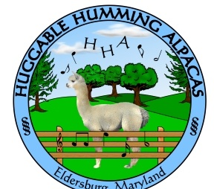
Alpacas make a variety of sounds. When they are in danger, they make a high-pitched, shrieking whine. Some breeds are known to make a "wark" noise when excited. Strange dogs – and even cats – can trigger this reaction. To signal friendly or submissive behaviour, alpacas "cluck," or "click" a sound possibly generated by suction on the soft palate, or possibly in the nasal cavity.
Individuals vary, but most alpacas generally make a humming sound. Hums are often comfort noises, letting the other alpacas know they are present and content. The humming can take on many inflections and meanings.
When males fight, they scream a warbling, bird-like cry, presumably intended to terrify the opponent.

Reproduction
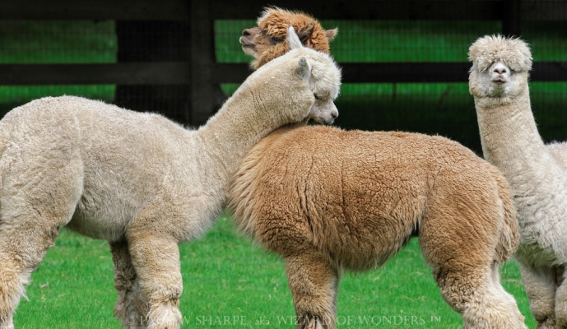
Alpacas can live for up to 20 years. A male is usually ready to mate for the first time between two and three years of age. A female alpaca may fully mature (physically and mentally) between 10 and 24 months. It is not advisable to allow a young female to be bred until she is mature, and has reached two-thirds of her mature weight.
The gestation period is, on average, 11.5 months, and usually results in a single offspring, or cria. Twins are rare, occurring about once per 1000 deliveries. Cria are generally between 15 and 19 pounds, and are standing 30 to 90 minutes after birth. After a female gives birth, she is generally receptive to breeding again after about two weeks.

Diet and Digestion
Alpacas require much less food than most animals of their size. They generally eat hay or grasses, but can eat some other plants (e.g. some leaves), and will normally try to chew on almost anything (e.g. empty bottle). Free-range alpacas may obtain the necessary vitamins in their native grazing ranges. However, ranchers can also supplement the grazing grass with low-protein grass hay to provide selenium and other necessary vitamins, ranchers will feed their domestic alpacas a daily dose of grain.
The alpaca digestive system is very sensitive and must be kept healthy and balanced. Alpacas are pseudoruminants and, like other camelids, have a three-chambered stomach; they will chew

Page 7

their food in a figure eight motion and combined with chewing cud, their three-chambered system allows maximum extraction of nutrients from low-quality forages.

Poisonous plants. Many plants are poisonous to the alpaca, including the bracken fern, fireweed, oleander, and some azaleas. In common with similar livestock, others include: acorns, African rue, agave, amaryllis, autumn crocus, bear grass, broom snakeweed, buckwheat, ragweed, buttercups, calla lily, orange tree foliage, carnations, castor beans, and many others.

History of the scientific name
The relationship between alpacas and vicuñas was disputed for many years. In the 18th and 19th centuries, the four South American lamoid species were assigned scientific names. At that time, the alpaca was assumed to be descended from the llama, ignoring similarities in size, fleece and dentition between the alpaca and the vicuña. Classification was complicated by the fact that all four species of South American camelid can interbreed and produce fertile offspring. The advent of DNA technology made a more accurate classification possible.
In 2001, the alpaca genus classification changed from Lama pacos to Vicugna pacos, following the presentation of a paper on work by Dr. Jane Wheeler et al. on alpaca DNA to the Royal Society showing the alpaca is descended from the vicuña, not the guanaco.

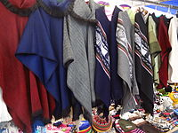
Fiber

A selection of products made from alpaca fiber

Alpacas are typically sheared once per year in the spring. Each shearing produces approximately five to ten pounds (2.2–4.5 kilograms) of fibre per alpaca. An adult alpaca might produce 50 to 90 ounces (1420–2550 grams) of first-quality fibre as well as 50 to 100 ounces (1420–2840 grams) of second- and third-quality fibre.
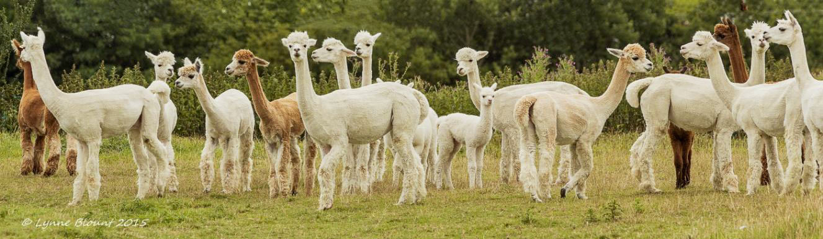
Alpaca fleece is a lustrous and silky natural fiber. While similar to sheep’s wool, it is warmer, not prickly, and bears no lanolin, which makes it hypoallergenic. Without lanolin, it does not repel water. It is also soft and luxurious. In physical structure, alpaca fiber is somewhat akin to hair, being very glossy. The preparing, carding, spinning, weaving and finishing process of alpaca is very similar to the process used for wool. Alpaca fiber is also flame-resistant, and meets the US Consumer Product Safety Commission's standards.

Hang on John
Page 8 Johns Rhymes

My name now is Hang On John
They say it every day
And when I'm teetering on the brink
I'll bet that's what they'll say.
When I am swinging on the light
Part of my daily lark,
"Hang on John" is what they'll shout,
"Or you'll put us in the dark" ..

Ouch ...
Damn, who put the wall here?

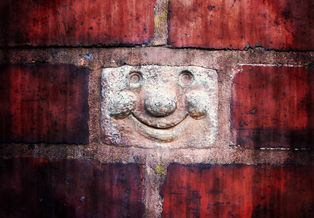

When I crash my wheels into the wall
With words too rude to tell,
I know exactly what they'll say.
"We must just get that bell".

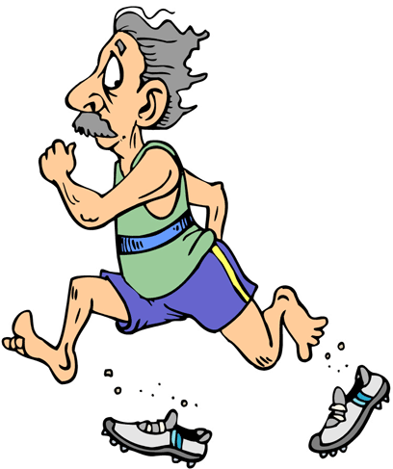
And if I'm really in a rush
With not a sec to lose
"Hang on John," is what they'll say,
"You haven't got your shoes."
But when I'm scorching round the track
In my E-Type Jaguar
It's no good shouting "Hang on John",
Just get a better car.

Never Been
I've never been to Windsor
Though they say the castle's grand
But if ever I do go there
Hope they'll be sure to play the band.
Never been to Berkhampstead
What a very silly name
Does it really mean a thing?
Or is it just a game?

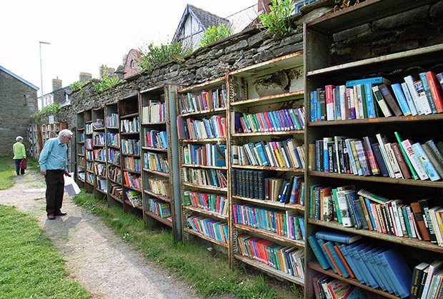
Never been to Swansea
Somewhere in darkest Wales
But I did once go to Cardiff
To see England lose to Wales.
Never been to Ross-on-Wye
Though a lovely place it looks
But I'd rather go to Hay-on-Wye
And browse among the books

Never been to Sherwood
Where Robin used to play
But did it really happen?
Or is it just hearsay?
Never been to Pontefract
Wherever that may be
But if I ever get there
I'll have some cakes for tea.
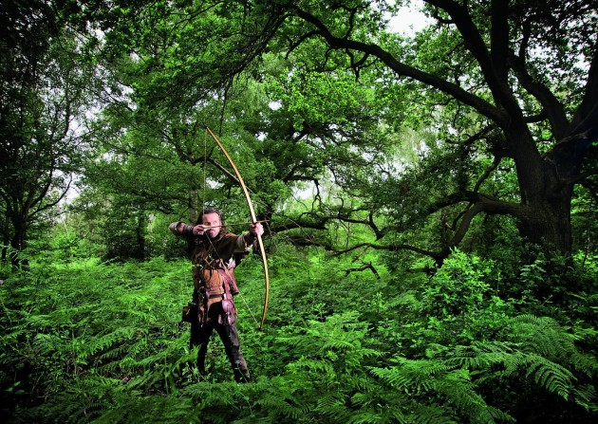

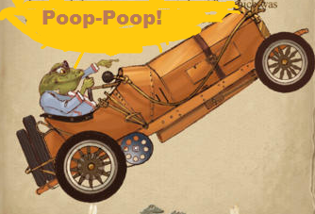
I've never been to Battle
King Harold's do or die
He peered out at the enemy
And copped one in the eye
I've never been to Arundel
Though it's only down the road
Roared around it many times
Poop! Poop! Like Mr Toad.

I know I've been to Worthing
A lovely sunny spot.
Some say that it's charming
Others well, p'raps not.

Page 9

Page 10 Entertainment

Some Entertainment Coming This Month
As well as our weekly outings in the mini-van or walk/ride to the shops/parks etc. we also have many of our favourite entertainers joining us, such as:

1ST- at 11am Sniffer Dogs Ted & Seamus – Bomb & Explosive Expertise
3pm – Pal O Mine (Pete Ridge) – Singer/Guitarist
3rd – Richard – Pianist/Singer
5th – Double time – Singing Duo
7th – Paul Rother on the Keyboard
8th - 2 in Accord – Accordion Duo
11th – Roger and Penny – Informative Talk
PLUS OUR USUAL
Yoga – Exercises – Aromatherapy – Manicures
Pampering Afternoons – Art and Crafts – Communion
Breathing Spaces - Outings in the mini-van - Shopping Trips
14th – Seaside Singers
18th – RSPB – Autumn Talk
19th – Daniel Singing
21st – GAPP – Singers
22nd Children in Need Day At The Shelley
23rd – Kevin History Talk “Sussex by the Sea”
24th - Robbie Magic
28th – John Beever – Keyboard
29th - Christmas Card Sale (Local Polio Group)

Page 11 Finally

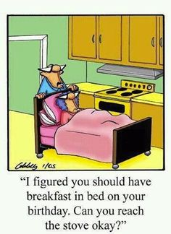

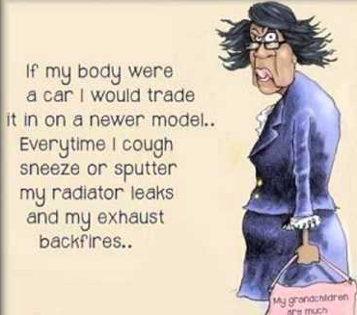

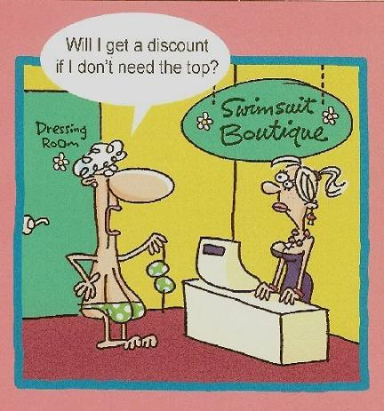

Autumn
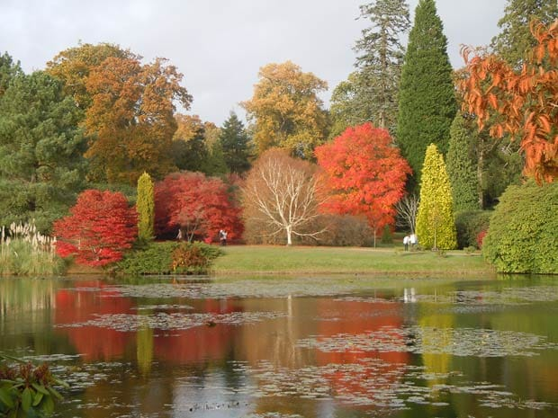
I'm rather fond of autumn
It's a pleasant time of year
The summer rush is over
There's time to stand and stare.
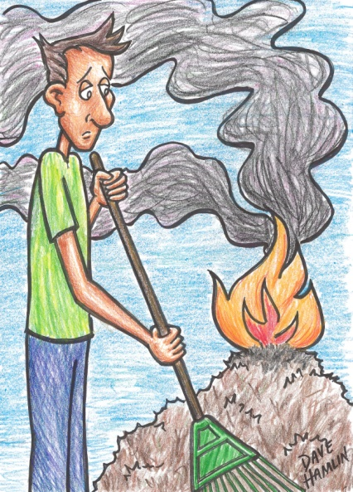
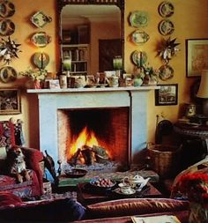
I like the autumn colours,
Faded greens and brown,
They tell you that the days grow short
It's time to settle down.
Some people say they like the spring,
Life bursting all around,
But when you're getting ancient,
You like the harvest sounds.
I like the darkening evenings,
The curtains being drawn,
I used to like a blazing fire
Just shows when I was born.
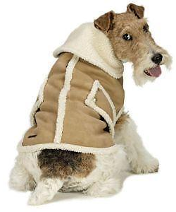
It's time for autumn bonfires
To tidy up the land
And time to plan for next year
Seed catalogue in hand.
So now the days are drawing in
The air begins to nip,
It's time to put the warm clothes on
And wait for winter's grip.

We’re on the Web!
Visit us: theshelley.com
Find us on Facebook: TheShelley Worthing
Read Past Newsletters: theshelleynewsletters.weebly.com/
For Just Photos: theshelleyphotos.weebly.com/
The Shelley does not hold, nor claim to hold the copyright on any article or photograph found in print or on the Internet.

Page 12 John Says

We’re on the Web!
Visit us: theshelley.com
Find us on Facebook: TheShelley Worthing
Read Past Newsletters: theshelleynewsletters.weebly.com/
For Just Photos: theshelleyphotos.weebly.com/
The Shelley does not hold, nor claim to hold the copyright on any article or photograph found in print or on the Internet.

