The Shelley

Newsletter – September 2016

**The Shelley -** 54 Shelley Road, Worthing, West Sussex, BN11 4BX. t: 01903 237000 e: [info@theshelley.com](mailto:info@theshelley.com)

### Inside This Issue

September 1

August in Pictures 2

Clever Equines 4

John’s Rhymes 6

Entertainment 8

Olympics 9

Paralympics 10

Charity events 13

Finally 14

All Residents

Join Pete in the Lounge to Celebrate

September 10th

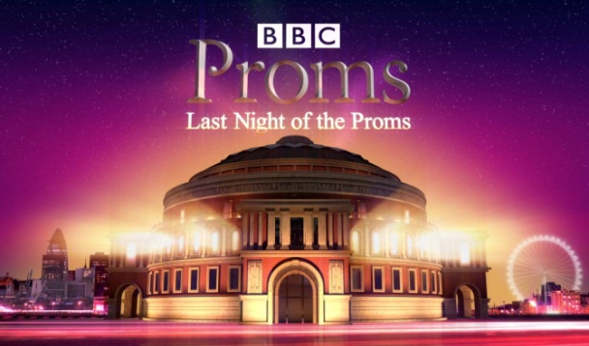

With Alpacas

Yes, Alpacas!

Another month,

another charity event

Macmillan Coffee Morning

Join us at 11am Friday September 23rd

[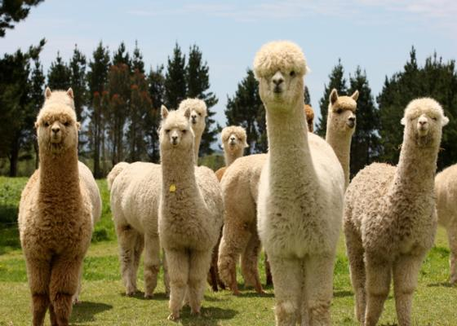](https://www.bookabach.co.nz/baches-and-holiday-homes/view/20789)

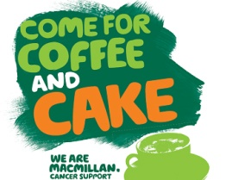

**And we continue this month**

**September 7th – 18th**

**See page 1o**

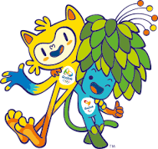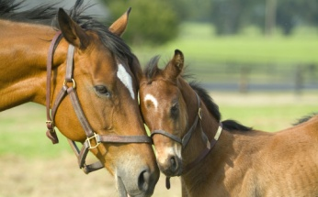 **What has this**

 **To do with this ?**

**Find out on pages 6-7**

Page 2 August in Pictures

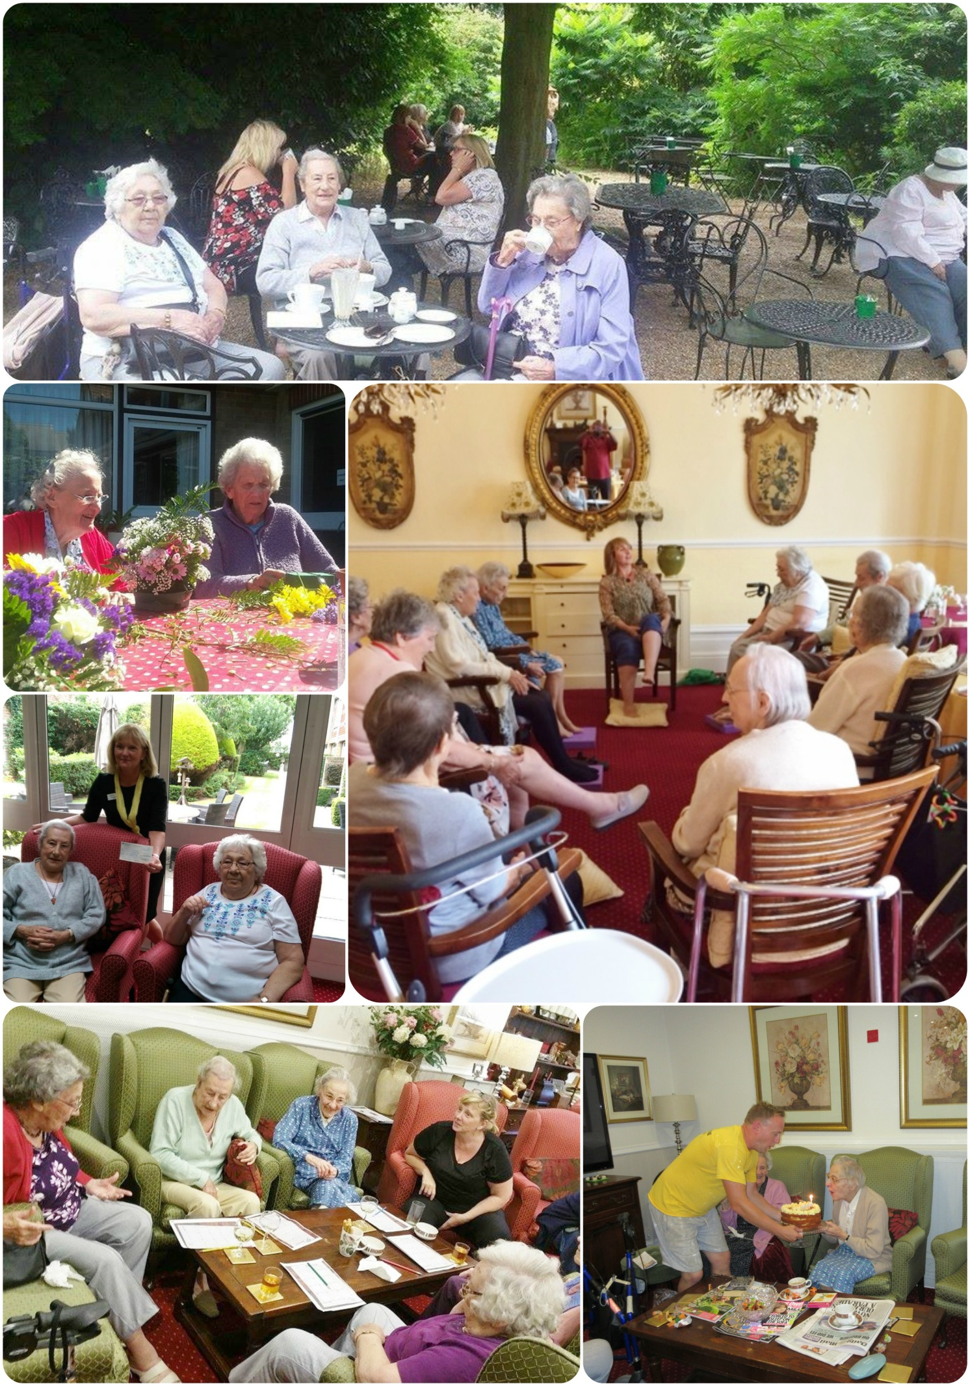

Page 3

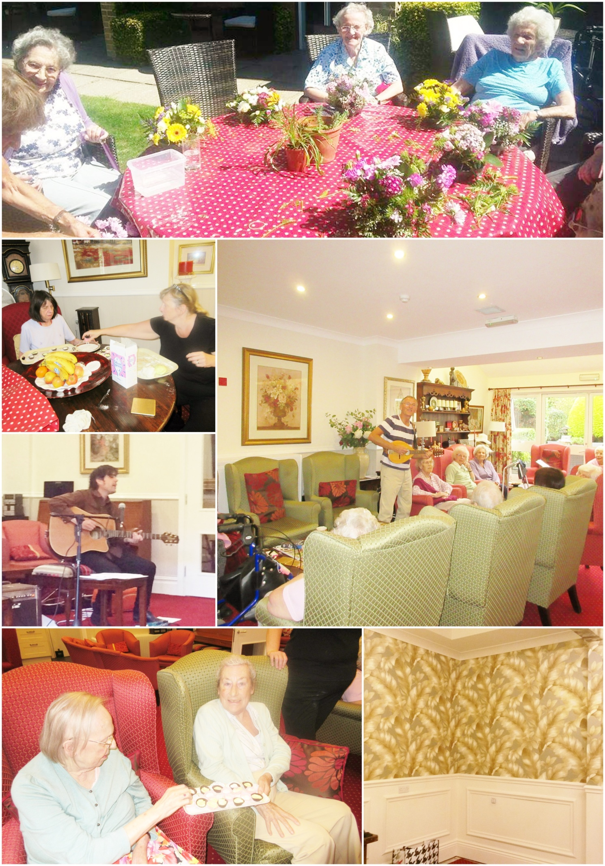

Page 4 Horses

Horses are undeniably clever animals and have been domesticated and used by man for anything from transport to food for well over 5000years. Beyond being proficient at relatively simple learning tasks, they are also recognised as having the capacity to solve advanced cognitive challenges involving categorisation learning and a degree of concept formation.

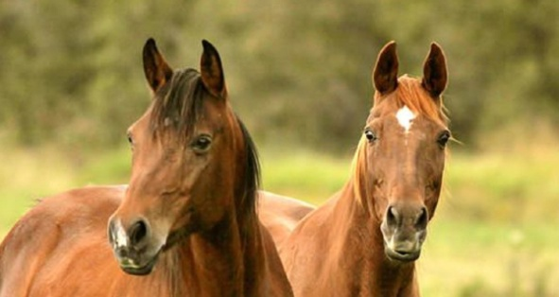They use their ears, eyes and nostrils to express their mood. When they are forward, it means they are alert or interested.

If they are pinned back close to the neck he is angry and about to bite or kick. Make sure you 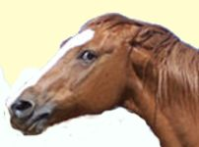get out of the way, and if you identify the source of their anger, steer them away.

Rapidly swiveling ears swinging back and forth – heightened state of anxiety or alertness.

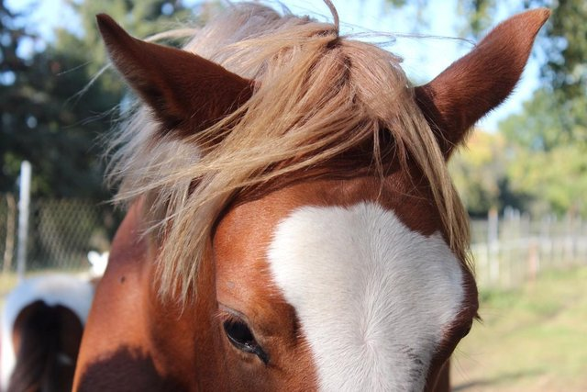 They also communicate their feelings through facial expressions. Horses and other equines have better senses of smell and hearing than humans. Their ears can turn in different directions to aid their hearing but in general the ear ‘looks’ the same way as the eye on that side. However, if you see their ears pointing in different directions they are looking in two different directions at different things at the same time.

Horses have fairly good eyesight, thanks to their [very peculiar eyes](http://books.google.fi/books?id=geenPyU7fSMC&pg=PA142&dq=horse+eyes&hl=fi&sa=X&ei=_pHEUpKZFeba4QS51QE&ved=0CFgQ6AEwBQ#v=onepage&q=horse%20eyes&f=false). At a diameter of roughly 5 centimeters (2 in), they are the largest of any land mammal. When measured in volume, a horse’s eye is up to [nine times larger](http://books.google.fi/books?id=0eKwAAAAQBAJ&pg=PA126&dq=horse+eyes&hl=fi&sa=X&ei=_pHEUpKZFeba4QS51QE&ved=0CFAQ6AEwBA#v=onepage&q=horse%20eyes&f=false) than that of a human.

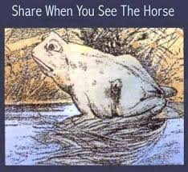 A horse’s eye has three eyelids—two ordinary ones and a third called the nictitating membrane—which is located in the inner corner of the eye and occasionally sweeps the eye, lubricating and cleaning it if need arises. Horses can’t properly focus their eyes like humans do. Instead, the lower parts of their retina see objects at a distance, and the upper ones are for closer viewing.

They have near 360 degree vision. They do however have blind spots directly in front and behind them. It is extremely dangerous to stand behind a horse as they are liable to kick out if they get scared by anything as kicking out is their way of defending themselves.

How is your eyesight? What do you see in the picture on the left?

Hint, there are two animals!

Page 5

Horses use a range of different vocalisations to communicate. Whinnying and neighing sounds are elicited when horses meet or leave each other. Stallions perform loud roars as mating calls, and all horses will use snorts to alert others of potential danger. Mares use deep smooth sounds, whickering, when they are nursing a foal.

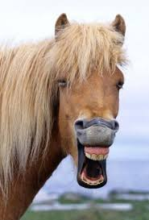You may have seen a horse and other animals making a strange expression where it curls its upper lip and bares its teeth into a wide grin. This is part of a special [nose-enhancing technique](http://www.horseswithamie.com/horsebehavior/horselaugh.html) called a flehmen response. They pull this amusing face in order to direct scents floating in the air toward special olfactory glands that are located at the end of the horse’s nasal passage. The lip-curling and the slight tilting of head help the animal to waft these smells toward these glands. The horse isn’t laughing at you, it’s just trying to determine whether you smell bad!

A 2010 study revealed some very surprising results about horse intelligence, [especially memory](http://news.discovery.com/animals/zoo-animals/horse-friends-memory-trainers.htm). Not only does our equine friend understand our words far better than we have previously anticipated, its memory is at least as good as that of an elephant. If a horse is treated kindly, it will remember the person as a friend for as long as it lives. The horse will instantly resume friendship when it sees them again, regardless of how long they have been apart. They also remember places very well—most horses [become nervous](http://www.scienceprofonline.org/animal-behavior/horse-long-term-sequential-memory.html) when they’re taken to a place where they’ve had a startling experience.

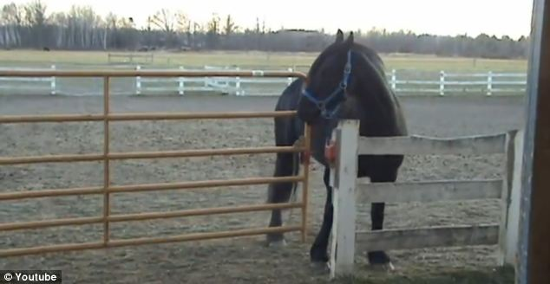The good memory and relatively powerful intellect of horses is not always a good thing, though. If they get bored, they can accidentally figure out how to untie themselves from posts and open latches and grain bins. Once they learn these methods of mischief, they’ll never, ever forget.

A quote from the Koran states: *‘Horse, thou art truly a creature without equal, for thou fliest without wings and conquerest without sword.’*

Page 6 John’s Rhymes

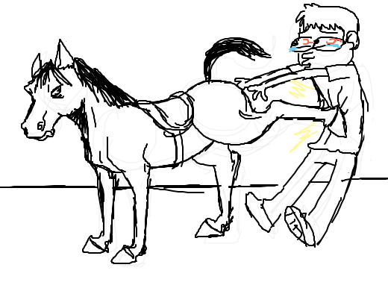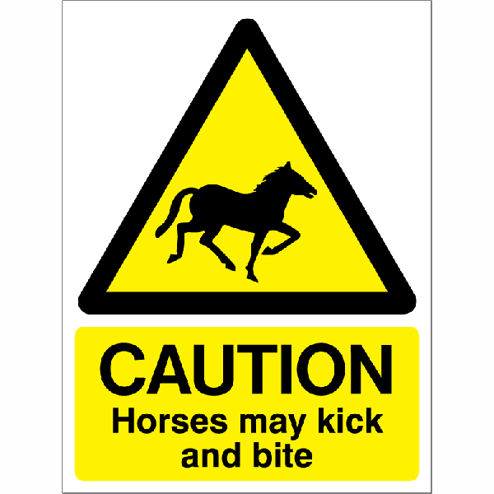 ***Horse Sense***

I don't know much about horses  
But I know that they can bite  
So steer clear of the front end  
Or it may give you a fright.

I don't know much about horses  
But I know that they can kick.   
It's best to stay a field away  
That always does the trick.

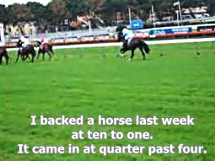

I don't know much about horses  
But I'm told some can run fast.  
I know that if you back one  
It always comes in last.

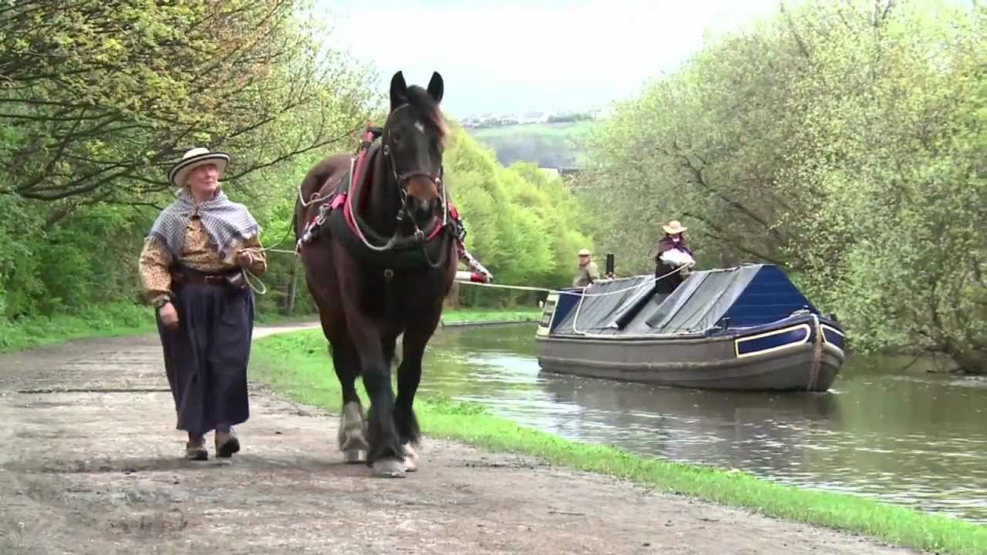

I don't know much about horses  
But I know they're rather large.  
So always when I see one  
I wish he pulled a barge.

I don't know much about horses   
But Knights rode them rattle clank  
Yet if it came to battle  
I'd rather have a tank.

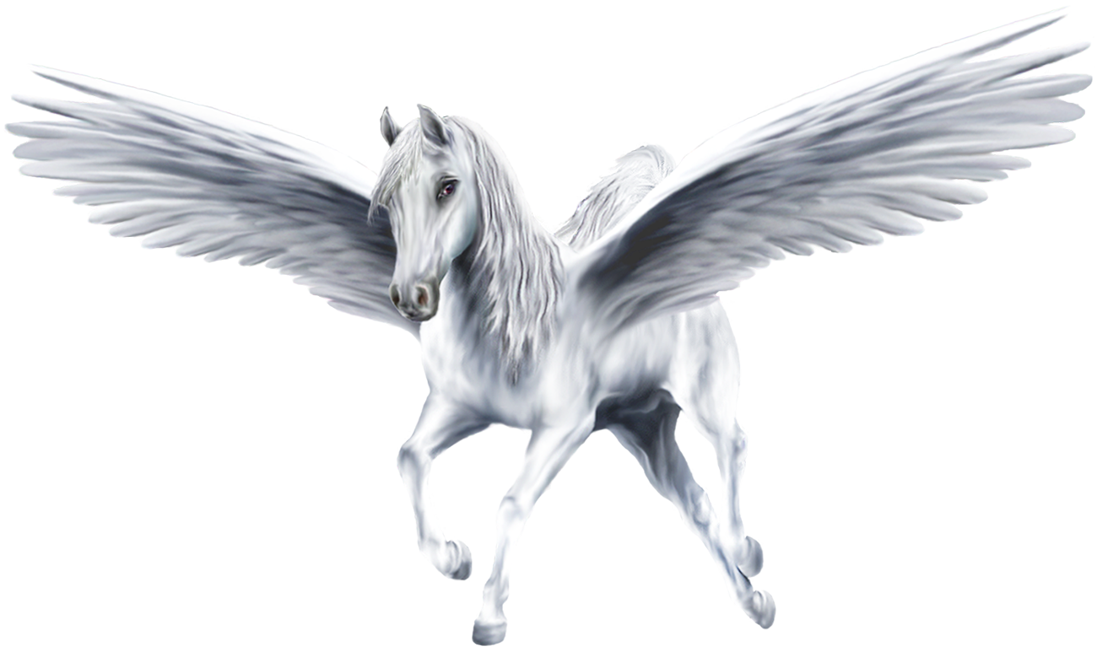

I don't know much about horses   
But I know that they can't fly  
Unless they're called  
Pegasus when they whiz across the sky.

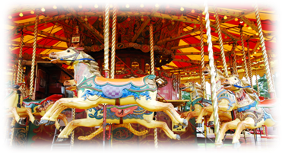

I don't know much about horses   
The reason is not sound  
But I like the ones at funfairs  
That just go round and round.

Page 7

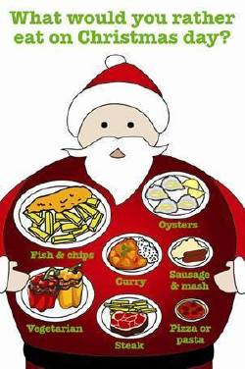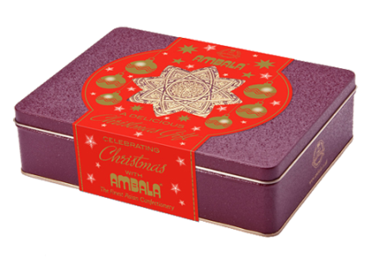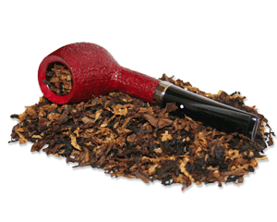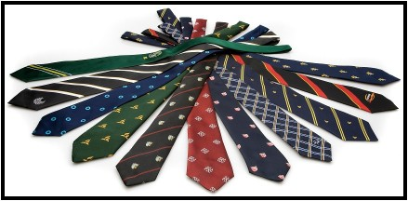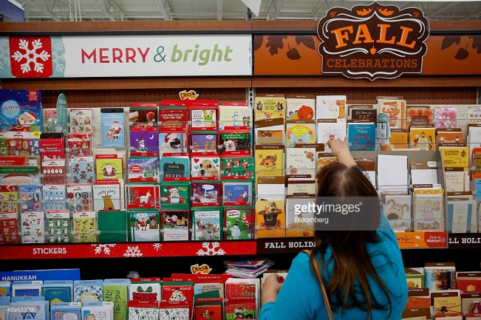 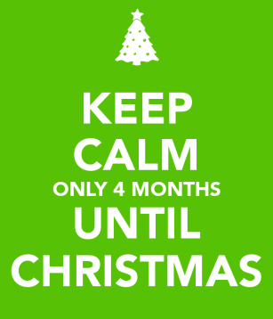Xmas is Here  
  
Xmas is upon us  
Only four months left to go,  
Time to get things moving  
A lot to do you know.  
  
Begin to buy the Christmas cards  
In the shops they're looking fine.  
And then the job of writing them  
Takes such an awful time.  
  
Then we must think of presents,  
Prepare the yearly list.  
Did Grandpa have a tie last year  
Or just an ounce of twist.  
  
And then there's Auntie Mabel  
Can't spend too much on her  
I know - a box of sweeties -   
Just like we gave last year.

Soon time to think of cooking.  
That really is a worry  
Let's have just one bird this year  
And make do with a curry.

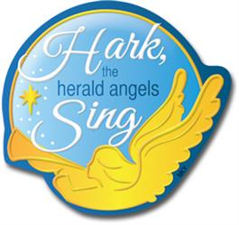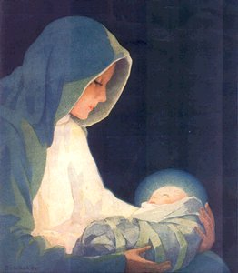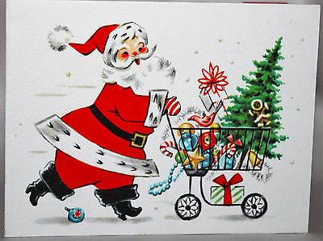Where shall we put the Christmas tree?  
If we have one ten feet tall  
It won't go in the parlour  
But it might go in the hall.  
  
Perhaps we should slow down a bit  
Until it's time to say  
"Hark the herald angels sing  
Christ the Lord was born today."

Page 8 Entertainment

Some Entertainment Coming This Month

As well as our weekly outings in the mini-van or walk/ride to the shops/parks etc. we also have many of our favourite entertainers joining us, such as:

*2nd – Singer - Rudi*

*3rd – Jack Winrow - Sings*

*7th – Ali – Singer/Sax*

*8th  - Spurtles*

*9th – Geoff Field Singer/Guitarist*

*10th – Last Night of the Proms*

**PLUS OUR USUAL**

Yoga – Exercises – Aromatherapy – Manicures

Pampering Afternoons – Art and Crafts – Communion

Breathing Spaces - Outings in the mini-van - Shopping Trips

*11th – John Chevey 30s – 60s Songs*

*16th – Poetry with Pamela*

*18th – Lori – Singer*

*19th - Mark – Jazz n Blues pianist*

*22nd Papa Geoff – singer/guitarist*

*23rd – Macmillan Coffee Morning*

*24th – Alan Campbell – Singer/Guitarist*

*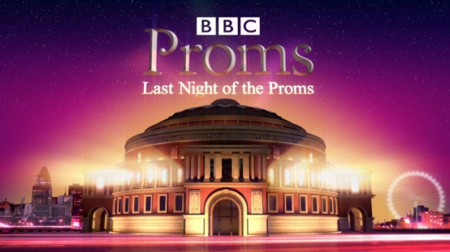30th – Geoffrey –Baritone Singer and Jean on Piano*

Page 9 Olympics

Page 9

**We all welcomed Pam** to us in August, what you may not know is she was married to **Denys John Carnill** who sadly passed away earlier this year.

Denys, former Great Britain and England hockey captain was a British field hockey player who competed in the 1952 Summer Olympics where the team won Bronze, in the 1956 Melbourne Olympics, and in the 1960 Rome Olympics. He also played one first-class cricket match for Oxford University in 1950, was capped 45 times for England and 27 times for Great Britain, in an era when very few internationals took place annually.

Those of you who came to watch this year’s Ladies hockey final were thrilled to be shown the Bronze Medal awarded to Denys.

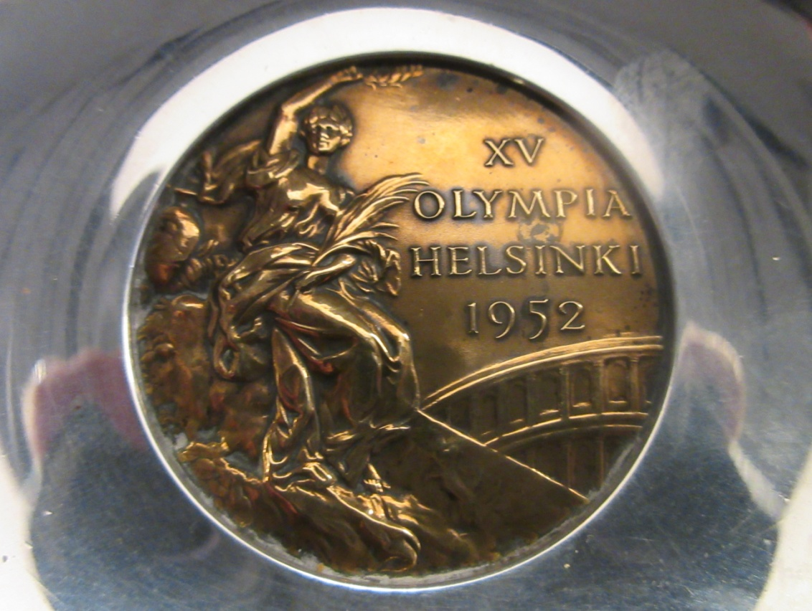For those of you who missed out, here is the next best thing – a photo of the medal.

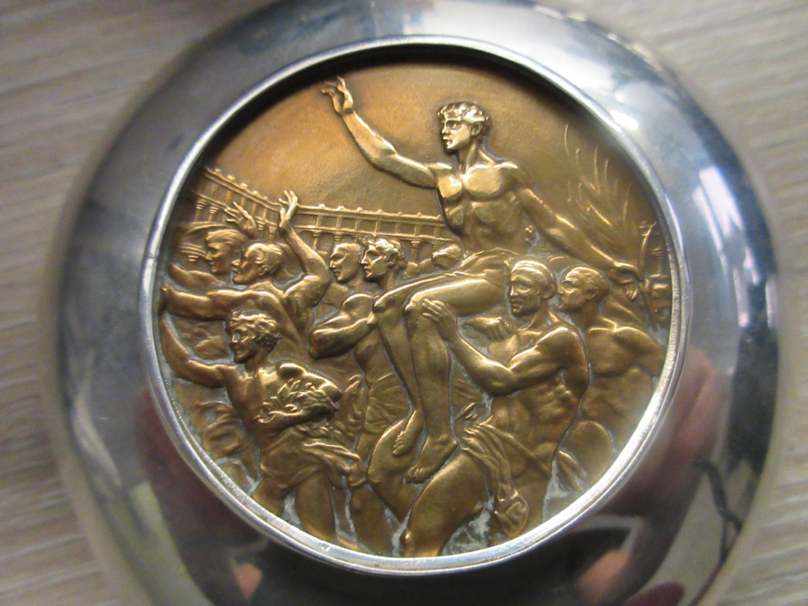

Page 10 Paralympics

**Sir Ludwig "Poppa" Guttmann**, [CBE](http://en.wikipedia.org/wiki/Order_of_the_British_Empire), [FRS](http://en.wikipedia.org/wiki/Fellow_of_the_Royal_Society) (3 July 1899 – 18 March 1980)[[2]](http://en.wikipedia.org/wiki/Ludwig_Guttmann#cite_note-biography-1) was a [German](http://en.wikipedia.org/wiki/Germany) [neurologist](http://en.wikipedia.org/wiki/Neurologist) who established the Paralympic Games while living in [England](http://en.wikipedia.org/wiki/England). The [Jewish](http://en.wikipedia.org/wiki/Jewish) doctor, who had fled [Nazi Germany](http://en.wikipedia.org/wiki/Nazi_Germany) just before the start of the [Second World War](http://en.wikipedia.org/wiki/Second_World_War), is considered to be one of the founding fathers of organized physical activities for people with a [disability](http://en.wikipedia.org/wiki/Disability).

In the [United Kingdom](http://en.wikipedia.org/wiki/United_Kingdom) he was awarded an [OBE](http://en.wikipedia.org/wiki/Officer_of_the_Order_of_the_British_Empire) and [CBE](http://en.wikipedia.org/wiki/Commander_of_the_Order_of_the_British_Empire). In 1966, he was knighted by Her Majesty Queen Elizabeth II.

**The first Paralympic Games were held in Rome, Italy, in 1960 and involved 400 athletes from 23 countries**.

Originally, only wheelchair athletes were invited to compete. Since that time, the Paralympic Games have grown dramatically. Visual impairment, physical disabilitities, amputee athletes, cerebral palsy, spinal cord injuries and Les Autres - athletes with a physical disability that are not included in the categories mentioned above (e.g., people with Muscular Dystrophy) are now all competitors in Paralympics games both summer and winter.

Initially the Paralympic and Olympic Games were implemented at different times, but in 1992 the approach was modified. Now the Paralympic and Olympic Games are held within two weeks of each other using the same venues and the same organising committee.

Today the Paralympic Games is the biggest multi-sport event for disabled athletes in the world. Participation spans 140 countries and covers six classification groups from those with spinal cord injuries to the visually impaired

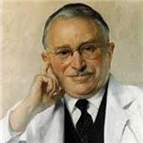  
Sir Ludwig Guttmann died in 1980, but his vision of sport for athletes with disabilities continues today. Clearly the value of sport in the lives of athletes with disabilities extends far beyond its rehabilitative benefits. Sportsmanship, camaraderie and an active lifestyle are other important benefits. The athletic talents of competitors with disabilities are becoming recognized worldwide, just as Dr. Guttmann intended. The skill and talent of high-performance athletics and competition are evident in the performance of today’s Paralympians from all nations.

*"The aims of sport for the disabled, as well as the non-disabled, are to develop mental activity, self-confidence, self-discipline, a competitive spirit and comradeship."*

Ludwig Guttmann

*The following two pages consist of a guide of events – heats and medal ceremonies*

Page 11

|  |  |  |  |
| --- | --- | --- | --- |
|  | EVENT | HEATS | MEDAL CEREMONIES |
| Archery | **Archery** | 10th | 11th to 17th |
| Athletics | **Athletics** |  | 8th to 18th |
| Boccia | **Boccia** | 10th, 11th, 13th, 14th, 15th | 12th and 16th |
| Canoe sprint | **Canoe Sprint** | 14th | 15th |
| Cycling road | **Cycling Road** |  | 14th to 17th |
| EquestrianCycling track | **Cycling Track** |  | 8th to 11th |
| Football 5-a-side | **Equestrian** | 11th and 12th | 13th to 16th |
|  | **Football 5** | 9th, 11th, 13th, 15th | 17th |
| Football 7-a-side | **Football 7** | 8th, 10th, 12th, 14th | 16th |
| Goalball | **Goalball** | 8th to 15th | 16th |
| Judo | **Judo** |  | 8th to 10th |
| Powerlifting | **Powerlifting** |  | 8th to 14th |

Following the success of the UK Olympic teams, the Paralympics are due to begin this month, although at the time of this Newsletter there were financial worries. These vary from the games not takings place and not enoguh volunteers to many athletes unable to reach Rio to take part. I hope by now that all these issues have been solved and I know we will all be cheering them on.

Page 12

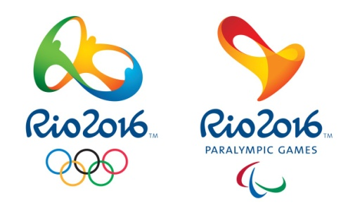

|  |  |  |  |
| --- | --- | --- | --- |
|  | EVENT | HEATS | MEDAL CEREMONIES |
| Rowing | **Rowing** | 9th and 10th | 11th |
| Sailing | **Sailing** | 12th to 16th | 17th |
| Shooting | **Shooting** |  | 8th to 14th |
| SwimmingSitting volleyball | **Sitting Volleyball** | 9th to 16th | 17th and 18th |
| Table tennis | **Swimming** |  | 8th to 17th |
|  | **Table Tennis** | 8th, 9th, 10th, 14th, 15th | 11th, 12th, 13th, 16th, 17th |
| Triathlon | **Triathlon** |  | 10th and 11th |
| Wheelchair fencingWheelchair basketball | **Wheelchair Basketball** | 8th to 15th | 16th and 17th |
| Wheelchair rugby | **Wheelchair Fencing** |  | 12th to 16th |
| Wheelchair tennis | **Wheelchair**  **Rugby** | 14th to 17th | 18th |
|  | **Wheelchair**  **Tennis** | 9th to 12th | 13th to 16th |

Good luck to all those taking part

Page 13 Charity Events

* Many of you will have seen the Thank You card in the main hall from Action for Deafness, a community charity who provide help and support those with hearing loss.

For this year’s Summer Fayre event we chose them as our charity and we can now tell you that you all managed to raise a record amount - £529.70 for this very worthy cause. Well done and many thanks to the organisers, helpers and most of all the visitors and residents for joining us on this very warm and special day!

A picture of them accepting the cheque can be seen on page 2 of this newsletter.

* As already announced, we will be supporting Macmillan with their Biggest Coffee Morning event. We will be holding ours on the 23rd and would love you to join us. Clever Pete has arranged for us to have Alpaca’s in the building on the day!
* The Children in Need charity needed to be cancelled at almost the last minute. I am delighted to tell you we shall be going ahead with this very worthwhile event next month. Keep an eye on our Facebook page and in-house for the date and times.

Looking further ahead, I am sure you will love to also join us for our Firework display – date for this is always hoped to be the 5th but we are in the hands of the weather!

Christmas is not long off (as John reminded us with his rhyme) and we are looking forward to the month’s events, residents party - with the real Father Christmas giving residents and some good children their early Christmas gifts, as well as far too many good things to eat and drink.

We hope you can all join us with your friends and families to at least some of these events.

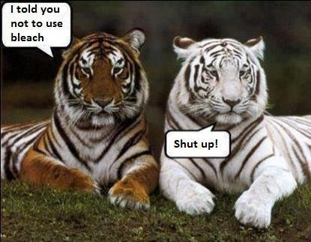

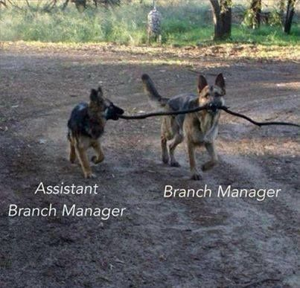

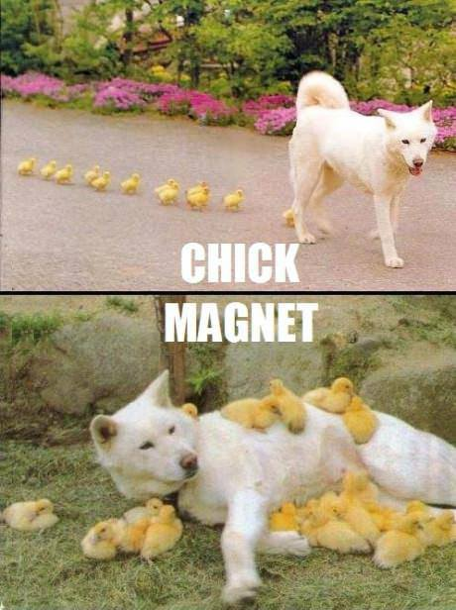

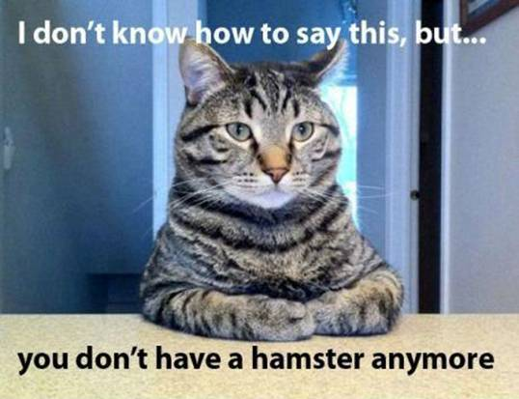

Thank you Rosemary, for sharing these Internet findings with us!

Page 14 Finally

***We’re on the Web!***

*Visit us:* theshelley.com

*Find us on Facebook:* TheShelley Worthing

*Read Past Newsletters:* theshelleynewsletters.weebly.com/

*For Just Photos:* theshelleyphotos.weebly.com/

*The Shelley does not hold, nor claim to hold the copyright on any article or photograph found in print or on the Internet.*