The Shelley Newsletter


SEPTEMBER - 2014

The Shelley - 54 Shelley Road, Worthing, West Sussex, BN11 4BX. t: 01903 237000 e: info@theshelley.com

September:
The name September comes from the old Roman word 'septem', which means seven, because in the Roman calendar it was the seventh month. The Anglo-Saxons called it Gerst monath (Barley month), because it was their time when they harvested barley to be made into their favourite drink - barley brew. They also called it Haefest monath, or Harvest month.
The Romans believed that the month of September was looked after by the god, Vulcan. As the god of the fire and forge they therefore expected September to be associated with fires, volcanic eruptions and earthquakes.
September is the start of the school year. Students return to school after the six week summer holiday.

Inside This Issue
September 1
Birthdays and other Celebrations 2
Entertainment and Outings 3
John’s Rhymes 4
On the beach 6
11 Missing Days 7
September Events 8
And Finally 9



Stop Press
Look what’s new for you all on the beach – page 6

Sayings and Beliefs for Michaelmas Day

The Michaelmas Daisies, among dede weeds,
Bloom for St Michael's valorous deeds.
And seems the last of flowers that stood,
Till the feast of St. Simon and St. Jude.

(The Feast of St. Simon and Jude is 28th October)

Eat a goose on Michaelmas Day  Want not for money all the year | He who eats goose on Michaelmas day  shan't money lack or debts to pay
'If St Michael brings many acorns, Christmas will cover the fields with snow.'

'A dark Michaelmas, a light Christmas’


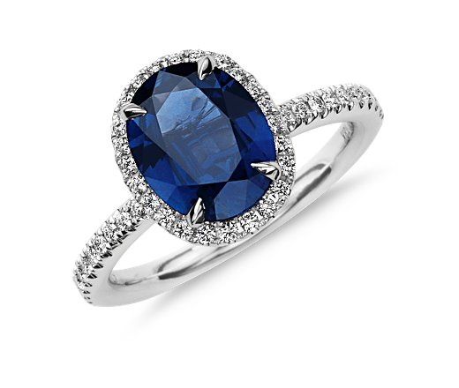
September
Gemstone – Sapphire
Flower - Aster

Page 3



August Birthdays

Many Happy Returns in August Went To:

Peggy and Val on the same day – also on this day in history: 1876 Mata Hari born. 1498 Christopher Columbus lands on Isla Santa, Venezuela. 1834 Slavery abolished throughout British Empire.

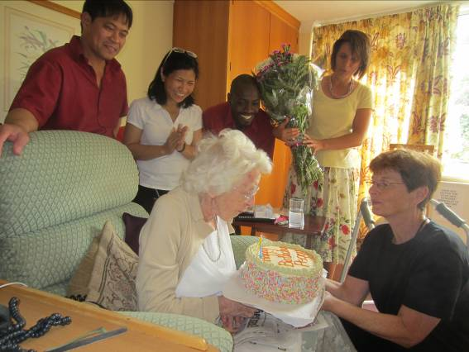
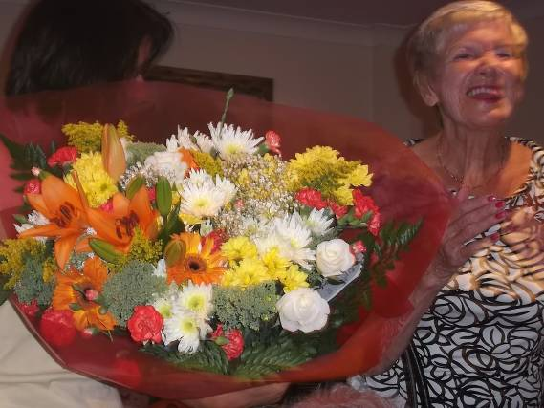

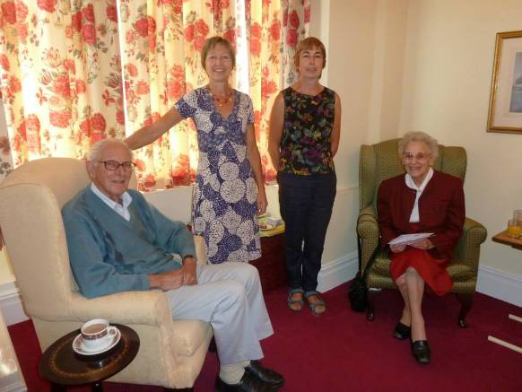

To Jean Buck – also on this day in history: Coco Chanel born,1883. Alastair Sim died in 1976 and in 1960 the first parking tickets issued in London.
Jeans family visited her on the day, bringing birthday gifts and a cake!

To Jean Barrow – also on this day in history: Mother Teresa born, 1910, Charles Lindbergh died 1974.
Poor Jean was not well for her birthday, her family visited and celebrated with her in her room.

To Sue – also on this day in history: Lyndon B Johnson born in 1908 and the world's first public passenger rail service began between Stockton and Darlington in the north of England in 1825. In hospital on her day, she celebrated on her return to us.

To Jack – also on this day in history: John Betjeman born 1906. Oliver Hardy died 1957 and Martin Luther King Jr. delivers his "I have a dream speech" in 1963.

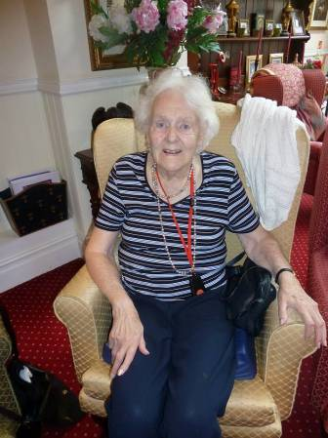

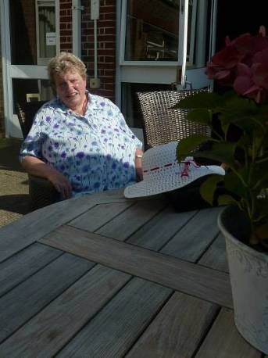

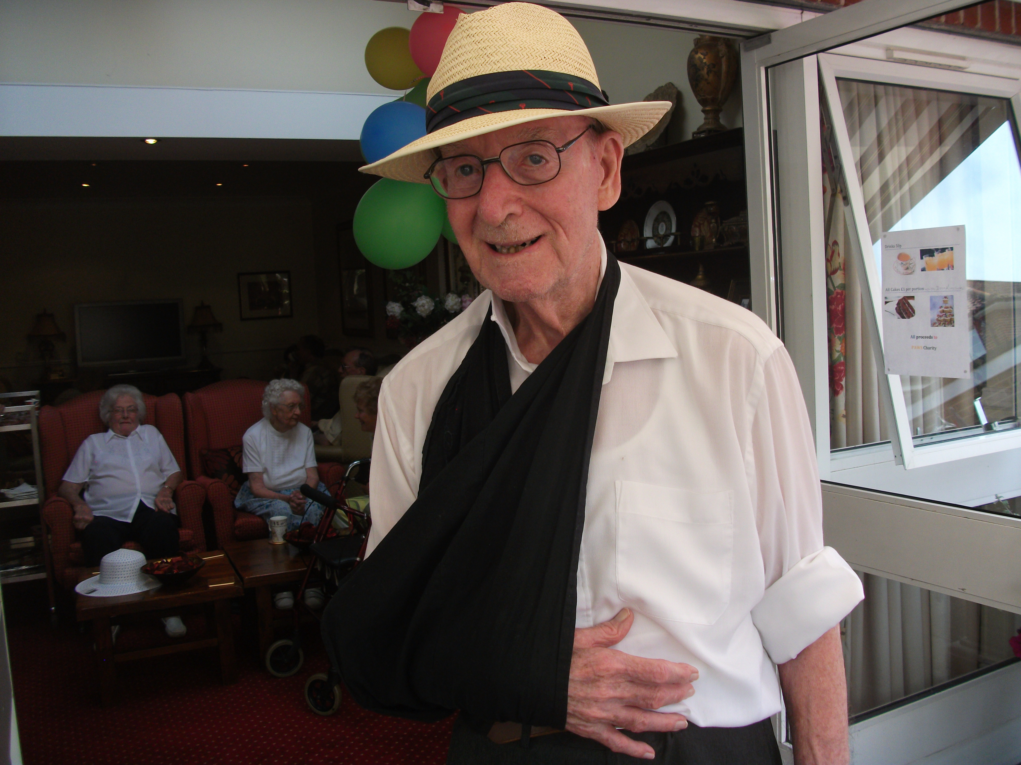

Entertainment and Outings

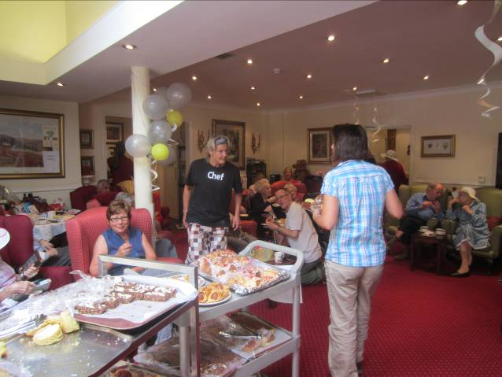
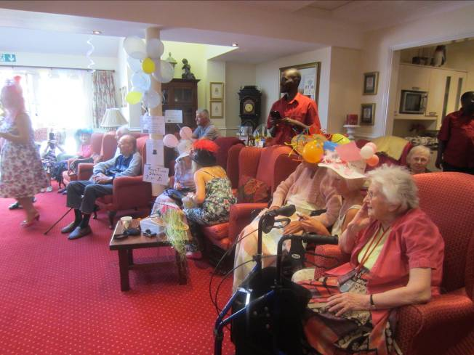
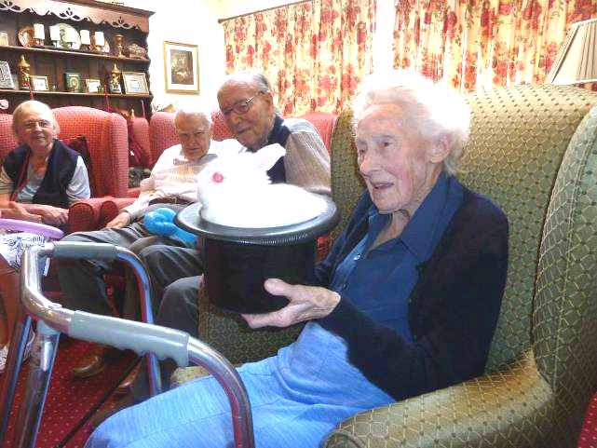
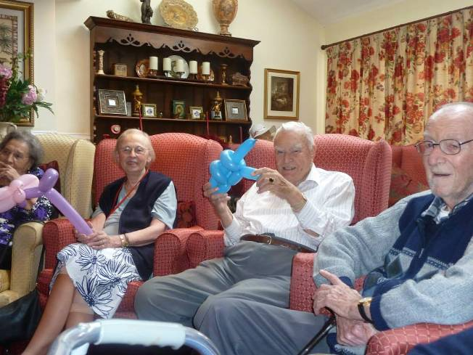
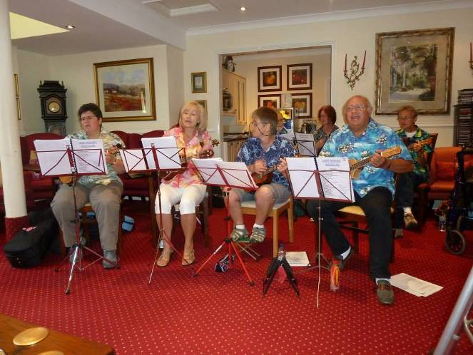
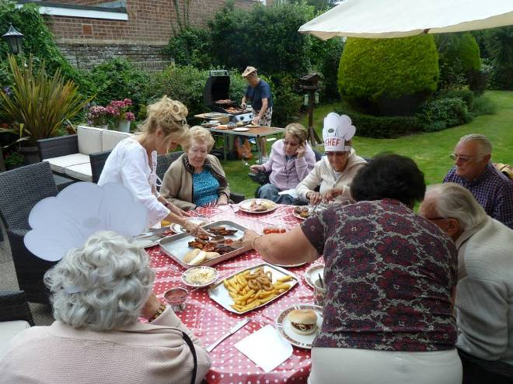
Page 3

Did you know?
Nothing whatsoever happened in British history between 3 and 13 September 1752. Find out why on page 7

Page 4

John’s Rhymes:

The Fair Ones
Marlene came to the Shelley fair
In party mode, I think,
She wore white trousers, flared a bit,
Or were they really pink?

Sherry had a stunning hat,  A marvelous creation,  With ribbons here and flowers there  To make the decoration.  Natasha's chosen outfit  Was all in blue and white  It suited to perfection  What more is there to write? | Beverley, who loves dressing up,  Wore none of her disguises  I thought she'd come as Goldilocks  But, sadly, no surprises.  Jeannette who loves a bit of fun  Wore a rosy summer frock  And she was working very hard  To make the party rock.
So there they are, the Fair Ones,
The Shelley beauty queens
They're really not a bad lot
If you know what middling means.

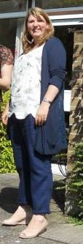
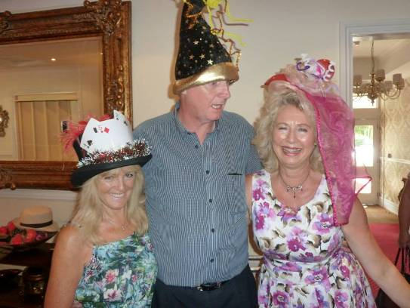
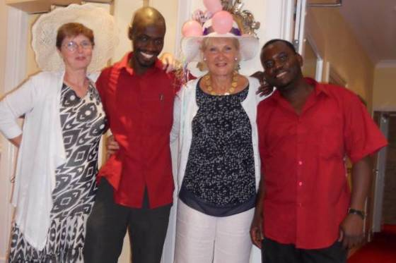

Page 5

Who Dunnit

King Richard III was a jolly fine chap
(Forget what Shakespeare said)
Who might have done old England proud
With the crown upon his head.
But up popped Horrid Henry
Who very quickly said:
"I'd rather like to be the king.
"I want that Richard dead."
They fought it out on Bosworth Field
A very messy do
Where Henry simply grabbed the crown
Then stuck to it like glue.
So now for history's poser
To ponder hour by hour:
Who really killed those princes
Then living in the Tower?
Was it Uncle Richard
Who liked the boys it’s known
Why would he kill his brother's sons
So very like his own?
Or was it Horrid Henry
Who all throughout his reign
Killed anyone who threatened him?
He really was a pain.
Of course we do not really know
And of course there is no need
But I think it was Henry
Wot done the horrid deed.

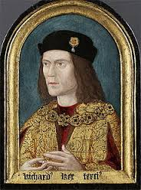

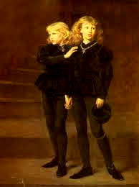
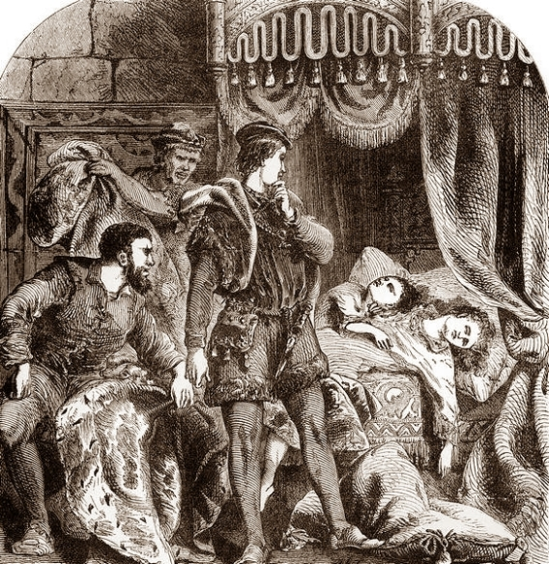

On the Beach

Page 6

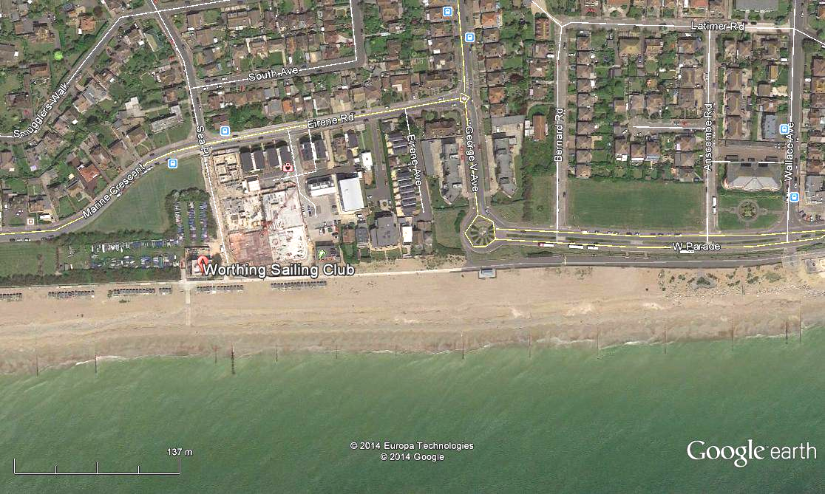



We have a beach hut, next to Worthing Sailing Club on West Worthing Beach with direct access from the car park and with a new paved area to facilitate access with a wheelchair; this hut will be able to be enjoyed by all!!

With comfortable seating areas inside and even a kettle to make a hot drink on those chilly days while enjoying the views.
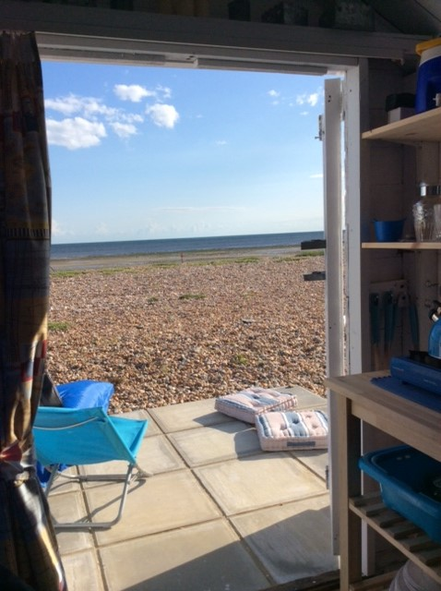


Page 7

11 Missing Days
The Gregorian calendar
The Gregorian calendar is the one most used nowadays. It is named after Pope Gregory Xlll who introduced it in 1582. There is a leap year every four years (or more precisely, 97 leap years every 400 years). This means that the year corresponds closely with the astronomical year (365.24219 days) so that it is just one day out every 3,300 years.

The Julian Calendar
Up until 1753, the calendar we used in Britain was the Julian Calendar. It was based on the solar year, the time it takes for the Earth to rotate around the Sun, and thus was less accurate than the Gregorian Calendar.

The Julian Calendar was 365.25 days long, which was fractionally too long, and the calendar over time fell out of line with the seasons.

All change Give us back our 11 days!
In 1752 Britain decided to correct this by abandoning the Julian calendar in favour of the Gregorian. By doing so, 3 September instantly became 14 September- and as a result, nothing whatsoever happened in British history between 3 and 13 September 1752.
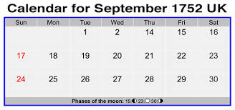

Many people believed their lives would be shortened. They protested in the streets, demanding Give us back our 11 days!

September Events

We also have many of our favourite entertainers and some new facesjoining us, such as:
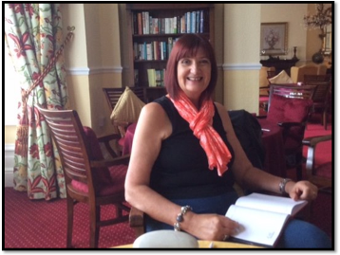

Richard Howell is coming to give us a talk on the 2nd and Gill, who will be coming to give a morning talk of “Favourite Poems” on the 4th.


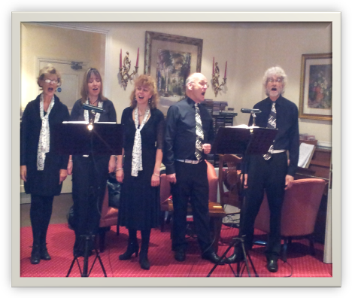
The 5th is also Fish n chip Friday and we have Sarah the violinist in the afternoon, followed by The Campbell singers in the evening.

Jo Claydon is joining us on the 6th, with her sing-along sessions which are enjoyed by many of you in the lounge.

The 12th and 13th will see the return of Frank King and Kerri respectively.

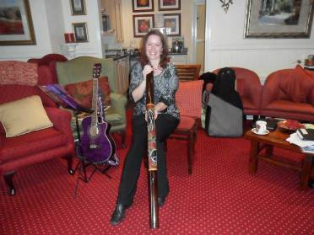
Becks is returning on the 16th, with GAPP on the 19thand

Tim West on the 20th.

Jo’n’Graham harmony singers will be here on the 27th and the Ratcliffe Brothers are coming on the 27th.
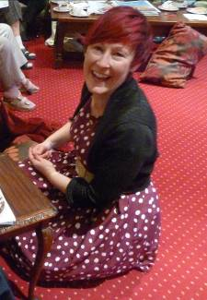

Finally, we have Pal’o’Mine on the 28th with Zoe performing for us on the last day of September

PLUS our regular..
Page 8

Yoga – Exercises with Nick / Roberta – Aromatherapy Manicures - Art with Anna / Eloise
Breathing Spaces - Outings in the mini-vans - Shopping Trips

Page 9
And finally


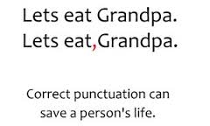
Our wonderful English language and how it can drive a scholar to distraction!

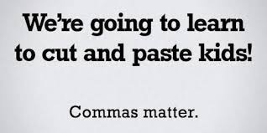

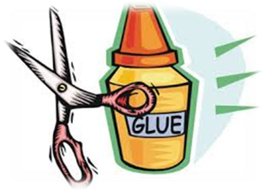

Why English is Hard to Learn:

We’ll begin with box; the plural is boxes
But the plural of ox is oxen, not oxes.
One fowl is a goose, and two are called geese,
Yet the plural of a moose is never called meese.

You may find a lone mouse or a house full of mice;
But the plural of house is houses, not hice.
The plural of man is always men,
But the plural of pan is never pen.

If I speak of a foot, and you show me two feet,
And I give you a book, would a pair be a beek?
If one is a tooth and a whole set are teeth,
Why shouldn’t two booths be called beeth?

If the singular’s this and the plural is these,
Shouldn’t the plural of kiss be ever called keese?

We speak of a brother and also of brethren,
But though we say mother, we never say methren.
Then the masculine pronouns are he, his and him;
But imagine the feminine…she, shis and shim!

Anonymous

Page 10

Keep these ‘informative’ emails coming Clare Bear, here is her latest – enjoy!

Punography
- I tried to catch some fog. I mist.
- When chemists die, they barium.
- Jokes about German sausage are the wurst.
- I know a guy who's addicted to brake fluid. He says he can stop any time.
- How does Moses make his tea? Hebrews it.
- I stayed up all night to see where the sun went. Then it dawned on me.
- I'm reading a book about anti-gravity. I can't put it down.
- I did a theatrical performance about puns. It was a play on words .
- This dyslexic man walks into a bra.
- I didn't like my beard at first. Then it grew on me.
- When you get a bladder infection, urine trouble.
- What does a clock do when it's hungry? It goes back four seconds.
- I wondered why the football was getting bigger. Then it hit me!
- Broken pencils are pointless.
- England has no kidney bank, but it does have a Liverpool .
- I used to be a banker, but then I lost interest.
- I dropped out of communism class because of lousy Marx.
- All the toilets in London police stations have been stolen. Police say they have nothing to go on.
- I took the job at a bakery because I kneaded dough. But I was told not to make buns; they are the lowest form of wheat.
- Velcro - what a rip off!
- Cartoonist found dead in home. Details are sketchy.
We’re on the Web!
Visit us: theshelley.com
Find us on Facebook: TheShelley Worthing
Read Our Newsletters: theshelleynewsletters.weebly.com/
Our Blog: theshelleyblog.weebly.com/
For Just Photos: theshelleyphotos.weebly.com/
Tweet us: #theshelley

The Shelley does not hold, nor claim to hold the copyright on any article or photograph found in print or on the Internet.

