The Shelley

Newsletter –August 2016

**The Shelley -** 54 Shelley Road, Worthing, West Sussex, BN11 4BX. t: 01903 237000 e: [info@theshelley.com](mailto:info@theshelley.com)

Children in Need

Celebrated by us this summer on

August 20th

See Page 11 for Details

### Inside This Issue

August 1

July in Pictures 2

Love them or Hate them? 5

John’s Rhymes 8

Entertainment 10

Olympics 12

Finally 16



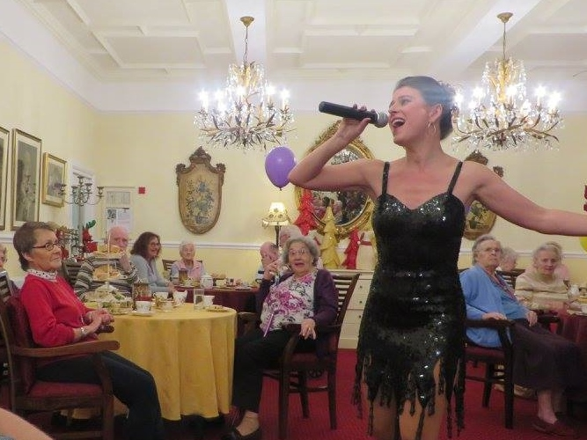

Superstar actress,

choreographer and singer

Julie Paton Stardust

back with us

Wednesday 3rd August

**August 5th – 21st**

**September 7th – 18th**

Like Marmite you either

love them or hate them

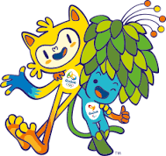



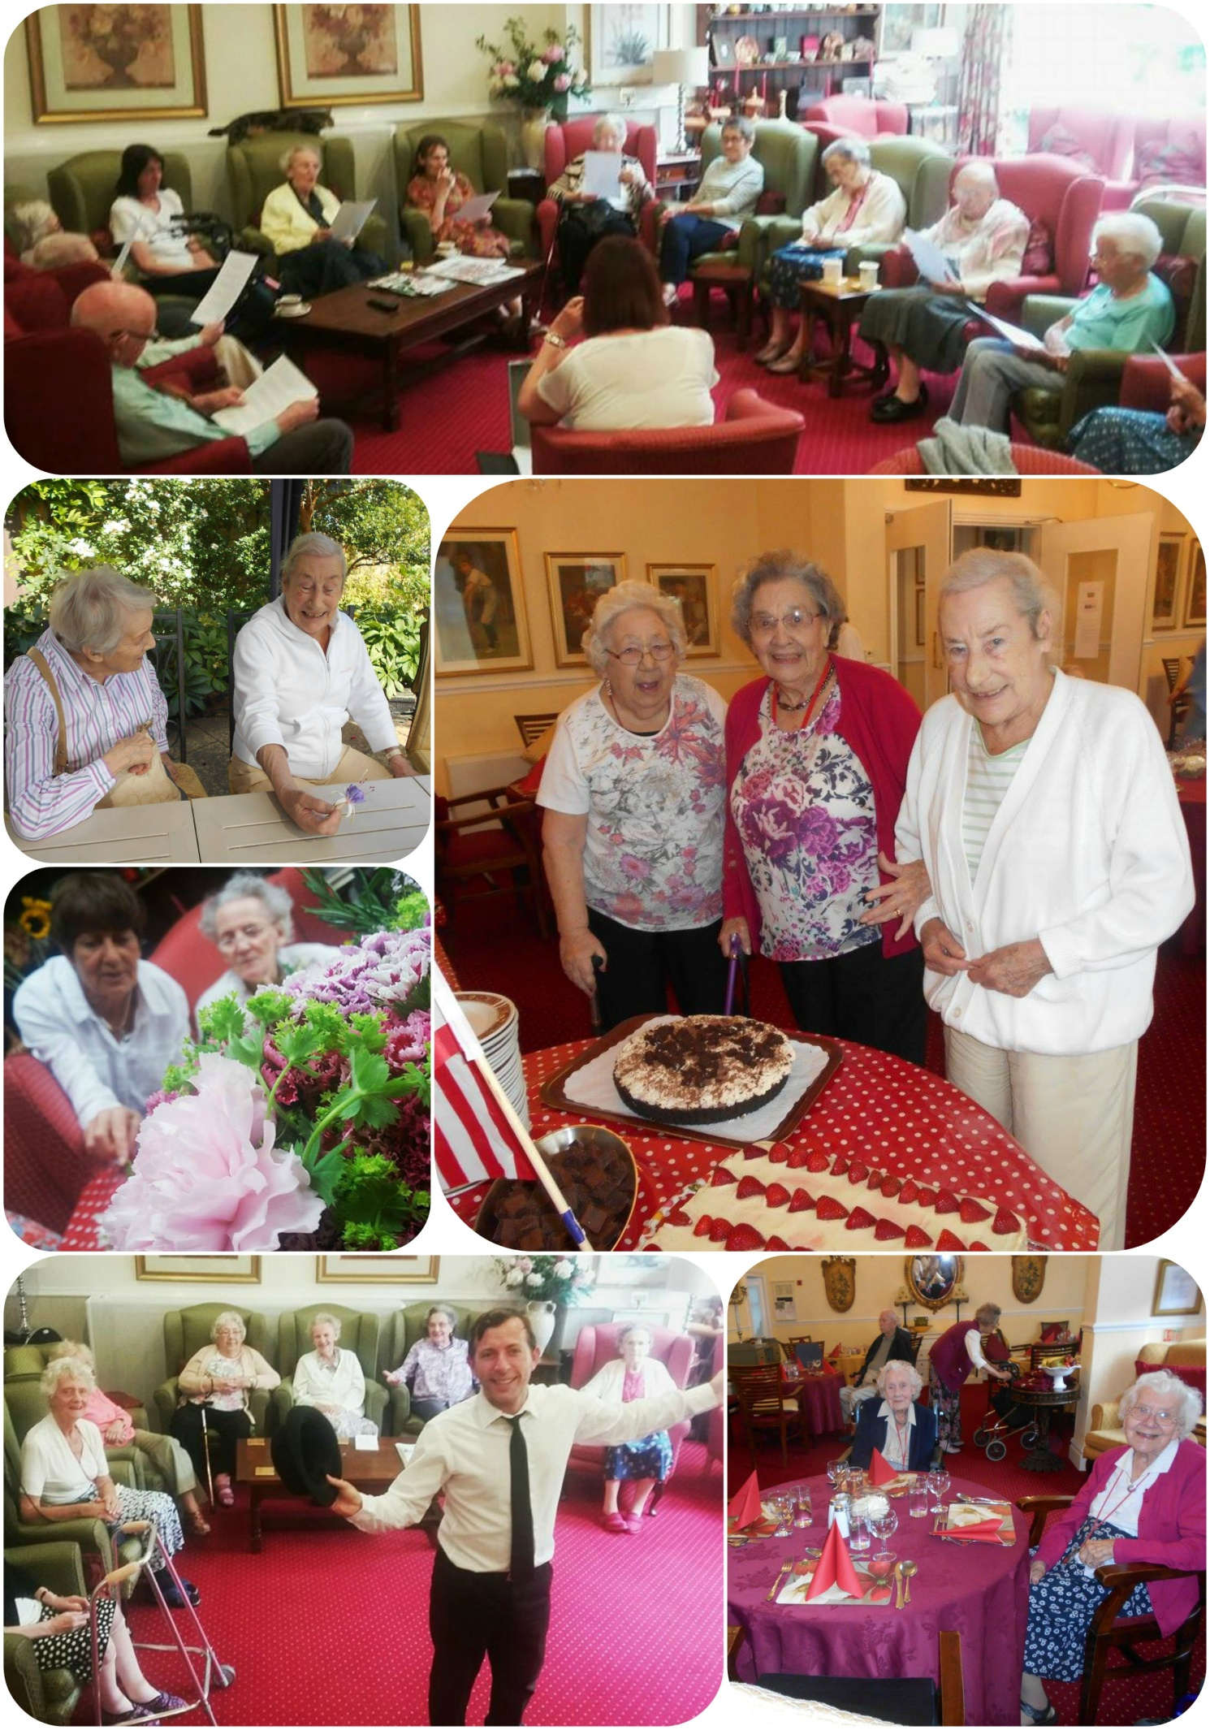

Page 2 July in Pictures



So much entertainment and fun – too many to include – many more on the hall screen though!

Page 3

Page 4 Summer Fayre

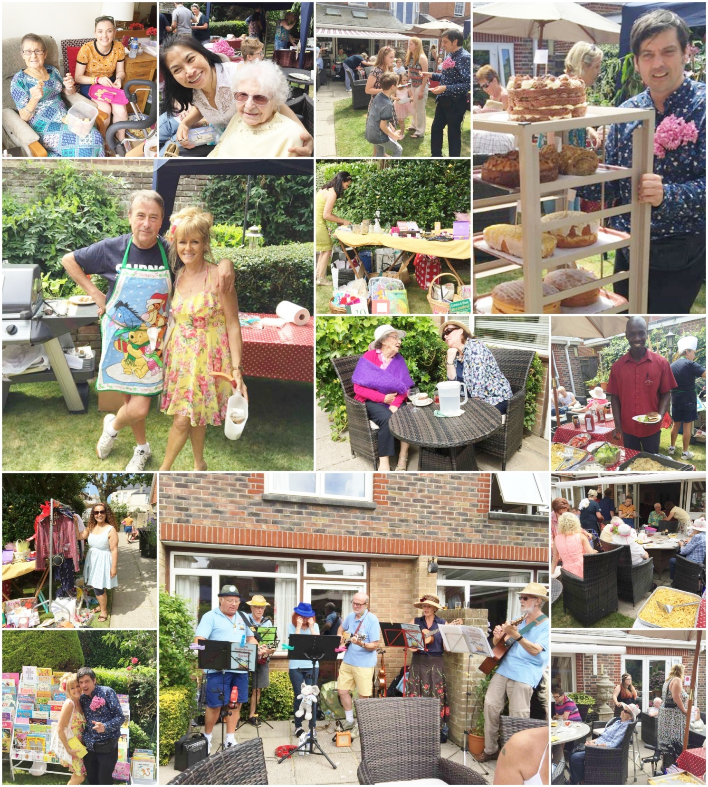Another succesful Summer Fayre – bringing together old, present and future residents and family and friends on one hot and sunny day of fun, laughter, music, stalls and games – oh, and never forgetting Rob’s BBQ food and chefs cakes and BBQ sides!

Page 5 The History of Garden Gnomes

What is the story behind them? Why did people start setting out statues of these tiny men with beards and pointy red hats? Why are the hats red?

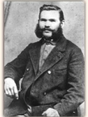 Although small gnome statues began appearing in Europe in the early 1600s, the garden or lawn gnomes as we know them appeared in Germany in the mid - to late 1800s when German sculptor and potter **Phillip Griebel** (seen here) started a business moulding ceramic into lifelike busts of animals, a fashionable home and garden decoration at the time. Inspired by the gnome myths of his home (GrÃfenroda, Thuringia), he began fashioning small, pointy-hatted ceramic gnomes for gardens; the first gnome went to market in Leipzig in 1884 and was an instant success.

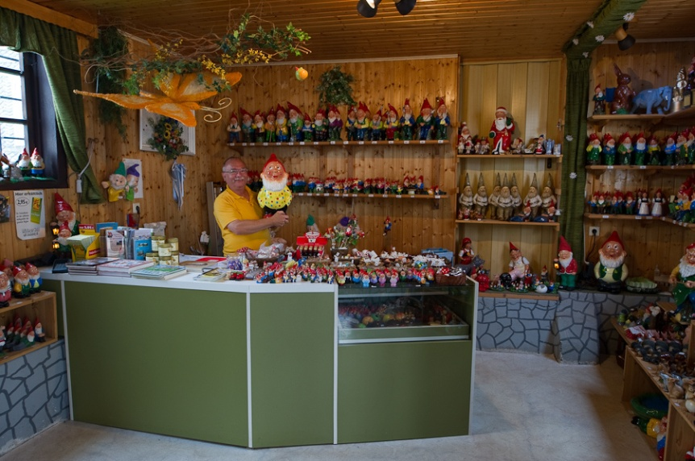 The gnome was used because local myths suggested that underground gnomes came alive at night to work in the garden and protect the gardens from evil sorcery. From Germany, garden gnome popularity quickly spread throughout Europe to France and England, and eventually the statues made their way into gardens in North America.

Production was halted during World War II, and following the fall of the Nazis, garden gnomes were banned briefly as the German Democratic Republic rose to power in East Germany. Still, the gnomes managed to pull through and Griebel's garden gnome dynasty exists even now, although in a much diminished capacity, owing to the cheap labor and even cheaper materials coming out of China and Eastern European markets.

Page 6

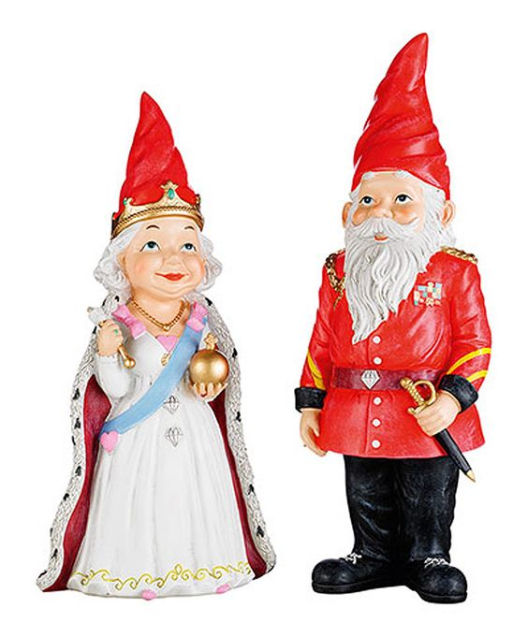 Nowadays gnomes are found in endless poses hands on hips; pushing a wheelbarrow; or holding open his robes to reveal his naughty bits and even copy famous celebrities, politicians and recently, the royal family!

Red hats

Apparently Mediterranean fishermen used to wear white hats at night if they wanted to be seen, and red hats if they did not. Gnomes almost never want to be seen.

Discrimination

This year the Royal Horticultural Society, which runs the Chelsea Flower Show lifted a 100-year-ban on garden gnomes.

Garden Gnome Fun Facts

* 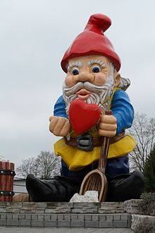There are 25 million garden gnomes in Germany today. While garden gnome production began in Germany, most are made in Poland or China today.
* The largest garden gnome in the world sits in Poland and is almost 18 feet tall.
* Those who reject these figurines in the garden are often seen as garden snobs.

Page 7

* “Gnoming” is the practice of stealing garden gnomes as a prank. In France, the “Garden Gnome Liberation Front” would “free” garden gnomes from forced garden labor by sending them back into the wild or by sending them on trips around the world.
* The travelling gnome prank involves stealing a gnome and photographing it in front of famous places, such as Big Ben in London, and then sending the photographs to the previous owner.
* Each year at the Inman Park Festival in Atlanta, Georgia, marchers dress up as garden gnomes to try to break the Guinness World Record of the most marching gnomes. Britain currently holds the world record with 478 marching gnomes.
* 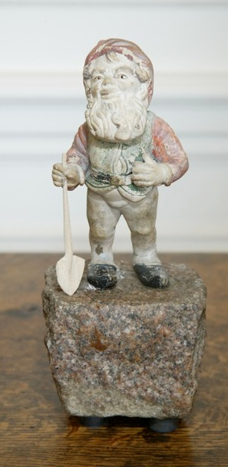A home insurance company said: “Though gnomes are much lower in value than other garden items, often it is those belongings that are one of a kind or sentimental in value that cause us most distress if they are stolen. One in five households report thefts from their garden, it’s better to be safe than sorry and we’d always advise homeowners to lock away any items that can be easily stolen at night or when you go away.”
* One gnome that is under lock and key is Lampy - the world’s oldest gnome. Brought to the UK from Germany in 1847 by English eccentric Sir Charles Isham it is said to be worth £2 million. He was re-discovered in the grounds of  Lamport Hall in Northamptonshire after the Second World War and was the only survivor of 21 gnomes that were imported in the 1840s.

Page 8 John’s Rhymes

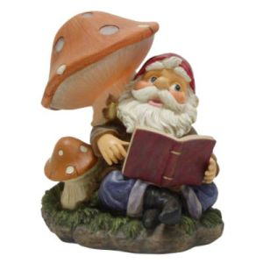Dolly  
  
We're sitting in the garden  
Beneath the sunshine brolly  
I'd really like to have a snooze,  
But no, here comes the trolley.

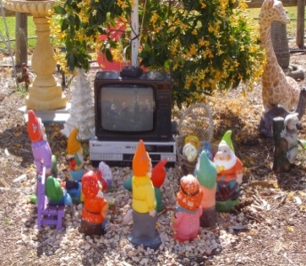We're doing arts and crafts today  
And making something jolly  
I'm not quite sure what it is  
Oh good! Here comes the trolley.

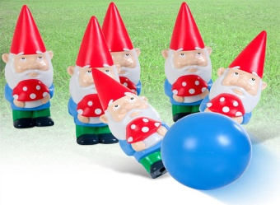  
We're watching someone on the box  
He really is a Wally  
It's time that they got rid of him  
Oh good! Here comes the trolley.

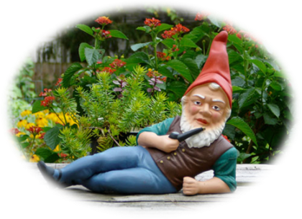  
Now we're doing crosswords  
A six-letter word for Polly  
I have no idea what it is  
Thank goodness for the trolley.

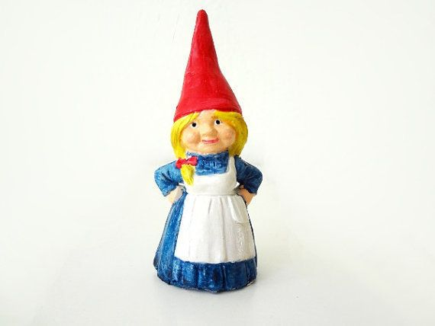  
Today we're playing skittles  
I whiz one down - oh golly!  
I think I've hit poor Beverley  
Oh! Where's that blessed trolley.

Who will bring our tea today?  
I think her name is Molly.  
She is the fairest of them all  
She is the trolley dolly.

Page 9

|  |  |
| --- | --- |
| I'd like to have an outing In the Shelley minibus Of course I might not like it Try not to make a fuss.  I'd like to have an outing And see the sea again I like to make sure that it's still there And if it's gone - what then.  I'd like to have an outing  To somewhere far away P'raps we could go to Bognor Once went there for the day.  C:\Users\sherr\Desktop\ALL Shelley\01Photos\2016\07 July\untitled.png | I'd like to have an outing See Cutty Sark again Beverley says she'll take me But she never does say when.  http://sobreinglaterra.com/wp-content/uploads/2009/05/cutty-sark.jpgI'd like to have an outing See trees and fields and all. The builders want to grab the land For a lovely shopping mall.  I'd like to have an outing Where shall we stop to eat? Not interested in tea and cakes Let's have a Chinese feast. |
| http://www.cornwall-online.co.uk/towns/towns1.jpgI'd like to have an outing To the place that I like best. Of course we might not get there Though we could always take a rest.  Some Entertainment Coming This Month | |

As well as our weekly outings in the mini-van or walk/ride to the shops/parks etc. we also have many of our favourite entertainers joining us, such as:

Page 10 Entertainment

*1ST – Lizzie & Tony - Singers*

*2nd – Informative talk with Roger*

*3rd – Julie Paton Stardust*

*5th – Tim West Singer/Guitarist*

*6th  - Pianist - Lucy*

*7th – Bertie Boater*

*13th – Bing - Accordionist*

**PLUS OUR USUAL**

Yoga – Exercises – Aromatherapy – Manicures

Pampering Afternoons – Art and Crafts – Communion

Breathing Spaces - Outings in the mini-van - Shopping Trips

*15th – Mark with his Mobile Piano*

*16th – Zoe - Alive*

*18th – Geoffrey James - Singer*

*20th – Children In Need Event Afternoon(see info on page 11)*

*Campbells at 7pm*

*21st – Richard – Singer/Pianist*

*24th – Linda - Pianist*

*30th – Skittles with Nick*

Page 11

**CHILDREN IN NEED FUNDRAISER**

**SATURDAY AUGUST 20th from 2.30pm**

**THE SHELLEY RESIDENTIAL HOME,**

**54. SHELLEY ROAD, WORTHING**

** **

**CAKE SALE in DINING ROOM ALL AFTERNOON**

**RAFFLE TABLE in DINING ROOM - RAFFLE TO BE CALLED AT 4.15pm**

**FACE PAINTING FROM 2.00pm with SHIRLEY**



**CHLOE doing “SAND ART” at 3.30 -4.30pm  - £5.00 per picture – children & adults**

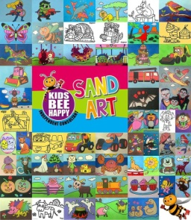

**" COASTLINE HARMONY" ENTERTAINING US at 3.00pm** in the lounge and lead **"THE SHELLEY SUNSHINE SINGING GROUP"** into song as we sing our children in need song **"I'D LIKE TO TEACH THE WORLD TO SING"**

**WE ARE FILMING OUR REDITION OF I'D LIKE TO TEACH THE WORLD TO SING & SENDING IT TO THE BBC FOR SUBMISSION TO THEM FOR THE TV NIGHT ON FRIDAY 18TH NOVEMBER, SO YOU MIGHT SEE US THERE TOO !!!**

Page 12 Summer Olympics

**According to historical records, the first ancient Olympic Games can be traced back to 776 BC. They were dedicated to the Olympian gods and were staged on the ancient plains of Olympia. They continued for nearly 12 centuries, until Emperor Theodosius decreed in 393 A.D. that all such "pagan cults" be banned.**

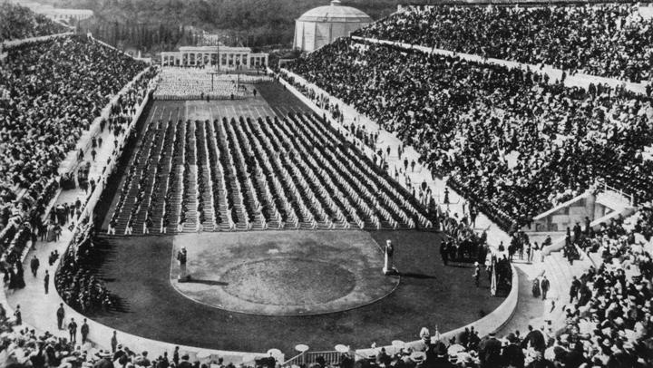The 1896 Summer Olympics, officially known as the Games of the Olympiad, was an international multi-sport event which was celebrated in Athens, Greece, from 6 to 15 April 1896. It was the first Olympic Games held in the Modern era.

The Olympics have increased in scope from a 42-event competition with fewer than 250 male competitors from 14 nations in 1896 to over 300 events with around 11,000 competitors.

Eighteen countries have hosted the Summer Olympics. The United States has hosted four Summer Olympics (1904, 1932, 1984, and 1996), more than any other nation, and Great Britain has hosted three Summer Olympics (1908, 1948, and 2012), all in London. Three cities have hosted two Summer Olympics: Los Angeles (1932 and 1984), Paris (1900 and 1924), and Athens (1896 and 2004).

The only Olympics held in the Southern Hemisphere so far have both been in Australia (Melbourne 1956 and Sydney 2000). This year Rio de Janeiro will host the first Summer Games in South America and the first Summer Games held during the local winter season.

Five countries – Greece, Australia, France, Great Britain and Switzerland – have been represented at all Summer Olympic Games. The only country to have won at least one gold medal at every Summer Olympic Games is Great Britain. The United States leads the all-time medal table.

Page13

*Who Are We?*

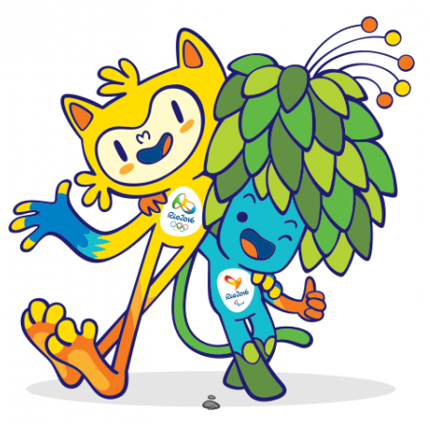

I am Tom the Paralympic Games mascot, a magical creature. I am a fusion of the entire flora in the Brazilian forests.

I am Vinicius the Olympic Games mascot, a mixture of all the Brazilian mammals.

We were born out of the explosion of happiness when  
we found out that the Paralympic Games were coming to Rio.

The names pay tribute to Brazilian musicians Vinicius de Moraes and Tom Jobim. They were part of the group that created Bossa Nova, the musical movement that got the whole world singing about the beauty of Rio de Janeiro.

Together, De Moraes and Jobim wrote *The Girl from Ipanema*, one of the most-played songs of all time.

*Rio 2016 Olympic Village*

*The following two pages consist of a guide of events – heats and medal ceremonies*

Page 14

|  |  |  |  |
| --- | --- | --- | --- |
|  | EVENT | HEATS | MEDAL CEREMONIES |
| p | **Archery** | 5th, 8th, 9th, 10th | 6th, 7th, 11th, 12th |
| http://olympic-museum.de/pictograms/2016/artistic_gymnastics.png | **Artistic Gymnastics** | 6th, 7th | 8th to 11th and 14th to 16th |
| https://upload.wikimedia.org/wikipedia/en/c/c5/Athletics,_Rio_2016.png | **Athletics** |  | 12th to 21st |
| http://www.rio2016.com/sites/all/themes/rio2016_v2/img/pictos/pt/olimpicos/118/seixo/azul/badminton.png | **Badminton** | 11th to 15th | 16th to 20th |
| p | **Basketball** | 6th to 19th | 20th and 21st |
| p | **Beach Volleyball** | 6th to 16th | 17th and 18th |
| https://upload.wikimedia.org/wikipedia/en/c/cf/Boxing,_Rio_2016.png | **Boxing** | 6th to 13th | 14th to 21st |
| Canoeing (Slalom), Rio 2016.png | **Canoe Slalom** | 7th and 8th | 9th to 11th |
| Canoeing (Sprint), Rio 2016.png | **Canoe Sprint** | 15th, 17th, 19th | 16th, 18th, 20th |
| p | **Cycling BMX** | 17th and 18th | 19th |
| https://upload.wikimedia.org/wikipedia/en/thumb/5/51/Cycling_(Mountain),_Rio_2016.png/140px-Cycling_(Mountain),_Rio_2016.png | **Cycling Mountain Bike** |  | 20th and 21st |
| p | **Cycling Road** |  | 6th, 7th, 10th |
| p | **Cycling Track** |  | 11th to 16th |
| p | **Diving** | 12th, 13th, 15th, 17th, 19th | 7th to 10th , 14th, 16th, 18th, 20th |
| p | **Equestrian** | 6th to 8th, 10th, 11th, 14th, 16th | 9th, 12th, 15th, 17th, 19th |
| p | **Fencing** |  | 6th to 14th |
| p | **Football** | 3rd, 4th, 6th, 7th, 9th, 10th, 12th, 13th, 16th, 17th | 19th and 20th |
| p | **Golf** | 11th to 13th and  17th to 19th | 14th and 20th |
| p | **Handball** | 6th to 19th | 20th and 21st |
| p | **Hockey** | 6th to 17th | 18th and 19th |
| p | **Judo** |  | 6th to 12th |

Page 15

|  |  |  |  |
| --- | --- | --- | --- |
|  | EVENT | HEATS | MEDAL CEREMONIES |
| p | **Marathon Swimming** |  | 15th and 16th |
| p | **Modern Pentathlon** | 18th | 19th and 20th |
| p | **Rhythmic Gymnastics** | 19th | 20th and 21st |
| p | **Rowing** | 6th to 9th | 10th to 13th |
| http://olympic-museum.de/pictograms/2016/rugby.png | **Rugby Sevens** | 6th, 7th, 9th, 10th | 8th and 11th |
| p | **Sailing** | 8th to 13th | 14th to 18th |
| http://olympic-museum.de/pictograms/2016/shooting.png | **Shooting** |  | 6th to 14th |
| p | **Swimming** |  | 6th to 13th |
| p | **Synchronised Swimming** | 14th, 15th, 18th | 16th and 19th |
| p | **Table Tennis** | 6th to 9th and  12th to 15th | 10th, 11th, 16th,17th |
| p | **Taekwondo** |  | 17th to 20th |
| p | **Tennis** | 6th to 11th | 12th to 14th |
| p | **Trampoline Gymnastics** |  | 12th and 13th |
| p | **Triathlon** |  | 18th and 20th |
| p | **Volleyball** | 6th to 19th | 20th and 21st |
| p | **Water Polo** | 6th and 8th to 18th | 19th and 20th |
| p | **Weightlifting** |  | 6th to 10th and 12th to 16th |
| p | **Wrestling** |  | 14th to 21st |

*Next month we will include a list of events for the Paralympics*

Page 16 Finally

**

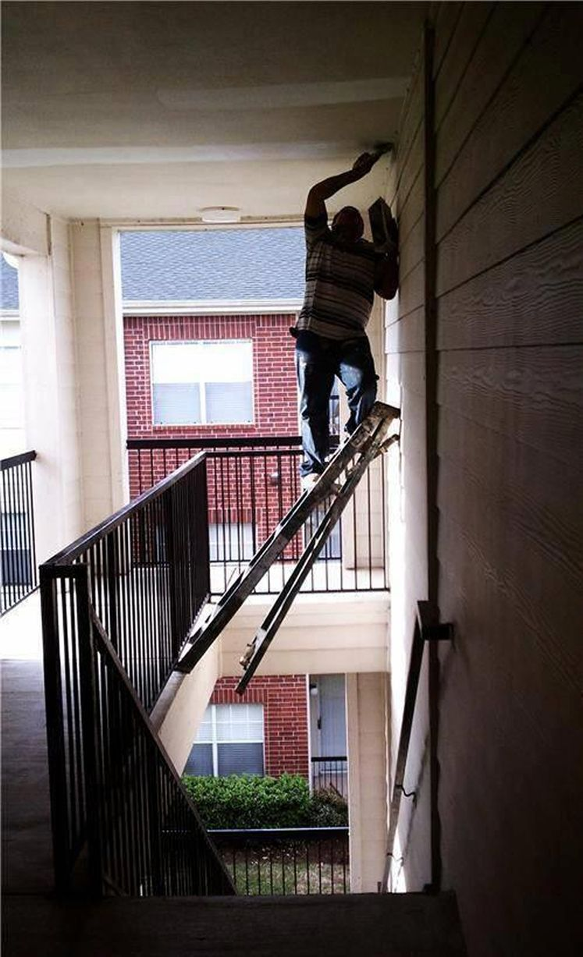

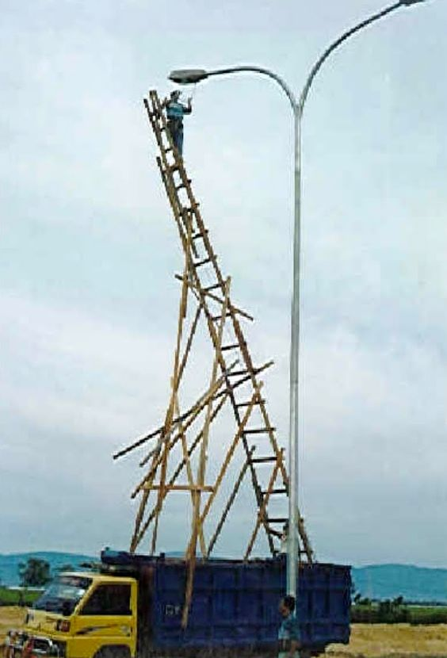

Some people have either never heard of the “Bee” Safe or the “Elf” and safety laws or think they are invincible!

***We’re on the Web!***

*Visit us:* theshelley.com

*Find us on Facebook:* TheShelley Worthing

*Read Past Newsletters:* theshelleynewsletters.weebly.com/

*For Just Photos:* theshelleyphotos.weebly.com/

*The Shelley does not hold, nor claim to hold the copyright on any article or photograph found in print or on the Internet.*