The Shelley
Newsletter –July 2016

The Shelley - 54 Shelley Road, Worthing, West Sussex, BN11 4BX. t: 01903 237000 e: info@theshelley.com

Inside This Issue
July 1
June in Pictures 2
Queen’s Tea Party 4
Beach Huts 5
John’s Rhymes 7
Entertainment 10
And Finally 11

On July the 23rd
we celebrate our
Annual Charity
Summer Fayre!

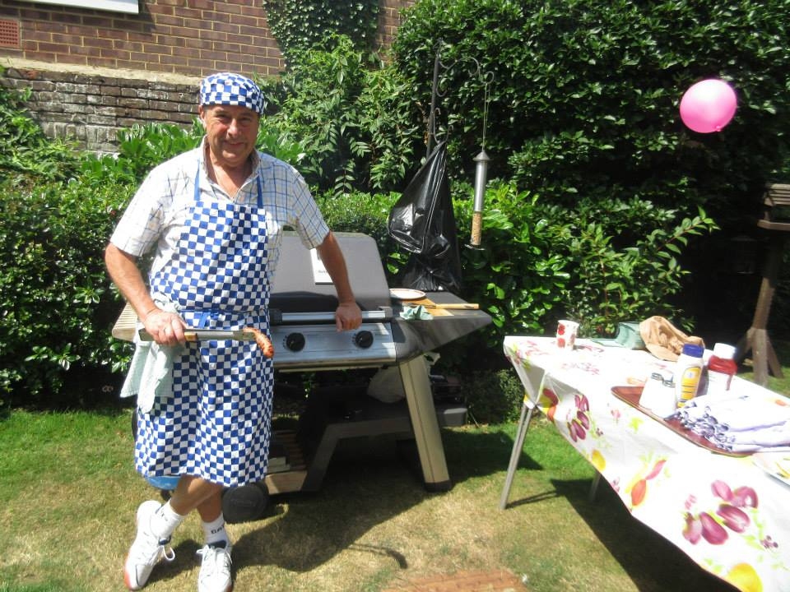

This year the Theme is
“Flowers”
Join us, dressed in flowery tops, bottoms, hats, shoes......
Everyone welcome!

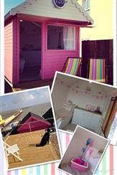

Football comes to an end and Wimbledon is well under way. We will be consuming Strawberries and cream washed down with a good dose of Pimm’s!

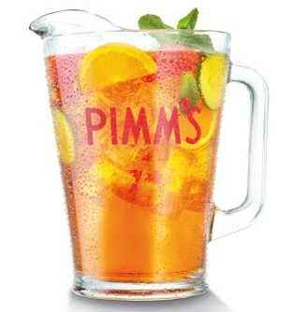

Page 2 June in Pictures

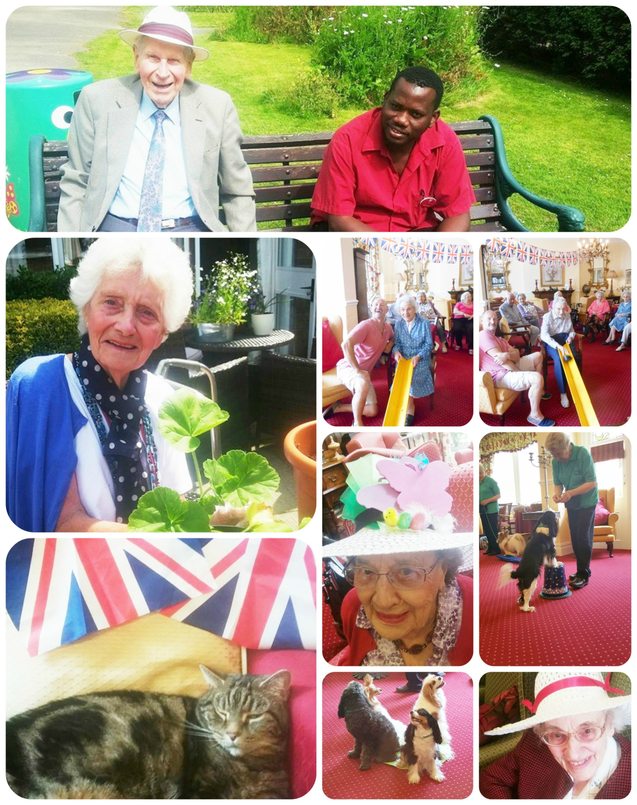

Page 3

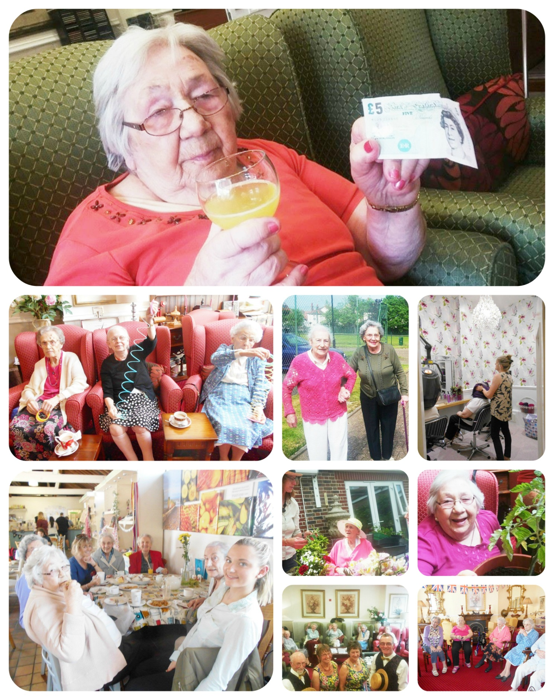

Page 4 Queen’s Tea Party

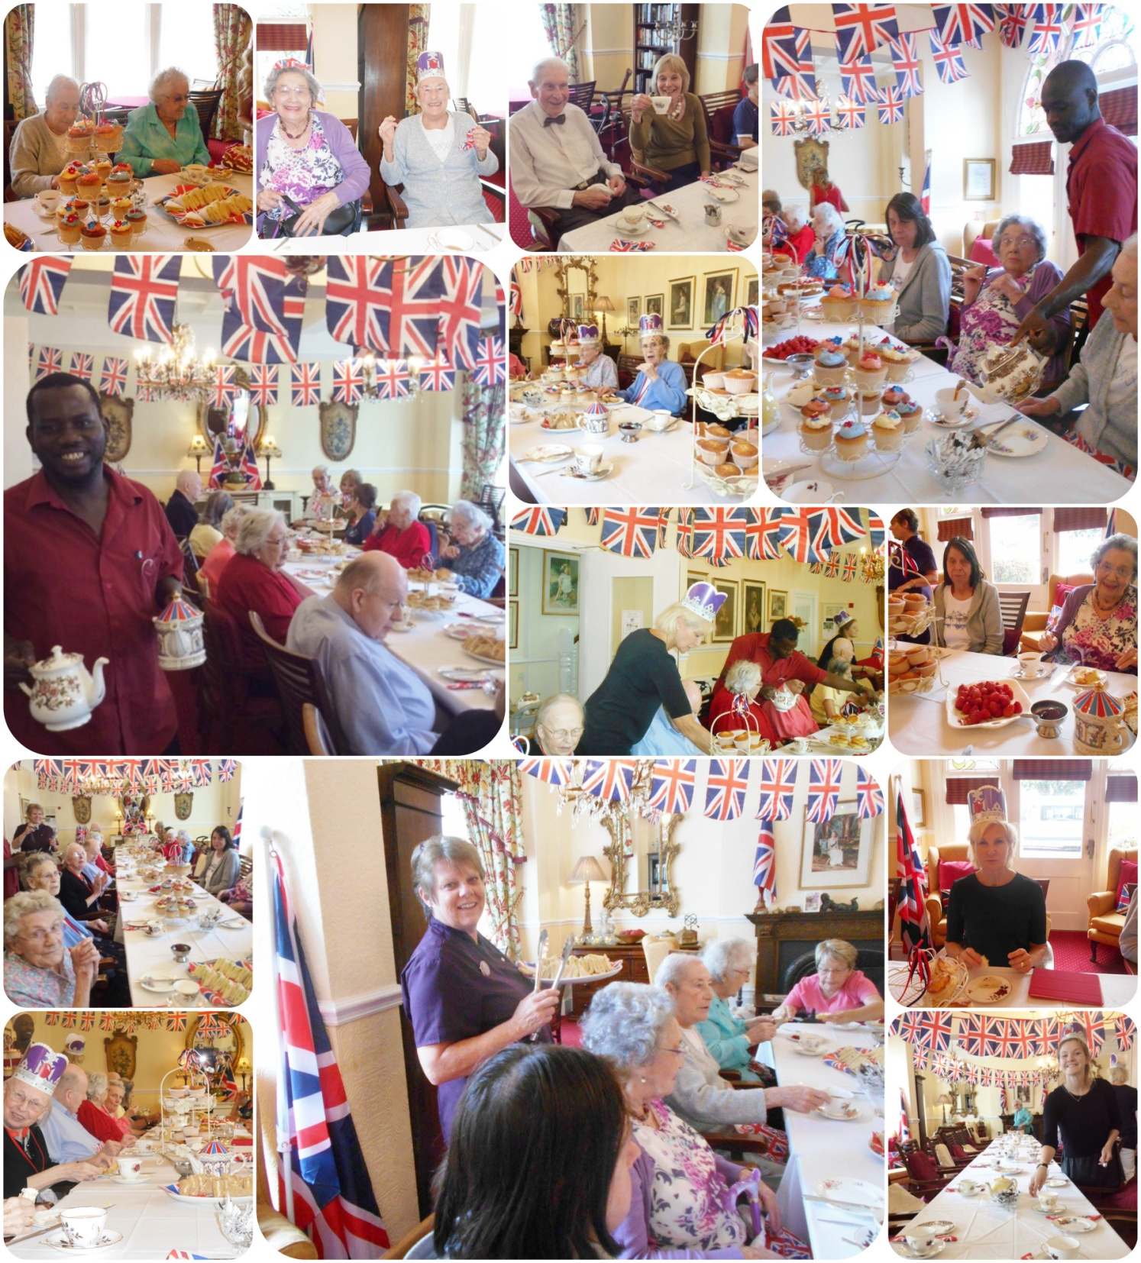
The whole country celebrated the Queen’s 9th birthday (again) with a Tea Party.
Due to inclement weather, we held ours in the dining room and great fun was had by all.

Page 5 Beach Hut Story

The story of beach huts was a recycling idea.

Beach huts were at first converted bathing machines that had their wheels removed, old fishermen's huts, or boatsheds.

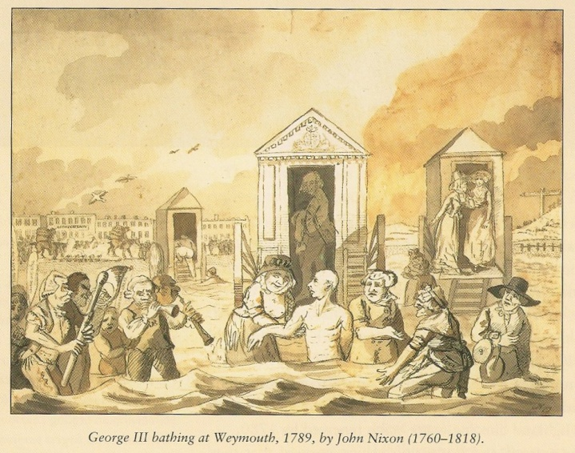
In 1789 George III gave royal approval to the new fashion when he took a medicinal bath at Weymouth to the musical accompaniment of ‘God Save the King’.

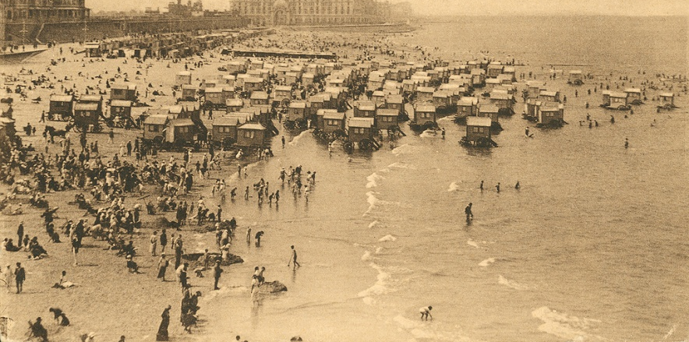
Mobile changing rooms were in use at Scarborough, the world’s first seaside resort located on the east Yorkshire coast. These simple vehicles, designed for the use of the wealthy but infirm, were evidence of a radical new fascination with the sea. Before this, no one but fishermen and smugglers used the beach. Then doctors began to prescribe the cold sea bath as the latest ‘cure-all’ remedy, the sick went to the coast to be treated and took their families with them. These people needed accommodation and entertainments so the modern concept of the seaside was born.
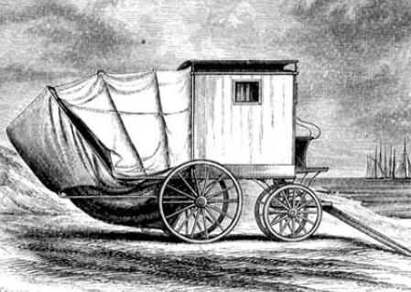
It wasn’t long after this that the bathing ‘machine’ was invented to offer greater privacy to those taking a therapeutic dip. In its original form this horse drawn carriage featured an enclosed room with a collapsible hood at the seaward end to shield patients as they were submitted naked to the waves by burly attendants called dippers.
In the Edwardian era and in the years following the First World War, the sight of people of both sexes in bathing costumes had become acceptable. However, changing in public was frowned upon and could result in a fine, even if decency was preserved under a Macintosh - so called "Macintosh Bathing". Hence councils provided and charged for beach huts to change in.
Page 6

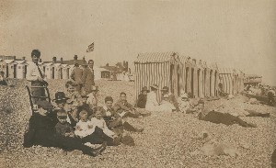
Enterprising people made use of the abandoned bathing machines by removing the wheels and turning them into beach huts. As an alternative to the beach hut, some seaside towns provided tents for hire, along with deck chairs. These were often brightly coloured and decorated with stripes.
Now you can buy your own beach hut or hire one for the day or a week. They make a great base for a family on a beach holiday.
At many seaside resorts, beach huts are arranged in one or more rows along the top of the beach. Depending upon the location, beach huts may be owned privately or may be owned by the local council or similar administrative body. On popular beaches, privately owned beach huts can command substantial prices due to their convenient location, out of all proportion to their size and amenity.
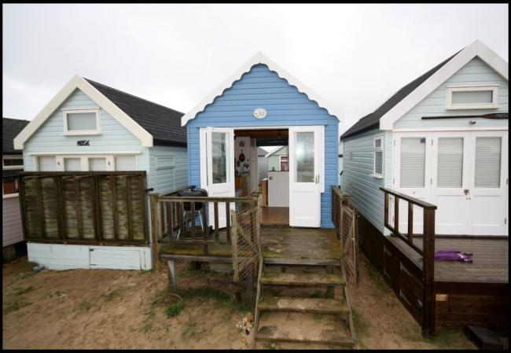
A pre-war wooden beach chalet at West Bexington, Dorset sold at auction for £216,000 in 2006, and a beach hut on Mudeford Spit sold for £170,000 in 2012.

In November 2015 this hut went up for sale for £250.000 The hut, which has just 138sq ft of accommodation, comes with spectacular sea views in an enviable position on remote Mudeford Spit in Christchurch.

The simple timber cabin has a fitted kitchen – although no running water – and can sleep six adults. It has a supply of electricity via solar panels on the roof.
However these were exceptional as in both cases overnight stays were possible.
Prices in 2009 for typical huts around the UK started from £6,000 in Walton on the Naze and typically up to £35,000.
Today there are believed to be around 20,000 beach huts in the U.K.

Page 7 John’s Rhymes

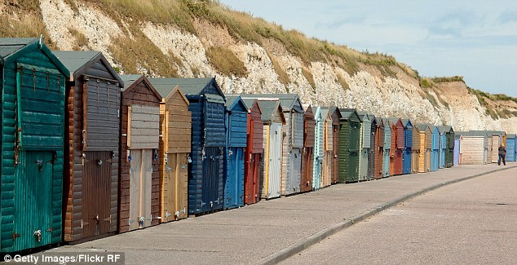
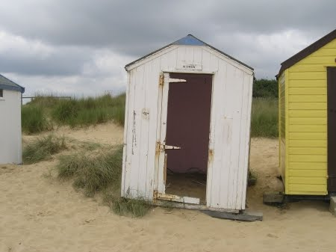
Beach Huts
I'd like to move the beach huts
Several feet into the sea
Then folk would have to paddle
When invited out to tea.
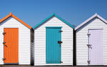
But then of course the question
Which way would they face?
Would they look back to the beach
Or face that strange French place?
I think perhaps the beach is best
Then we could have some fun
Seeing what they're up to
With a Thermos and a bun.
It really would be better
Than looking at their backs
When you walk along the front just now
It's like a row of shacks.
You can hardly see the sea at all
Just these awful wooden houses
And really they're no use at all
Hardly big enough for mouses.
And yet I'm told they cost a bomb
I can't imagine why
I wouldn't give you tuppence
Till the day that all pigs fly.

Bargain £40,000

Beach Hut

Page 8

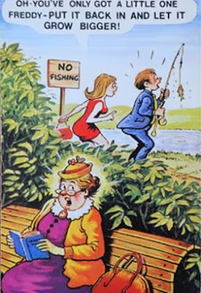
I am a seaside postcard
And a saucy one at that
There's going to be some fun and games
When I land upon the mat.

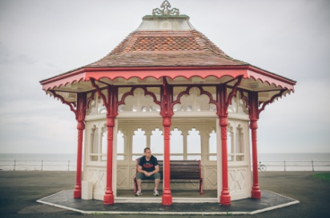

I am seaside shelter
To keep off wind and rain
Sometimes people sleep in me
Which really is a pain.

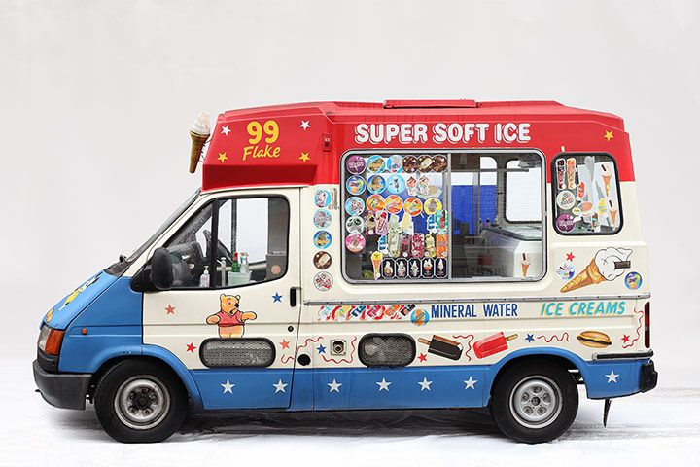
I am a seaside ice cream van
Children crowd to get the stuff
And whenever I run out of it
They run off in a huff.

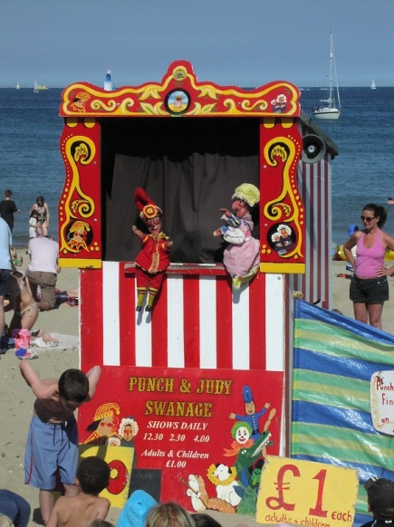

I am a seaside Mr Punch
Heading for the rocks
People don't think much of me
They'd rather watch the box.
.

Page 9

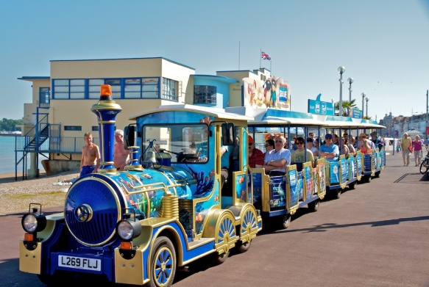
I am a seaside road train
Chugging on the front
And when I have to turn around
There really is shunt

I am a seaside deck-chair
To go with others on the sand
And sometimes people sit on us
And sometimes they hold hands.

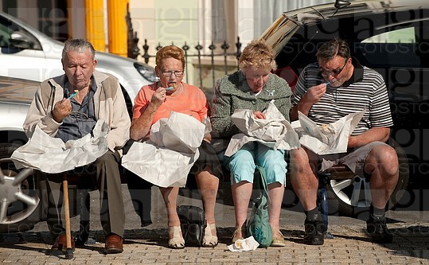
I am seaside chip shop
Fish as well of course
People come in starving
You would think they'd eat a horse.

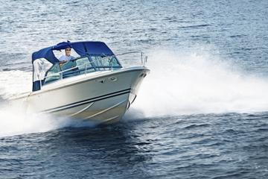
I am a seaside swimming pool
Can't see the reason why
People come to swim in me
When the sea is just hard by
I am a seaside speed-boat
My business name is Flash
But if you come and ride in me
You'll find it should be Splash.

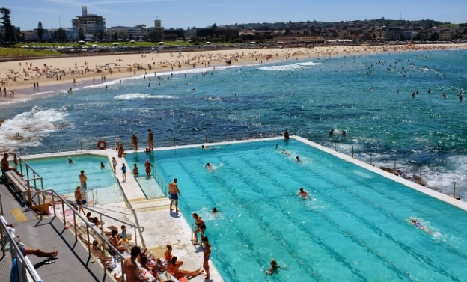

Page 10 Entertainment

Some Entertainment Coming This Month
As well as our weekly outings in the mini-van or walk/ride to the shops/parks etc. we also have many of our favourite entertainers joining us, such as:

1ST – Fish n Chip Friday and
Amaryllis (Nelson Vanguard Production)
5th – Sandgate Singers
7th – Poetry with Gill in the morning
Rocky road Duo in the afternoon
8th – Dean Ager (Rat Pack Style)
9th - Residents Meeting
And Strawberry Tea Afternoon (Final Ladies Wimbledon)
10th – Pimms & Strawberry Afternoon (Final Men’s Wimbledon)
11th – Art Class with Trishie
PLUS OUR USUAL
Yoga – Exercises – Aromatherapy – Manicures
Pampering Afternoons – Art and Crafts – Communion
Breathing Spaces - Outings in the mini-van - Shopping Trips
13th – Mark with his Mobile Piano
14th – Singer Nathan
15th - Violinist Sarah
18th – Crafts with Eloise
19th – Singer, Jonathan Nulty
22nd – John Beever, Keyboard
23rd – Our Annual charity Summer Fayre
25th Magic with Robbie
29th – New Dimensions

For the many of you who have not joined Facebook – here are a few of the many daily quotes, comments and funnies posted there.

Page 11 Finally

General practice is getting busier and busier, GPs find it harder to spend time with patients who genuinely need help and have less time with patients with chronic disease.
Here are some examples of non-urgent or no needs to speak to a doctor.
“I went to the gym yesterday and now my arms are hurting.”
“My son’s shoes are rubbing him.”
“Doctor, my stomach makes this weird rumbling/gurgling noise whenever I haven’t eaten. It’s starting to affect my work.”
“I’m worried about a white lump in my baby’s gum.” (It was a tooth).
“When I drink certain types of beer I vomit and have a headache the next morning.”
“I would like to undergo fertility testing as I have not become pregnant for two years now.” (The husband had been away for 18 months).
“I have had a runny nose for the last half hour.”
“Can you cut my sons toenails as he doesn’t like it?” (He was 17 years old)
“I’m allergic to avocados — if I eat eight I’m sick.”
“I have had a sore throat since this morning.”
“Doctor, I cannot fart without making a noise.”
And best of all
“Hi Doctor. I booked this appointment two weeks ago but the problem has gone now. I didn’t want to waste the appointment so I thought it best to come anyway.”
We’re on the Web!
Visit us: theshelley.com
Find us on Facebook: TheShelley Worthing
Read Past Newsletters: theshelleynewsletters.weebly.com/
For Just Photos: theshelleyphotos.weebly.com/
Page 12

The Shelley does not hold, nor claim to hold the copyright on any article or photograph found in print or on the Internet.

