The Shelley
Newsletter – July 2015

The Shelley - 54 Shelley Road, Worthing, West Sussex, BN11 4BX. t: 01903 237000 e: info@theshelley.com
Inside This Issue
Looking back/towards1
Entertainment and Outings2
Officially – The UK3
Your Contributions5
Residents Meeting8
Entertainment10
And Finally11

Half way through the year and what a busy year.
Many of you stayed up and enjoyed bringing in the New Year with bubbly, poppers, snacks, hats and games while watching the celebrations broadcast on the big screen TV in the lounge.
We have celebrated Mother and Fathers Day for all who have either brought up their own children, foster children or looked after nephews and nieces, we say well done to all of you.
St Patrick, St David and St Georges Days were intermingled and celebrated with The Boat Races and the Grand national, Derby Day and not forgetting more recently - Ascot’s Ladies Day (with your own decorated hats).

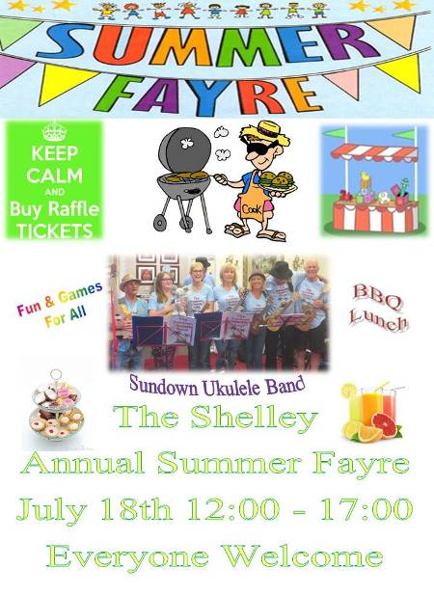


Find inside - the official super hero, voted the best in the UK

We are looking forward to the next six months, starting with our Annual Summer Fayre on July 18th. This year we are starting at 12, we will serve a BBQ lunch, there will be a Raffle, fun and games for all ages and the Sundown Ukulele Band will be playing for us.
Afternoon tea and cakes will bring the event to an end at about 5pm.
Family and friends of the residents (past present and future) all welcome!

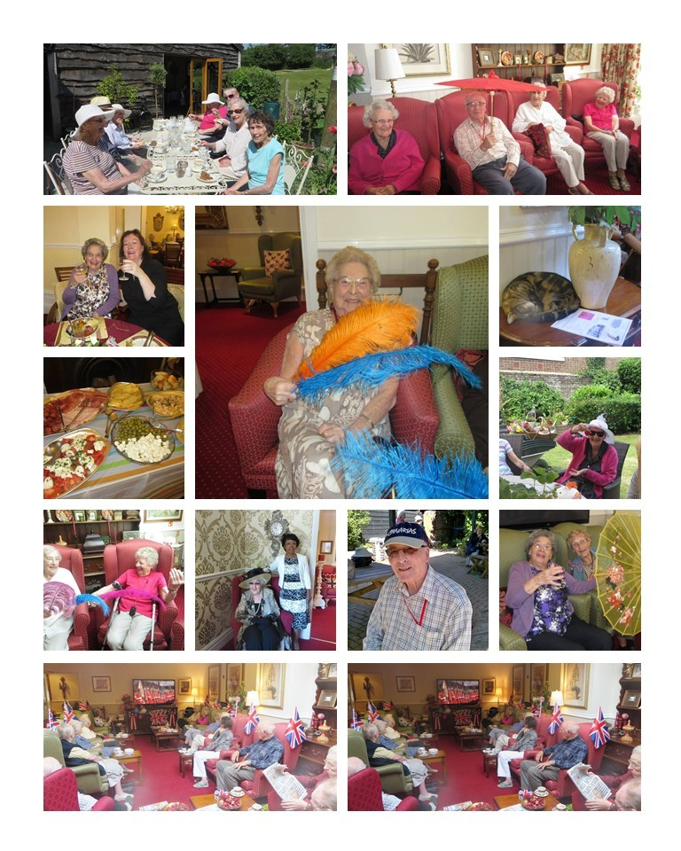
Page 2 June in Pictures

Page 3 Officially Uk…

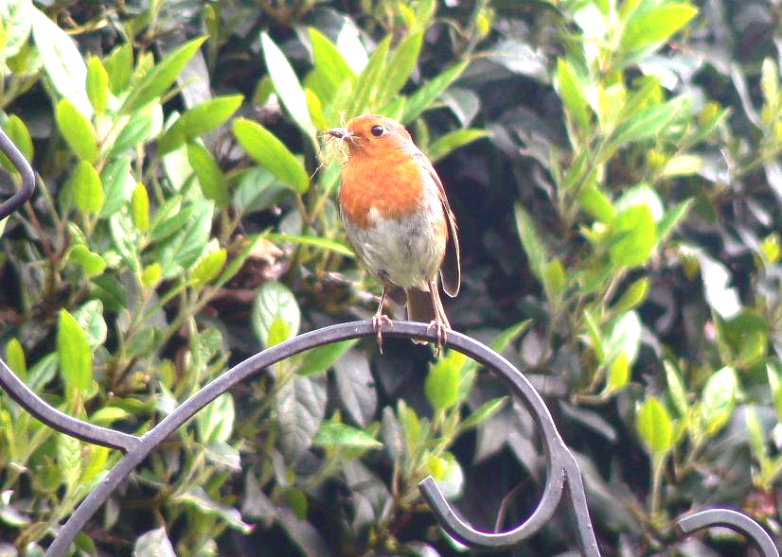

Denis’s patience paid off, he managed to capture this Robin on its way back to the nest with soft grass, ready to make a comfortable lining for the young to hatch into.

Without knowing it, Denis has captured the perfect photograph of the bird that the British people have voted as Britain’s National bird.
According to “Country Living”
Almost 225,000 votes have been cast since the ten finalists were announced in mid-March but with an overwhelming and not altogether unexpected majority of 34% – more than 75,000 votes and almost three times as many as the bird in second place – the feisty, red-breasted robin has emerged victorious.

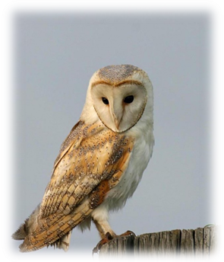
Second and third place in the vote – cast via a website, postal votes and ballot boxes in schools across the UK – became a closely fought battle between the barn owl and the blackbird.
The nation’s favourite owl claimed 12% of the final tally coming in with an impressive 24,870 votes, narrowly beating the beady-eyed blackbird’s 11% or 23,369 votes.

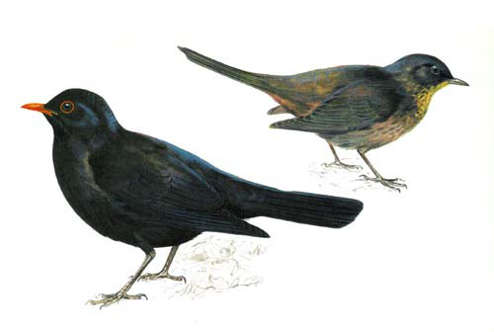

Page 4

The tiny, flitting wren or ‘Jenny wren’ claimed fourth spot with 9% of the total votes cast. Results for the remaining six birds were incredibly close with the relatively recently reintroduced red kite – a conservation success story – earning 6% in fifth position and the iconic but less often spotted puffin a shock entry in last place, garnering only 5% of the final count – full results of which are shown below.

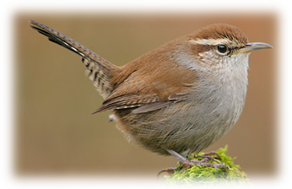


Britain’s National Bird results
Robin 34% (75,623)
Barn owl 12% (26,191)
Blackbird 11% (25,369)
Wren 9% (19,609)
Red kite 6% (14,057)
Kingfisher 6% (13,922)
Mute swan 6% (13,480)
Blue tit 6% (13,123)
Hen harrier 5% (12,390)
Puffin 5% (10,674)

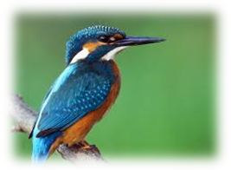

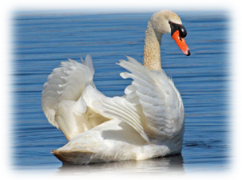

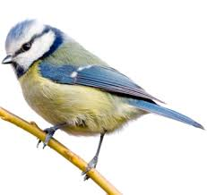

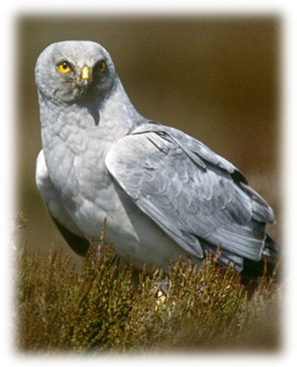

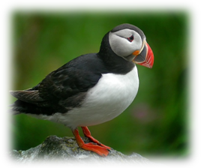

Voting began back in the autumn of 2014 when a list of 60 British birds was released by birder and campaign organiser David Lindo. This round of proceedings saw the skylark, cuckoo and nightingale eliminated and – perhaps less surprisingly – also ended any hopes of success for the ring-necked parakeet, the pheasant and the feral pigeon.

What do you think? Is the Robin your favourite, or would you/did you vote differently?
Page 5 Your Contributions

Contributions are always very welcome and important to compiling the monthly newsletter.
John has been a busy contributor with his rhymes as well as residents, Clare, Peter, Betty, Andrew, Denis, Ron and everyone who manages to pose or get caught by our cameras and end up on the hall photo frame!

Andrew told me a very interesting story of an occurrence which took place every midsummer’s day (we reached this day on the 24th June).

Historically, ale-conners were chosen annually by the common-hall of the city to ensure the goodness and wholesomeness of bread, ale, and beer.
The four chosen Ale-conners also had to ensure that the beer was sold at a fair price.

According to Wikipedia:
Ale-conners were sworn "to examine and assay the beer and ale, and to take care that they were good and wholesome, and sold at proper prices according to the assize; and also to present all defaults of brewers to the next court-leet." The mediaeval post of ale conner was far from a popular or sought-after position. Hops are a preservative, so before the introduction of hopping, ale would not keep well and had to be brewed on site, meaning there were many small breweries to visit. In addition, ale frequently "went off" for the same reason, so tasting it was not uniformly pleasant. Finally, as a representative of the authorities and dispenser of fines, an ale-conner could become unpopular in the community. Ale-conners sometimes had to be impressed into service, and the post was often rotated amongst a number of individuals.
The tradition was maintained in London into the 20th century. The 1911 Encyclopædia
Britannica reports:

In London, four ale-conners, whose duty it is to examine the measures used by beer and liquor sellers to guard against fraud, are still chosen annually by the liverymen in common hall assembled on Midsummer Day. Since ale and beer have become excisable commodities, the custom of appointing ale-tasters has fallen into disuse in most places.
The title was also used of officers chosen by the liverymen in London to inspect the measures used in the public houses. The title is a sinecure.

It is sometimes said that: The Ale Conner was a type of early tax-man whose job it was to test the quality and strength of beer, not by quaffing, but by sitting in a puddle of it! They travelled from pub to pub clad in sturdy leather britches. Beer was poured on a wooden bench and the Conner sat in it. Depending on how sticky they felt it to be when they stood up, they were able to assess its alcoholic strength and impose the appropriate duty. However, the accuracy of this colourful legend is doubtful!

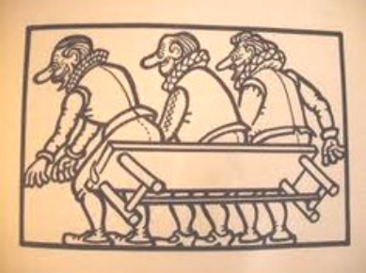

Page 6 John’s Rhymes

Battle of Waterloo – 200 years ago – 18/06/1815
Warriors
If Wellington fought at Trafalgar
And Nelson at Waterloo
What an awful mess it would have been
A terrible to-do
If Nelson fought at Waterloo
"Come on lads," he'd cry,
"Engage the enemy more closely.
"We're going to do or die."
And off they'd rush across the field
To hit Napoleon's lot
And of course it might have worked
But then again, p'raps not.
If Wellington fought at Trafalgar
He'd have been all at sea.
"I'm not going to attack" he'd say,
"I want them to come to me."
But the others did not want to fight
They wanted to escape
And so they would have sailed away
And kept their fleet in shape.
So don't give a ship to a soldier
Or put a sailor on land
Unless you want to see Boney's men
Come marching down The Strand.







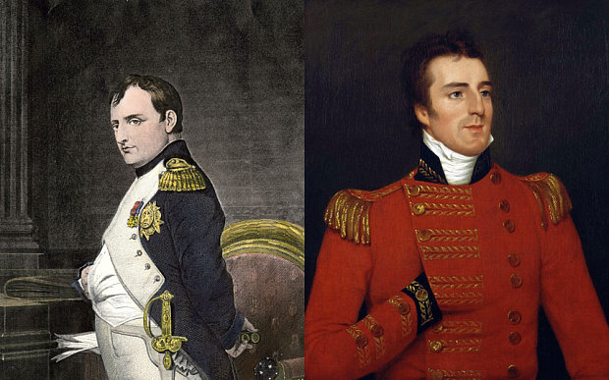


Page 7



Good enough
What's so good about walking?
To get from place to place
You're bound to get there some time
It's not some kind of race.
What's so good about running?
You go so very fast
Till all at once your foot slips
And you end up on the grass.
What's so good about cycling?
The wheels go round - then clunk
You see you have a puncture
And you haven't got a pump.
What's so good about rowing?
As o'er the waves you skim
Until you hit a hidden rock
Then whoops! and you go in.
What's so good about swimming?
And floating in the sea
Until you see the sun's gone in
And think it's time for tea.






What's so good about diving?
It's over in a flash
You're in the air and going down
And suddenly it's splash.
What's so good about fishing?
I really wish I knew
I've been here since last Christmas
And I've only caught the flu.
What's so good about singing?
Now this I really know
Folks all around stand up and scream
And very quickly go.
What's so good about drinking?
I really cannot say
Except glub-glub slurp-slurp
It helps to pass the day.







Page 8 Residents Meeting

A reminder of topics from last month’s residents meeting:



- Welcome back to Clare who had a lovely holiday in the Witterings this week

- Ivan has now left The Shelley, and we will miss him, he is now at The Heathers in Durrington
- Iris recently had a birthday with her choice of cake, lemon drizzle. Remember to let Beverley & Jeannette know your wishes for cakes choice and present choices for your forthcoming birthday
- Rob, our handyman and behind the scenes “boy” is now helping on Jeannette’s trips as the driver for her, which is nice as we see him in a different role, thank you Rob
- Contributions to our newsletter are always welcome and thanks as always to John for his poems & rhymes
- Beverley’s Spanish themed evening was a great success and she is planning another “foodie” session, this time I will do it at lunchtime, so that we can eat more and have a “siesta” afterwards
- Gardening club is great fun as ever and we are now eating our first few strawberries which are delicious, we have lovely bright pink mini watering cans, courtesy of Marlene, so please use them freely and water our fruit, veg and plants with them
- Beverley is going to try to do a cinema matinee afternoon on a more regular basis as she has been asked by a few residents. The new film “Mr Holmes” is on soon so will find dates and ask who wishes to attend
- All very welcome at our new debating group, and the next meeting will be on the subject of The Royal Family, are they worth the money or not ? So, if you can start to have a think please
- The Shelley surgery open day was visited, and a lady called Jill Jones from the surgery is coming to do a talk for us

Page 9

- Is anyone interested in adult learning at Northbrook College? If so please speak to Nada, Beverley or Jeannette. It will be a full day with lunch included. We need to organise it so names will be appreciated
- We have had 4 students in the last few months for the college, who have been very helpful and they have enjoyed the placement with us
- A trip to Hayling Island is planned soon for a picnic lunch dependant on weather with Rob & Jeannette
- A trip to the Wishing Well tearooms is planned for lunch with Beverley & Bob in the next month or so
- Summer fayre is coming up soon, Saturday 18th July, all donations to Beverley for the raffle will be gratefully received, we will have ukulele playing on & off during the day. We will have a plant stall, an art & craft stall and many other things, so we are all looking forward to it. The proceeds this year could be used to buy something for the residents, Clare suggested maybe a cool box for our picnic trips, any other suggestions very welcome to Beverley or Jeannette
- Mathew is coming to do Holy communion this Thursday, and is apologetic for missing the last one
- Anyone who ever wishes to talk privately about any issue, personal or otherwise, please feel free to talk to Beverley or Jeannette or any member of staff at all, we will always make time for you privately
- The Care Homes inspections are all ongoing throughout the country and are imminent here, Marlene & Nada, and all staff work very hard to make your home as happy as possible, the staff love working here and feel privileged to do so
- Clare mentioned the new reports coming out and only 1% of care homes received “excellence” in yesterday’s news, she feels The Shelley is excellent as do many of you and wanted to say a huge thank you to Marlene & to Nada, without who the rest for us work under to achieve that for you all
- Any decision making or things you would like to see altered or changed in any way, please always feel free to speak to Nada or Marlene
- Ron brought up some things about food, but we decided that as Beverley runs a “food reflection group” that we will discuss at the next meeting, Beverley now brings along foods, nibbles etc to encourage you along, bribery is sometimes a good thing !

Next Residents meeting is Saturday 5th September

Page 10 Entertainment

Some Entertainment Coming This Month
As well as our weekly outings in the mini-van or walk/ride to the shops/parks etc.
we also have many of our favourite entertainers joining us, such as:
PAUL ROTHERA – KEYBOARD
LIZZIE & TONY – TO GIVE A TALK
ALISON – SAX PLAYER/SINGER
RUDI
WIMBLEDONN FINALS WEEKEND (WITH PIMMS)
DAWN
ANNUAL SHELLEY FAYRE
SARAH – VIOLINIST
QUAKER GARDEN PARTY
NEW DIMENTIONS
PLUS OUR USUAL
Yoga – Exercises with Nick – Aromatherapy – Manicures Pampering Afternoons – Art and Crafts – Communion
Breathing Spaces - Outings in the mini-van - Shopping Trips

Page 11 And finally

From a resident not wanting to be named!

You will never get me up in one of those!



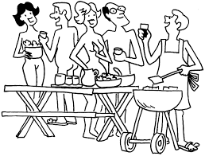
What is the definition of a nudist camp?

A place where people can air their differences!

Have you ever wondered about the hereafter?

Oh yes,
I often get to the larder and wonder what am I here after!

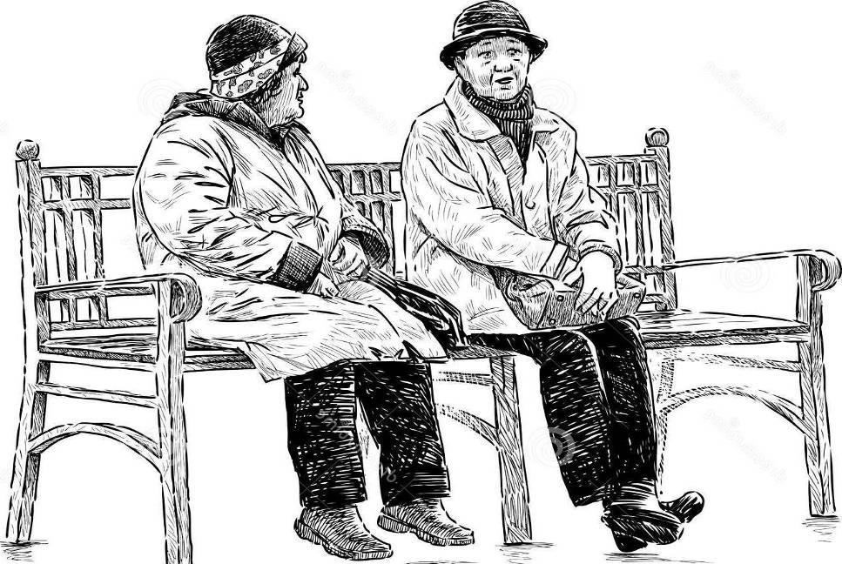

Page 12

Next month we will be exploring English language trends
and text-speak!


We’re on the Web!
Visit us: theshelley.com
Find us on Facebook: TheShelley Worthing
Read Past Newsletters: theshelleynewsletters.weebly.com/
For Just Photos: theshelleyphotos.weebly.com/

The Shelley does not hold, nor claim to hold the copyright on any article or photograph found in print or on the Internet.

