The Shelley
Newsletter –June 2016

The Shelley - 54 Shelley Road, Worthing, West Sussex, BN11 4BX. t: 01903 237000 e: info@theshelley.com

This month we celebrate Donut Day!

Inside This Issue

June 1
May in Pictures 2
Donut Day 4
Peregrine Falcons 6
John’s Rhymes 8
Entertainment 11
And Finally 12

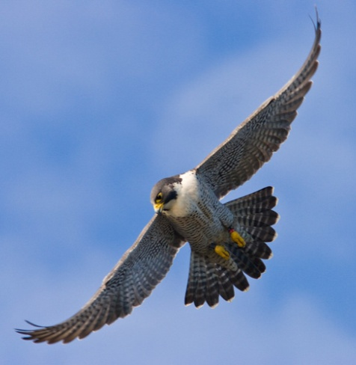

Chichester Falcons

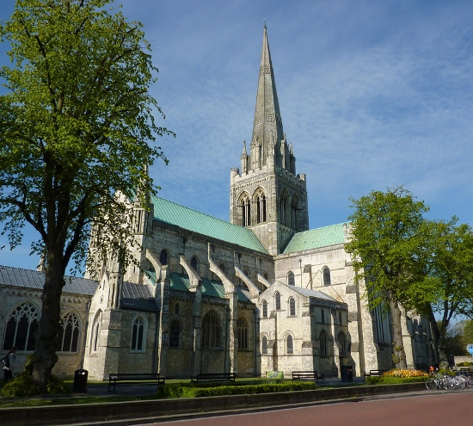

Summer is meant to arrive this month, usually with holidays at some point.

While we are waiting, John has a view on holidays in his rhyme – See Page 8

Page 2 May in Pictures

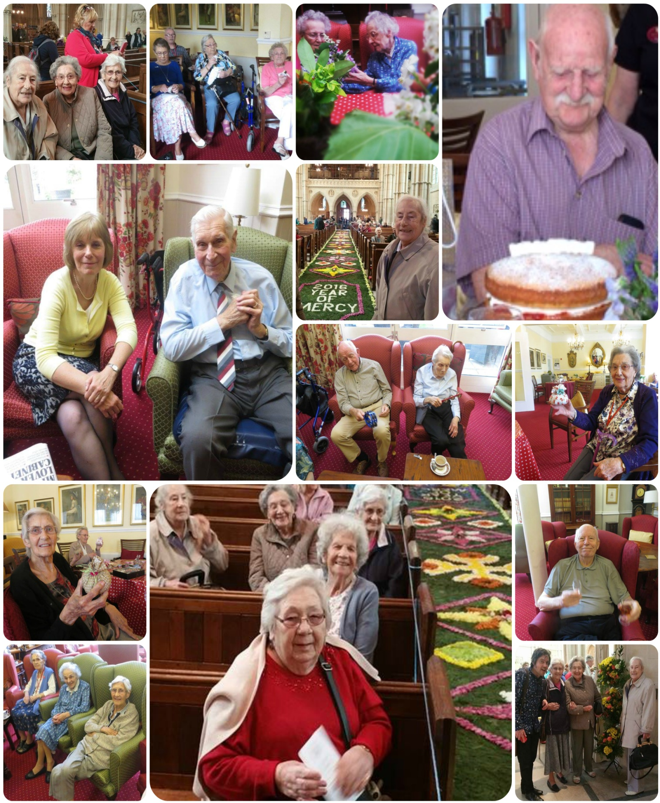

Page 3

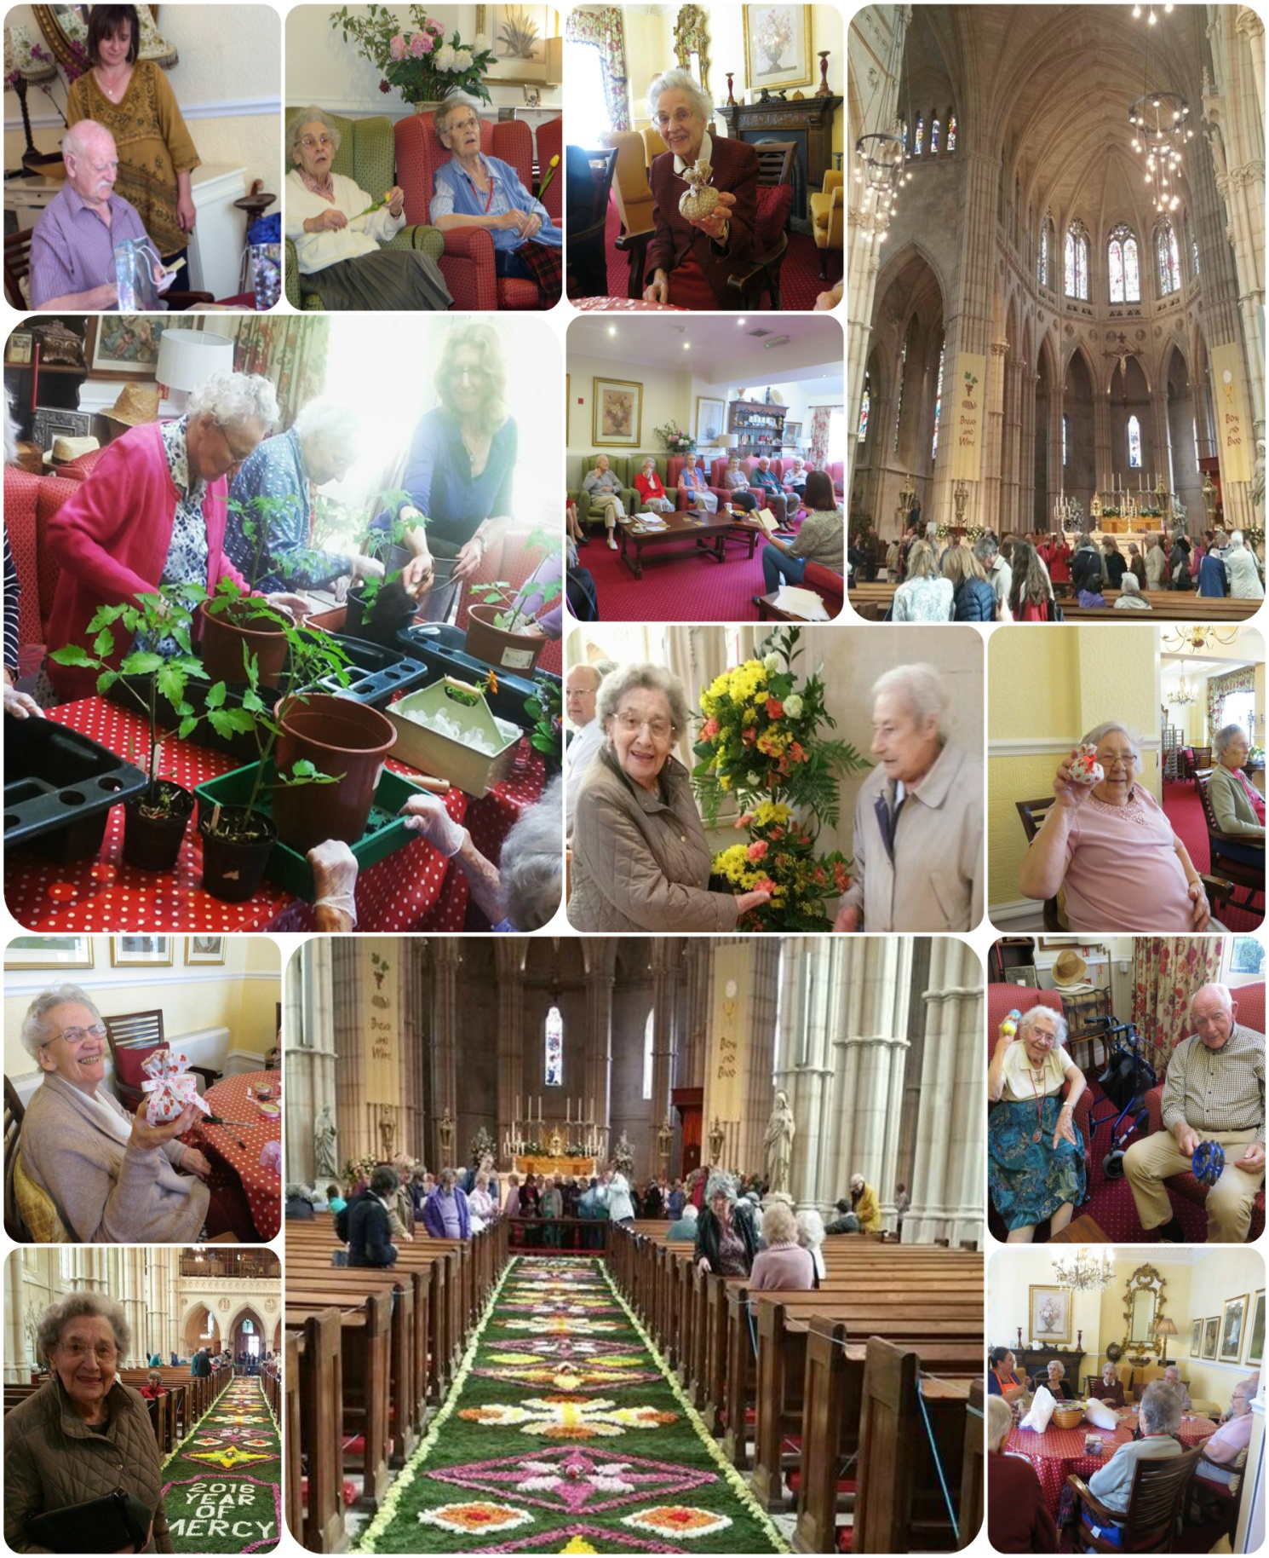

Page 4 Donut Day

What is Donut Day?
If you love a donut, then paying your respects to the Salvation Army is necessary, the founders of Donut Day.

When is This Day Celebrated?
Donut day is celebrated on every First Friday of June.

Why is This Day Celebrated?
Donut day is celebrated to honour the Salvation Army “Lassies” of First World War. Donut day is also the means of fund raising for the needy causes of Salvation Army.

When was the First Donut Day Established?
The first Doughnut Day was established on 1938 by the Chicago Salvation Army in order to raise fund for needy causes of Great depression and to honour Salvation Army lassies during World War I.
Donut Day was started in 1938 by the Salvation Army as a fundraising event to honour the Salvation Army volunteers who had offered home cooked to meals to soldiers fighting overseas during World War 1.

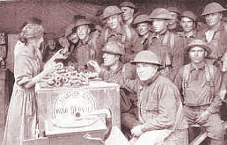
Legend has it the ladies cooked many different breakfast items for the soldiers, but the most popular was the down home donut. Donuts were fried in whatever was available to hold the oil over a open fire. Many times metal trash cans or even the soldier's helmet was used as the pot in which to cook the donuts. And those boys ate them up!
Page 5

Donut Day in the USA is the day when many donut shops offer free donuts (1 per customer) or free donuts with a beverage purchase. How can you go wrong with that deal.
Donuts have evolved from their glazed or sugar coated origins. Many shapes, sizes or flavours are now available.

Which ones get your tummy rumbling?

Page 6 Peregrine Falcons

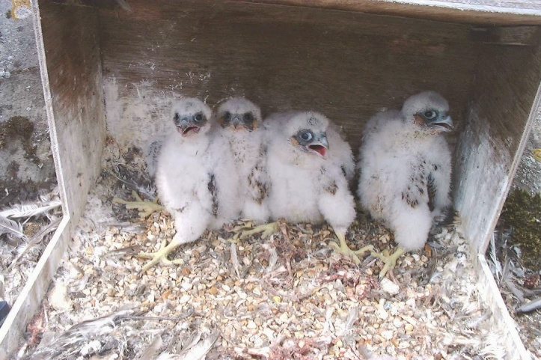
Peregrine falcons have been nesting in the Chichester Cathedral turrets since 2001. The first pair of falcons raised 46 chicks together between 2001 and 2013! In 2014 two new peregrines claimed the nest site and have successfully hatched five chicks to date. This year, the peregrines have returned to the nest and four eggs produced four eggs al successfully hatched. The chicks hatched at the end of April. Their sex was identified by measuring their feet, as female peregrines have bigger feet than males.
The four new arrivals were given unique rings to identify them in the future. DNA samples were also made during the ringing by removing a tiny feather from each chick.
This is only the second time a hat trick of females has been produced by the peregrines since the birds began breeding here in 2002.

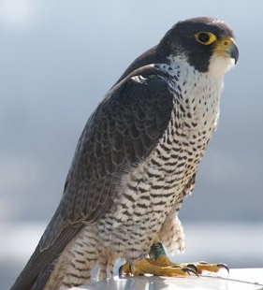
The peregrine has long, broad, pointed wings and a relatively short tail. It is blue-grey above, with a blackish top of the head and an obvious black 'moustache' that contrasts with its white face. Its breast is finely spotted. Most peregrines nest on cliffs, including the Sussex coast between Brighton and Eastbourne, but Cathedral turrets will do as they are similar, i.e. high and made of stone. Peregrines have suffered illegal killing from gamekeepers and landowners, and been a target for egg collectors, but better legal protection and control of pesticides (which indirectly poisoned birds) have helped the population to recover considerably from a low in the 1960s. Some birds, particularly females and juveniles, move away from the uplands in autumn.

Page 7

The peregrine is a large falcon and the fastest flying bird in the world, known for its spectacular aerial dives or 'stoops' in pursuit of its prey. Dives have been known to reach up to 390km (240miles) per hour. The Cathedral peregrines do not hunt around the immediate Cathedral precincts, however, as there are too many other buildings and not enough space.

The Dive Sequence of the Peregrine falcon, shows how they go from full winged flight to ‘bullet’ mode in moments.
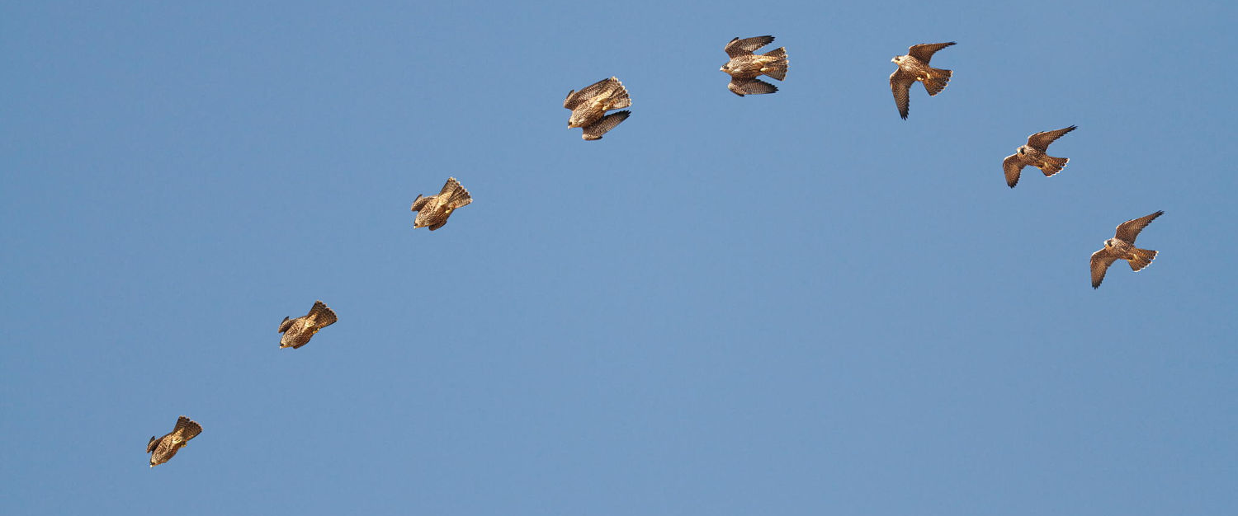

Arrows may have feathers, but they're slow compared to Peregrine falcons, they are masters of flight.

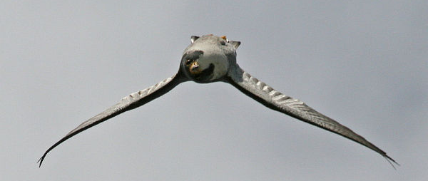
They like to show off their agility, sometimes flying upside down to catch food dropped by a mate.

Page 8 John’s Rhymes

"Did you enjoy your holiday?"
You hear it quite a lot.
But really it's a courtesy
They don't care if you did not.
"We went to dear old France again
"To a favourite place of mine.
"We swam bit and sunbathed
"And drank some ghastly wine."
"I went to climb the Matterhorn
"To see if I would dare
"But when I got there, darn it,
"It was shut down for repair."

Page 9

"We went off to Austria
"All those hills and things
"And there's a chap called Mozart
"Apparently he sings."
"We thought we'd go to Spain again,
"Went to a big bull-fight
"I thought that it was horrid
"Vomited all night."

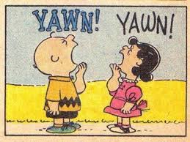
"We thought we'd stay at home this year
"Just be ourselves, we said
"My goodness it was boring
"We were glad to go to bed."

"Next year will be different
"Try out somewhere new.
"Haven't quite decided yet
"But it may be Timbuktu.

Page 10

The Sea Front
If I lived on the sea front
How lovely it would be
To see the big ships cruising by
Though far out to sea.
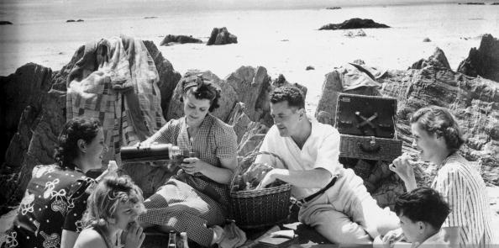
If I lived on the sea front
How lovely it would be
To see the people on the beach
Drinking cups of tea.

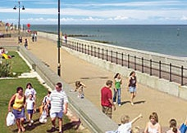
If I lived on the sea front
How lovely it would be
To see the girls all sun-bathing -
A gorgeous sight to see
If I lived on the sea front
How lovely it would be
To go for walks along the prom
After all it's free.
If I lived on the sea front
How lovely it would be
To remember all those fighting ships
That defended me and thee.
If I lived on the sea front
How lovely late at night
To hear the waves come washing in
And know everything's alright.
Page 11 Entertainment

Some Entertainment Coming This Month
As well as our weekly outings in the mini-van or walk/ride to the shops/parks etc. we also have many of our favourite entertainers joining us, such as:

3rd – GAPP – on Donut Day
4th – Shirley & Bill Two in Accord
5th – Clever Cavaliers – Dog Show
6th – Mark, Singing Ragtime/Boogie/Blues
7th – A Historical Talk from Kevin
8th – Ali sings and play the Saxophone
10th – Paul Rothera – keyboard
11th – Trooping the Colour
12th – English Afternoon Tea
13th – Skittles with Nick
16th Ladies Day at Ascot
18th - Royal Ascot
19th Fathers Day
24th - Pal ‘o’ Mine Pete – Singer Guitarist
27th - Curtis Singer
29th – Daniel and the music workshop

PLUS OUR USUAL
Yoga – Exercises – Aromatherapy – Manicures
Pampering Afternoons – Art and Crafts – Communion
Breathing Spaces - Outings in the mini-van - Shopping Trips

Page 12 Finally

Page 13

Amazing what can be achieved with a couple of big plants and a pair of shears!

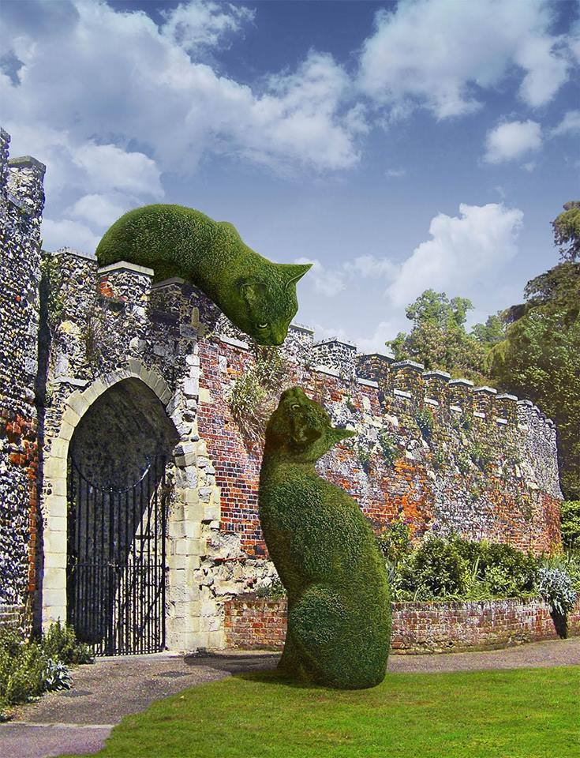

These are actual excuse notes (original spelling intact) from some of the most unintentionally hilarious parents around:

My son is under a doctor’s care and should not take P.E. today. Please execute him.
Please excuse Lisa for being absent. She was sick and I had her shot.
Dear School: Please excuse John being absent on Jan. 28, 29, 30, 31, 32, and also 33.
Please excuse Roland from P.E. for a few days. Yesterday he fell out of a tree and misplaced his hip.
John has been absent because he had two teeth taken out of his face.
Chris will not be in school cus he has an acre in his side.
Please excuse Ray Friday from school. He has very loose vowels.
Please excuse Pedro from being absent yesterday. He had diahre dyrea direathe the runs.
Irving was absent yesterday because he missed his bust.
Page 14

We’re on the Web!
Visit us: theshelley.com
Find us on Facebook: TheShelley Worthing
Read Past Newsletters: theshelleynewsletters.weebly.com/
For Just Photos: theshelleyphotos.weebly.com/

The Shelley does not hold, nor claim to hold the copyright on any article or photograph found in print or on the Internet.

