The Shelley Newsletter


June 2015

The Shelley - 54 Shelley Road, Worthing, West Sussex, BN11 4BX. t: 01903 237000 e: info@theshelley.com

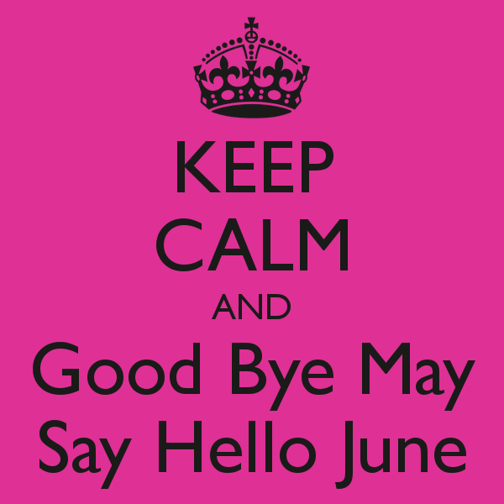
Inside This Issue
This Month1
Birthdays & Other Celebrations2
Entertainment and Outings3
Monarchy and Honours4
John’s Rhymes8
Next Month10
And Finally11

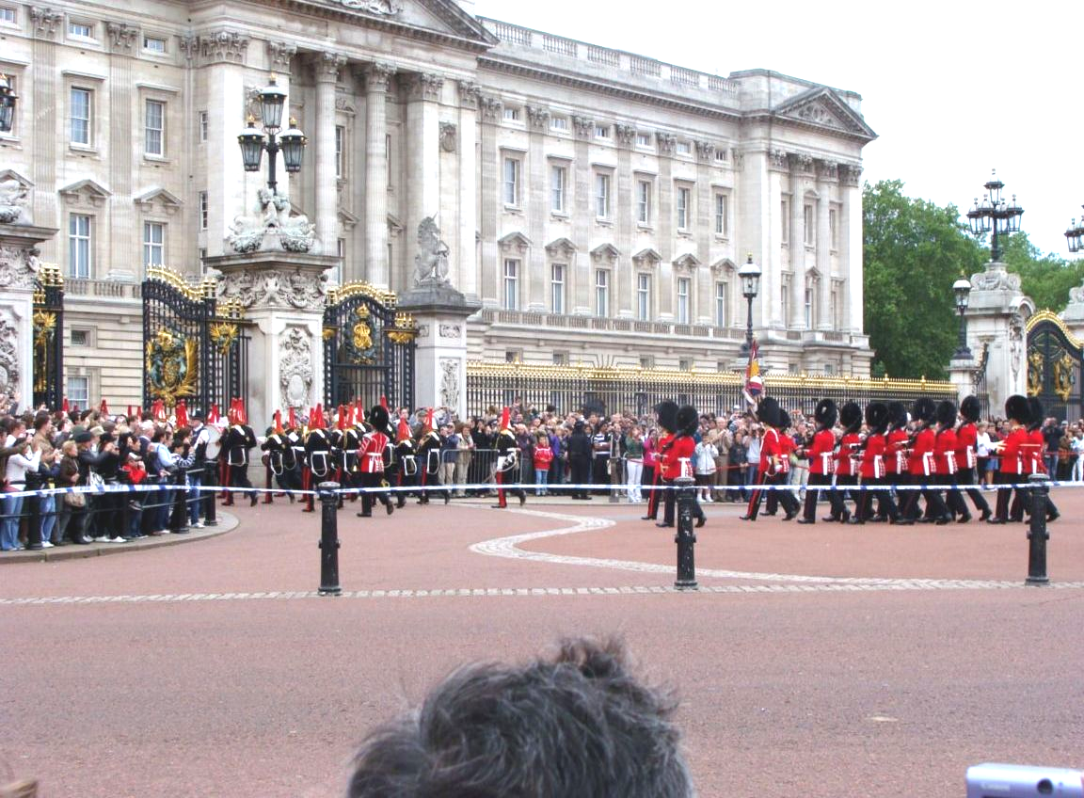
Pages 4-7

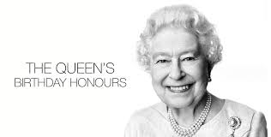

Pages 8 & 9


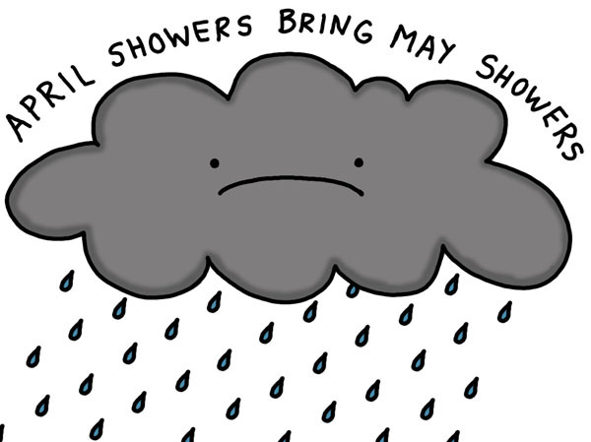

PLEASE be kind to us June!

Page 2 Birthdays and Other Celebrations

Since our Last Newsletter Many Happy Returns went to:
No one at all but that does not mean that some residents had nothing to celebrate:

Jeans niece came over from France to see her and Ron had visits from family and friends from Germany and Australia.



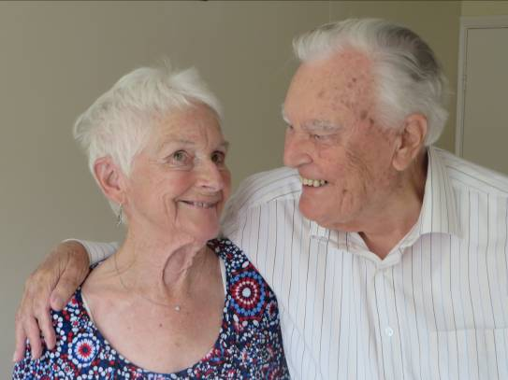

Clare went away for a week on holiday with her family touring Devon and Cornwall, maybe next time I say the roads are narrow there, Clare might believe me, I believe a LOT of praying was a daily event in the mini bus they hired!

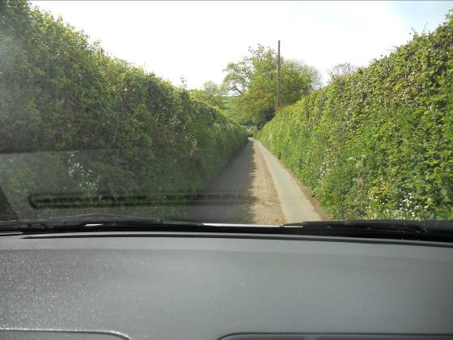
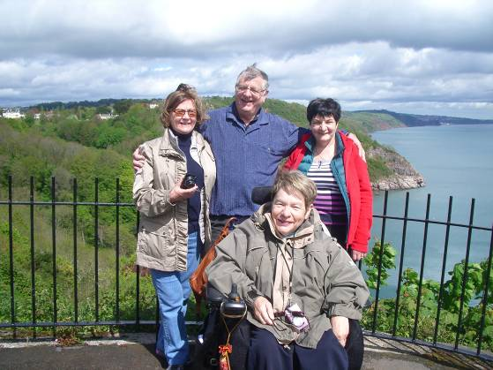

Then we all had a great party while the boss was away. What! You missed it? Never mind, she is away again in a few weeks time.
Oh Nada, as if we would!!



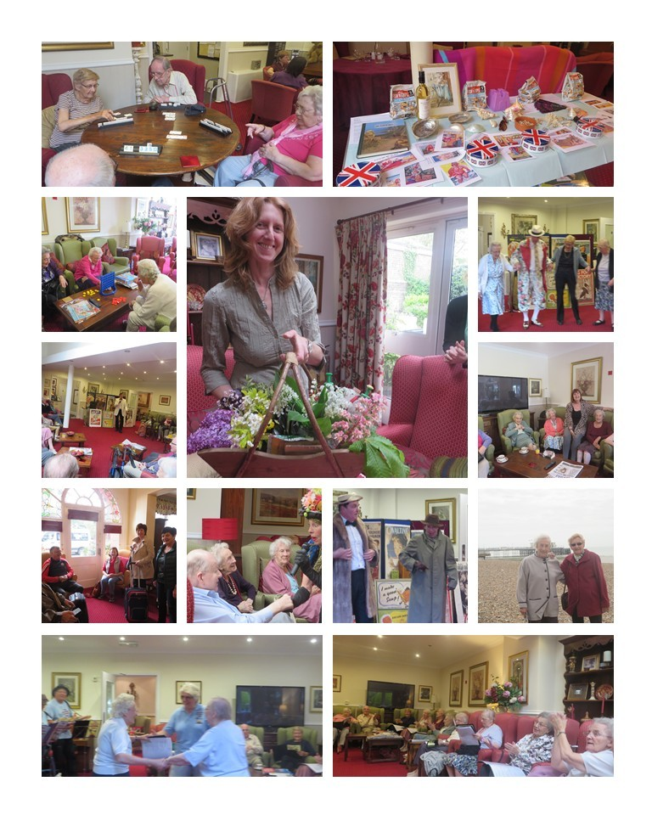
Page 3 May Entertainment in Photos

For more photographs of outings and entertainment from this month, see the frame in the hall or online (see the back page for addresses)

Page 4 Monarch’s Honours Celebrations – Changes To Come?

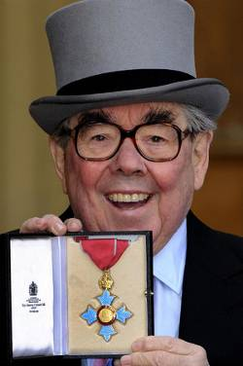
The Monarch’s Official Birthday is the selected day on which the birthday of the monarch of the Commonwealth realms (currently Queen Elizabeth II) is officially celebrated in those countries. The date varies as adopted by each Commonwealth country, but is generally around the end of May to the start of June, to coincide with a high probability of fine weather in the Northern Hemisphere for outdoor ceremonies.
The sovereign's birthday was first officially marked in the United Kingdom in 1748. Since then, the date of the king or queen's birthday has been determined throughout the British Empire and later the Commonwealth according to either different royal proclamations issued by the sovereign or governor or by statute laws passed by the local parliament. The exact date of the celebration today varies from country to country and, except by coincidence, does not fall on the day of the monarch's actual birthday, that of the present monarch being 21 April. In some cases, it is an official public holiday, sometimes coinciding with the celebration of other events. Most Commonwealth realms release a Birthday Honours List at this time
Honours have been awarded on the sovereign's birthday since at least 1891 under Queen Victoria. The birthday of her successor, King Edward VII (r. 1901–1910), fell on 9 November 1901. After 1908 the monarch's official birthday was moved to the first, second or third Saturday in June (for the UK). Other Commonwealth realms celebrate the official birthday on different dates (generally late May or early June), and release their honours lists accordingly.

New Year and Birthday Honours
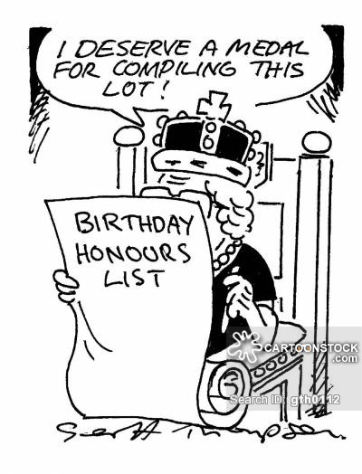
A complete list of approximately 1,350 names is published twice a year, at New Year and on the date of the Sovereign's (official) birthday. Since their decisions are inevitably subjective, the twice-yearly honours lists often provoke criticism from those who feel strongly about particular cases. Candidates are identified by public or private bodies, by government departments or are nominated by members of the public. Depending on their roles, those people selected by the honours committee are submitted either to the Prime Minister, Secretary of State for Foreign and Commonwealth Affairs, or Secretary of State for Defence for their approval before being sent to the Sovereign for final approval. Certain honours are awarded solely at the Sovereign's discretion, such as the Order of the Garter, the Order of the Thistle, the Royal Victorian Order, the Order of Merit and the Royal Family Order. The awards are then presented by the Sovereign or her designated representative. The Prince of Wales, the Duke of Cambridge and the Princess Royal have deputised for the Queen at investiture ceremonies at Buckingham Palace.

BUT
Is this all set to change when Charles is king?
Page 5

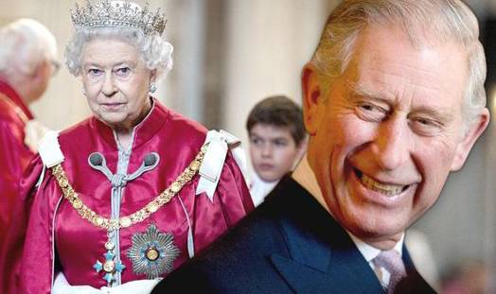
According to The Daily Telegraph in January this year Prince Charles will among many other things, demand a thorough reform of the honours system when he becomes king, it has been reported.
He firmly believes that honours are currently being handed out "to the wrong people for the wrong reasons".
The heir to the throne is said to want to scrap honours such as the CBE - the Commander of the Order of the British Empire - preferring a smaller number of modern and more egalitarian awards.
One member of his inner circle, reportedly speaking for the Prince, said: "Why should people still be invested with an order of a defunct British empire?"
Charles also thinks the honours ceremonies should be more of a celebration.
A figure close to him said a party would be more suitable way of recognising an individual's achievements, telling the Daily Mail: "It’s a shame that after receiving an honour at the palace, recipients have to leave. How much more appropriate it would be for the occasion to be marked by a party."

The Orders bestowed at sovereign’s discretion include:
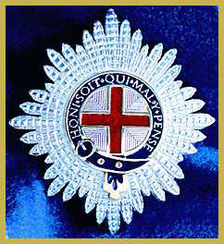
The Order of the Garter - the most senior and the oldest British Order of Chivalry and was founded by Edward III in 1348.
The Order, consisting of the King and twenty-five knights, honours those who have held public office, who have contributed in a particular way to national life or who have served the Sovereign personally
The number of knights is limited to 24, plus Royal knights. For much of its history, the Garter was limited to the aristocracy, but today the knights are from varied backgrounds. If there are vacancies in the Order, appointments are announced on St George's Day (23 April).
Every June, the Knights of the Garter gather at Windsor Castle, where new knights take the oath and are invested with the insignia. A lunch is given in the Waterloo Chamber, after which the knights process to a service in St George's Chapel, wearing their blue velvet robes (with the badge of the Order - St George's Cross within the Garter surrounded by radiating silver beams - on the left shoulder) and black velvet hats with white plumes.

Page 6

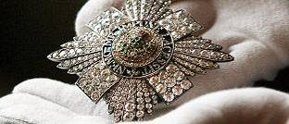
The Order of the Thistle represents the highest honour in Scotland. It is second only in precedence in the UK to the Order of the Garter.
The Order honours Scottish citizens who have held public office or who have contributed in a particular way to national life.
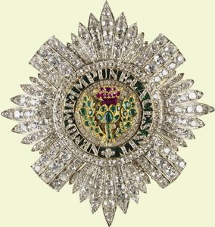
The date of the foundation of the Order is not known, although legend has it that it was founded in 809 when King Achaius made an alliance with the Emperor Charlemagne.
The Order may have been founded by James III (1488-1513), who was responsible for changes in Royal symbolism in Scotland, including the adoption of the thistle as the Royal plant badge

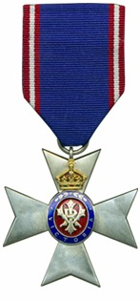
The Royal Victorian Order is given by The Queen to people who have served her or the Monarchy in a personal way.
These may include officials of the Royal Household, family members or perhaps British Ambassadors who have helped organise a State Visit to a particular country.
The Order was founded in April 1896 by Queen Victoria as a way of rewarding personal service to her, on her own initiative rather than by ministerial recommendation.

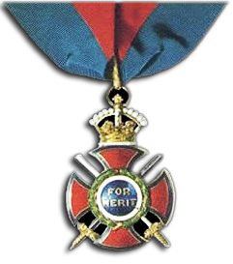
The Order of Merit is a special honour awarded to individuals of great achievement in the fields of the arts, learning, literature and science.
The Order was founded by King Edward VII at the time of his coronation in 1902, to be ‘given to such persons, subjects of Our Crown, as may have rendered exceptionally meritorious services in Our Crown Services or towards the advancement of the Arts, Learning, Literature, and Science or such other exceptional service as We are fit to recognise’.
The Order of Merit is in the sole gift of the Sovereign and is restricted to 24 members as well as additional foreign recipients.
Page 7

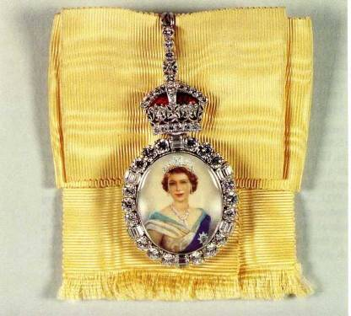
Royal family Order - George IV started the formal practice of presenting Family Orders, or portraits of the Sovereign set in diamonds suspended from a ribbon.
Before 1820, the Sovereign's portrait set in a jewelled frame had been worn by both ladies and gentlemen at Court, and especially by female members of the Royal Family.
George IV's successors continued this practice, with most sovereigns presenting jewelled portraits of themselves suspended on different coloured ribbon for each monarch - that of George V was white, that of George VI was rose pink, and The Queen's is chartreuse yellow.
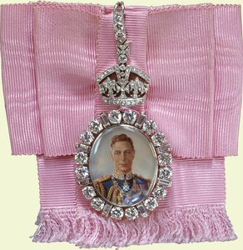
The Orders are now worn on formal occasions by female members of the Royal Family only. The Queen and her late sister, The Princess Margaret, were given their awards by their father, George VI, and both wore them as young girls at the coronation of their parents in 1937.
More than one Order can be worn at the same time. For example, Queen Elizabeth The Queen Mother wore the Orders of both The Queen and George VI.

Page 8 John’s Rhymes

He is broaching a controversial subject, were you feeling ‘down’ the day you wrote this John?

Reynard
The urban fox is very proud
And often he's on show,
He's also very confident
For there's no more hunts you know.
The urban fox is very smart,
Knows all there is to know
But he's never seen a single field
Though there's no more hunts you know.



The urban fox lives in a drain
Near where the trains all go
He doesn't care about the noise
For there's no more hunts you know.
The urban fox is hungry
Last meal a while ago
He'll go and see what's in that bin
For there's no more hunts you know.
The urban fox is lazy
Which means he's very slow
Sometimes he wishes he could run
But there's no more hunts you know.

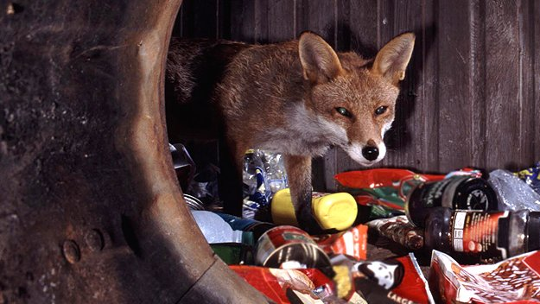

The urban fox is sick with mange,
His lovely coat won't grow
And yet he staggers bravely on
There's no more hunts you know.
The urban fox is very old
He hasn't long to go
He'll end up on the council tip
There's no more hunts you know


(This one was saved by RSPCA)

Page 9

On a lighter note, John asks if you can identify the poets from the snippets below (answers on the back page – no cheating!)
1. I wandered lonely as a cloud
That floats on high o'er vales and hills,
When all at once I saw a crowd
2. The church bell tolls the knell of passing day,
The lowing herd winds slowly o'er the lea,
3. Cannons to right of them
Cannons to left of them volleyed and thundered,
Into the valley of death
4. Hail to thee blithe spirit
Bird thou never wert
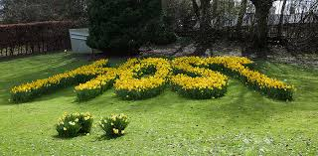

5. In Inja's sunny clime
Where I used to spend me time
A'serving of 'er Majesty,
The Queen

6. Water, water everywhere
Nor yet a drop to drink.
7. They're changing guard at Buckingham Palace
Christopher Robin went down with Alice
8. I am a young executive
Whose cuffs there are none cleaner
I have a slimline brief-case
And I drive the firm's Cortina.
9. The boy stood on the burning deck
Whence all but he had fled
The flames that lit the battle's wreck
10. We are not wholly bad or good
We who live under Milk Wood

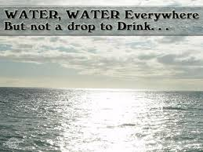


Page 10 This Month

Some Entertainment Coming This Month
As well as our weekly outings in the mini-van or walk/ride to the shops/parks etc.
We also have many of our favourite entertainers joining us, such as:

CHESSWOOD SCOOL CHOIR
AND RECORDER GROUP

ZOE - ALIVE

QUEENS BIRTHDAY CELEBRATION
WITH TROOPING THE COLOUR

PETE (PAL o MINE)

Johnny (singer)

Curtis

Ladies day at ascot
(Get your hats ready ladies)

John beever

A talk from roger brett

And the children from storm are back

Aromatherapy and Manicures Pampering Afternoons
Yoga – Exercises with Nick – Art and Crafts – Communion
Breathing Spaces – Gill’s Poetry Mornings -

We would like to apologise for the entertainers that did not appear last month. Both were booked in good faith and neither of them called to say they were unable to attend, you may remember that Jeanette and other staff entertained you in their places.

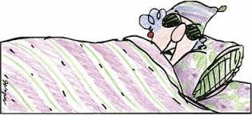
Lying around, pondering the problems of the world,
I realized that at my age I don't really give a fig anymore.
If walking is good for your health, the postman would be immortal.
A whale swims all day, only eats fish, drinks water, but is still fat.
A rabbit runs and hops and only lives 15 years, while a tortoise doesn't run and does mostly nothing, yet it lives for 150 years.
And they tell us to exercise? I don't think so.
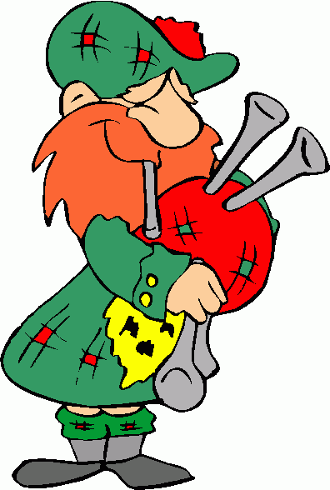
My neighbour knocked on my door at 2:30am this morning, can you believe that 2:30am?!
Luckily for him I was still up playing my Bagpipes.

A teddy bear is working on a building site.
He goes for a tea break and when he returns he notices his pick has been stolen. The bear is angry and reports the theft to the foreman.
The foreman grins at the bear and says "Oh, I forgot to tell you, today's the day the teddy bears have their pick nicked."
Page 11 And Finally



I'm thinking of buying a Labrador said one man.
"Blow that" says his friend, have you seen how many of their owners go blind?"

The wife has been missing a week now.
Police said to prepare for the worst.
So I have been back to the charity shop to get all her clothes back.



Page 12

Answers to John’s snippets (Page 9)
1. Wordsworth. Daffodils.
2. Gray. Elegy written in a country churchyard.
3. Tennyson. Charge of the Light Brigade.
4. Shelley. Ode to a skylark.
5. Kipling. Gunga Din.

6. Coleridge. The Mariner.
7. A.A. Milne. The Palace.
8. Bêtjeman. The Executive.
9. Felicea Dorothea Hemans. Casablanca.
10. Dylan Thomas. Under Milk Wood.

How many did you get?

We’re on the Web!
Visit us: theshelley.com
Find us on Facebook: TheShelley Worthing
Read Past Newsletters: theshelleynewsletters.weebly.com/
For Just Photos: theshelleyphotos.weebly.com/

The Shelley does not hold, nor claim to hold the copyright on any article or photograph found in print or on the Internet.

