The Shelley
Newsletter – May 2016

The Shelley - 54 Shelley Road, Worthing, West Sussex, BN11 4BX. t: 01903 237000 e: info@theshelley.com

This month we remember
VE Day – May 8th
1945

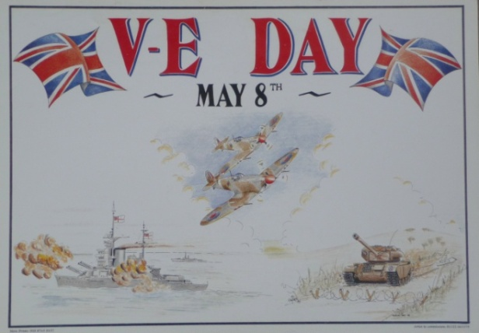

Inside This Issue
May 1
April in Pictures 2
Bitter Sweet 4
Sirens 5
John’s Rhymes 7
A Mystery of The Sea 9
Entertainment 10
And Finally 11

The Queen’s 90th Birthday Celebrations continue from 12th – 15th May, in the private grounds of Windsor Castle.
Some of the best known names in the entertainment world will perform with 900 horses and over 1500 participants,
This will be televised later on ITV
Date to be confirmed.

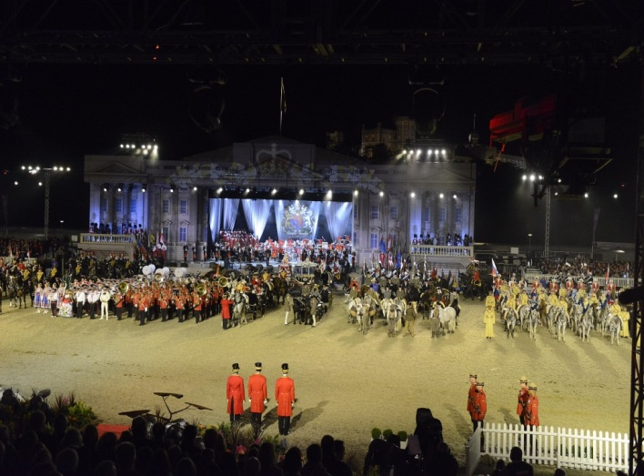

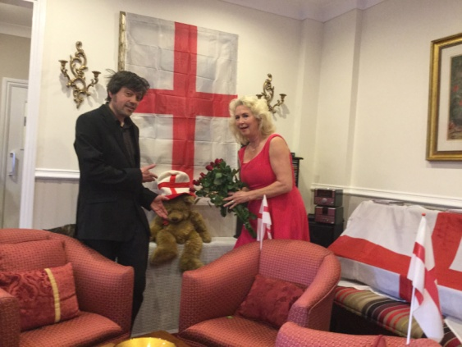
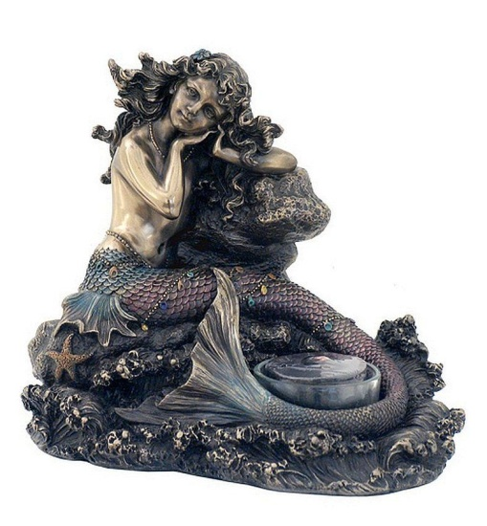
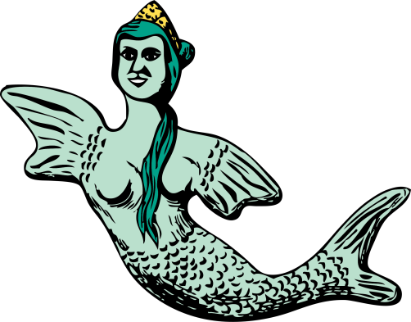

Page 2 April in Pictures

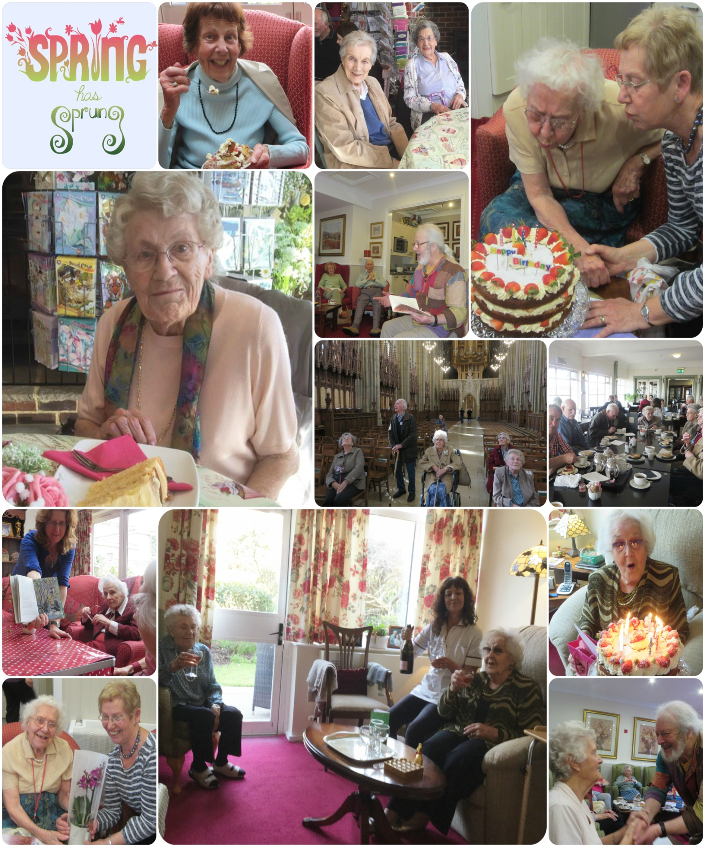
Birthday celebrations, outings and in-house entertainment in April – something for everyone!

Page 3

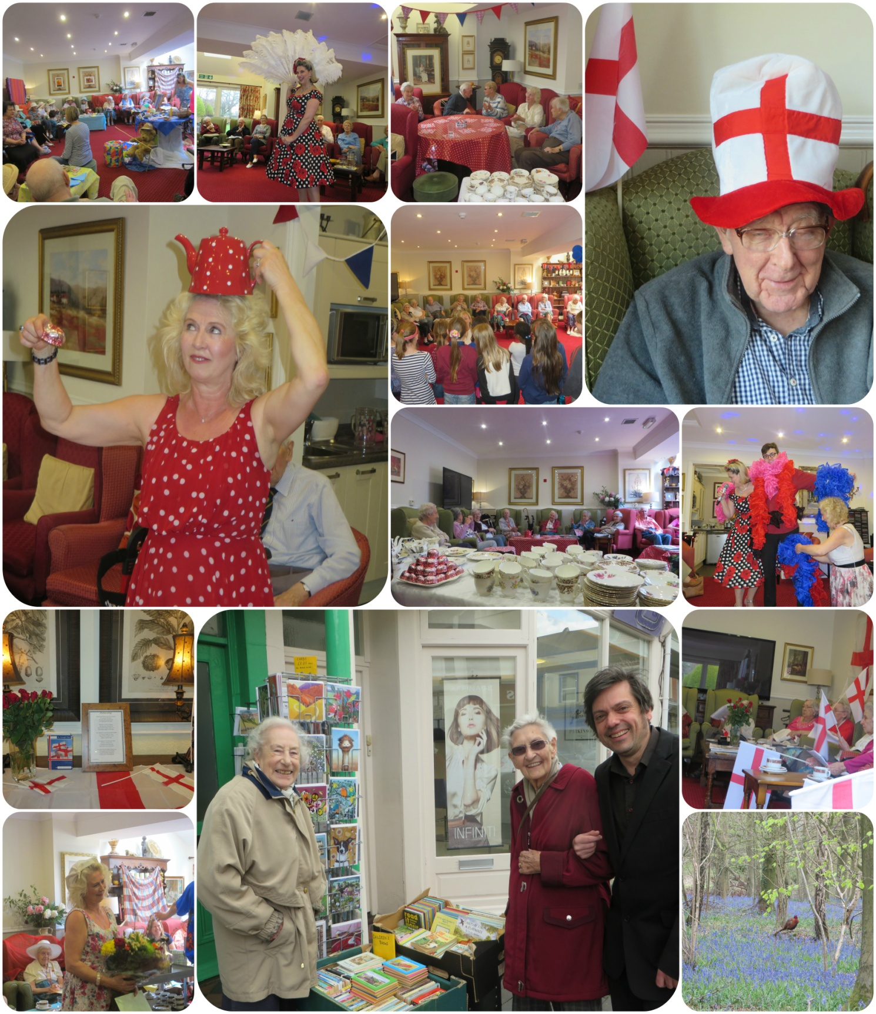

Page 4 Bitter - Sweet

Goodbye to Jeanette – we wish you all the very best and we will all miss you.
Hello to Pete, taking over the reins from Jeanette – big shoes to fill – Welcome to you from us all.
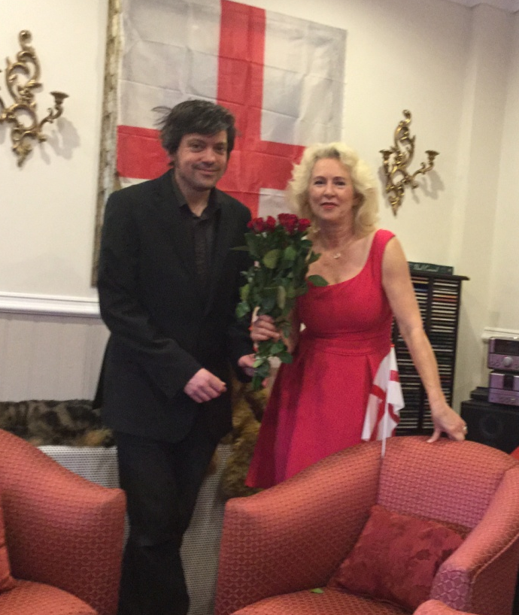

Pete has a varied past including round the world trips as a musician in a band, tour manager, events manager, artist and official Quizmaster and more, which we are yet to discover.
He runs a car-boot sale and is known by many companies in the area, including the Wetlands Centre in Arundel and where he is known by our Friday “Breathing Spaces” Lisa.
He is looking forward to taking you out on weekly trips in the mini bus and shopping trips into town.

Page 5 Mermaid vs Siren

Mermaid vs Siren
Mermaids and sirens are imaginary creatures that have the upper body and faces like women with lower bodies of birds or fish. Mermaids commonly find mention in the folklore of most civilizations and cultures as beautiful aquatic creatures that are half woman and half fish. However, there are many different names given to such creatures like sirens, nixies, undines, water nymphs, mermaids, and so on that are enough to confuse people. People remain especially confused between mermaid and siren because of their similarities.
They are different as will be explained.

Mermaid
Water in all cultures is believed to be full of life. Across all cultures, myth and folklore mention aquatic creatures that are half woman and half fish. These gentle creatures have always been depicted as beautiful, gentle, and helping sailors and others travelling through the seas.
Despite the fact that these creatures do not exist and are only found in folklore, books, and films, they remain as charming and enduring as ever, and we find artifacts and depictions in all cultures across the world.
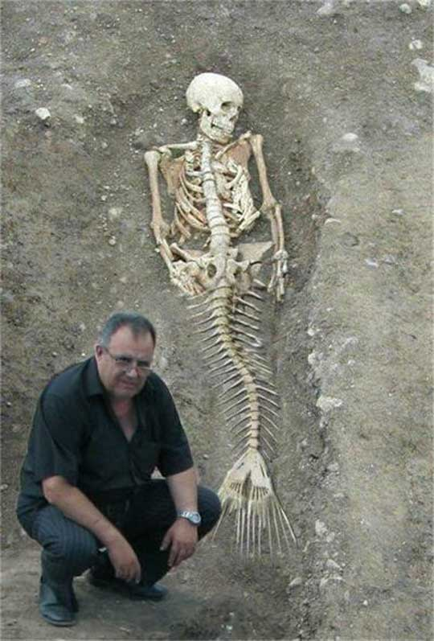
The first of the mermaids is believed to be Atargatis who jumped into the sea, to transform herself into a mermaid for accidentally causing the death of her lover. In most stories, these creatures are shown as innocent and benevolent beings helping humans in one way or the other. In fact, in some of the stories, a mermaid is shown falling in love with a human being.

Human beings have been reporting sightings of creatures like mermaids since time immemorial. There has been no concrete proof of their existence (or has there?!), but they remain a part of our art and culture in the form of cartoons, books, movies, gift items and other items used for decoration.

Page 6

Siren
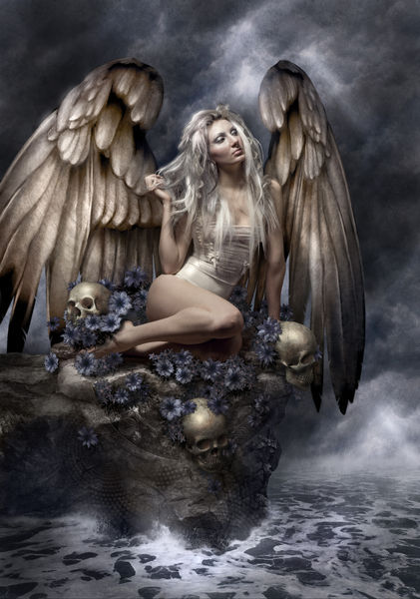
Sirens are mythological characters or creatures found in Greek mythology. They were pointed out as nymphs who lived on islands surrounded by cliffs and enchanted approaching sailors by their voice and music. It is the appearance of the sirens that has been confusing as in some stories they are depicted as birds with human heads while in others they are depicted as half woman and half fish, to make them look like mermaids. There is also confusion because of the fact that, in some languages like French, the word for mermaids is actually siren. However, in most of the stories, sirens have been shown singing songs to attract sailors. Sailors became lured and lost their sense of direction thereby causing shipwreck, and drowned in the seas.

What is the difference between Mermaid and Siren?
• Mermaids are aquatic creatures while sirens are not.
• Mermaids find mention in the folklore and stories of all cultures and civilizations while sirens are found in Greek mythology only.
• Mermaids are shown as gentle and benevolent, whereas sirens are believed to have evil intentions.
• Mermaids are half woman and half fish whereas sirens are believed to be birds with head of the woman.
• Sirens sing songs to mesmerize sailors and cause their drowning. They are also shown as man eaters in some stories. On the other hand, mermaids are always depicted as gentle and benevolent, and ready to help human beings. In some stories, they even fall in love with human beings.

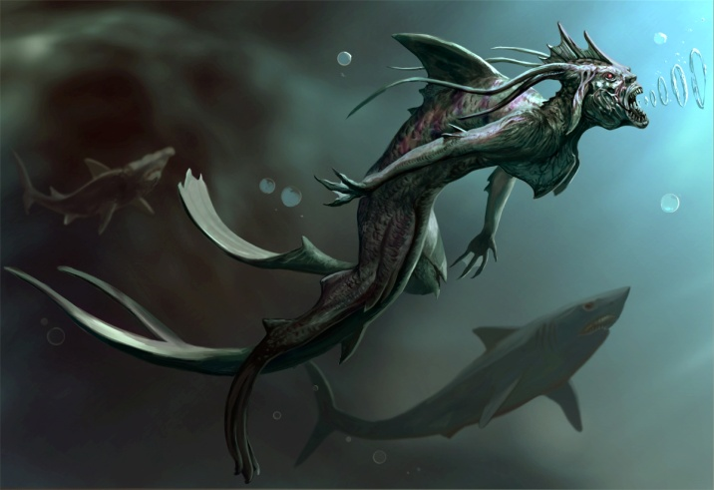
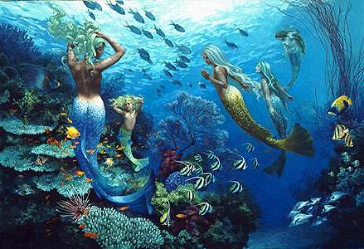

Page 7 John’s Rhymes

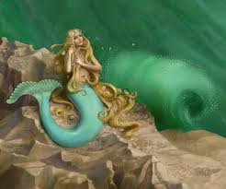
The Mermaid
The mermaid sat upon her rock
Combing her golden hair
She watched a ship approaching
With something like despair.

"Oh! Not another one," she said
"They surely wouldn't dare,"
But dare they did and on they came
And smashed up fair and square.
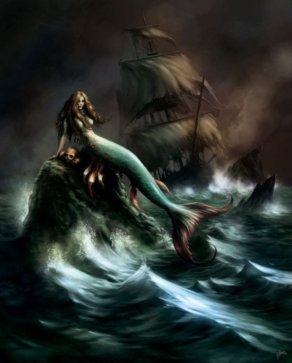
"Well I don't know" the maid complained
"It's a very trying view.
"If I can't comb my hair in peace
"What am I to do?"

"She's done for us that wretched witch,"
The angry skipper cried.
"Aye aye Sir," the bos’un said
And swam away and died.

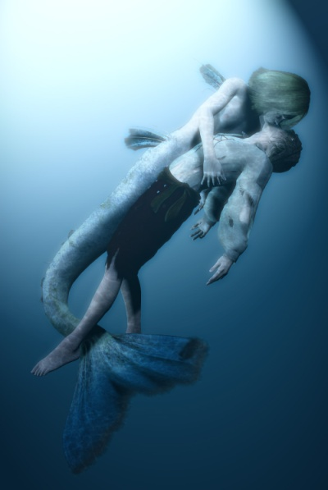
And now the skipper too
Began to sink beneath the waves
But the mermaid caught him in her arms
And thought he might be saved.

"Come with me, my darling,
"I'll show you where it's best,
"There's seaweed soup for supper
"You can put it to the test."

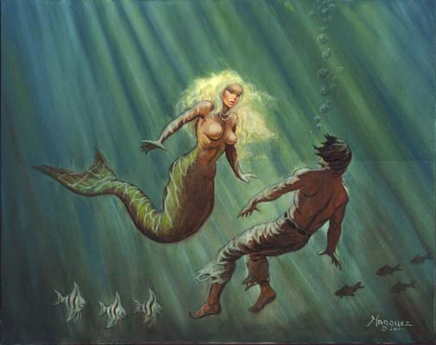
But sad to say the skipper
Had already gone
"Bother it," the mermaid said,
"That makes it ninety-one."

Page 8

The Best
What is it that is best in life?
Depends what you desire.
Some would say a pile of gold
Others, perhaps, a fire.
What is it that is best in life?
Many would say good health
And certainly it is bound to be
Better than great wealth.
What is it that is best in life
To give you lots of joy?
Some would say a little girl
Or else a little boy

What is it that is best in life
Is it freedom from that pain?
Of knowing that at last it's gone
And it won't come back again.
What is it that is best in life?
Is it simply fame?
From playing on a guitar
Or at some silly game.
What is it that is best in life?
Is it peace of mind?
Of knowing that the past is past
And leaving it behind.

Page 9 A Mystery

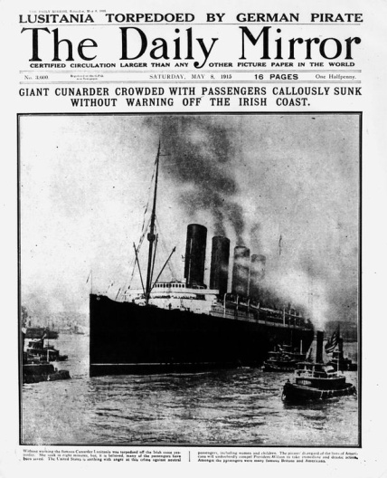
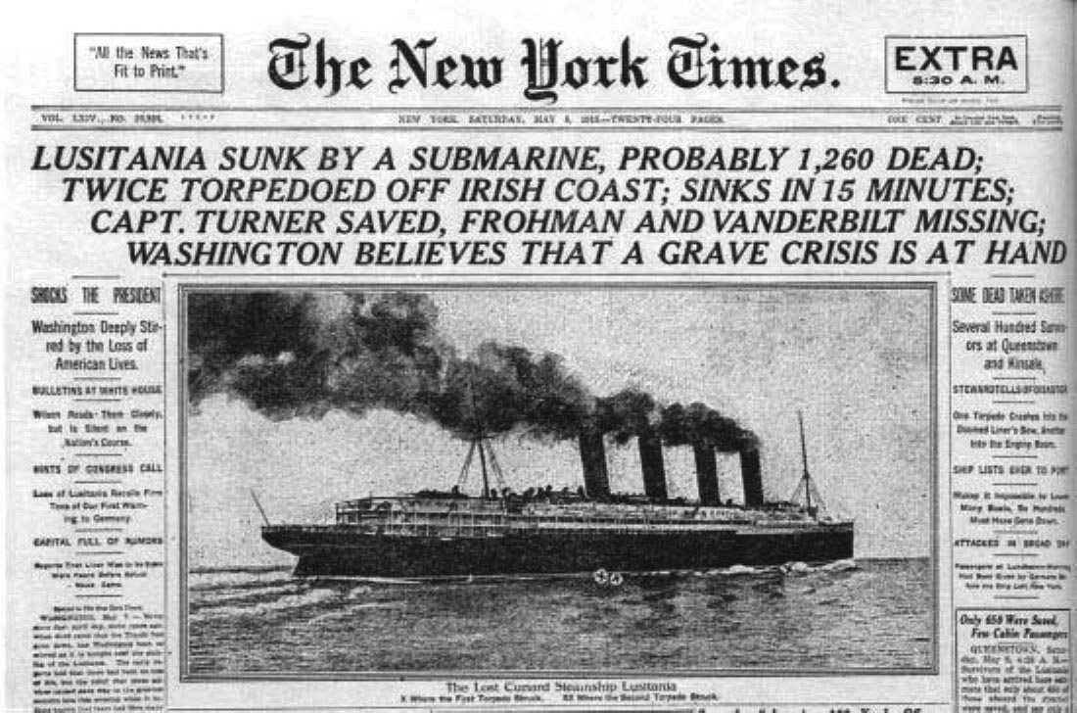
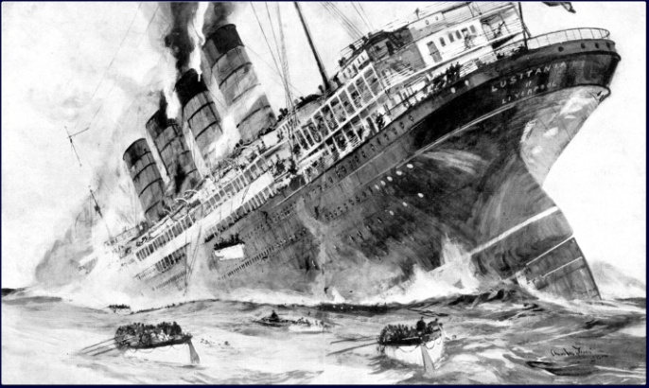
A Mystery of the Sea
On May 7 1915 the liner Lusitania was torpedoed off the South coast of Ireland and sank with the loss of 1.198 lives, including 128 Americans.
Shortly after the torpedo struck there was a second explosion. This caused the ship to heel, severely hampered the launching of lifeboats and caused Lusitania to sink more quickly – 18minutes.
In England it was assumed there had been a second torpedo. But the U-boat commander said he had fired only one, this was supported by the U-boat's log.
The Germans maintained that Lusitania, an American and therefore neutral vessel, had been carrying munitions to Britain, and that these had exploded, causing the second and disastrous explosion.
In England there was outrage at the sinking, and an official inquiry was held in London. It was still widely believed that there had been a second torpedo though Germany denied it. They stuck to the munitions allegation, though there was no evidence for it.
Survivors, including the ship's Master, gave evidence. The suggestion that there might have been a boiler explosion was discounted by the Master and others.
The munitions story was hotly denied, and other suggestions ranging from sabotage to an explosion of coal dust, were also ruled out.
Not surprisingly the inquiry decided that, despite German denials, there had been a second torpedo. But had there? And if it was not a torpedo, what was it?
We still don't know. (Thank you John)

Page 10 Entertainment

Some Entertainment Coming This Month
As well as our weekly outings in the mini-van or walk/ride to the shops/parks etc. we also have many of our favourite entertainers joining us, such as:

2nd May - Singers - Lizzie and Tony
5th May – A talk from Air Ambulance
6th May – Singer/Guitarist - Geoff Field
7th May – Sundown Ukulele Band
9th May – Robbie Magic
10th May – Crafts with Eloise
11th May – Singer Lynne
13th May – Jessica, Rustington Curator
14th May – Singer Terry
20th May – Singer Rudi
21st May – Papa Geoff
23rd May – Zoe, Alive Activities
24th May – Roger – Informative talk
25th May – Bertie Boater – Singer and Banjo Player
27th May – Singers - Harvest Home
28th May – Alan Campbell
29th May – Singer – Lori
30th May – Sand Art

PLUS OUR USUAL
Yoga – Exercises – Aromatherapy – Manicures
Pampering Afternoons – Art and Crafts – Communion
Breathing Spaces - Outings in the mini-van - Shopping Trips

Thank you Rosemary,
for sharing these cards with us.

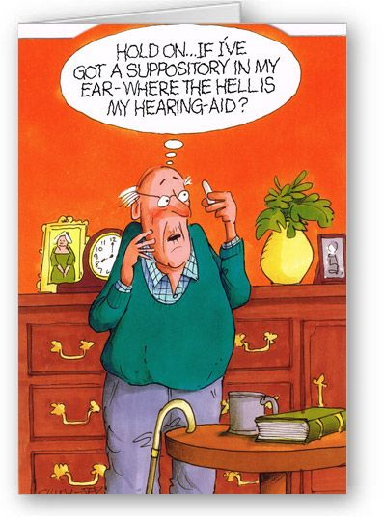

Page 11 Finally

Animals with a sense of humour

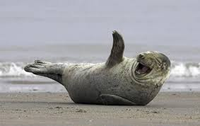

Page 12

We’re on the Web!
Visit us: theshelley.com
Find us on Facebook: TheShelley Worthing
Read Past Newsletters: theshelleynewsletters.weebly.com/
For Just Photos: theshelleyphotos.weebly.com/

The Shelley does not hold, nor claim to hold the copyright on any article or photograph found in print or on the Internet.

