The Shelley
Newsletter – April 2016

The Shelley - 54 Shelley Road, Worthing, West Sussex, BN11 4BX. t: 01903 237000 e: info@theshelley.com
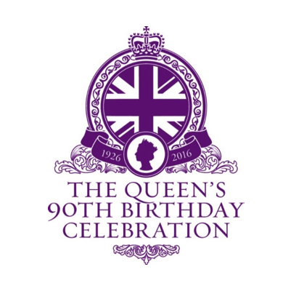

Inside This Issue
April 1
March in Pictures 2
Famous Fools 4
No Fuss 90 5
Resident Contributions 9
Coins 11
John’s Rhymes 16
Entertainment 18
And Finally 19

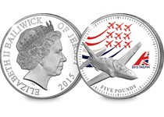
We are celebrating
The Queen’s 90th with a Vintage Tea Party
on the 21st April.

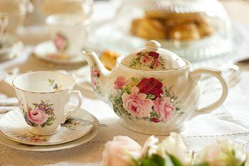
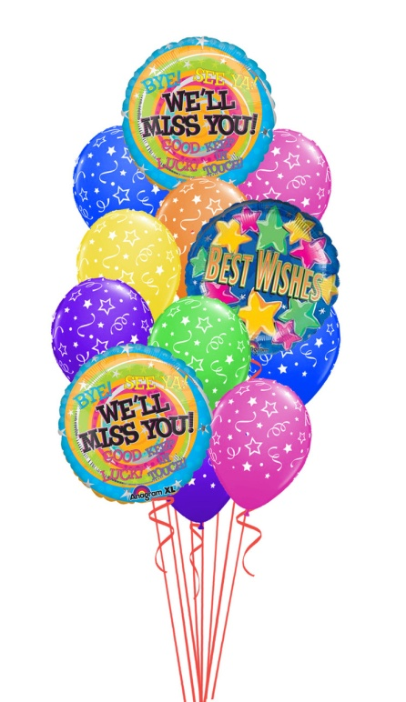

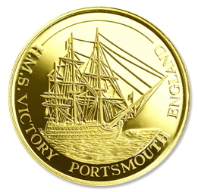

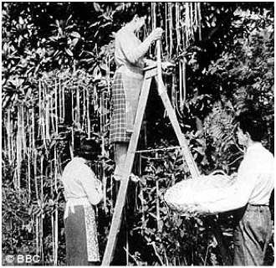

Page 2 March in Pictures

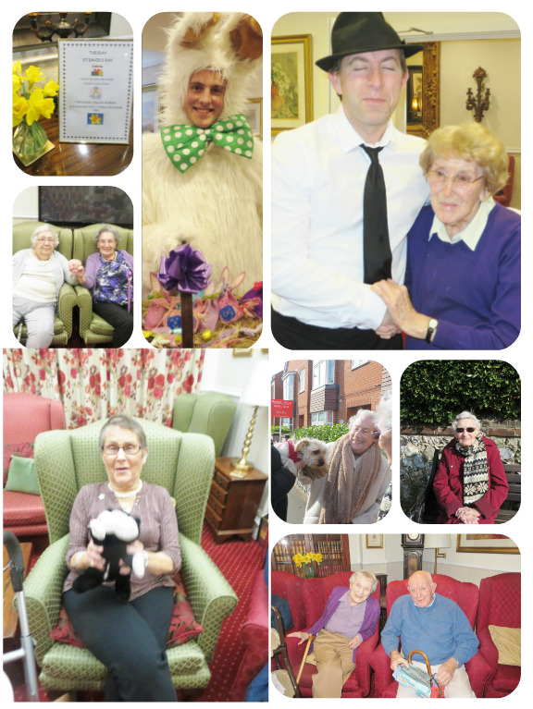

Page 3

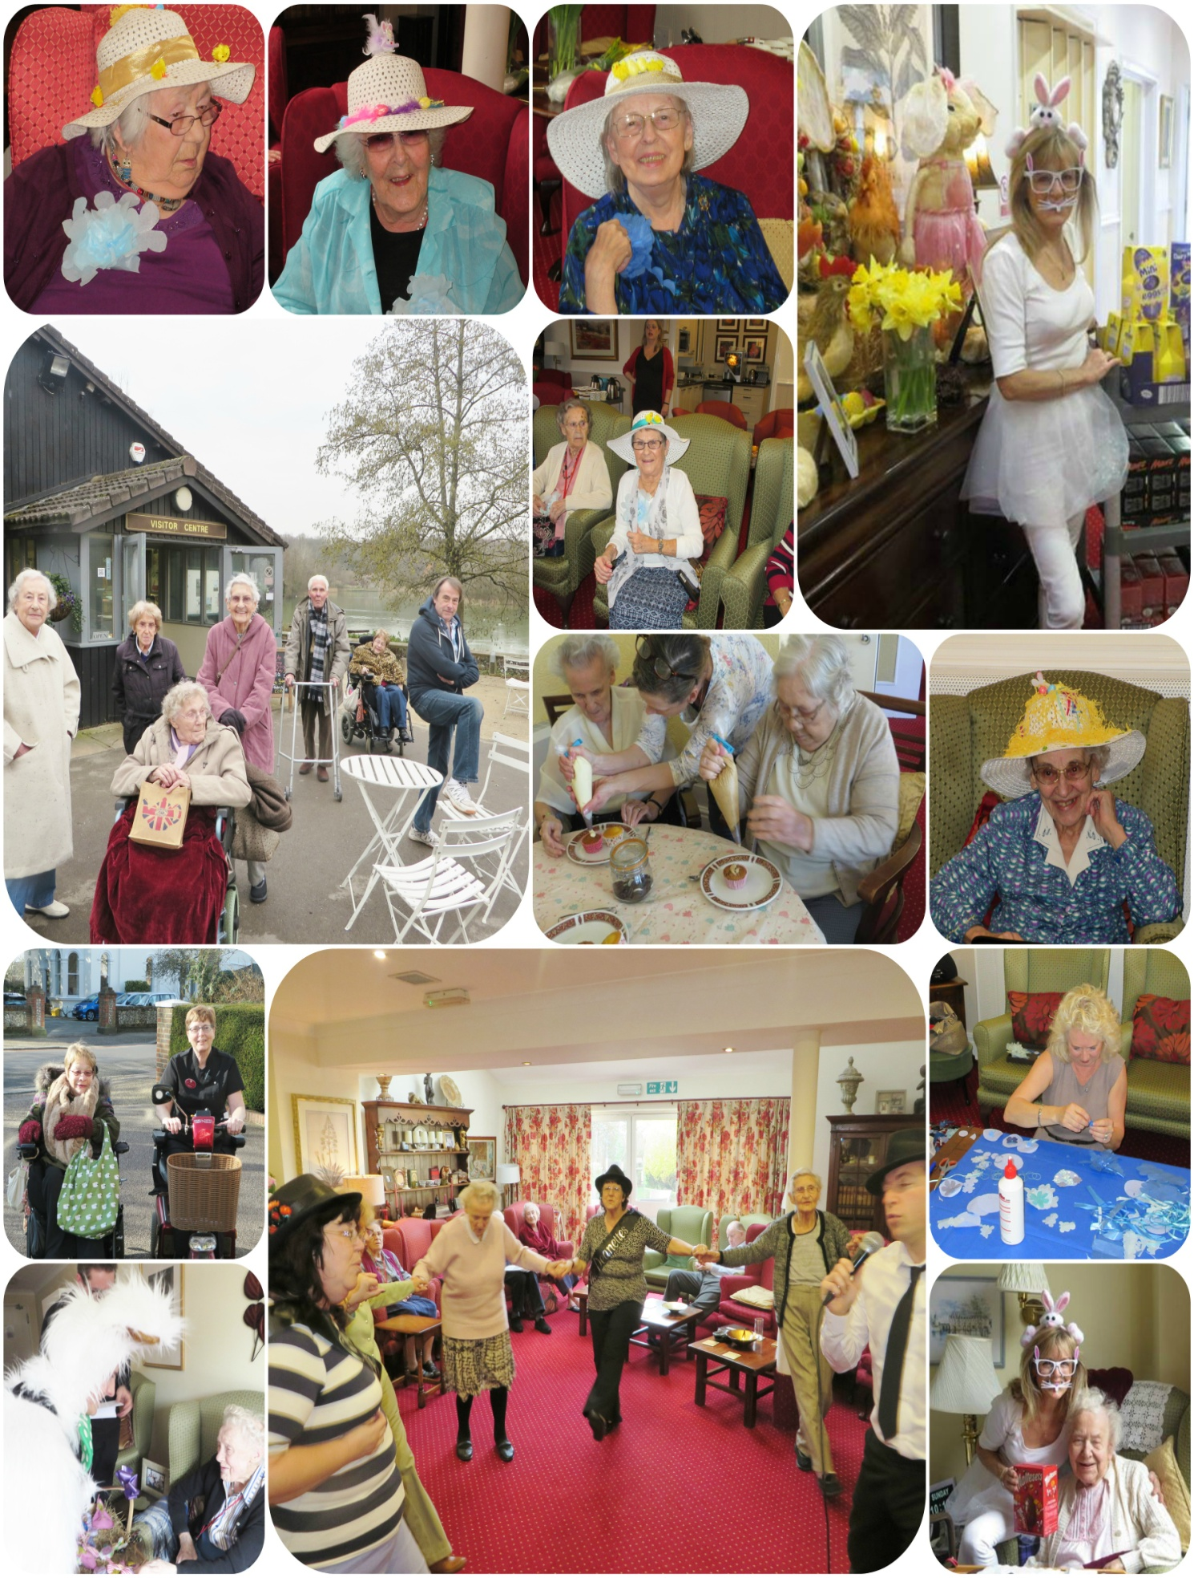

Most of us know of the spaghetti growing BBC April Fool hoax announcement of 1957.
Page 4 Famous Fools

Probably the best one after that was:
April 1, 1976: During an early-morning interview on BBC Radio 2, the British astronomer Patrick Moore announced that at 9:47 AM that day a once-in-a-lifetime astronomical event was going to occur. Pluto would pass behind Jupiter, and this planetary alignment would temporarily counteract and lessen the Earth's own gravity. Moore told his listeners that if they jumped in the air at the exact moment the alignment occurred, they would experience a strange floating sensation. When 9:47 AM arrived, the station began receiving hundreds of phone calls from listeners claiming to have felt the sensation. One woman reported that she and her friends had risen from their chairs and floated around the room. Moore had intended his announcement to be a spoof of a pseudoscientific theory that had recently been promoted in a book called The Jupiter Effect, alleging that a rare alignment of the planets was going to cause massive earthquakes and the destruction of Los Angeles in 1982.

We hope you were not fooled too much on the 1st this year – Happy April Fool’s Day!

Page 5 Elizabeth At 90

This month is Queen Elizabeth 2nd 90th birthday; she will celebrate her day at Windsor Castle.
This month we will look at those 90 years

21/04/1926
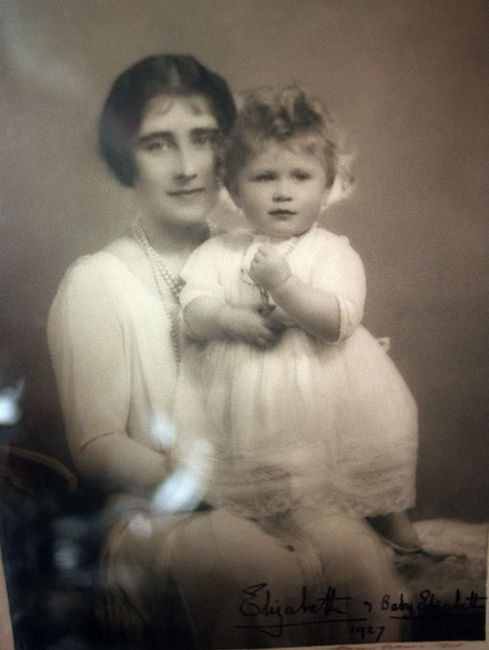
The Queen was born at 2.40am on April 21, 1926, at 17 Bruton Street in Mayfair, London.

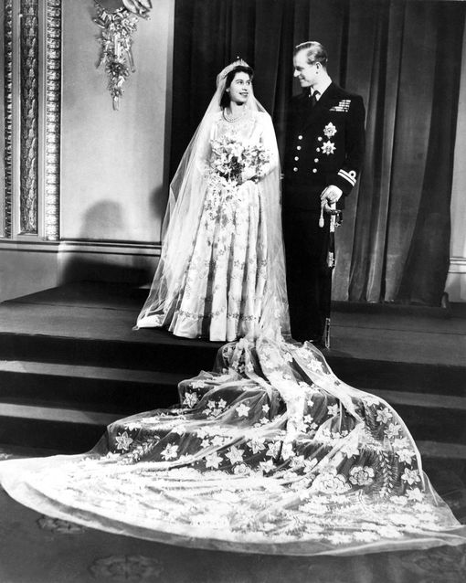
20/11/1947
The Queen and The Duke of Edinburgh were married on November 20, 1947, in Westminster Abbey. The event was fairly simple, as Britain was still recovering from the war, and Princess Elizabeth had to collect clothing coupons for her dress, like any other young bride.

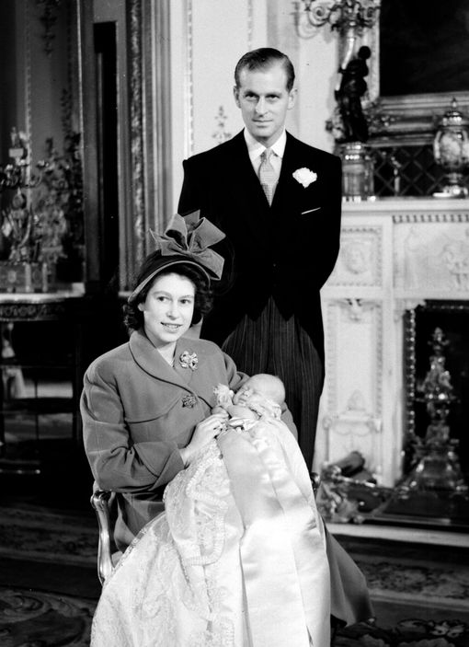

14/11/1948
Prince Charles, the heir apparent of Queen Elizabeth II, is born,

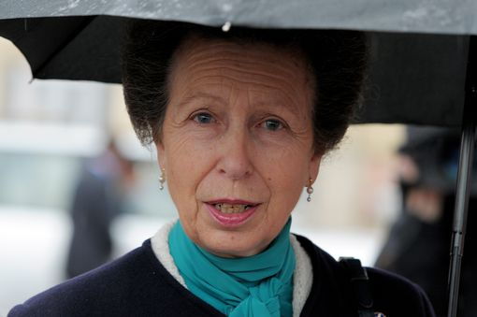
15/08/1950
The Princess Royal, the second child and only daughter of The Queen and The Duke of Edinburgh, was born at Clarence House, London, on August 15, 1950

Page 6

06/02/1952
On February 6, 1952, Princess Elizabeth received the news of her father's death and her own accession to the throne, while staying in a remote part of Kenya. The tour had to be abandoned, and the young Princess flew back to Britain as Queen.

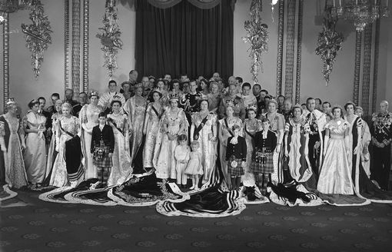

02/06/1953
The Coronation took place in Westminster Abbey on June 2, 1953. It was a solemn ceremony conducted by Dr Geoffrey Fisher, Archbishop of Canterbury.

19/02/1960
Prince Andrew was born at Buckingham Palace on February 19, 1960. He was the first child born to a reigning monarch at Buckingham Palace since the birth of Queen Victoria's youngest child, Princess Beatrice, in 1857.

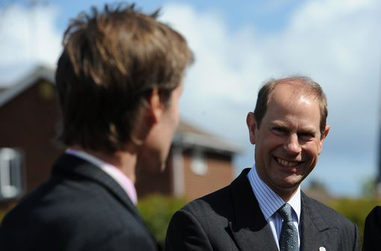

10/03/1964
Prince Edward was born at Buckingham Palace on March 10, 1964, the fourth and last child of Queen Elizabeth II and the Duke of Edinburgh.

Page 7

07/06/1977
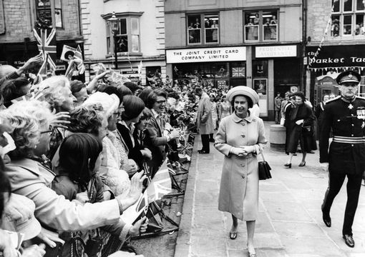
In 1977, The Queen marked 25 years as Sovereign. The Silver Jubilee was met with a nationwide tour, Commonwealth visits and celebrations at every level. Jubilee Day, June 7, 1977, was marked by a bonfire chain, a public holiday, and a thanksgiving service in St. Paul's Cathedral. Street parties were held around the country.

21/04/1986
In 1986 The Queen took part in celebrations in Windsor and London to mark her 60th birthday.

20/11/1997

The Queen and The Duke of Edinburgh celebrated their Golden Wedding. A special garden party for couples celebrating their Golden Wedding was held at Buckingham Palace in July.

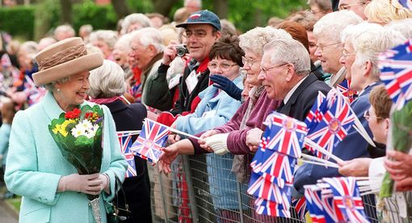
06/02/2002
The year 2002 marked the 50th anniversary of The Queen's Accession to the throne. The year began with personal sadness for The Queen. Her sister, Princess Margaret, died in February and The Queen Mother, aged 101, died only a few weeks later, on March 30. Despite her bereavements, The Queen continued her duties, and embarked on a programme of events to mark her Golden Jubilee.

Page 8

21/04/2006
The Queen turned 80 on April 21, 2006. A number of events took place to celebrate the birthday, both around Her Majesty's actual birthday and her official birthday on June 17.

20/11/2007
The Queen and The Duke of Edinburgh celebrated their 60th wedding anniversary on November 20, 2007

06/02/2012
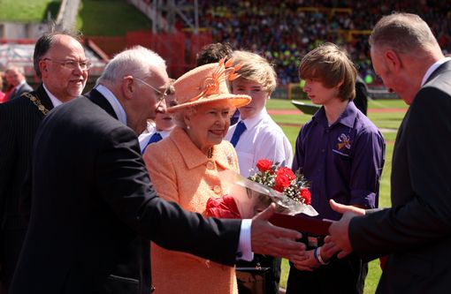
The Queen’s Diamond Jubilee was marked with a spectacular central weekend, a series of regional tours throughout the United Kingdom by Her Majesty, and Commonwealth visits undertaken by other members of the Royal family in support of The Queen.

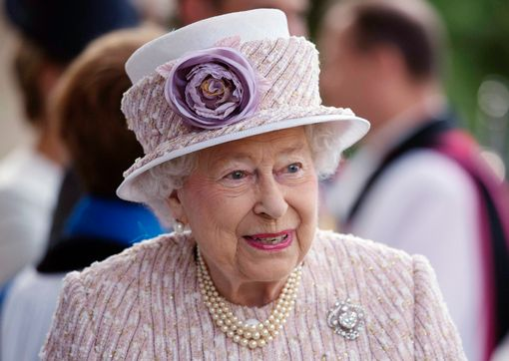
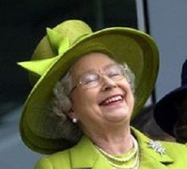

09/09/2015
Queen Elizabeth II makes history by becoming the UK’s longest serving monarch - overtaking Queen Victoria’s reign of 63 years, seven months and two days.

Page 9 Resident Contributions

Joy was given this ‘advice’ by a friend and would like to share it with us all.
They can be found in some sea-side shops in the UK and abroad.

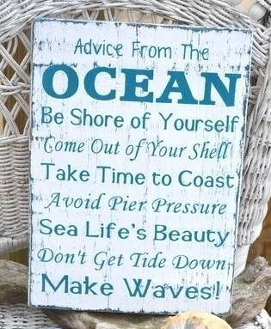

Page 10

See page 19 for the answers

- What is even worse than taking a bite from your apple and finding a worm in it?

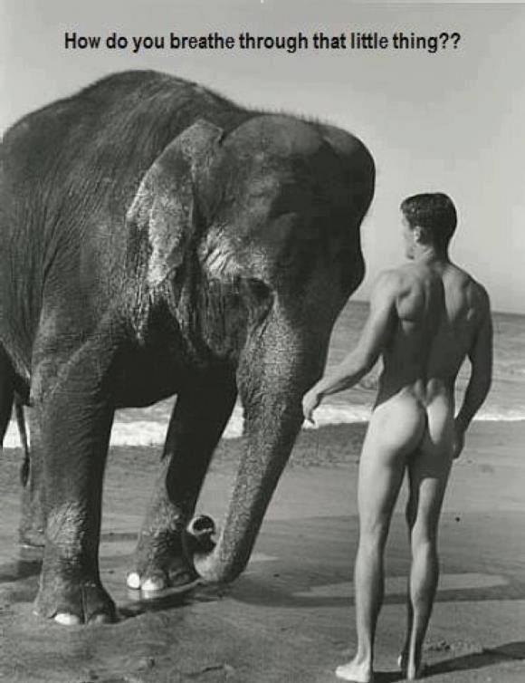
- Mice can multiply very fast. Adult mice can give birth once every month, and baby mice grow into adult mice in just two months after they are born.
With that information, can you work out the following?
If you would buy a baby mouse just after it was born, how many mice would you have in 10 months?

- What do you call an alligator in a vest?

- What happens if you eat yeast and shoe polish?

- Where do bees go to the bathroom?

Page 11 Commemorative Coins

Contemporary coin collecting and appreciation began around the fourteenth century. Before then, people used to collect or hoard coins for their bullion value since they were made.
From The Jubilee Mint
Today there are a number of mint offices in the UK, all producing commemmorative coins, trying to out-do each other with the most inovitive design to tempt buyers.

The most well know company is The Royal Mint. Others include – Westminster Collection, The London Mint Office, The Tower Mint, Windsor Mint, British Pobjoy Mint, Birminham Mint, Jubilee Mint and St Pauls Mint.

Commemorative coins have been issued by the Royal Mint in the United Kingdom since 1935. Initially they only came out to mark events of great interest, but since the turn of the millennium have been minted yearly.
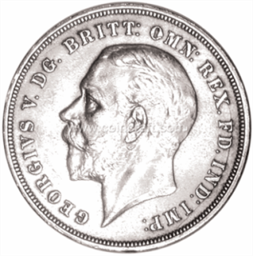
Until decimalisation crowns (five shilling coins) were used for this purpose as they were the highest denomination of the time, but due to inflation this rôle has been transferred to higher value coins.
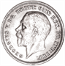
The 1935 Specimen Crown
The 1935 George V Silver Jubilee Specimen Crown can still be found on offer at £89.50 on some web pages.

In 1935 King George V celebrated his Silver Jubilee and the Royal Mint issued its first commemorative crown to honour the event. They issued them in Gold and Silver Proof, but both sold out so quickly, that there were a lot of disgruntled collectors around, who didn't get one. So to solve the problem, they issued a Special Specimen edition of the Crown in 500 fine Silver. The Specimen coins have a Prooflike field and just are much better looking.
Crowns, £5 Coins and (until 1996) £2 Coins are non-circulating, although they are still legal tender. These denominations are only used for commemoratives. During the decimal era, crowns were converted to twenty-five pence.
50p and recent £2 Coins circulate normally and can be found in change. Usually about 5 million of each of these are the commemorative issue, the rest being of the standard design. Since 1982 all of these have also been produced as Sterling silver and 22 carat Gold proofs.
Although the design of the £1 Coin changes every year, these are not considered to be commemoratives, as they do not mark an event or its anniversary.

Page 12

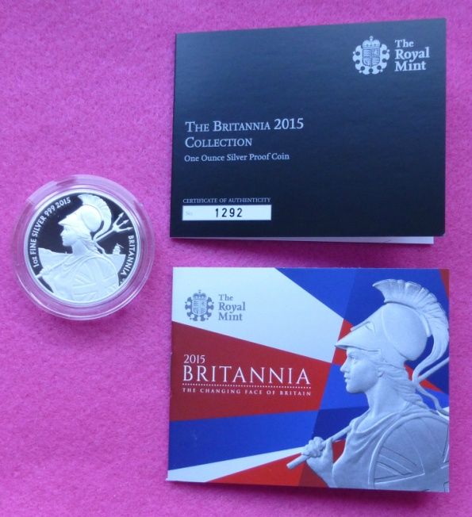
Andrew has been collecting commemorative coins for some time now and shares these delightfully with us. With many of us waiting with anticipation to see what he will find next.
It has to be said that the designers of these coins never cease to amaze us with their innovative creations.
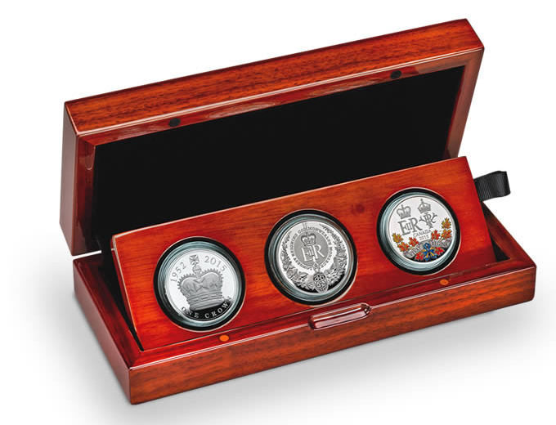
Here are a few of the designs The Royal Mint have produced.

Longest Reigning Monarch of the Commonwealth Silver Set

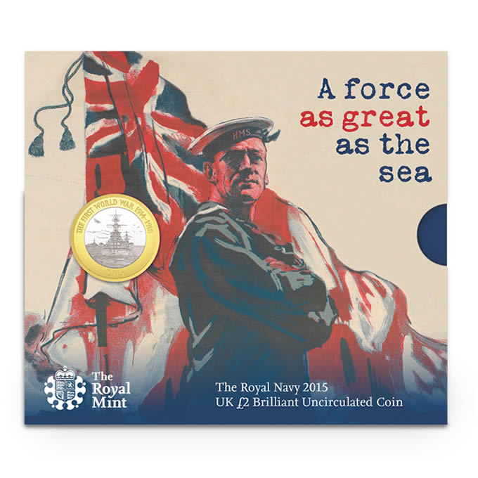
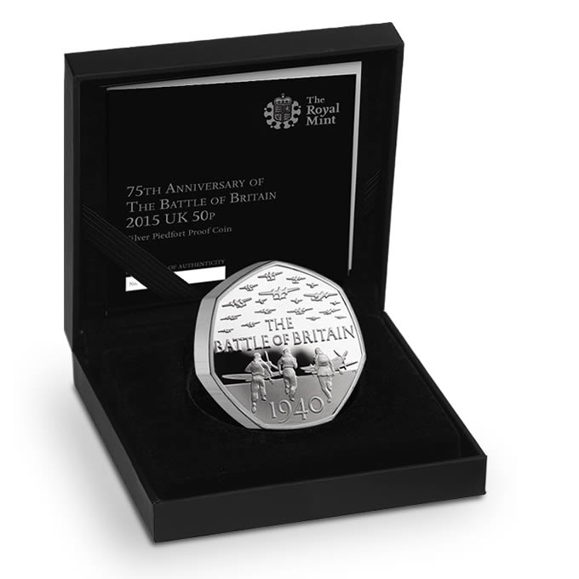
The Royal Navy minted to mark the Centenary of WW1

The 75th Anniversary of
The Battle of Britain

Page 13

Is The London Mint Office the same as The London mint? The quick answer is no, it isn’t. As seen on the Internet, someone else asked this question and had this reply: “The Royal Mint is in Llantrisant, South Wales! this London Mint is a private company who have commissioned coins. they will then entice you with a 'free coin' into buying more of the series! if you want to buy them fine!”
Further investigation appears to hold up the general consensus that this is a scam company that will send out coins for approval and then bill the person for them if they want them or not.
Interestingly, "The Consumer Protection (Distance Selling) Regulations 2000 states that unsolicited goods which have not been ordered and are sent ‘out of the blue’ can be treated as an unconditional gift”; in other words, you can keep them or dispose of them as you wish. The Regulations make it a criminal offence to demand payment or threaten legal action to obtain payment for unsolicited goods or services. You can write to them and asking them to collect the goods and remind them that it is an offence to demand payment. I would be wary of ringing because the phone line tariff could be expensive and another way of them making money from the people they are already harassing.
A complaint about the London Mint Office was upheld by Advertising Standards Agency in 2008, ie. sending people coins and wording the letter to make it look like they had committed to the purchase.
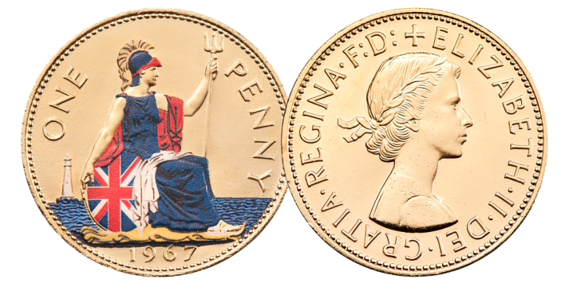
The last-ever Pre-decimal Penny
Offered free of charge on their web page.

Queen Elizabeth II 90th Birthday Commemorative Coin Set
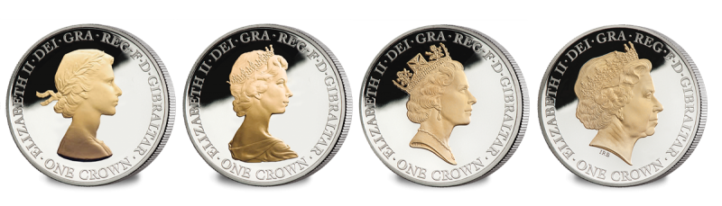
6 Piece Commemorative Set - Layered in pure Silver and Accented in pure Gol

The Westminster Collection is a leading distributor of collectable stamps and coins, acting on behalf of Postal Administrations, Mints and Ministries of Finance across the globe. The roots of the family business go back to 1945.
Page 14

The original Harry Allen business was established after the war by Mr Allen who transformed his childhood “business” trading stamps at school into a “proper” business wholesaling new issue stamps. At the vanguard of the philatelic boom of the late 1960 and 1970s, Harry Allen was one of the very first companies to sign an international stamp agency agreement, allowing face value wholesale sales of stamps outside the issuing country.

The Harry Allen name remains at the forefront of today’s new issue philatelic trade, holding philatelic agencies for around 75 countries, including, USA, Canada, Australia, New Zealand and Eire.

In 1987 his son, Stephen Allen, formed The Westminster Collection to make stamp collecting more interesting and accessible to general public. Within a few years coins were also featuring alongside thematic stamp collections for events such as the Queen Mother’s 90th Birthday, the 40th Anniversary of the Accession and the 50th Anniversary of D-Day.

By bringing together some of the key issues for events of importance for the British collector and creating exclusive and limited edition pieces, The Westminster Collection has provided a way for many hundreds of thousands of collectors to own a piece of British history and heritage – perfect to pass down to children and grandchildren.

The Westminster Collection remains a family business, with Stephen as Chairman. We hope that our many years experience servicing the needs of collectors helps set The Westminster Collection apart from other foreign-owned businesses and the more impersonal world of national mints and postal authorities.
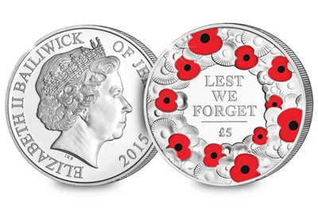

The Remembrance Day £5 Silver Poppy Coin

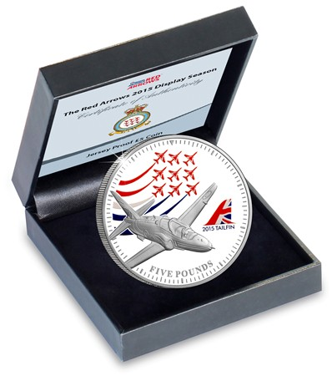

Page 15

Minted to celebrate the 2015 Display Season of the RAF Aerobatic Squadron – the Red Arrows.
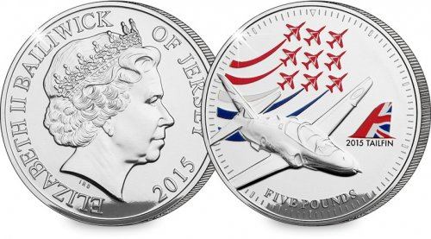

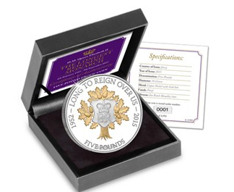

Longest Reigning Monarch
£5 Proof Coin

And then, just when you think Westminster could do no better, they produced the first Quilled coin.
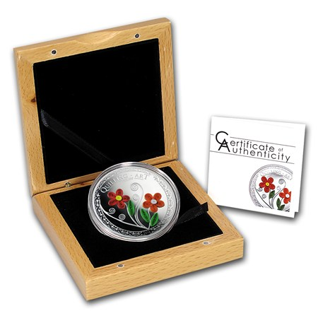
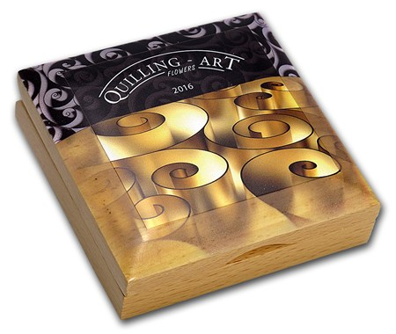
Even the presentation box is stunning.

The first coin of its kind features the 500 year old art of Quilling, combining the elaborate art form with the highest minting standard.
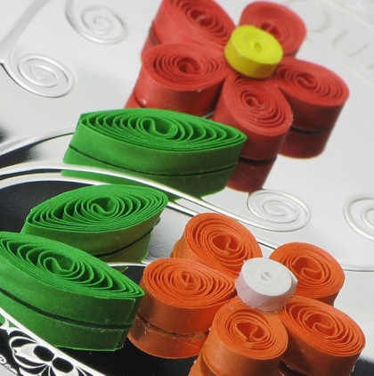
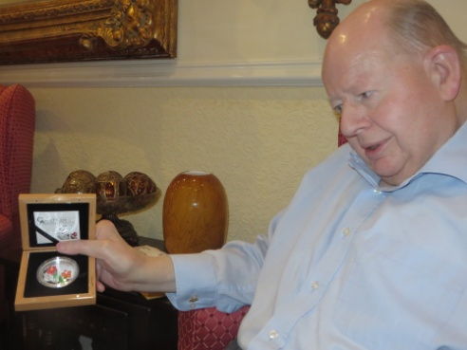
Quilling involves the skillful rolling and forming of paper strips to create wonderful, vibrant 3D images.
This stunning coin is 50mm in diameter, an unusual size for a legal tender coin, and has been struck in 1/2 oz of pure silver to a proof finish. The quilled element has never been seen in the numismatic world before and forms the shape of two colourful flowers.

The Open Road
Page 16 John’s Rhymes

I have a brand new atlas
Not all the world you know
Just all the roads of Britain
So l know where I could go.
There used to be a lot of bits
Of roads that I knew well
But now that it's all fading
The maps will do as well.
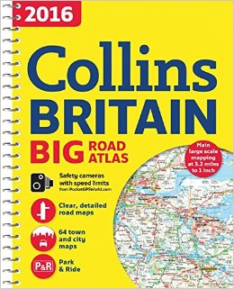

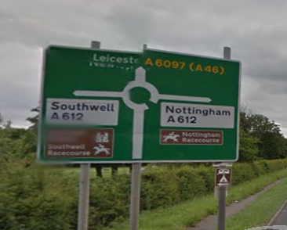
Oh! Here's a place said “Suth-ell”
Once went there for a spin
But of course I called it South-well
Which made the natives grin.
I once knew every town
Upon this stretch of road
But I don't remember that one
P'raps, like Topsy, it just growed.

Now here's a hill they call the Wrekin,
A very famous mound,
If they say you're going round it
They mean the long way round.
And what of dear old Worthing
Once came here years ago
Didn't think much of it
Now I'm living here you know.
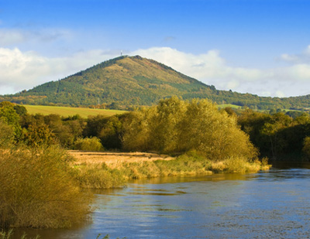

Mary Rose
Page 17

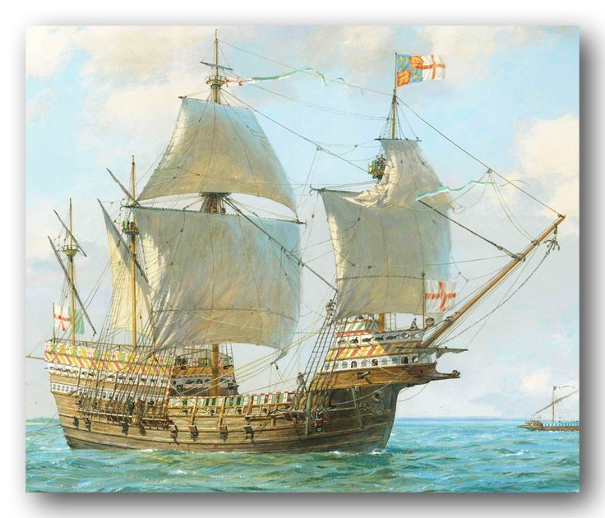

On Southsea Castle stood the king
Both fists clenched up tight
His enemies were very close
Right by the Isle of Wight.
Then out from Portsmouth Harbour
Sailed his very latest toy
It was the good ship Mary Rose,
His special pride and joy.

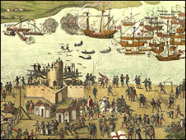
"We'll sail right past the castle,"
Said Sir Archibald Dimwit,
"Then we'll turn right and wave our swords
"And really go for it."

"I want the gunports open
"And my men brought up on deck
"So the king can see those guys
"Will get it in the neck."
"But Sir," exclaimed the skipper,
"Is that very wise?"
"For if a sudden squall should come
"We'd be sure to capsize."
"Do what I say," roared Archibald,
"Don't argue any more
"If you upset me once again
"I'll wop you on the jaw."
Then every seaman in the ship
From the skipper to the lad
Knew that if a squall should come
It would be very bad.
And sure enough the squall that came
Laid them on their side
And in the ports the water rushed
And, sadly, they all died.

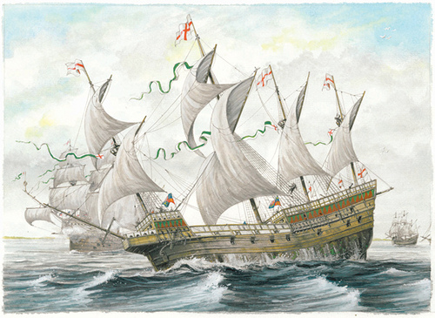

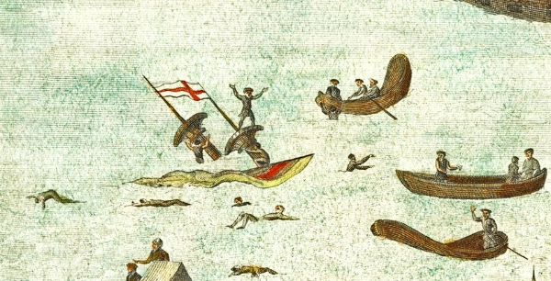

"I'll get that stupid Dimwit,"
The angry monarch bawled,
"I'll make him wear pink ankle socks,
"The harshest thing of all."
"You can't do much to Dimwit,"
Said courtier Twinkle Toes,
"He's down there with the fishes
"And so is Mary Rose."

Page 18 Entertainment

Some Entertainment Coming This Month
As well as our weekly outings in the mini-van or walk/ride to the shops/parks etc. we also have many of our favourite entertainers joining us, such as:

2nd April - Bing – Singer and Accordion player

5th April – Curtis singer

6th April – Art lessons with Trisha

7th April – Rocky Road Duo Singers

8th April – Tim West Singer / Guitar Player

9th April – New Dimensions – Singers

15th April – Dawn – Burlesque -Singer

17th April – Jonathon Nulty – Singer

18th April - Arts and Crafts

21st April – Queens 90th Celebrations

22nd April – Geoffrey – Singer/ Pianist

23rd April - St George’s Day Celebrations

29th April - Mary – Accordionist

30th April – Seaside Fun Afternoon

PLUS OUR USUAL
Yoga – Exercises – Aromatherapy – Manicures
Pampering Afternoons – Art and Crafts – Communion
Breathing Spaces - Outings in the mini-van - Shopping Trips

Page 19 Finally

Fishing For….
“Poor Old fool,” thought the well-dressed gentleman as he watched an old man fish in a puddle outside a pub. So he invited the old man inside for a drink. As they sipped their whiskeys, the gentleman thought he’d humor the old man and asked, “So how many have you caught today?”
The old man replied, “You’re the eighth.”

The statements below are taken from actual insurance accident claims forms.
Incidents with Pedestrians.

- The pedestrian ran for the pavement, but I got him.
- The guy was all over the road. I had to swerve a number of times before I hit him.
- I was sure the old fellow would never make it to the other side of the road when I struck him.
- To avoid hitting the bumper of the car in front I struck a pedestrian.
- The pedestrian had no idea which way to run as I ran over him.
- The car in front hit the pedestrian but he got up so I hit him again.
- I saw a slow moving, sad faced old gentleman as he bounced off the roof of my car.
- A pedestrian hit me and went under my car.
- I saw her look at me twice. She appeared to be making slow progress when we met on impact.
Collisions, calamities, and injuries.

- Coming home I drove into the wrong house and collided with a tree I don't have.
- I told the police that I was not injured, but on removing my hat found that I had a fractured skull.
- I pulled away from the side of the road, glanced at my mother-in-law and headed over the embankment.
- I thought my window was down, but I found it was up when I put my head through it.
- As I approached an intersection a sign suddenly appeared in a place where no stop sign had ever appeared before. I was unable to stop in time to avoid the accident.
- In an attempt to kill a fly, I drove into a telephone pole.
- I was thrown from my car as it left the road. I was later found in a ditch by some stray cows.

Answers to page 10 questions.
  - Finding half a worm.
  - One. You cannot have more mice if you start with one!
  - An Investigator
  - Every morning you'll rise and shine!
  - At the BP station!

We will miss you so much, dear Jeanette
Your outings we will never forget!
Your energy and planning
And crosswords and caring -
Now Daniel, and family. No regrets
(Rosemary)

We’re on the Web!
Visit us: theshelley.com
Find us on Facebook: TheShelley Worthing
Read Past Newsletters: theshelleynewsletters.weebly.com/
For Just Photos: theshelleyphotos.weebly.com/

Page 20

The Shelley does not hold, nor claim to hold the copyright on any article or photograph found in print or on the Internet.

