The Shelley
Newsletter – March 2016

The Shelley - 54 Shelley Road, Worthing, West Sussex, BN11 4BX. t: 01903 237000 e: info@theshelley.com
Spring Is Sprung – 20th March!

Inside This Issue
March 1
February in Pictures 2
Whales 4
John’s Rhymes 6
Saint Days 8
Resident Contributions 12
90th Birthday 13
Entertainment 14
And Finally 15

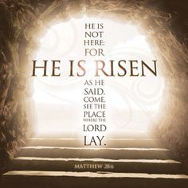

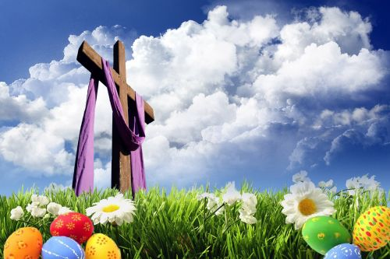
We Have a ‘Communion of Saints’ and Celebration Days in March:
St David’s, March 1st
St Piran’s, March 5th
Mothering Sunday, March 6th
St Patrick’s, March 17th
Easter – Good Friday, March 25th

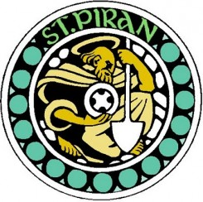

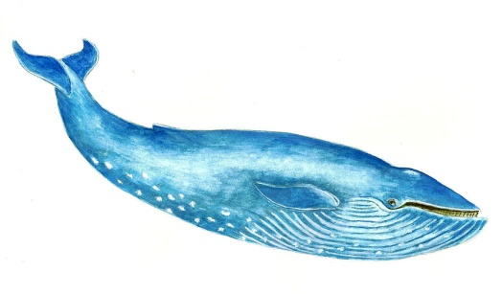

Birthdays, Valentines and the Chinese New Year
Page 2 February in Pictures

Page 3

Last month - Monday, Feb 1 Reported:
Page 4 Whales

Whales wash up on British coast beach.

But Why?

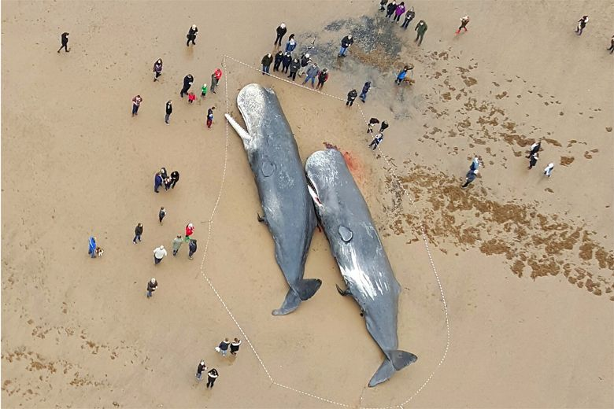
Historical records show that whales have been beaching themselves since at least 300 B.C., however scientists are discovering that whale stranding’s appear to be occurring more frequently and in larger numbers than previously known and while scientists are unclear as to whether this increase in numbers is simply due to more people reporting stranding’s or because the number of stranding’s has actually increased due to human factors it has raised some concerns in the eyes of marine biologists, activists and whale lovers.

Below are some possible causes that may contribute to the beaching of whales.
- Injuries from collisions with boats, ships and other aquatic machines. As more ships take over the ocean and global trade continues to increase so does the opportunities for whales to collide with ships and become injured or disoriented causing them to accidentally strand themselves.

- Water pollution, whales can become sick or poisoned due to pollutant chemicals such as gas and acid, or from the accumulation of daily waste created from everyday living.

- Confusion due to man-made sonar, some biologists and scientists speculate that whales may become disoriented, sick and confused by the use of man-made sonar which may interfere with a whales brainwaves or use of echolocation causing the whale to lose its sense of direction and beach itself.

- Natural diseases, just as humans suffer from sickness and natural diseases marine mammals may also be subject to natural diseases beyond their or our control.

- Attacks from sharks or other marine mammals, whales may beach themselves in an attempt to escape or find cover from shark attacks or attacks from other marine mammals such as the killer whale.

- Poison from various aquatic species, while it is more difficult to find adequate information regarding whales being poisoned by other aquatic species it is definitely possible that a whale could become poisoned and disoriented causing it to swim to shore.

Page 5

- Changes or abnormalities in the earth’s magnetic field, some biologists believe that abnormalities caused by changes in the earths magnetic field may interfere with a whales biological navigation causing it to lose its sense of direction.

- Pneumonia, just as humans get Pneumonia so do whales and there are recorded cases of whales swimming to shore as a result of catching pneumonia.

- Traumas caused by various aquatic elements in the environment, while whales generally have a good sense of direction and are excellent swimmers there are some instances when a whale may collide with a large natural element (ie: a large rock) in its environment causing it to become injured and disoriented.

- Changes in the weather and ocean caused by global warming, a common topic discussed now-a-days is global warming and its impact on the earth. Changes in the tides, melting icebergs and shifting food sources such as fish may force whales to relocate and wander off course causing them to swim into shallow waters or possibly even beach themselves.

- The whale has already died, in some cases a whale may end up beached because it has already died and ended up washing ashore.

- Following the pack, whales are very social creatures often travel in large pods or groups. In rare instances some pods or groups may unknowingly follow a sick or disoriented whale towards shallow waters and/or beaches where they can possibly get stuck in shallow water or end up beaching themselves.

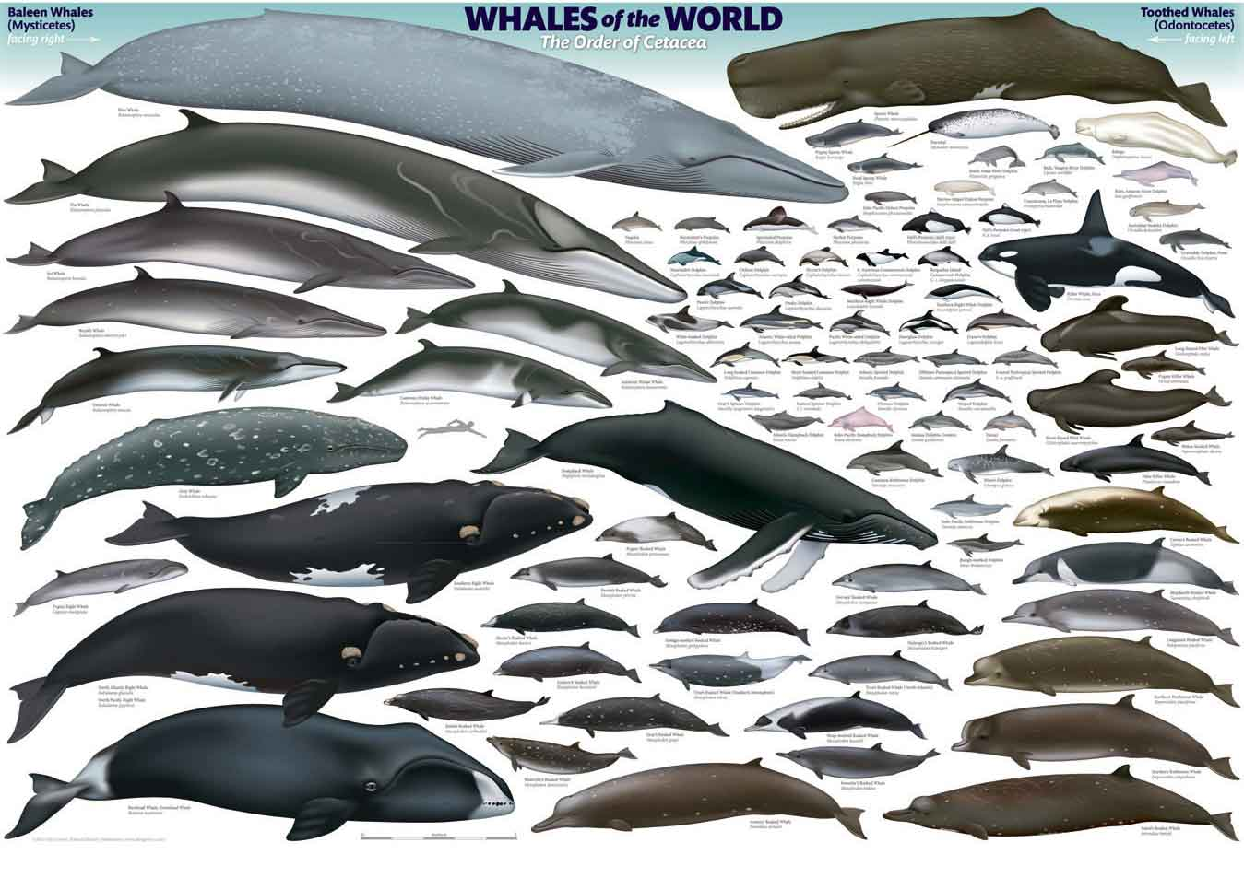
As some of these theories are difficult to prove on a large-scale, they are worth noting because each concept posses a possibility as to why whales beach themselves and is important for finding possible solutions to this problem, especially those that may be caused by the contribution of humans.

Page 6 John’s Rhymes

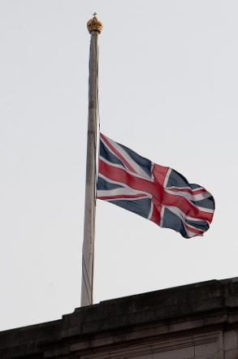
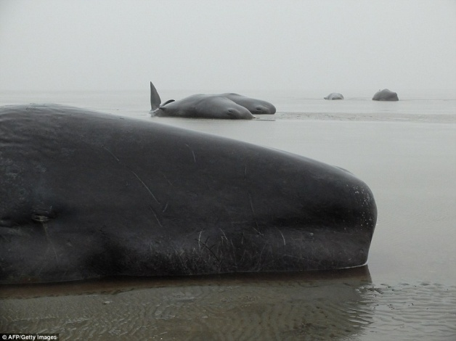
Five Whales
Five dead whales at Worthing,
Washed up on the sand,
Sightseers come from all around
A crowd on every hand.
The council's going crazy,
"It's going to cost a packet,"
On and on so mournfully
And making such a racket.
But what on earth to do with them?
Take them out to sea perchance
Sink them nice and deep
And hope they'll visit France.
Or pass them on to Bognor
Really make their day
Or else perhaps to Brighton
If we went the other way.
Or else we'll have to dump them
A lorry for each one
Five tails sticking out behind
Red flag on every one.
Of course we'll have to close the roads
To let the convoy past
And everywhere for miles around
The flags fly at half-mast.

(Five whales have so far washed up on Britain's coast this year (D. Mirror 25/01/16))

Page 7

They always say that exercise
Helps to keep you fit
Until you fall down flat of course
Then you don't half feel a twit.
Some people go for running
You see them jogging past
But I don't see the point of it
They never will be fast.

I knew of a man who ran
With bagged potatoes on his shoulder,
May have given it up by now
He's certainly much older.
Marching must be very fine
Like the Army does of course,
But one thing that I've noticed,
The General's on a horse.

Distance swimming's very good
(But please don't hit a boulder)
I know a girl who swam for miles
Until she wrecked her shoulder.
I used to get some exercise
Walking with the dog
But the dog's long gone, and anyway
I couldn't do the slog.

So now I get my exercise,
Do me good I hope,
Walking round and round the house,
Confound that wretched slope.

Page 8

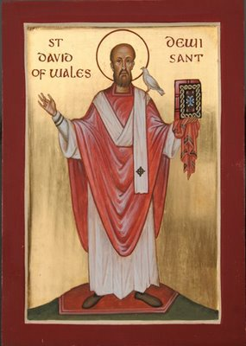
St David plays a very important role in Welsh culture but little is known about his life. It is believed that he lived to be 100 years old and that he died in 589, but the first texts on his life only appeared around five hundred years after his death. This means that it is difficult to tell which aspects of the St David’s story are true and which are legend. He was supposed to have been very gentle and physically strong and tall despite eating a frugal diet. His parents were Sant, the grandson of a prince of Ceredigion in south-west Wales, and Non, a niece of the legendary King Arthur.
St David founded several churches and a monastery in Wales and eventually became an archbishop. St David was canonized in 1120 and March 1 was included in the church calendar as St David's Day. People started making pilgrimages to St David’s monastery after he was canonized. A cathedral still stands on its origina site

St Piran was born in Ireland.

After studying the scriptures in Rome he returned and was made a Bishop.
In Ireland he was said to have performed many miracles, such as raising from the dead soldiers slain in battle. But the Kings of Ireland at the time were not impressed.

It is reported that in the 5th Century St Piran was flung into the sea in Ireland.
He had a millstone around his neck but miraculously he floated across the water to Perran Beach in Perranporth. It was here that he built a small chapel.

St Piran built his oratory amongst the sand dunes. People would come from miles around to hear him preach there.

St Piran discovered tin too, but quite by accident.
A black stone on his fire leaked a white liquid. St Piran had discovered tin.

The Cornish Flag, the Flag Of St Piran (white cross on a black background) represents white tin flowing from the black rock, or good overcoming evil.

St Piran is believed to have lived for 200 years. He was fond of a drink and met his end falling down a well. No date of his death was recorded.

St Piran is one of three Patron Saints Of Cornwall. The other two are St Michael and St Petroc. Michael is associated with St Michael's Mount and St Petroc with Padstow.

Page 9

Most people know St. Patrick 's Day as that you must wear green or you'll get a pinch from your friends. It is an occasion to celebrate, sometimes with green beer and other assorted alcoholic beverages. However, few really know what they are celebrating or why the holiday is so important, particularly in the Americas. Here are 10 facts, some you may not know.

10. March 17th is when Patrick died.
Saint Patrick is a saint of the Catholic Church, and his holy day is the day of his death, and subsequent entrance to heaven, rather than the day of his physical birth. After spending most of his adult life converting the pagans of Ireland to Christianity, St. Patrick went to his reward on March 17, 461 AD

9. St. Patrick wasn't Irish.
St. Patrick wasn't Irish, and he wasn't born in Ireland. Patrick's parents were Roman citizens living in modern-day England, or more precisely in Scotland or Wales (scholars cannot agree on which). He was born in 385 AD.

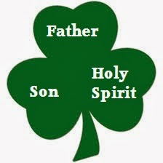
8. St. Patrick was a slave.
At the age of 16, Patrick had the misfortune of being kidnapped by Irish raiders who took him away and sold him as a slave. He spent several years in Ireland herding sheep and learning about the people there. At the age of 22, he managed to escape. He made his way to a monastery in England where he spent 12 years growing closer to God.
7. St. Patrick used the shamrock to preach about the trinity.
Many claim the shamrock represents faith, hope, and love, or any number of other things but it was actually used by Patrick to teach the mystery of the Holy Trinity, and how three things, the Father, The Son, and the Holy Spirit could be separate entities, yet one in the same. Obviously, the pagan rulers of Ireland found Patrick to be convincing because they quickly converted to Christianity.
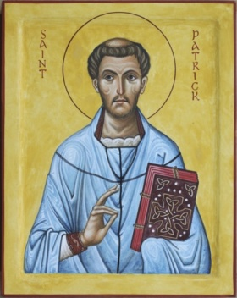
6. Legend says St. Patrick drove all the snakes from Ireland.
According to legend, St. Patrick drove all the snakes, or in some translations, "toads," out of Ireland. In reality, this probably did not occur, as there is no evidence that snakes have ever existed in Ireland, the climate being too cool for them to thrive. Despite that, scholars suggest that the term "snakes" may be figurative and refer to pagan religious beliefs and practices rather than reptiles or amphibians.
5. Patrick's color is blue.
The original color associated with St. Patrick is blue, not green as commonly believed. In several artworks depicting the saint, he is shown wearing blue vestments. King Henry VIII used the Irish harp in gold on a blue flag to represent the country. Since that time, and possibly before, blue has been a popular color to represent the country on flags, coats-of-arms, and even sports jerseys.
Green was associated with the country later, presumably because of the greenness of the countryside, which is so because Ireland receives plentiful rainfall. Today, the country is also referred to as the "Emerald Isle."

Page 10

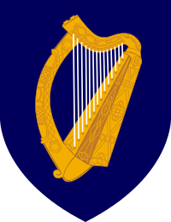
4. The Shamrock is not the symbol of Ireland.
The shamrock is a popular Irish symbol, but it is not the symbol of Ireland. As early as the medieval period, the harp has appeared on Irish gravestones and manuscripts. However, it is certain that the harp was popular in Irish legend and culture even well before that period.
Since the medieval period, the harp has represented the nation. King Henry VIII used the harp on coins as early as 1534. Later, the harp was used on Irish flags and Irish coats of arms. The harp was also used as a symbol of the Irish people during their long struggle for freedom. Starting in 1642 the harp appeared on flags during rebellions against English rule. When Ireland became an independent country in 1921, it adopted the harp as the national symbol.
3. There are more Irish in the USA than Ireland.
Well, sort of. An estimated 34 million Americans have Irish ancestry. Some are pure-blood Irish, meaning they or their parents came from Ireland, but many more have mixed ancestry today. By contrast, there are 4.2 million people living in Ireland. This peculiarity has a lot to do with the troubled history of Ireland. During the potato famine in Ireland, millions of Irish left the country for the US. This diaspora of Irish continued throughout much of the 19th century. Great numbers of Irish immigrants filled factories, served as railroad laborers --and even joined the military, sometimes immediately upon stepping foot on American soil! During the US Civil War, entire regiments of troops were comprised exclusively of Irish immigrants. It wasn't until the economic boom of the 1990s that more Irish stayed in their native country than traveled abroad searching for better opportunities.
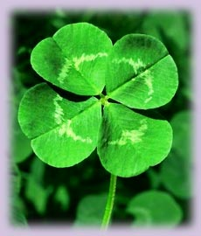
2. St. Patrick's Day in the US has a strong political history.
In the mid 19th century, the Irish faced discrimination much like that faced by African Americans. In a few rare instances, prejudice against the Irish was even more fierce! The Irish were culturally unique, Catholic, and because of deplorable conditions in Ireland, flooded into the US in large numbers. They were perceived as a potentially disloyal and were treated harshly. To combat this, the American Irish began to organize themselves politically. By the end of the 19th century, St. Patrick's Day was a large holiday for the Irish and an occasion for them to demonstrate their collective political and social might. While the political emphasis has faded along with the discrimination, the holiday remains ever popular as an opportunity for festivity regardless of one's cultural background.
1. St. Patrick's was a dry holiday in Ireland until 1970.
Aside from the color green, the activity most associated with St. Patrick's Day is drinking. However, Irish law, from 1903 to 1970, declared St. Patrick's Day a religious observance for the entire country meaning that all pubs were shut down for the day. That meant no beer, not even the green kind, for public celebrants. The law was overturned in 1970, when St. Patrick's was reclassified as a national holiday - allowing the taps to flow freely once again.

Your odds of finding a four-leaf clover are about 1 in 10,000.

Page 11

Mothering Sunday is the fourth Sunday of Lent.
It is not absolutely certain exactly how the idea of Mothering Sunday began. It is known however, that on this day, about four hundred years ago, people made a point of visiting their nearest big church (the Mother Church). People who visited their mother church would say they had gone "a mothering."
Young girls and boys 'in service' (maids and servants) were only allowed one day to visit their family each year. This was usually Mothering Sunday. Often the housekeeper or cook would allow the maids to bake a cake to take home for their mother. Sometimes a gift of eggs; or flowers from the garden (or hothouse) was allowed. Flowers were traditional, as the young girls and boys would have to walk home to their village, and could gather them on their way home through the meadows.

Easter Sunday is a Christian holiday about Jesus Christ's resurrection.
Easter Sunday is the first Sunday after the first full moon on or after the vernal equinox. For many people, Easter marks the celebration of the resurrection of Jesus Christ after his crucifixion. However, many of the origins of the customs around Easter originate in the pagan beliefs held by the inhabitants of England, Wales, Scotland and Ireland before they were converted to Christianity.
People who regularly attend church often attend special services on Easter Sunday.
Easter is an important time for the confectionery industry. Chocolate Easter eggs are covered in decorative foil and packaged in elaborate boxes.
Many people celebrate Easter Sunday by decorating, exchanging or searching for eggs. The eggs may be fresh or boiled eggs laid by chickens or other birds, chocolate eggs or eggs made of other materials. Many children believe that the Easter bunny or rabbit comes to their house or garden to hide eggs. They may search for these eggs or find that the Easter bunny has left them in an obvious place.

Page 12 Resident Contribution

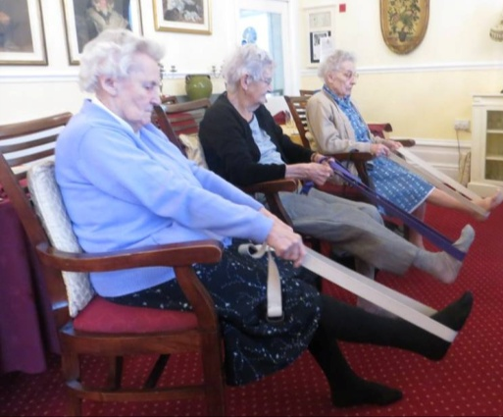

Yoga Day

Hip Hip Hooray, Its yoga day today
Hilary comes with belts & blocks
Come on ladies, remove your socks

Up with our arms
Up with our legs
Don't overdo things, please, she begs

These lessons we love, despite the pain
We can't be too bad
She's smiling again

We ooh'd and we aah'd
But we love it and smile
Now we relax for a blissful short while

Toes, knees, arms, breathing
We now understand
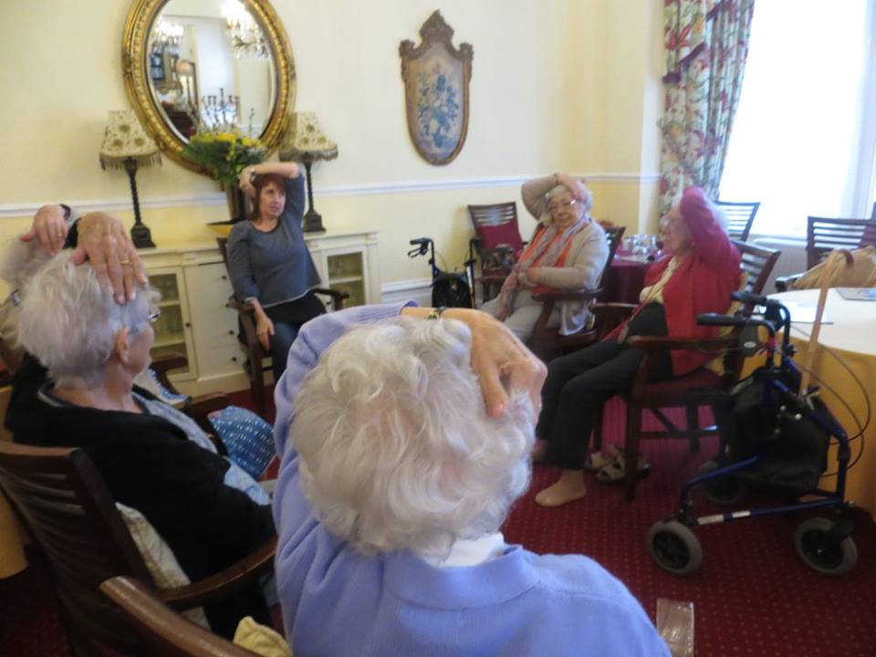
While enjoying our yoga, they go hand in hand

So, `Namaste` dear Hilary
You've made it so clear
In both mind and body
We'll enjoy the new year

Our thanks to Joy

Page 13 90 Next Month

As we all know, Queen Elizabeth II celebrates two birthdays, her actual day of birth on the 21st April and her official birthday, celebrated throughout the commonwealth which was marked on the first, second, or third Saturday in June and since 1974, it has been the Saturday in the range 11 – 17 June.

This year she will celebrate her 90th and will celebrate between 12th and 15th May at Windsor Castle.
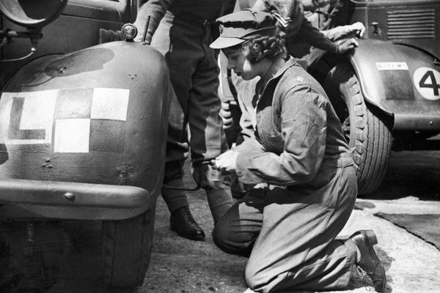
Next month we will dedicate the Newsletter to her majesty; in the meanwhile here is a pictorial diary of her 90 years.
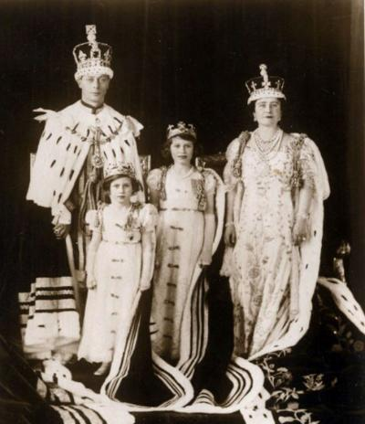

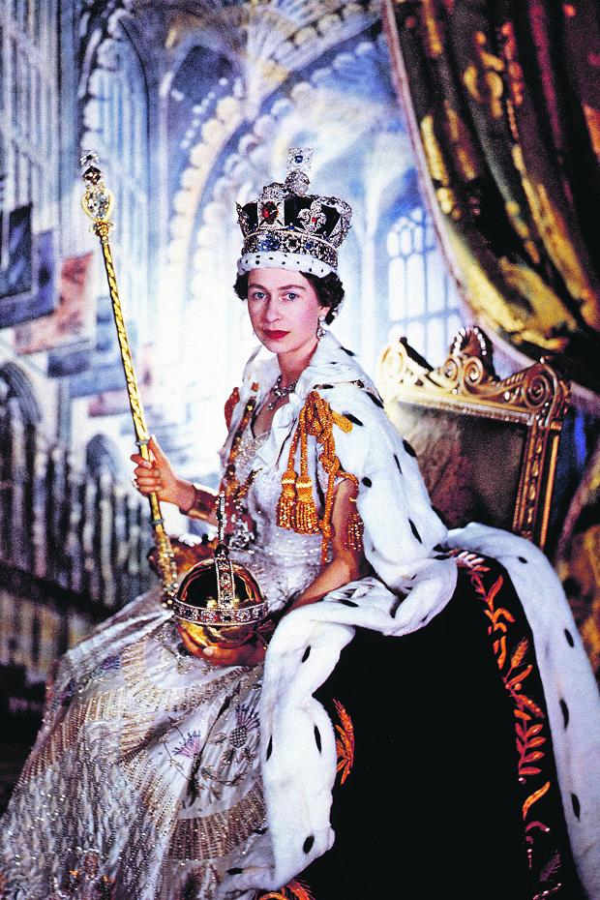
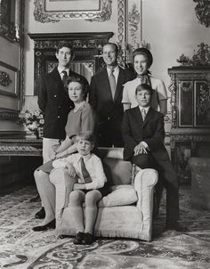

Some Entertainment Coming This Month
Page 14 Entertainment

As well as our weekly outings in the mini-van or walk/ride to the shops/parks etc. we also have many of our favourite entertainers joining us, such as:

Sarah – Violinist 4th
Residents Meeting am / The Campbells pm 5th
Mothering Sunday & Boater Bertie 6th
Rat Pack Dean Ager 11th
Double Time 13th
Penny – Informative Talk (American Wild West) 15th
Easter Service – Mathew (Holy Trinity) 18th
STORM am / Lucy pm 19th
Owls About Town 21st
Pamela 25th
The Boat Race on Easter Sunday 27th
Skittles 29th
Alex – Saxophone Player 30th

PLUS OUR USUAL
Yoga – Exercises – Aromatherapy – Manicures
Pampering Afternoons – Art and Crafts – Communion
Breathing Spaces - Outings in the mini-van - Shopping Trips

Page 15 And Finally

Page 16

Page 17

Here are some riddles for you (Answers page 18)

- There are three men in a boat with four cigarettes but no matches or other way to light them. How do they manage to smoke?
- A boy was born before his father, killed his mother, and married his sister. How is this possible?

- Why is it against the law for a man living in England to be buried in Wales?

- I am a mother and a father, but have never given birth. I’m rarely still, but I never wander. What am I?

- A man rode into town on Friday for a two day visit, then rode out. He arrived on Friday and left on Friday. How?
- In British Columbia you cannot take a picture of a man with a wooden leg. Why Not?

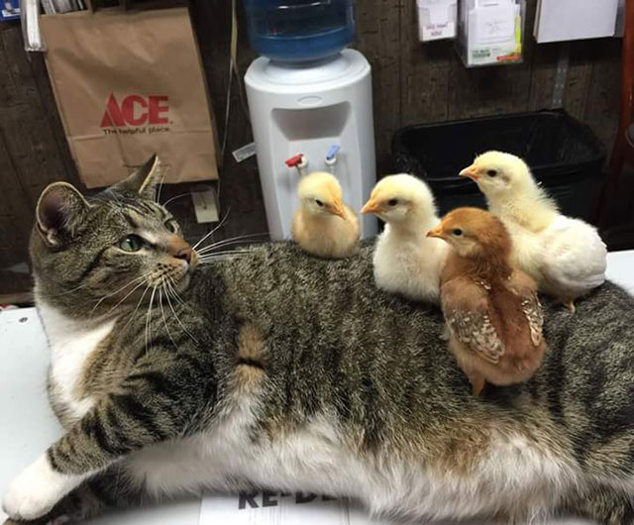

- Can you name three consecutive days of the week without using Wednesday. Friday or Sunday?

Answers to the riddles on page 17

- They throw one cigarette overboard and made the boat a cigarette lighter!
- He was born before his father (As in in-front of), his mum died giving birth, and he married sister when he became a priest.
- Because they are living!
- A Tree
- His horse is called Friday
- Because you can’t take a photo with a wooden leg - you need a camera.
- Yesterday, today and tomorrow.

Page 18

We’re on the Web!
Visit us: theshelley.com
Find us on Facebook: TheShelley Worthing
Read Past Newsletters: theshelleynewsletters.weebly.com/
For Just Photos: theshelleyphotos.weebly.com/

The Shelley does not hold, nor claim to hold the copyright on any article or photograph found in print or on the Internet.

