The Shelley
Newsletter – February 2016

The Shelley - 54 Shelley Road, Worthing, West Sussex, BN11 4BX. t: 01903 237000 e: info@theshelley.com
There Is A Lot To Celebrate This Month

Chinese Zodiac
2016 is the year of the Monkey and starts 8th February.
Based on the year you were born, rather than the month, this zodiac uses 12 animal signs like the rat, horse and dragon.
The 12 animals were chosen deliberately, after many revisions. The zodiac animals are either closely related to ancient Chinese people’s daily lives, or have lucky meanings.

To find out more, read this month’s Newsletter supplement.

Inside This Issue
February 1
January in Pictures 2
Pancakes 4
Resident contributions 7
John’s Rhymes 8
Entertainment 10
And Finally 11

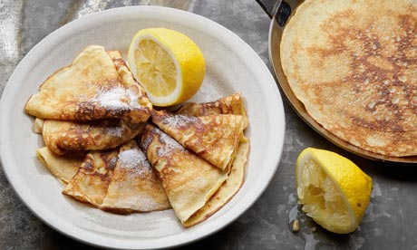

This year Shrove Tuesday, also known as Pancake Day, falls on the 9th of February, the day after Chinese New Year.

And Valentines Day on the 14th

Page 2 January in Pictures

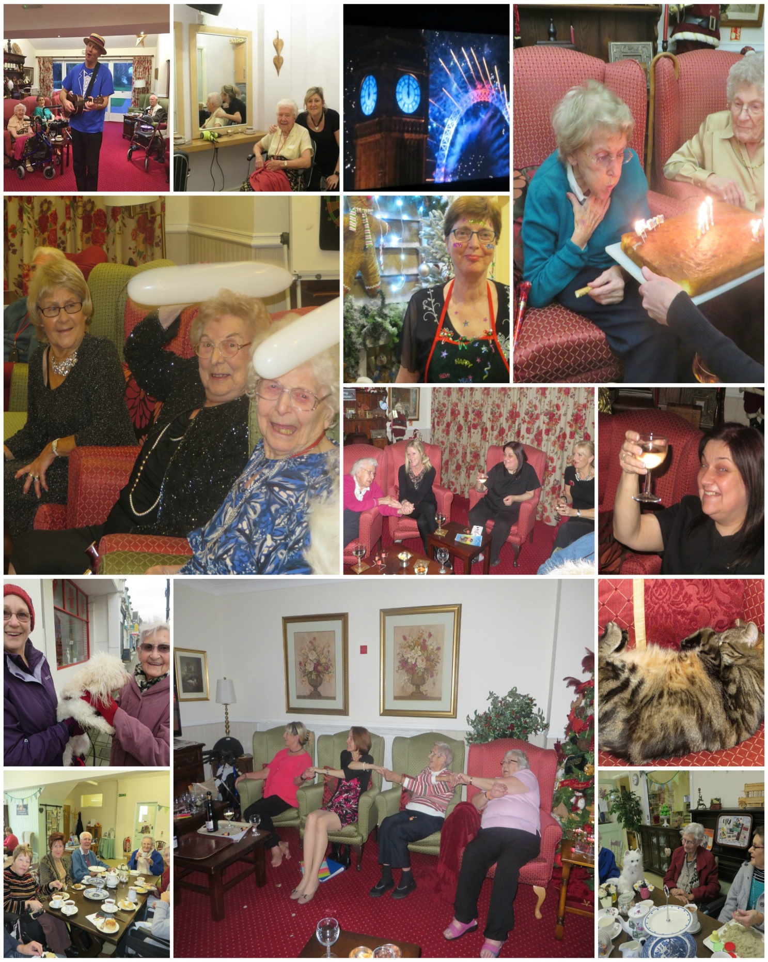
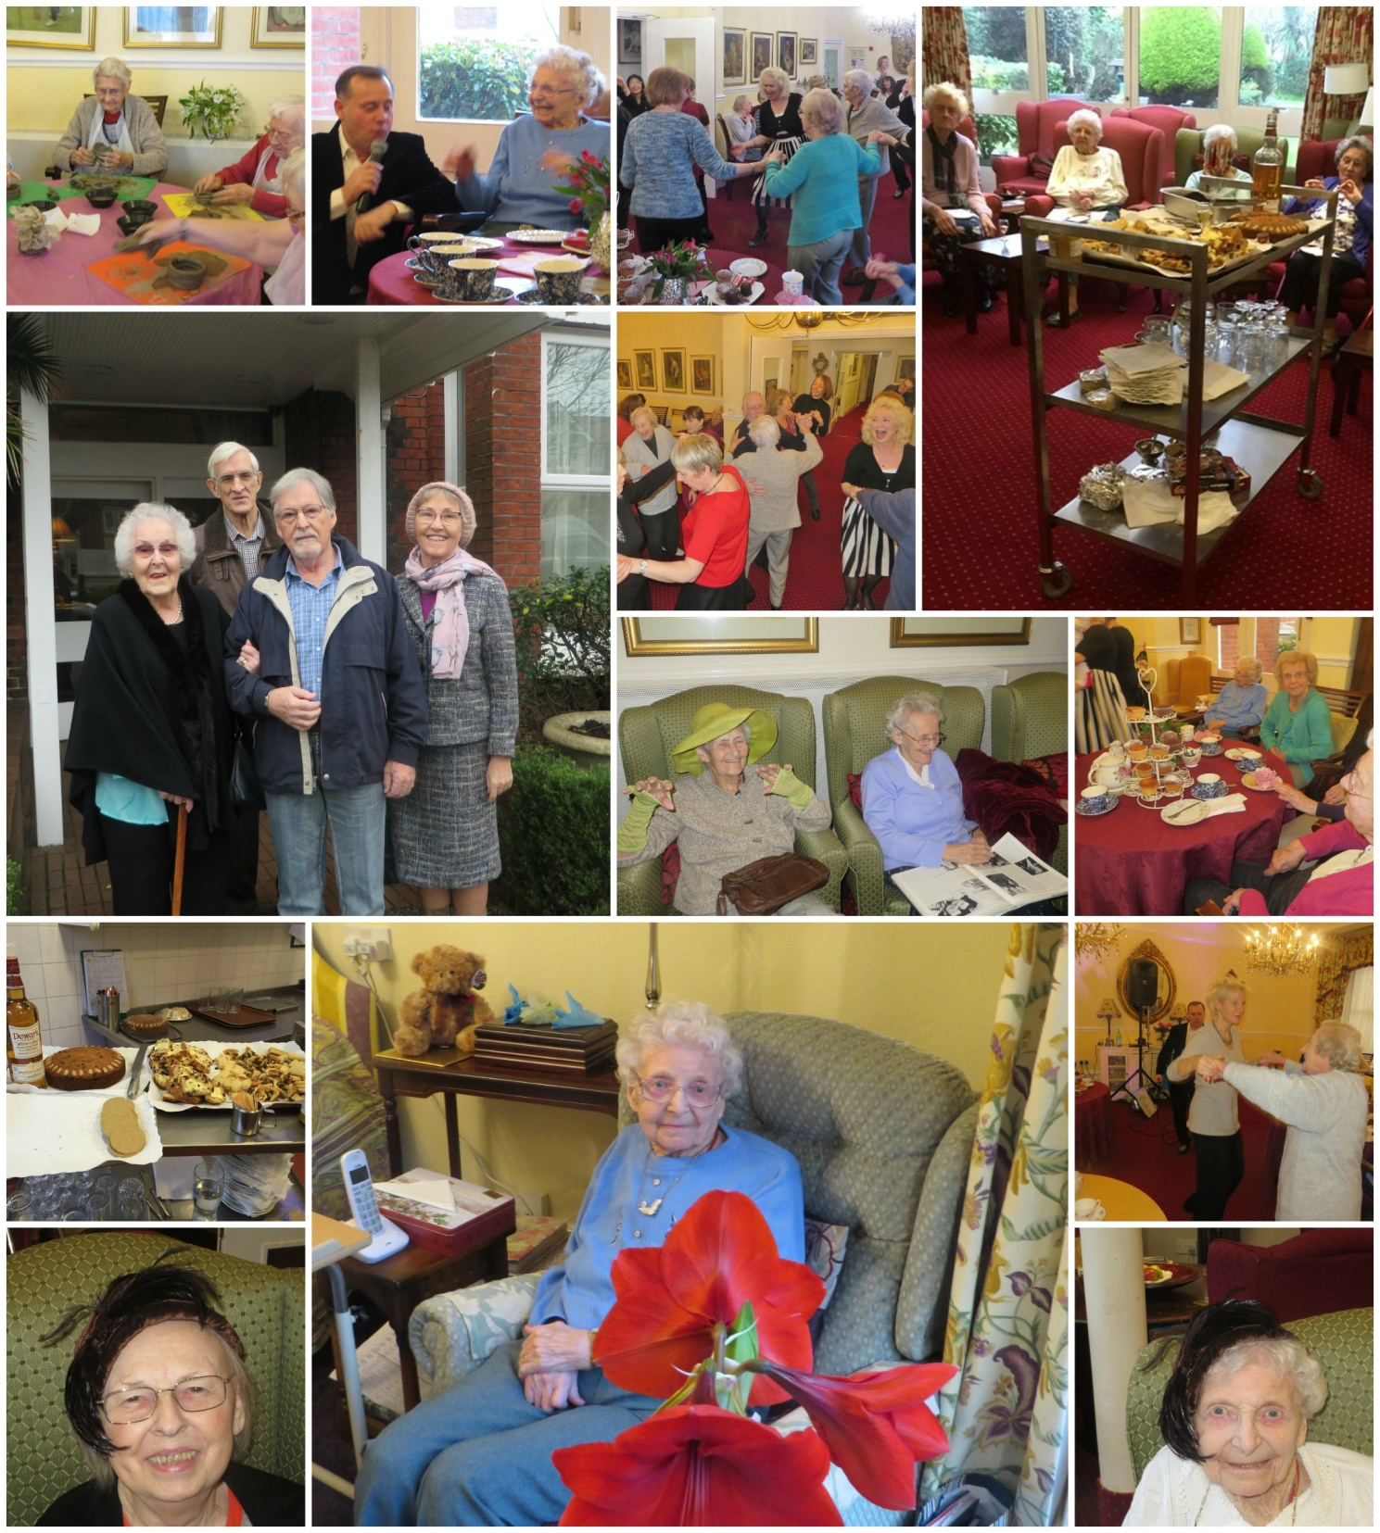
Page 3

It was lovely to see so much fun

Page 4 Pancakes

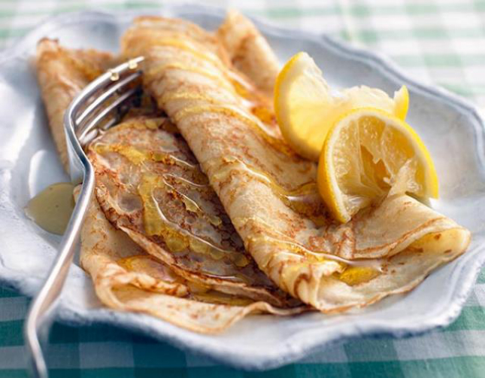
Pancake Day / Shrove Tuesday
A traditional feast day before the start of Lent (a time of fasting 40 days leading up to Easter), when everyone went to confession and were "shriven" (absolved from their sins). A bell would be rung to call people to confession. This later came to be called the “Pancake Bell” and is still rung today.
Shrove Tuesday falls 47 days before Easter Sunday, so the date varies from year to year and falls between February 3 and March 9. This year Shrove Tuesday will fall on the 9th February, the day after Chinese New Year.
Shrove Tuesday was the last opportunity to use up eggs and fats before embarking on the Lenten fast and pancakes are the perfect way of using up these ingredients. A traditional English pancake is very thin and is served immediately. Golden syrup or lemon juice and caster sugar are the usual toppings.
The pancake has a very long history and featured in cookery books as far back as 1439. The tradition of tossing or flipping them is almost as old: "And every man and maide doe take their turne, And tosse their Pancakes up for feare they burne." (Pasquil's Palin, 1619).
The ingredients for pancakes can be seen to symbolise four points of significance at this time of year:
Eggs ~ Creation
Flour ~ The staff of life
Salt ~ Wholesomeness
Milk ~ Purity
Here in the UK, pancake races form an important part of the Shrove Tuesday celebrations - an opportunity for large numbers of people, often in fancy dress, to race down streets tossing pancakes. The object of the race is to get to the finishing line first, carrying a frying pan with a cooked pancake in it and flipping the pancake as you run.

Page 5

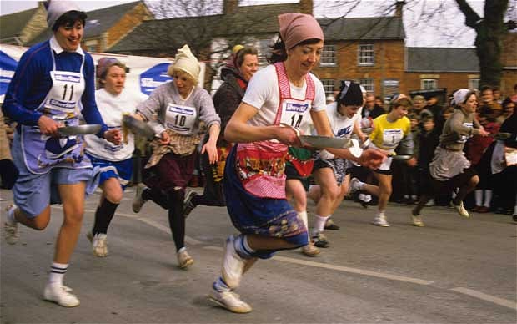
The most famous pancake race takes place at Olney in Buckinghamshire. It is said to have started back in 1445 when a housewife of Olney heard the shriving bell while she was making pancakes and ran to the church in her apron, still clutching her frying pan. The Olney pancake race is now world famous. Competitors have to be local housewives and they must wear an apron and a hat or scarf.
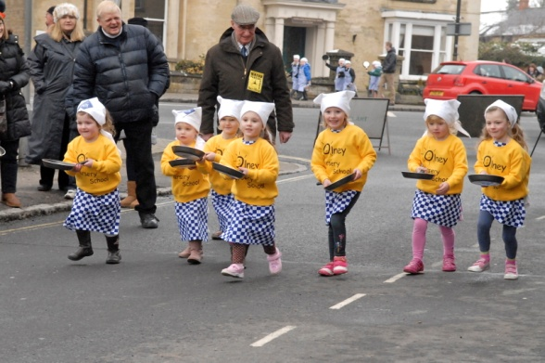
Each contestant has a frying pan containing a hot pancake. She must toss it three times during the race. The first woman to complete the course and arrive at the church, serve her pancake to the bellringer and be kissed by him, is the winner.
The Olney Pancake Race is now not just for housewives but for children, with many who race to raise money for their charity.
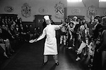
At Westminster School in London, the annual Pancake Grease is held. A verger from Westminster Abbey leads a procession of boys into the playground where the school cook tosses a huge pancake over a five-metre high bar. The boys then race to grab a portion of the pancake and the one who ends up with the largest piece receives a cash bonus from the Dean.
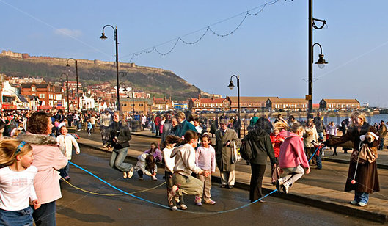
In Scarborough, Yorkshire, on Shrove Tuesday, everyone assembles on the promenade to skip. Long ropes are stretched across the road and there maybe be ten or more people skipping on one rope. The origins of this custom is not known but skipping was once a magical game, associated with the sowing and spouting of seeds which may have been played on barrows (burial mounds) during the Middle Ages.

Page 6

Many towns throughout England held traditional Shrove Tuesday football ('Mob Football') games dating back as far back as the 12th century. However, this mostly died out with the passing of the 1835 Highways Act which banned the playing of football on public highways, with only a very few towns carrying in with the tradition to the present day including Alnwick in Northumberland, Atherstone in Warwickshire, Sedgefield (called the Ball Game) in County Durham, and St Columb Major (called Hurling the Silver Ball) in Cornwall, and possible the most famous, in Ashbourne in Derbyshire (called the Royal Shrovetide Football Match) which had to be cancelled in 2001 due to foot and mouth disease in the UK but was reinstated with royal approval in 2003 when Prince Charles ‘turned up the ball’.

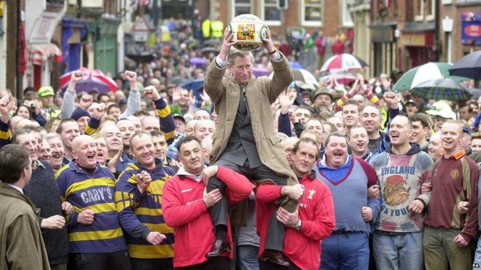
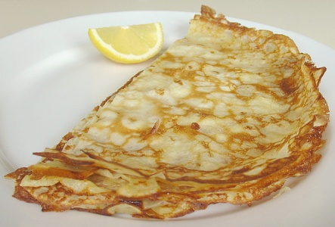
I think it far less energetic and stressful to partake of the finished cooked, tossed and served pancake at the lunch table – don’t you?
We hope you enjoy/enjoyed your pancakes on the 9th of February

Page 7 Resident Contributions

Limericks by Rosemary
(who will also deal with any complaints!!)

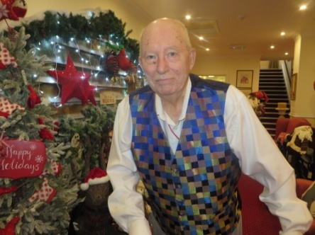

A poet who lived in the Shelley
Got rid of his books and his telly
He longed for some port
But of that he was thwart
So he threatened to buzz off to Delhi

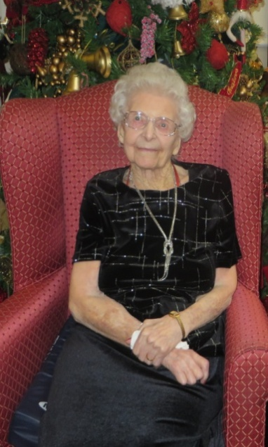
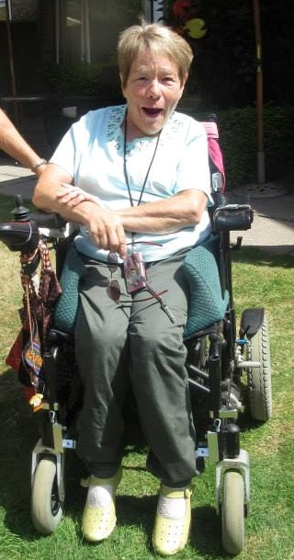
There is a dear lady called Clare
Whose generosity goes everywhere
At fund-raising she's great
And she's so literate
All's well if there's plenty of air.

A little old lady called Connie
Is humorous, "with it", and bonny
At one-hundred-and-two
She's all ticketyboo
And thinks her new room is so sunny.
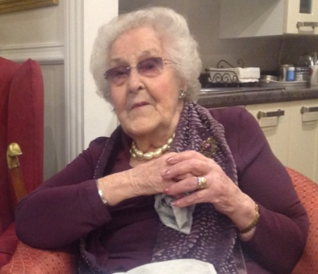

This lady's a real exception
And good for a nonagenarian
Well travelled, devout
And laughing, no doubt
But above all a humanitarian.
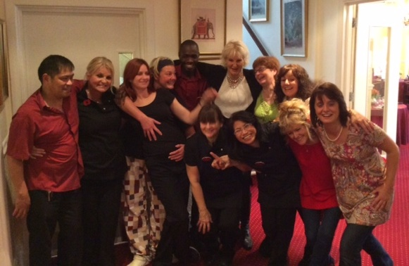

The Shelley's a grand place to be
If you fancy some good company
We all like the nosh
And a place that's quite posh
And the fact that the staff are all happy.

Page 8 John’s Rhymes

Pills
I used to want an oil well,
Just a little one,
Now I'd rather have a pill factory
Making money by the ton.
Do you remember Smarties?
Those very little sweets
They came in lovely colours
For children just a treat.
The pills are not bright coloured
More in pastel shades
Not quite sure why that is
Perhaps they think we're staid.
<="">

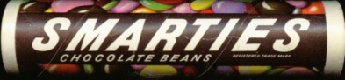

They have a special trolley
To cart pills at the Shelley
And if it just goes on like this
They'll soon be using Nellie.
I sometimes stop to wonder
As I swig a handful down
Just who has to pay for them
They must be costing pounds.
For on this earth, as we all know
Nothing's really free
And someone pays for all the pills
I'm thankful it's not me.

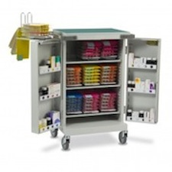

Page 9

The Maestro
When I was very very young,
A lad still in my teens,
I thought I'd like to play a tune
By any kind of means.
I bought myself a trumpet,
From a junk shop you must know,
But though I paid a bob or two,
It simply wouldn't blow.
Next came a ukulele,
Very simple, you would think,
But though I whacked it very hard
It just went plonk, plonk, plink.
Then I tried a guitar,
I bought it in Majorca,
But though it made a lovely sound
It was just another porker.
Next came the piano,
My dear wife played it well,
So you'd think that I could play it
But could I? Could I Hell.
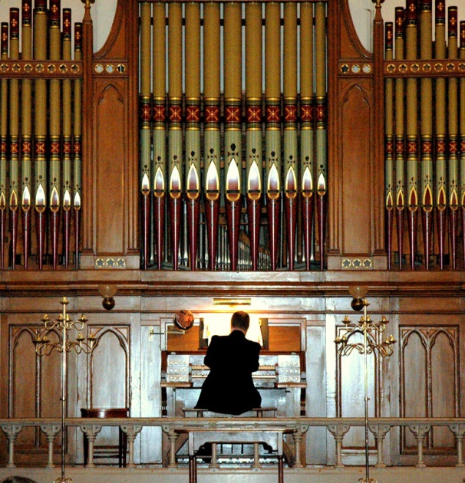

But now upon reflection
What I'd really like to play
Is a great big huge pipe organ
Smash windows miles away.

Page 10 Entertainment

Some Entertainment Coming This Month
As well as our weekly outings in the mini-van or walk/ride to the shops/parks etc.
we also have many of our favourite entertainers joining us, such as:

Robbie - Magic
Art with Trisha
Seaside Singers
G A P P
Pal o’ Mine
Two in Accord
Zoe – Alive Activities
Evening Music Workshop
Paul Rothera
Papa Geoff
John Beaver
Sweetheart Melodies
An Evening with Lori

PLUS OUR USUAL
Yoga – Exercises – Aromatherapy – Manicures
Pampering Afternoons – Art and Crafts – Communion
Breathing Spaces - Outings in the mini-van - Shopping Trips

Page 11 And Finally

True Pupil / Teacher Stories

Page 12

Dogs Bedtime Prayer
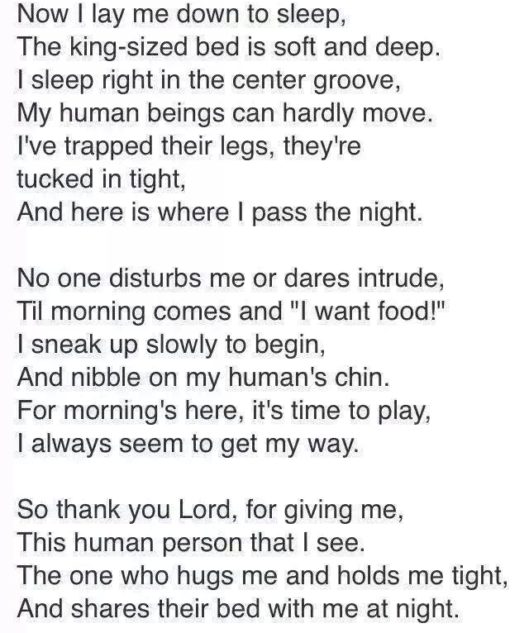

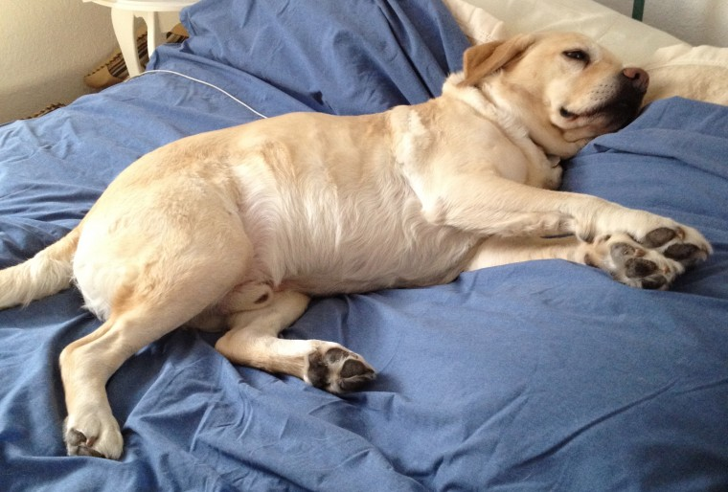

Page 13

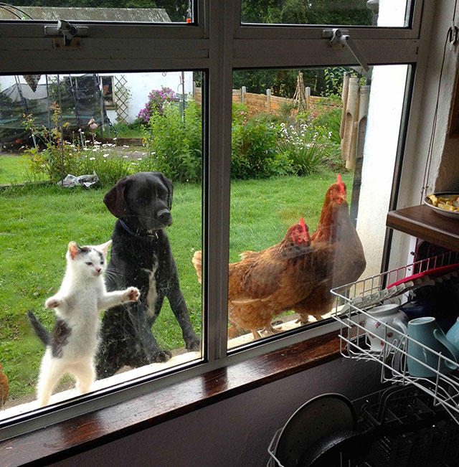

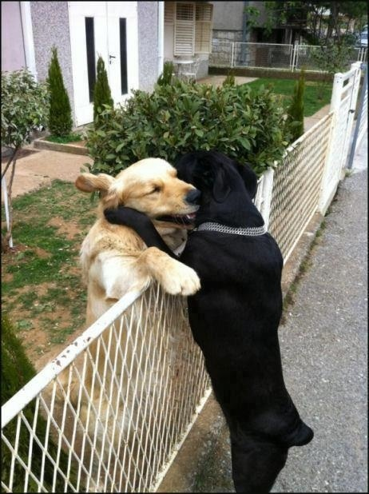

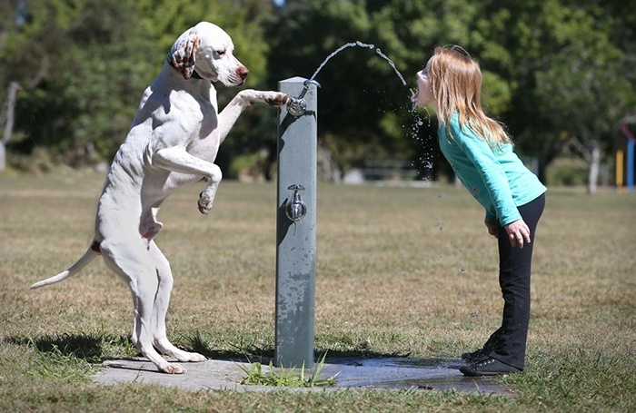

Page 14

We cannot end this Newsletter without mentioning a funny incident that happened when Johnny Earl came to entertain us (The Elvis singer and tea party/dance event)

Marlene’s daughter Holly did not know that one of rooms was not occupied but being used as Johnny’s changing room. Just before he was due to start she was asked to go and remind residents to come to the dining room if they wanted to join in. She knocks on the door where Johnny was changing, finding him getting dressed and politely informs him the entertainment was going to start in 10 mins!

Now, if this was the West end stage that could be called a ‘curtain call’ but to Holly’s embarrassment Johnny announces to everyone that it had been at least 30 years since he had such a beautiful young lady in his dressing room. He then thought about it again, and where he was, and continued to say he also hadn’t realised how much he must have aged! Just Remember

We’re on the Web!
Visit us: theshelley.com
Find us on Facebook: TheShelley Worthing
Read Past Newsletters: theshelleynewsletters.weebly.com/
For Just Photos: theshelleyphotos.weebly.com/

The Shelley does not hold, nor claim to hold the copyright on any article or photograph found in print or on the Internet.

