The Shelley

Newsletter – January 2016

**The Shelley -** 54 Shelley Road, Worthing, West Sussex, BN11 4BX. t: 01903 237000 e: [info@theshelley.com](mailto:info@theshelley.com)



### Inside This Issue

January 1

December in Pictures 2

New Year? Not For All 5

John’s Rhymes 7

Pardon me 9

Entertainment 11

And Finally 12

***Thank You – Marlene***

*Another fantastic (Residents) party full of fun, food, laughter, friendship and excitement. Santa and his merry helpers gave the children and adults lots of joy. A huge thank you to Marlene and all the staff and volunteers who worked tirelessly to ensure everyone had a most enjoyable and very happy time. Congratulations and thank you. Thank you. Thank you. Happy Christmas and New Year.*

*From Clare.*

***Thank You – Marlene***

*For an OUTSTANDING Staff Party held in Angmering Manor Hotel!*

*VERY tempted to put some photos in here but we don’t want to shock too many residents!*

*Suffice to say a great time was had by all who came and a special thanks to those who stayed behind on duty allowing us to do so.*

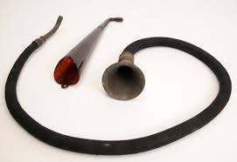

***What Are These For?***

***See page 9***

Page 2 December in Pictures

10th year Anniversary – with Fireworks

Residents Party – with Father Christmas

All before Christmas weekend

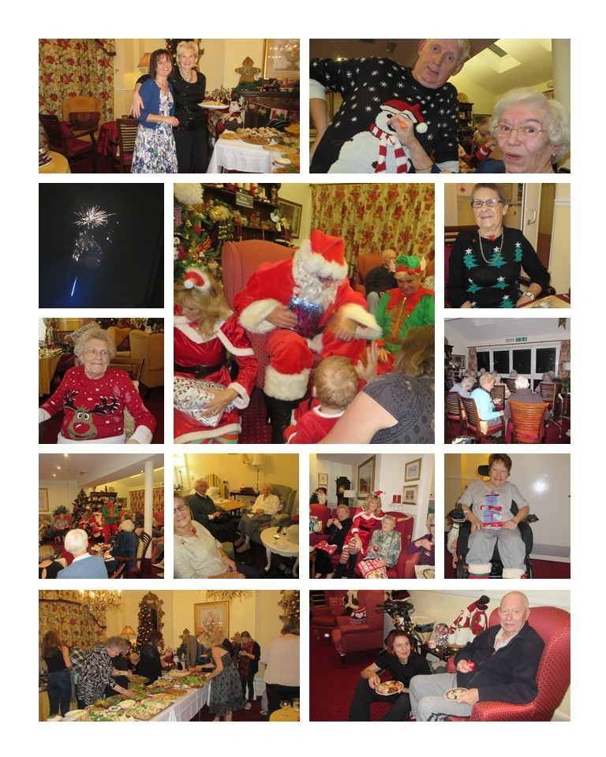

Page 3

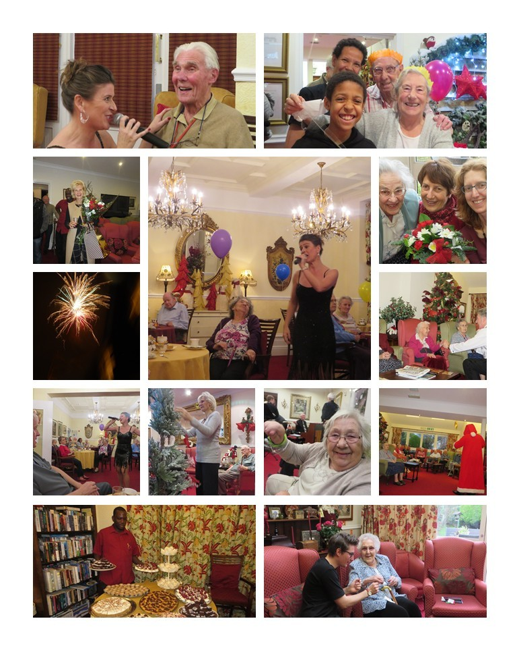

Page 4

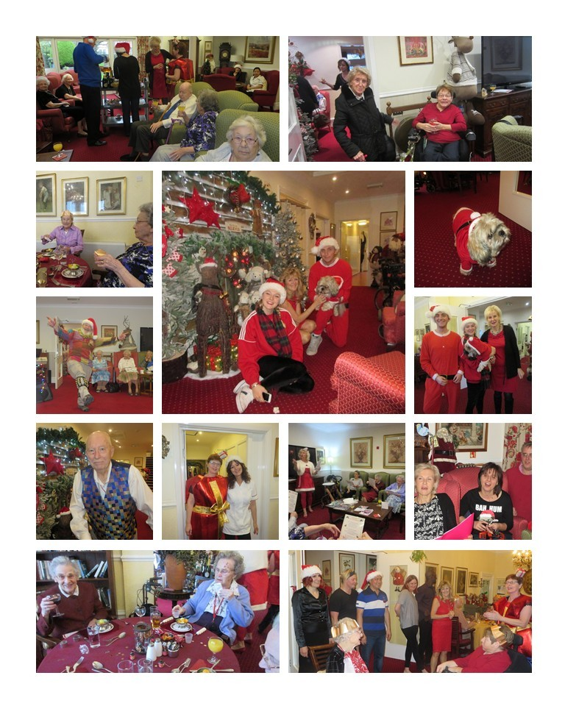

Page 5 Country and Religious New Year Differences

The Gregorian calendar was first introduced in 1582 and was named after the man who first introduced it: Pope Gregory XIII. Today it is the internationally accepted civil calendar and is also known as the "Western calendar" or "Christian calendar".

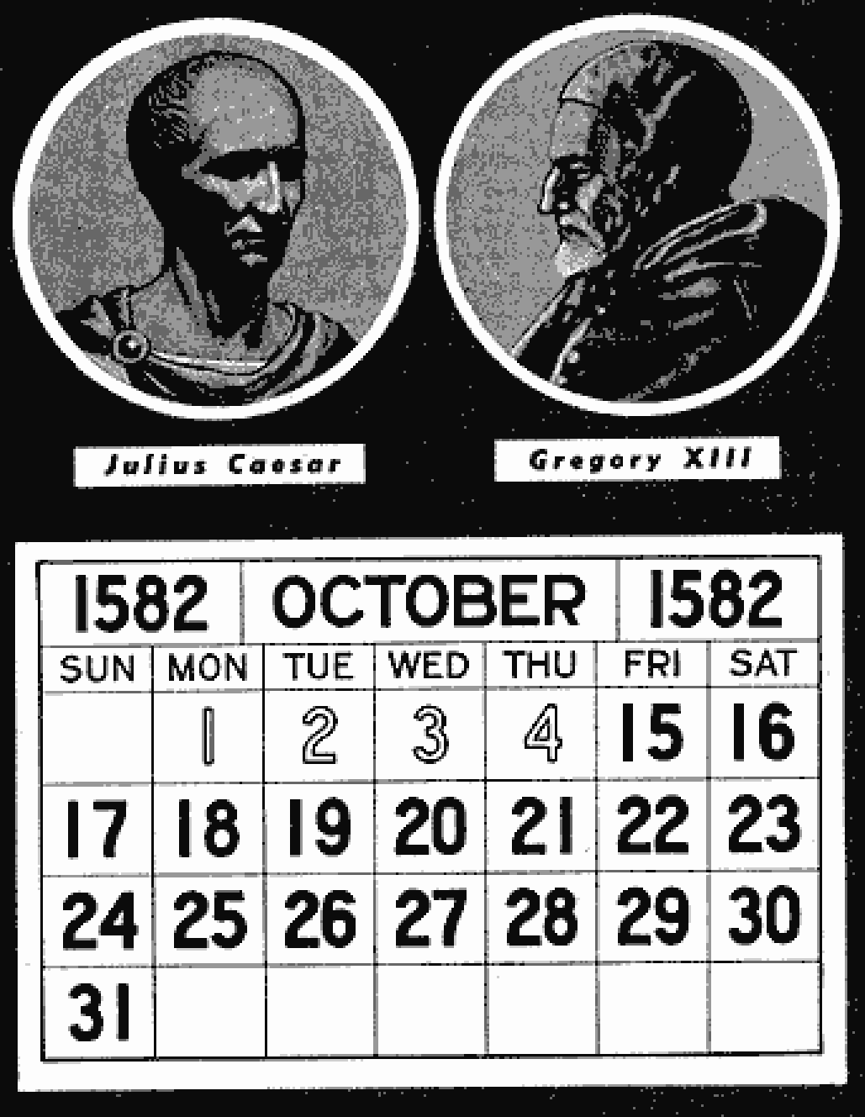

The [Gregorian Calendar's](http://www.timeanddate.com/calendar/gregorian-calendar.html) predecessor, the Julian Calendar, was replaced because it did not properly reflect the actual time it takes the Earth to circle once around the Sun, known as a tr

opical year or solar year. The Julian calendar was introduced by Julius Caesar in 45 BCE (Before Common Era) and replaced the Roman calendar. The Julian calendar has a regular (common) year of 365 days divided into 12 months with a leap day added to the month of February every four years (leap year).

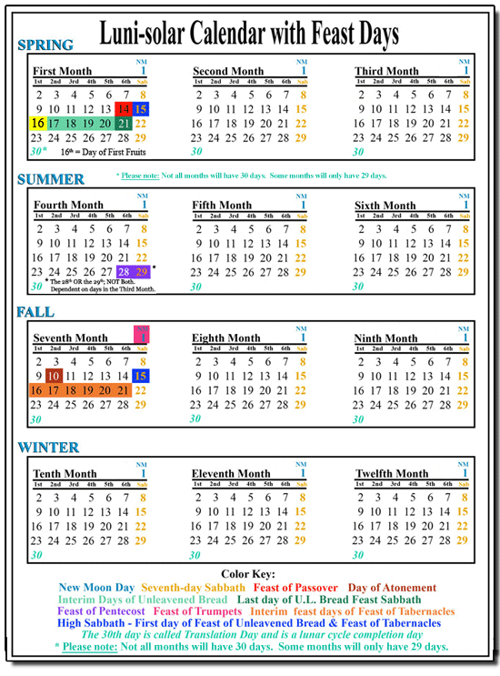

This Luni-solar calendar [LSC] is based on each month, or lunation, beginning at dawn following the moon's conjunction with the sun.  The first day of each month is called New Moon Day and is observed by abstaining from common labour and in worshipful consecration of oneself to Yahuwah, the Creator. The New Year is reckoned by the New Moon closest to the spring (vernal) equinox.  In order to keep the lunar year aligned with the solar year, [a 13th month](http://www.worldslastchance.com/yahuwahs-calendar/a-13th-month-the-divine-precision-of-the-luni-solar-calendar.html) must sometimes be added.  There are seven thirteen-lunation years in every nineteen year cycle; this is called the Metonic Cycle. This makes the calendar truly luni-solar.  These adjustments are somewhat similar to the extra day in the leap year of the Gregorian calendar.

**Christians** celebrate on the 1st January in accordance of the Gregorian calendar of 365/6 days. This is the calendar most accepted around the world.

However there are many other countries or religious groups who celebrate their New year according to different calendars, usually Lunar or Luni-Solar calendars.

**Countries that differ:**

**Chinese New Year** known as Yuan Tan is calculated according to the lunar Calendar and can occur any day between mid January and mid February. Celebrations can go on for up to 15 days.

Page 6

**Japan** used to follow the same calendar until 1873 when they stared to use the Gregorian Calendar.

**Sri Lanka’s New Year** occurs in mid April and is known as Aluth Avurudhu

**India’s New years** are different depending on which part of the country you are in. In general they follow a lunar calendar and celebrate around the middle of April.

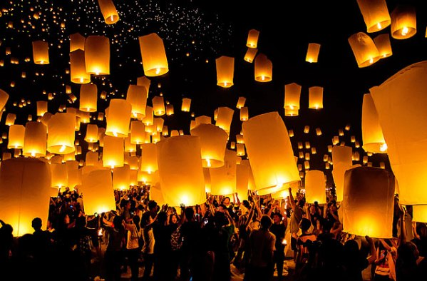**Religions which differ:**

**Hindu’s** have undergone several changes since ancient times and generally follow a luni-solar pattern.

**Muslims** follow a lunar calendar of 354 days meaning the New Year changes annually.

**The Sikh’s** New Year begins with Chet 1 which is usually March 14th as per Gregorian calendar.

**Buddhists** use the lunar-solar calendar and varies from country to country. In china, Vietnam and Korea it is Mid Jan to Mid Feb. While in Tibet it is in March and Sri Lanka, Burma and Thailand celebrate in April.

**Bahai’s** celebrate New Year on the Vernal Equinox, usually March 21st as they follow the Badi calendar which has 19 months plus extra days in leap years.

**Jewish** families celebrate on the month of Tishri which occurs in September or October. Tishri-years is an ancient calendar system used in Israel/Judea, and the Jewish people in Diaspora. It is based on, and is a variation of, the Nisan-years. Tishri-years is often called the Jewish Civil Calendar, in contrast to Nisan-years, which is often called the Jewish Religious Calendar.

*Next month we will look at the different zodiac signs around the world.*

Page 7 John’s Rhymes

The All Blacks

The All Blacks are a famous team,  
They hardly ever lose  
And if they are defeated  
All New Zealand get the blues.  
  
Shelley All Blacks are better yet,  
They just can't be defeated  
Any team that has a go  
Will just get over-heated.  
  
Thalia's the line-out jumper  
No doubt at all for that  
And Claire must be the full-back  
She'll put them on the mat.  
  
And what about the wingers?  
They really have to go  
Sherry on the one side  
And perhaps Michelle you know.  
  
And I'm afraid I have to say  
We need more weight within the pack  
They must start eating burgers  
And lovely stuff like that.  
  
And then there is the number ten,  
Not sure who'd be best  
Of course it could be Marlene  
If she were properly dressed.  
  
Now what about the substitutes?  
A real problem here,  
Three girls sitting on the bench  
And they're all called Maria.



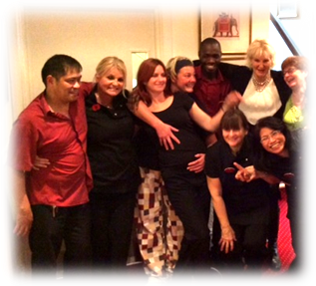

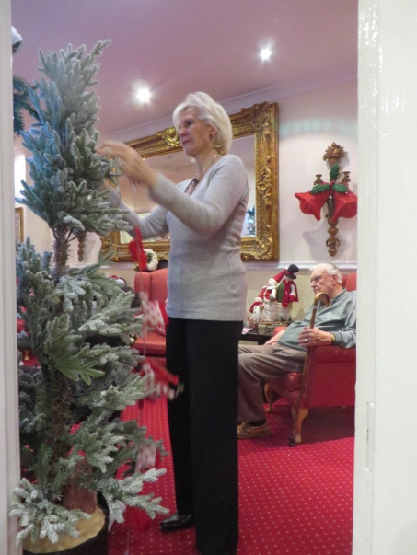

Page 8

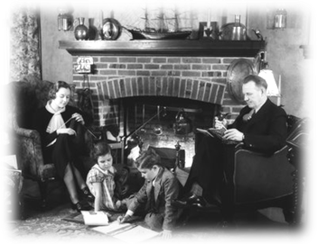In the Dark.

I've always liked dark evenings  
Even as a boy  
The curtains drawn, the fire aglow,  
A very special joy.  
  
Sometimes we had the radio,  
But not so very much,  
But always, always, always,  
Always there were books.

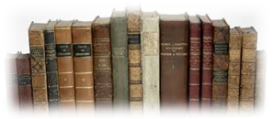

I must have been top customer  
At our library's local branch,  
I'd browse and browse sometimes for hours  
You'd think I was in a trance  
  
Years later there came TV,  
Best thing you'd ever seen  
With lovely things like interludes  
To fill the waiting screen.

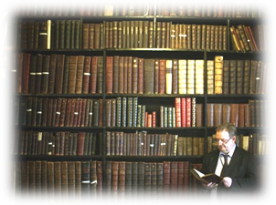

For years we watched it quite a lot  
And had our favourite bits  
But now I've thrown the thing right out.  
To me it's just the pits.  
  
So what shall I do now it's getting dark again?  
I shall sit and snooze and dream of days of yore  
And thank goodness I still have some books  
So I shall simply read some more

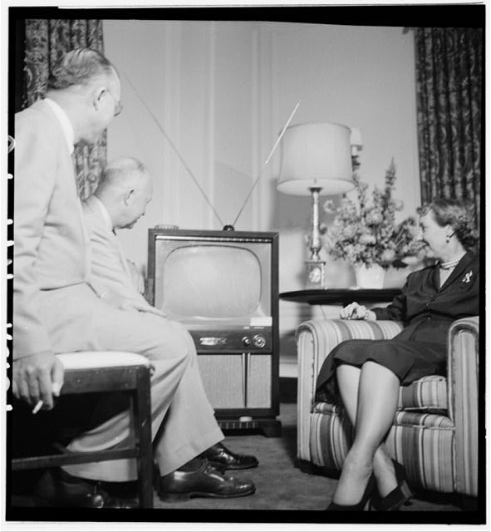



For years we watched it quite a lot  
And had our favourite bits  
But now I've thrown the thing right out.  
To me it's just the pits.  
  
So what shall I do now it's getting dark again?  
I shall sit and snooze and dream of days of yore  
And thank goodness I still have some books  
So I shall simply read some more

Page 9 Pardon me

*Hearing aids and how they have evolved.*

Next time you hold your hand to just behind your ear and say “pardon”, have a thought for those ladies and gentlemen of years ago.

For many years, it was believed that people who could not hear well also had additional disabilities and were discriminated against.

In the early 16th century Pedro Ponce, a Spanish monk proved that there is no connection between people's hearing ability and their intellectual capacity. Around 1530, he taught Pedro and Francisco, the deaf sons of the nobleman Juan Fernández de Velasco y Tovar, how to read, write, do maths and speak.

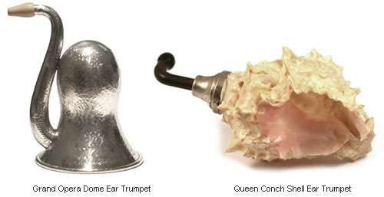 The first and most primitive period of aids for hearing was the acoustic era in which objects such as horns, trumpets, and speaking tubes were used to amplify sound. As early as the thirteenth century, animal horns were adopted as a device to aid humans to hear more clearly.

Many people did not want to admit they had a hearing problem and during the 16th century ear trumpets were often concealed either in fans or made part of a walking stick and even camouflaged in jewellery. They were made from different materials including sheet iron, wood, animal horns, silver and even snail shells. The long tube device above is used for a person to speak or shout into while the other end is inserted in the ear of the person hard of hearing.

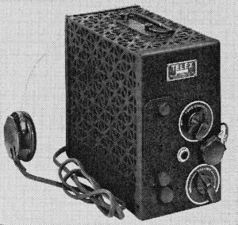Miller Reese Hutchinson created the first electronic aid in 1898, based on the principles used in telephones but it wasn’t until 1902 that practical and wearable aids were available in the crudest form and a further 20years before these became adapted and popular. Even so, they only had enough power to correct moderate hearing loss and the size of the battery pack was not an easy item to carry around!

Page 10

As the batteries grew smaller, so the ease of using a hearing aid became 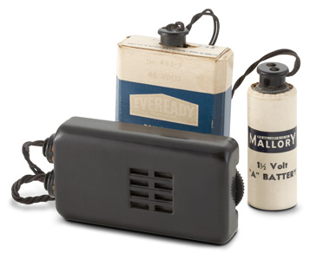more practical to use and by the 1950s a transistor was used with a simple on/off switch.

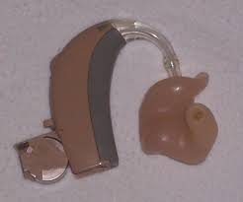Later, by making transistors out of silicon, hearing aids were again able to shrink in size. First they became “body aids”, and then in the 1960s, ear-friendly instruments worn behind the ear, in the ear shell, or ultimately, within the ear canal.

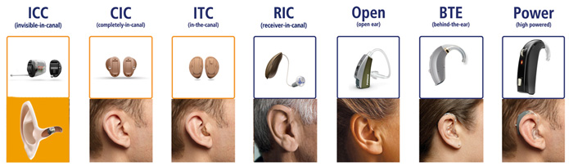By the mid-1990s, digital hearing aid technology was common-place. Digital circuitry allowed sound to be amplified, reduced, filtered, and directed, as needed. Hearing aid programs could be customized to a user's lifestyle – soft amplification for quiet home settings, targeted amplification of voices in restaurants, and could diminished wind noise on the golf course for example.

These aids have become tiny, so much so that they can – in some cases, be completely inserted into the ear canal, meaning they are completely invisible.

So what is next, what hearing solutions are being developed? In 2013 The Daily Mail reported *“a potential cure for permanent deafness has been found by scientists using a drug codenamed LY411575, triggers the regeneration of sensory hair cells.*

*Until now it has not been possible to restore the cells once they have been lost due to factors such as loud noise exposure, infection and toxic drugs. Tests with this new drug on mice have shown the hair cells can be regenerated from surrounding cells in the cochlea.*

Page 11 Entertainment

Some Entertainment Coming This Month

As well as our weekly outings in the mini-van or walk/ride to the shops/parks etc.

we also have many of our favourite entertainers joining us, such as:

***Alan - Singer and Guitarist***

***Bertie - Singer***

***The Sandgate Singers***

***Geoff Field***

***Jack Winrow – Cabaret Style Singer***

***Rudi***

***Sundown Ukulele Band***

***Arts and Crafts with Nicki***

***Roger – An Informative Talk***

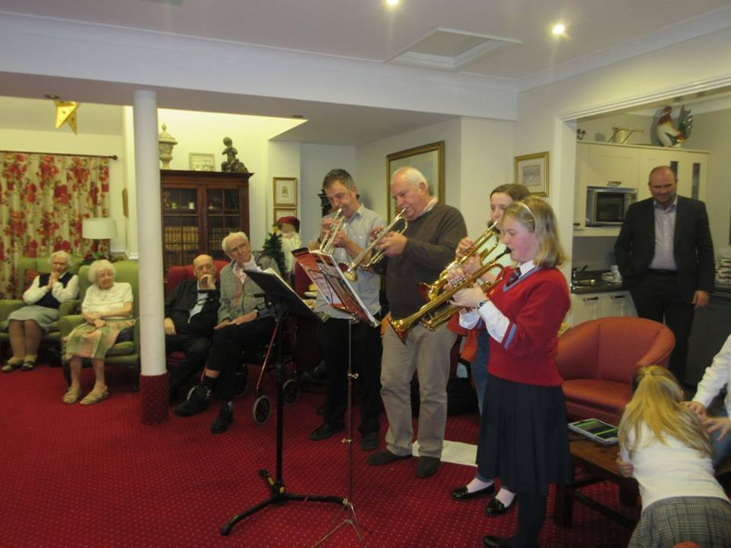***Sussex Music Workshop***

**PLUS OUR USUAL**

Yoga – Exercises – Aromatherapy – Manicures

Pampering Afternoons – Art and Crafts – Communion

Breathing Spaces - Outings in the mini-van - Shopping Trips

Page 12 And Finally



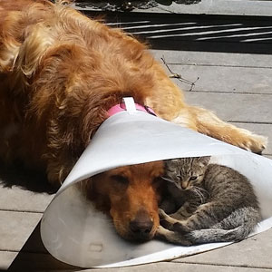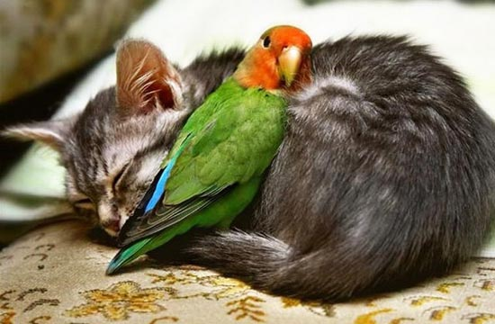Animals can get on – what a shame humans cannot do the same!

Whatever your New Year resolutions are, more than anything -

Be Happy



***We’re on the Web!***

*Visit us:* theshelley.com

*Find us on Facebook:*  TheShelley Worthing

*Read Past Newsletters:* theshelleynewsletters.weebly.com/

*For Just Photos:* theshelleyphotos.weebly.com/

*The Shelley does not hold, nor claim to hold the copyright on any article or photograph found in print or on the Internet.*