
The Shelley - 54 Shelley Road, Worthing, West Sussex, BN11 4BX. t: 01903 237000 e: info@theshelley.com
The Shelley Newsletter

JANUARY 2015

A very Happy New Year
to you, from all the staff at The Shelley.

So what can we expect in 2015? We could say “about the same as last year” but that would make The Shelley like any other care home. To be fair, if you have not lived in another care home you may think The Shelley is the norm but as many will tell you we are anything but normal – just look at our new web page!

Inside This Issue
Happy New Year 1
Last Month’s Events etc 2
Residents Contributions 4
John’s Rhymes 6
History of Pantomime 8
And Finally 11

See Clare’s letter of thanks on pages 4-5



However, we do have some regular, popular activities to look forward to in 2015, such as:

Our Summer Fayre – watch this space for the 2015 theme.

Days at The Races – Where we follow Ascot’s Ladies Day in our home-made hats and may even have a flutter on The Derby or Grand National.

Easter eggs for all on Easter Sunday

Birthday cakes and gifts all year

And for the very good (or even naughty ones), Santa will visit once more!

Page 3

Last Month’s Events, Entertainment and Outings



Many Happy Returns Went To:

Joyce, Maureen, Barbara and Ivan.
There was cake, candles and presents for all.

Almost every resident and member of staff managed to sit on Santa’s knee at the Residents Party

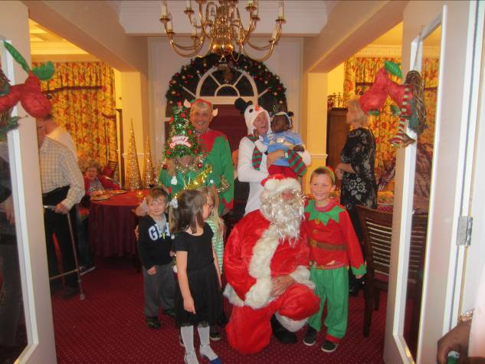
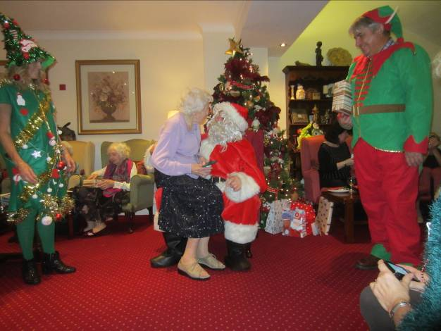

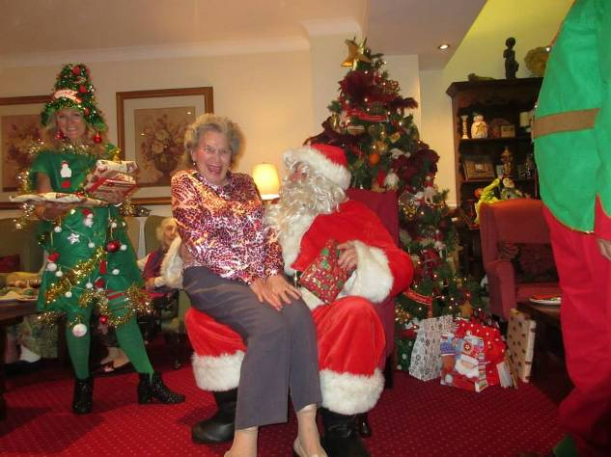
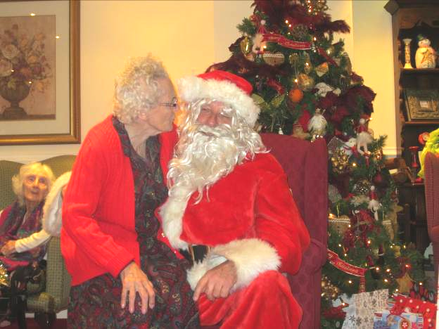

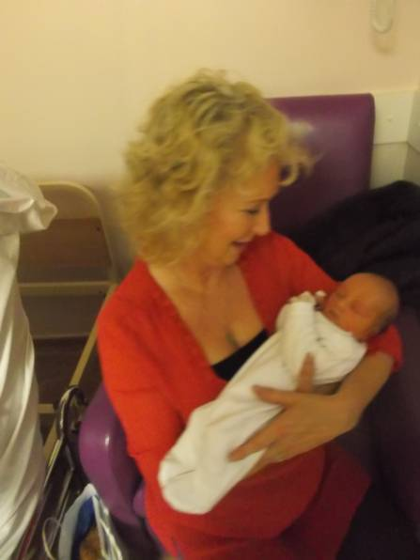
We have a stop press event to announce

Our congratulations go to Jeanette and Daniel for the birth of their first grandchild – little Benjamin.
Mum and baby are both doing very well.

John has been at it again !
See pages 6-7

Christmas Day and Boxing Day, where fun was had by all

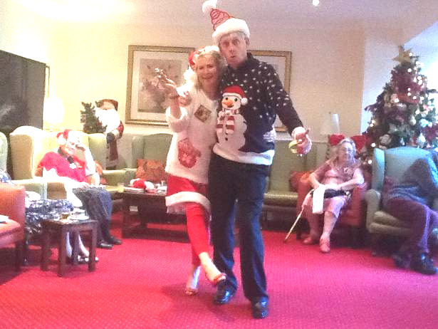
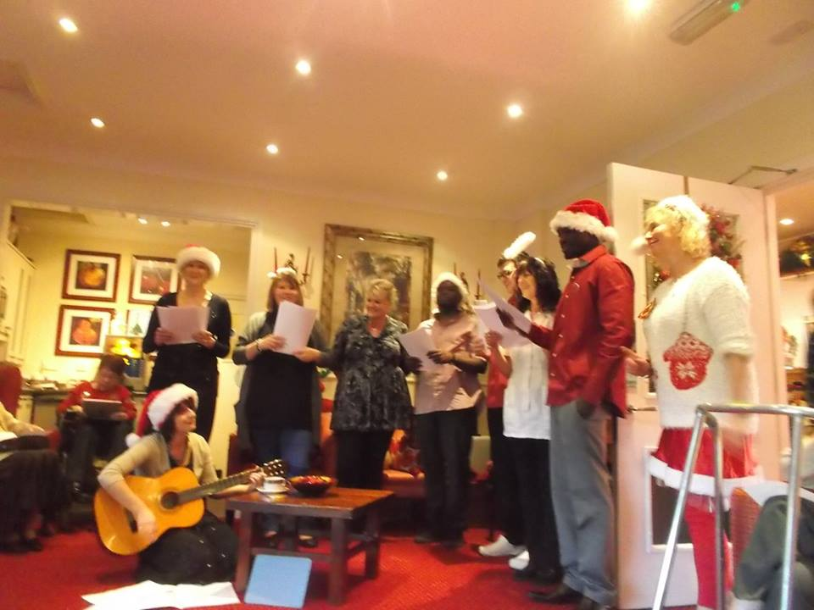

Page 3

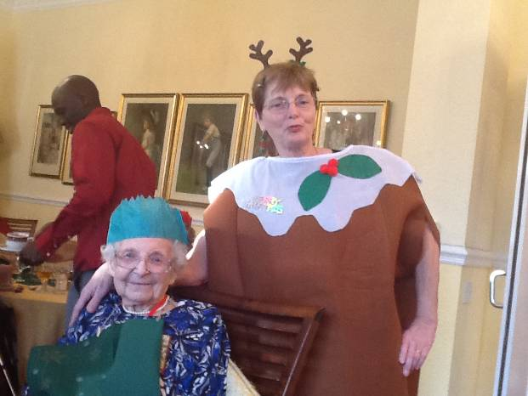
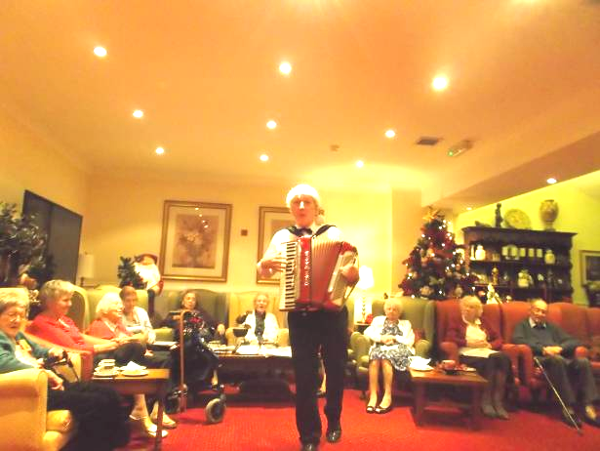

Some December Outings included:
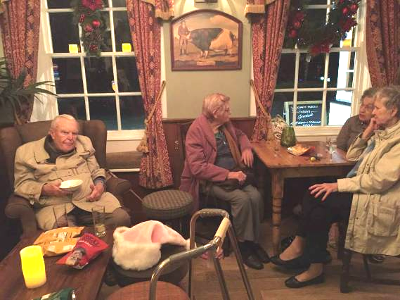
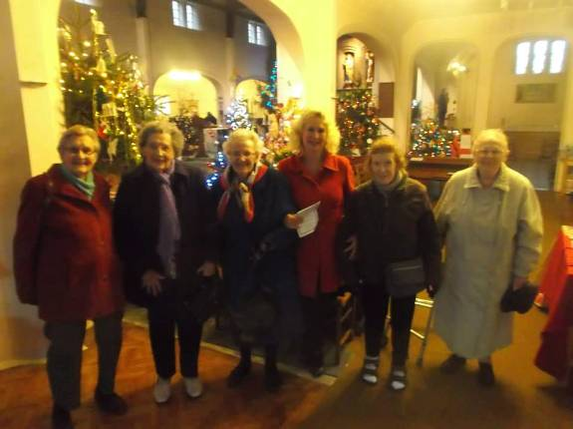

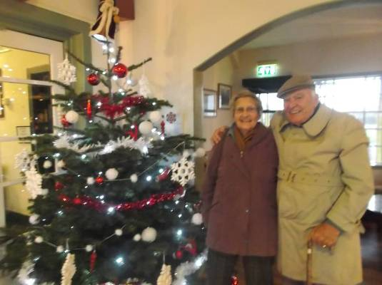
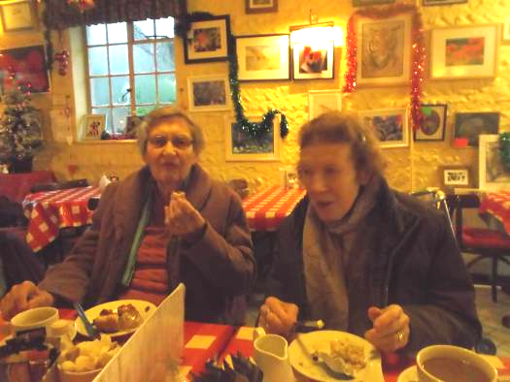

Page 4

Residents Contributions:

LIVING AT THE SHELLEY

The year 2014 flew by so quickly and it was filled with lots of things to keep us occupied. There was little time to be bored or lonely.
Our Activities Co-ordinators, Jeanette and Beverley, are kept busy organising lots of entertainment, outings, activities, shopping trips, library visits, health appointments, and many many other jobs. They are sometimes ably assisted by their husbands, Daniel and Bob, who give up their time voluntarily and help in many ways.
The yearly Garden Party and Xmas Party, plus the spectacular Fireworks Display for 5 November, are big highlights in The Shelley calendar. These are wonderful events where enormous planning and thoughtfulness is shown.
Throughout the year many events are held to raise money for local charities. Because of the kindness and generosity of residents, staff and visitors, we always manage to do extremely well.
The Shelley's animals keep us amused in many ways. There are 3 cats owned by The Shelley: Fudge who sleeps mostly in the lounge and on the radiator through thunderous noises. Plus Timmy and Tiddles who live in the ground floor room with Lesley. A new resident, Kay, has brought her own cat called Holly, and they live together in another of the ground floor rooms.
We also have regular visits from two beautiful dogs, Indie and Rex, who belong to Marlene and Keith. Then there are the little and big birds, squirrels, foxes, pigeons and the gulls out in the garden. We have seen the baby gulls fall off the top roof onto the lower roof, and then on to the garden. Staff are then attacked mercilessly as they try to rescue them. They come away bruised and bleeding with their ears ringing from the terrible screeching. The Shelley is the animals equivalent of "Heaven".
The Shelley doesn't stay behind in the dark ages!! Oh no, not at all. We are on Facebook and have our very own website. Family and friends are able to see what is happening, and can also view pictures of loved ones. The screen in the hallway shows the latest pictures of outings, events, etc. Photos are taken by many people and given to Sherry who then transfers them on to the screen.
A big thank you to Sherry for all the work entailed in putting together the monthly Newsletter for The Shelley. What a joy it is to read it every month and to see all the pictures. Sherry does everything involved in getting the Newsletter up and running in her own personal time. What a tremendous task indeed. Each month John contributes one of his memorable poems and these are gratefully received. Thank you John and please keep them coming.
Our weekly pampering is a must for most residents. Having an aromatherapy massage is so relaxing and eases many pains and joint stiffness. Getting our hands and nails manicured and painted is also so therapeutic and essential to a woman's well being.

Page 5

Food, glorious food. Plentiful at The Shelley where small portions do not exist!! We are so lucky to have two outstanding chefs who delight us every day with a variety of delicious food. As if the main meals were not sufficient, we are then tempted every day with homemade cakes, biscuits and pastries. The Shelley "belly" quickly happens to many of us humans, and also to the animals. The Shelley also boasts a 5 star hygiene award for a spotless kitchen. This is due to the constant hard work, dedication and cleanliness of Celis, Lucas and the two chefs. Congratulations and many thanks to you all.
There are many staff who go beyond the call of duty and work tirelessly on our behalf. Even during their days off work, they think nothing of turning up to work during emergencies, helping out at parties and other occasions. These unsung heroes help the wheels of The Shelley to always keep turning round and round. You know who you are but most residents will be totally unaware of your continual dedication and loyalty. It would not be sensible for me to name you but thank you so very much for everything.
Our excellent Manager, Nada, has a job which is extremely challenging, labour-intensive and enormously stressful. Despite all of this, she is always there for everyone offering advice, comfort, support, love and understanding. We greatly appreciate everything you do for all of us. Not forgetting your great care of all the animals.
The Shelley employs a lot of staff who carry out many different tasks daily, and we are very lucky to be well taken care of by all of you. It would be a long list to name everyone so on behalf of all the Residents I extend our sincere thanks for all your care and support. We appreciate everything you do for us at all times.
This just leaves me with the biggest challenge of all - to adequately thank Marlene and Keith for so very much. They are extraordinary generous with gifts, their time, etc. and it is not easy finding the right balance to ensure The Shelley continues to be a very special "home" for everyone. We are the luckiest people to live in such a luxurious Home where we are pampered and thought about in a major way. Words are inadequate in saying how we feel about your abundant care of us. Everything is greatly appreciated and welcomed in a huge way. Thank you, Marlene and Keith, for everything.
May 2015 be a healthy, prosperous and joyous year for each and every one of us.
Happy New Year from all the Residents.
Written by Clare (room 11)

Page 6

John’s Rhymes

Magical
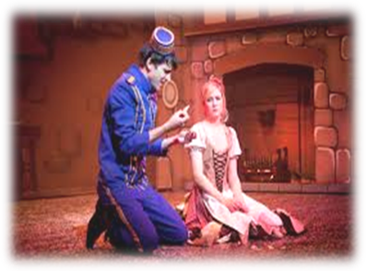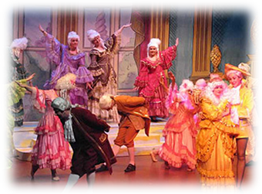After presents and the pudding
Always came the pantomime
It marked the end of Christmas
All done until next time.
The principal boy was always a girl
I often wondered why
But it didn't seem to matter
So long as she slapped her thigh.
And then there were the funny men
To make us laugh a lot
They always seemed to be there
No matter what the plot.
The sets were built of magic
And lots of sparkle too
Except for Cinders' kitchen
And that would go, you knew.
The transformation scene
Enthralled us one and all
Things turned and moved and twisted
And became the palace ball.
The principal boy wore a three-cornered hat
That always had a feather
And a very very fitting top
And long boots made of leather.
Cinders wore a gorgeous gown
That must have cost them pounds.
So after is it locked away
Until next year comes round?
The people at the telly
Can't do stuff like that
They simply cut from set to set,
What's magical in that?


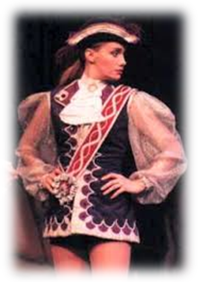










Page 7

Oh No He Didn't!

Long John Silver
A pirate very bad
Became very very famous
When he said "aha Jim lad".
Squatting in a barrel
The boy learned Silver was a cad
If the pirate knew that he was there
There'd be no more Jim lad.
They planned to kill the goodies
Steal everything they had
And as they sailed the ship away
They'd shout "aha Jim lad".
But thanks to Jim for being smart
The goodies beat the bad
And everyone was glad to say
"Well done!" to our Jim lad.
But, Robert Newton in the film
First used the famous words
Long John Silver in the book
Said "Tell it to the birds".
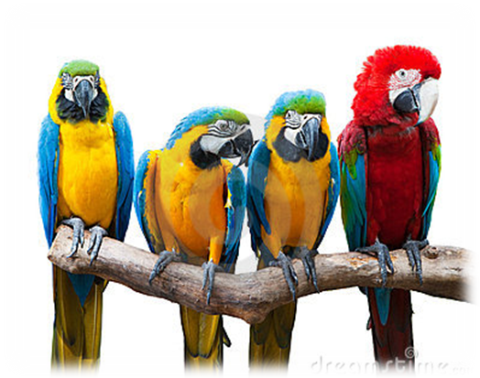
“Aha Jim lad”


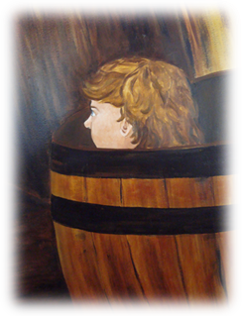

"Tell it to the birds"

Page 8
History of Pantomime

Pantomime has become a British institution which takes place around the Christmas and New Year period but where did they originate?
Pantomime comes from the Greek ‘panto’ "all kinds" of ‘mime’ "imitator or actor" (panto-mime) and was a popular form of entertainment in ancient Greece and later, Rome. Like theatre, it encompassed the genres of comedy, tragedy and sex. No ancient pantomime libretto has survived.
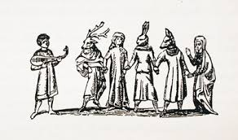
In the Middle Ages, the Mummers Play was a traditional English folk play performed during the festive gatherings of both urban and rural communities and contained many of the archetypal elements of the contemporary pantomime such as stage fights, coarse humour and fantastic creatures. Gender role reversal reflected the old festival of Twelfth Night, a combination of Epiphany and midwinter feast, when it was customary for the natural order of things to be reversed
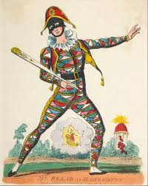
Precursors of pantomime also included the masque, which grew in pomp and spectacle from the 15th to the 17th centuries. The dancing master at Drury Lane, is cited as the first pantomime produced on the English stage but it was not a success and it was not until 1717 when the Harlequin character from the Italian masque performances in the 17th century was introduced to England that pantomime gained popularity.
The early pantomimes were silent, or "dumb show", performances consisting of only dancing and gestures. Spoken drama was only allowed in London in certain "patent theatres" until Parliament changed this restriction in 1843 and Harlequin was given the power to create stage magic in league with offstage craftsmen who operated trick scenery. Armed with a magic sword or bat (actually a slapstick), Harlequin treated his weapon as a wand, striking the scenery to sustain the illusion of changing the setting from one locale to another. Objects, too, were transformed by Harlequin's magic bat.
Pantomime gradually became more topical and comic, often involving spectacular and elaborate theatrical effects as far as possible and pantomime continued to grow in popularity.

Page 9

By the early 1800s, the pantomime's classical stories were often supplanted by stories adapted from European fairy tales, classic English literature or nursery rhymes.
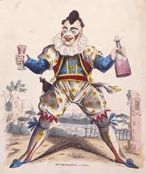
In the first decade of the 1800s Joseph Grimaldi came to dominate London pantomime and made the character Clown as important in the entertainment as Harlequin. His performances elevated the role by "acute observation upon the foibles and absurdities of society, and his happy talent of holding them up to ridicule and became the principal schemer trying to thwart the lovers. He is the finest practical satyrist that ever existed. Grimaldi's performances were important in expanding the importance of the harlequinade until it dominated the pantomime entertainment.
It was in the 1800’s that children went to the theatre around the Christmas and New Year holiday (and often at Easter or other times) primarily to witness the craziness of the harlequinade chase scene. It was the most exciting part of the "panto", because it was fast paced and included spectacular scenic magic as well as slapstick comedy, dancing and acrobatics.
The opening "fairy story" was often blended with a story about a love triangle: a "cross-grained" old father who owns a business has a pretty daughter, who is pursued by two suitors. The one she loves is poor but worthy, while the father prefers the other, a wealthy fop. Another character is a servant in the father's establishment. Just as the daughter is to be forcibly wed to the fop, or just as she was about to elope with her lover, the good fairy arrives. This was followed by what was often the most spectacular part of the production, the magical transformation scene. In early pantomimes, Harlequin possessed magical powers that he used to help himself and his love interest escape. He would tap his wooden sword (a derivative of the Commedia dell'arte slapstick or "batte") on the floor or scenery to make a grand transition of the world around him take place. The scene would switch from being inside some house or castle to, generally speaking, the streets of the town with storefronts as the backdrop. The transformation sequence was presided over by a Fairy Queen or Fairy Godmother character. The good fairy magically transformed the leads from the opening fairy story into their new identities as the harlequinade characters.

Page 10

In the late 19th century, Augustus Harris, proprietor of the Theatre Royal, Drury Lane, hired well-known variety artists for his pantomimes.
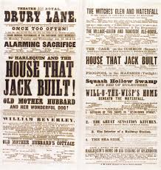

A tradition which carries on, as many modern pantomimes use popular artists to promote the pantomime, and the play is often adapted to allow the star to showcase their well-known act, even when such a spot has little relation to the plot.


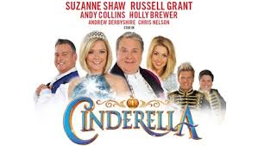

Page 11
And Finally


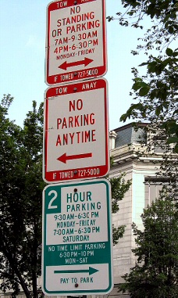

Signs that contradict or just do not make sense.

There is a good reason we use the term ‘Guide Dogs’ or ‘Assistance Dogs’. All dogs see through their eyes – Don’t they!





We’re on the Web!
Visit us: theshelley.com
Find us on Facebook: TheShelley Worthing
Read Past Newsletters: theshelleynewsletters.weebly.com/
For Just Photos: theshelleyphotos.weebly.com/
Page 12

The Shelley does not hold, nor claim to hold the copyright on any article or photograph found in print or on the Internet.

